**The KonMari Method**

**The KonMari Creator**

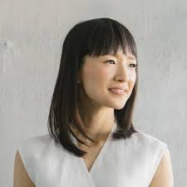

[Marie Kondo](https://konmari.com/) is a Japanese author and organization expert who currently lives in Los Angeles with her husband and children. She began her journey to tidiness when she was in the equivalent of American middle school. The classroom bookshelf would be frequently messy, and so she became her class’ official bookshelf manager and kept them clean. While studying sociology at Tokyo Woman's Christian University she created an organization consulting business. She has since written four books, the most popular of which is [*The Life-Changing Magic of Tidying Up: The Japanese Art of Decluttering and Organizing*](https://www.amazon.com/Life-Changing-Magic-Tidying-Decluttering-Organizing/dp/1607747308/ref=sr_1_3?ie=UTF8&qid=1548276632&sr=8-3&keywords=marie+kondo+the+life+changing+magic+of+tidying+up). It was an instant bestseller in Japan, was translated into 9 other languages, and over 7 million copies have been sold so far. Marie Kondo now has a Netflix series, *Tidying Up with Marie Kondo*, that premiered on January 1st, 2019.

[](https://www.youtube.com/watch?v=WvyeapVBLWY)

**What is KonMari?**

KonMari is the name of the method that Marie Kondo has created to more effectively declutter and tidy a space. It can be used at home, the office, or anywhere else where decluttering is necessary. The most important part of the KonMari method is to ask yourself, “Does this spark joy?” Joy can be different item to item or person to person. Clothing might bring you joy when you wear it, or it could bring you joy to see it if it has sentimental value. Books might bring you joy if you have read them, if they were a gift from someone you care about, or if they look nice on a shelf. There are many ways an item could spark joy, but if it doesn’t then Marie Kondo says that it is best to thank the item for serving you and to pass it on so it may bring joy to someone else. The KonMari method focuses on types of items, not location, and items should be decluttered in order before organization can begin.

[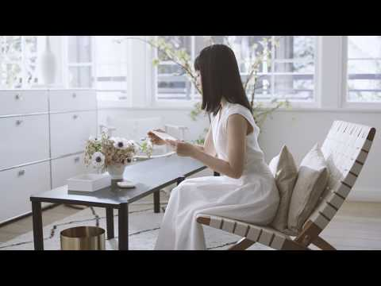](https://www.youtube.com/watch?v=qo2v645STW0)

**How do I KonMari?**

The first step of the [method](https://konmari.com/pages/about) is to fully commit to tidying up your space. Without commitment the space will never reach its full potential and you won’t feel fulfilled by your tidying efforts. The second step is to figure out exactly how you want your space to look, and how having it look and feel that way will impact your life. Having a specific vision will lead to better results than vague ideas because it is easier to create a plan to reach your tidying goals. The next step is to resist the urge to make things look nice as you declutter. Letting your space go through a transitional period is important because you can focus your energy on decluttering and finding items that bring you joy that you didn’t know you had. As an example, if you find a beautiful picture that you forgot you had and decide to put it up, it’s easier to put it up after you see what other pictures could go up with it. The next step is to declutter, in order of category and not location. The categories, in order, are clothing, books, papers, miscellaneous, and sentimental. To accomplish this all items from each category would be done at once, so all clothes would be done at once, all books, etc. If multiple people live in a home their items can be done separately, but still in order of category, or together. The order is designed to have the most impact on space and ease of decluttering frontloaded. It is easy to get rid of clothes or books that don’t spark joy, but decluttering sentimental items can be a long and arduous process. This is especially true if the space being decluttered has items from children now grown, recently deceased relatives, or any other situations that would involve there being many sentimental items. The final step of the KonMari process is to tidy, organize, and decorate.

**KonMari Organization**

A big part of the KonMari method includes how to organize once items have been decluttered. This includes the use of items already owned, especially storage containers that have been freed up from other decluttered items, giving items a specific place to be, and checking to see if you have something before buying more. The most important organization tactic used by Marie Kondo is the idea that you should be aware of the items you own. If you do not see an item, how can it bring you joy and how can you use it? The short answer to that is you can’t. Therefore, Marie Kondo strongly advises organizing things so you can see all of your items. This includes [folding clothes](https://www.youtube.com/channel/UCNaPKFA1niUFRgzkVqqhJVg/videos) in a special way so they can stand up in a drawer and all items can be seen at once.

[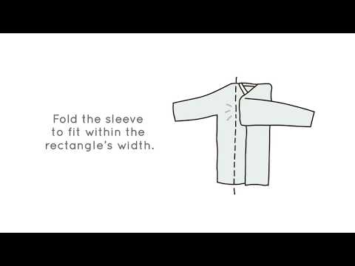](https://www.youtube.com/watch?v=yXQt6aXME7s)

**Why Should I use the KonMari Method?**

The KonMari method works well for [most people](https://www.forbes.com/sites/amandalauren/2019/01/24/konmari-is-the-latest-home-organizing-craze-but-does-it-really-work/#6e6f4e606e95) because of the focus on joy. The point of Marie Kondo’s method is not to have fewer items for the sake of cleanliness, but to make your life better. If someone likes to own more books than most people, or have a large wardrobe, or otherwise have many items they can still be using the method effectively. Marie Kondo’s focus on joy, not amount of items, means you shouldn’t have items that don’t bring you joy. You can still have a larger number of items if those items make you happier, but if they don’t then they should be passed on to someone who will get joy from them.

Sharing this Blog

Facebook:

For Facebook I would use either none or few hashtags as they do almost nothing on Facebook. Before the article I would put a more personal spin on it than on other sites as that is how most people use Facebook. I would use a photo of a space that I have personally cleaned using the KonMari method and say “This is how I cleaned up my [insert type of space].” As I have been decluttering my home recently I don’t have any good photos, but it would be something like this.

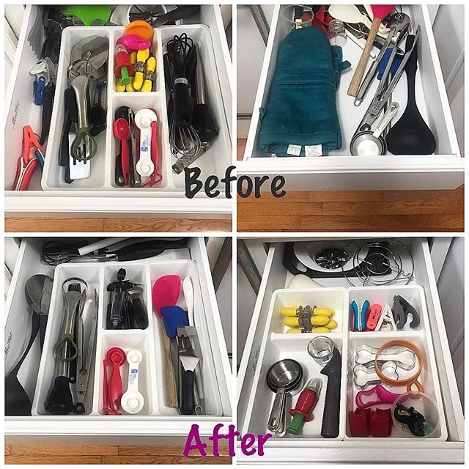

Twitter:

For Twitter I would use two or three hashtags integrated as part of the post as they add to the character count. Photos don’t work as well because it wouldn’t show the rest of the content without clicking on it, at least in the app, so I wouldn’t use one. If I did then people wouldn’t see I was linking to an article unless they clicked on it, which always lowers the chance of someone seeing the link. I would also at Marie Kondo so people who are unfamiliar can instantly see it, or people who follow her already would be more likely to see it. “@MarieKondo and the #konmari method have made a huge difference in my #tidyingup journey, and she can help with yours too! [insert article link]”

Instagram:

For Instagram since the description is unlimited I would post as many hashtags as I could find. Instagram also doesn’t allow the swipe up feature on stories unless the account is verified and links cannot link outside of Instagram except for in the bio of the page, so I don’t think Instagram would be ideal for this kind of content. I would post a before and after similar to the one for Facebook with the caption “The KonMari method really works! Can’t wait to do this to the rest of my home!” with the hashtags “#mariekondo #tidyingupwithmariekondo #mariekondomethod #declutter #decluttering #declutteryourlife #minimalism #minimalist #tidy” and possibly more.

Pinterest, Snapchat, Youtube, Tumblr, Google+:

I see no reason to use any of these websites for blog post sharing. Pinterest and Snapchat are both popular, but I don’t think they are ideal for marketing. Youtube is literally useless as this is written not visual content. Tumblr has seen a massive dip in popularity at this point, and Google+ never had a user base to begin with. These two websites would not be useful for sharing this blog’s content.