Module 4 assignment

Eric Dee

10/3/2022

***1.1***

***1.2***

***2/3.***

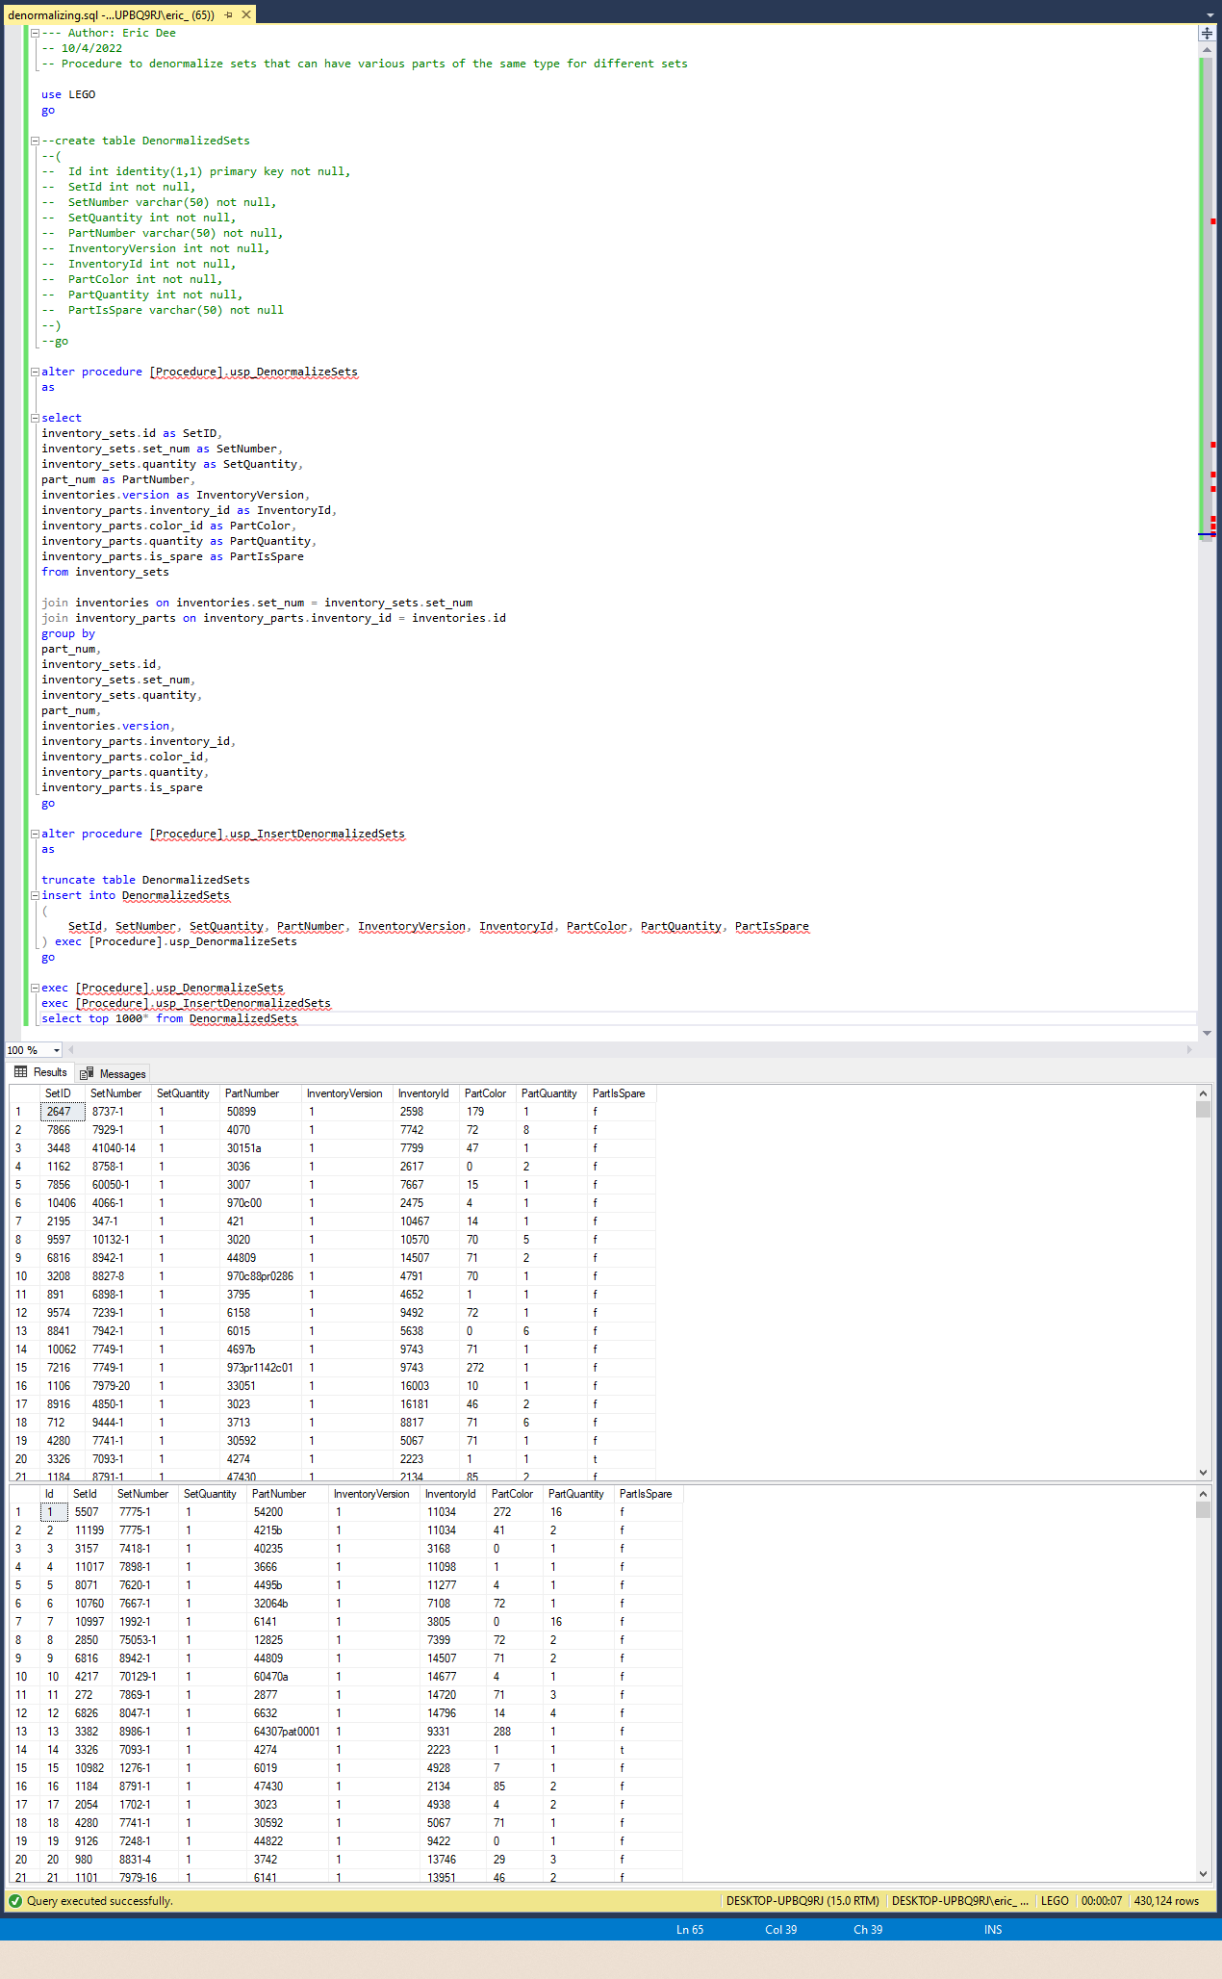

4.

