Eric Dee – Module 1: Execute Package – 10/22/2022

***3-a.***

***3-b.***

***3-c.***

***4-B.***

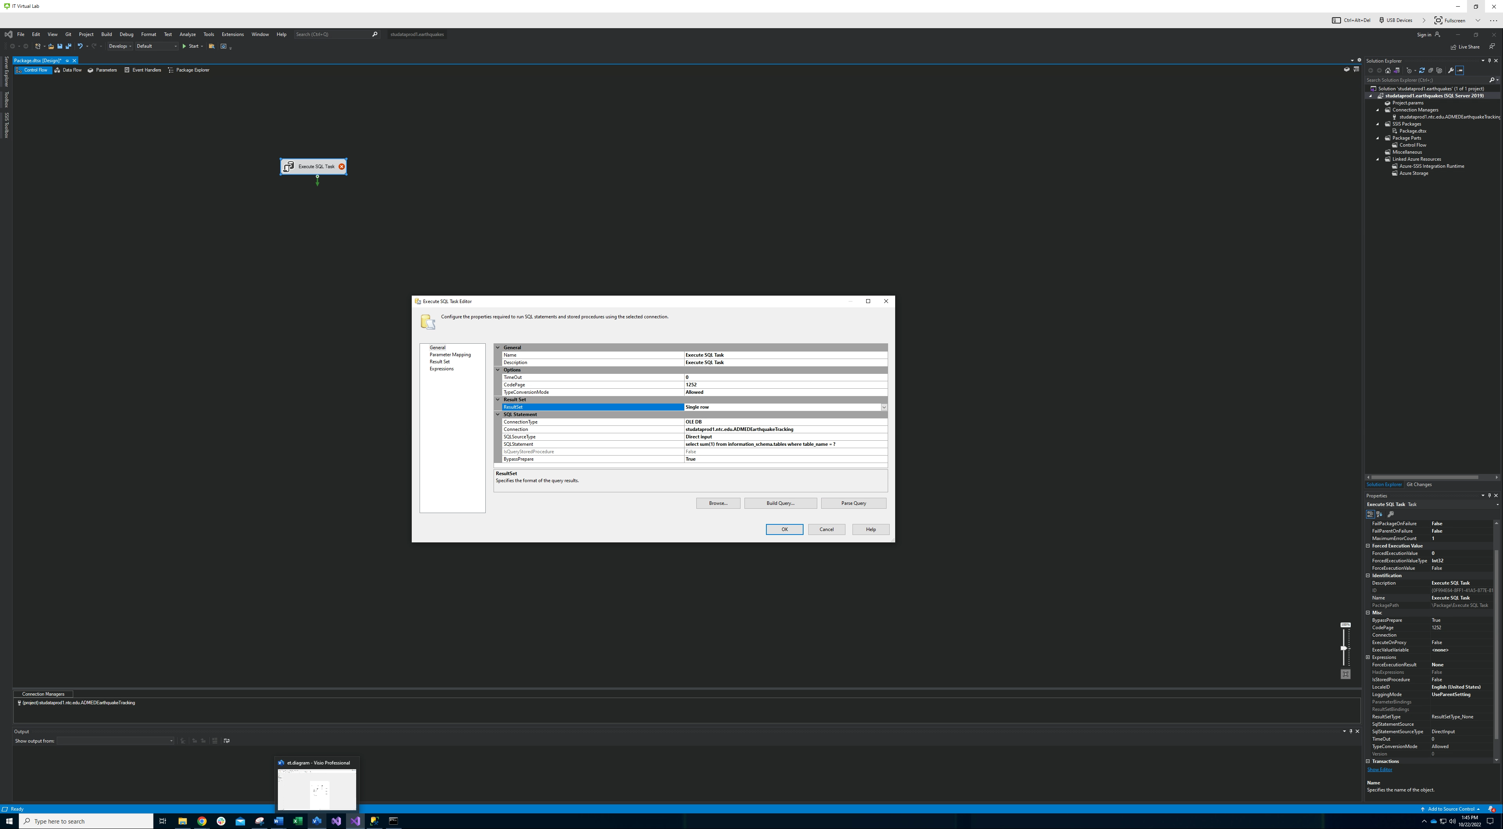

***Displaying a table count:***

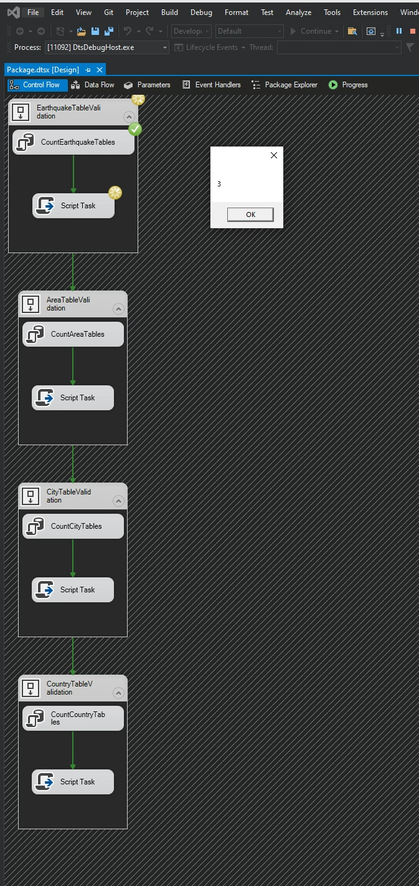

***All checks passed:***

***Added a sp run:***

***Before:***

***After:***

***4-C.***

***Nested the containers into ETL:***

***D.***

Truncation occurs as part of the transformation stored procedure, and here:

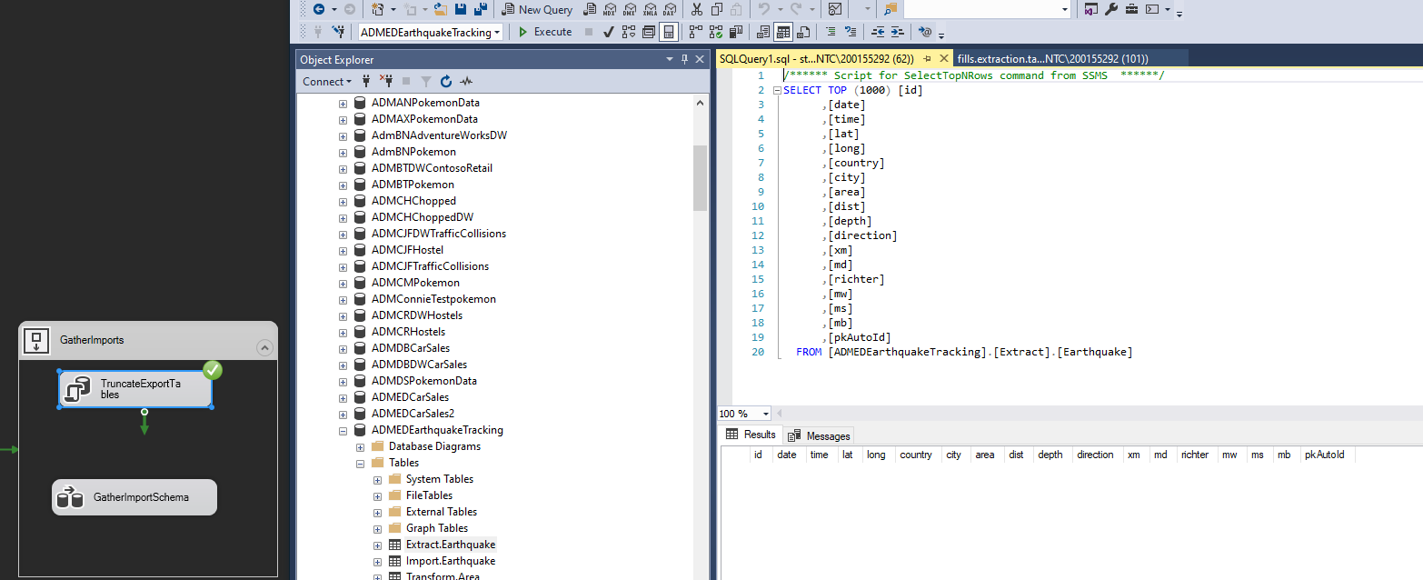

***E.***

***F.***

***G.***

Before refresh:

After refresh (The task should be named SelectTransformIntoLoad):

Has data:

Area has 5,322 rows by default

As seen here the process merges with success

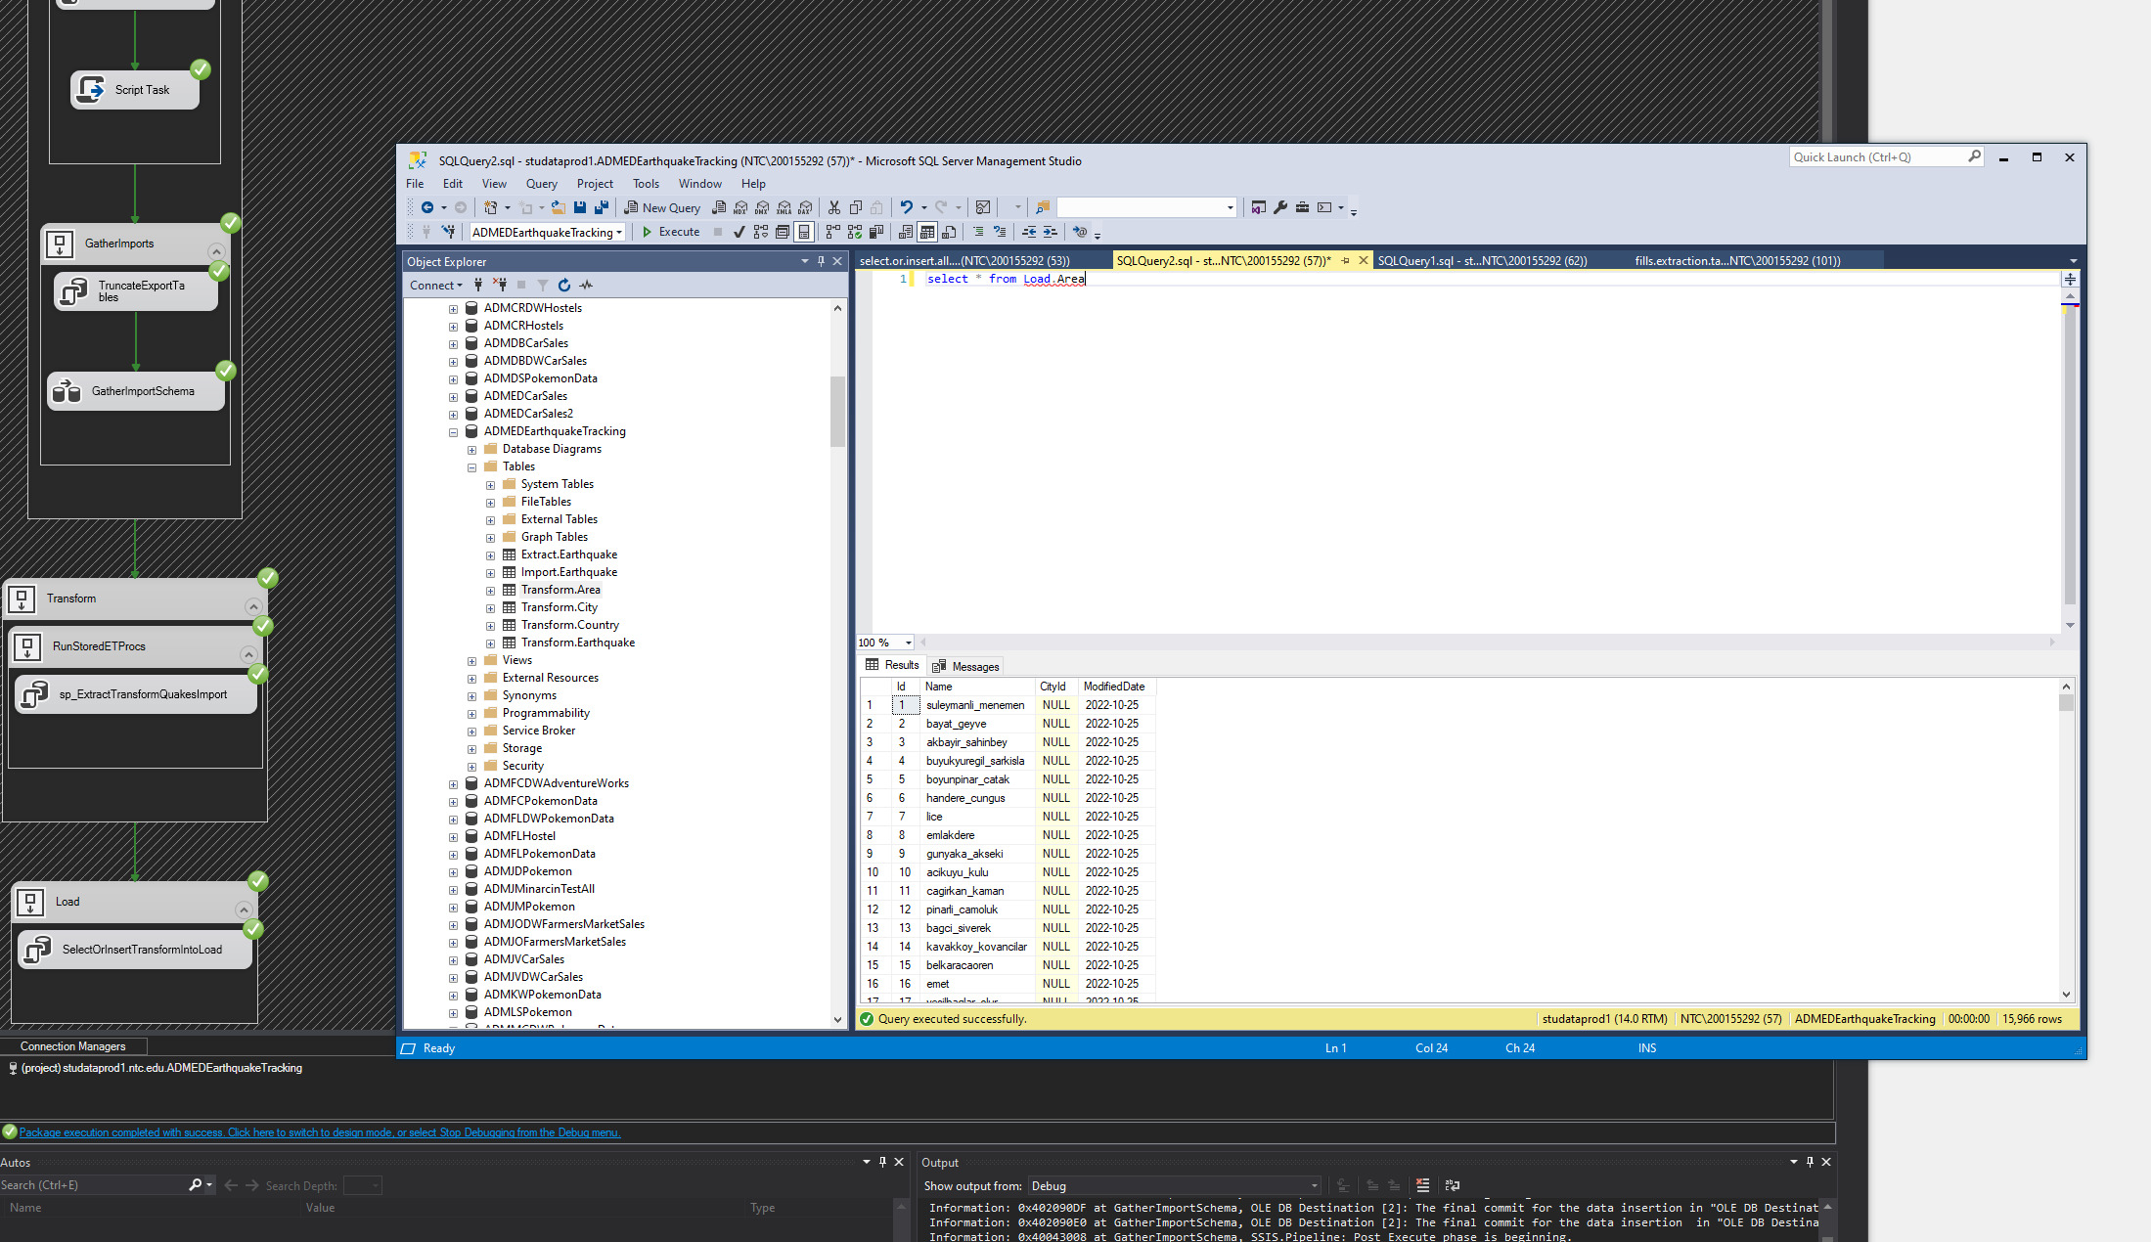

***Notes:***

The if else block in the load query confuses the SQL interpreter on the first run, but it creates the tables and loads properly and this has been validated in SSMS. The error can be ignored if you are building the data warehouse for the first time. ***It occurs, because*** the interpreter reads the else block and prints an error, but that else block is only ever run when the table is not null; therefore, no identity insert exists until after the first run, and the tables have been created. Hence this generated error has zero effect on the actual success of the container/task. All subsequent runs will not produce this error as seen below:

***H.***

***I.***

***J.***

