Module 2 DB

Eric Dee

9/28/2022

2.

This flat file is not supportive of fully dynamic population due to the possibility of new country/city/area codes. The database has been conceptualized around it, so that a user would manually update null foreign key values after automated insertion of a new country or city, or area. I foreign key values equal to 1 for this assignment (there are over 5,000 different areas). The flat file was not conductively formatted and caused a lot of wasted time working on the stored procedures. Additionally, seeking out an area to city to country data is an excessive task that could take hours. There are a lot of areas pertaining to cities pertaining to countries in the dataset.

The earthquake id values in the downloaded flat file are also clearly incomprehensible, and not accurate, as they only range from 200-210 or so, and have numerous duplicates. The id column in the flat file has been deleted and the table itself is set to auto increment, and it is assumed that the imports thereafter will not include an id.

***A.***

***

***C.***

SQL was not accepting dates for “not in” clauses. It seemed like there was potentially an extra byte or two from the flat file that I couldn’t find. I wound up having to drop the date constraint to get this to work 100% of the time:

***D.***

***E.***

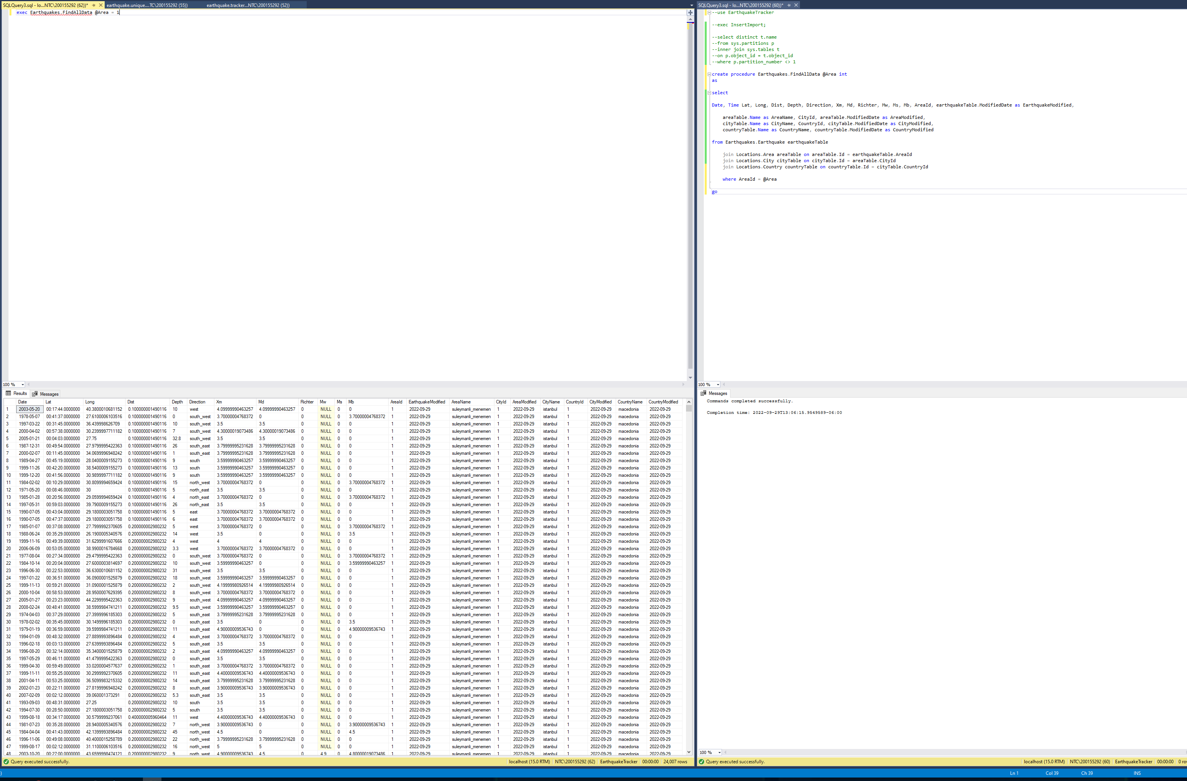

***D.***

