TASK 2: UNEMPLOYMENT ANALYSIS WITH PYTHON
Dataset: Unemployment in India (2019–2020)

1. Introduction
This analysis examines unemployment rates in India using the two CSV files supplied in the dataset archive. Python and the pandas, matplotlib and numpy libraries were used to clean, explore and visualize the data. The first file provides monthly rural and urban observations from May 2019 to June 2020. The second provides regional observations from January to October 2020 and is used to check the later trend.

2. Data Cleaning and Method
The first file contains 768 rows, including 28 blank records. These blank records were removed, leaving 740 usable observations covering 28 regions. The date column was converted to a date format, column names were standardized, and unemployment rates were checked for missing values. The second file contains 267 observations across 27 regions. Monthly averages below are simple averages of the available regional/area records, not population-weighted national estimates. The two files have different structures and coverage, so their values are not merged into one series.

3. Unemployment Trend
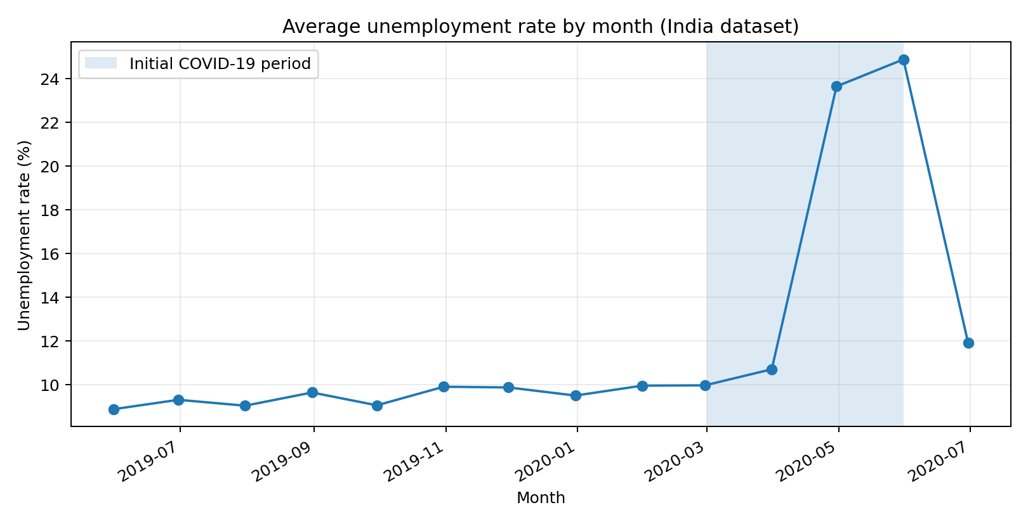
The average rate was approximately 8.9% in May 2019 and remained mostly around 9–10% through February 2020. It rose to 10.7% in March 2020, then increased sharply to 23.6% in April and 24.9% in May. It fell to 11.9% in June 2020. The second file shows the average falling further from 10.9% in June to 8.0% in October 2020, suggesting a gradual recovery in the months covered.

4. Impact of COVID-19
Using January–February 2020 as the pre-lockdown comparison period, the average unemployment rate was 10.0%. The average for April–May 2020 was 24.3%, an increase of 14.3 percentage points (approximately 143.6% relative to the pre-lockdown average). May recorded the highest monthly average in the first file. This sharp increase coincides with the COVID-19 outbreak and lockdown period, when restrictions disrupted business activity and employment. The dataset shows an association in time; by itself it cannot prove that COVID-19 was the only cause.

5. Rural and Urban Comparison
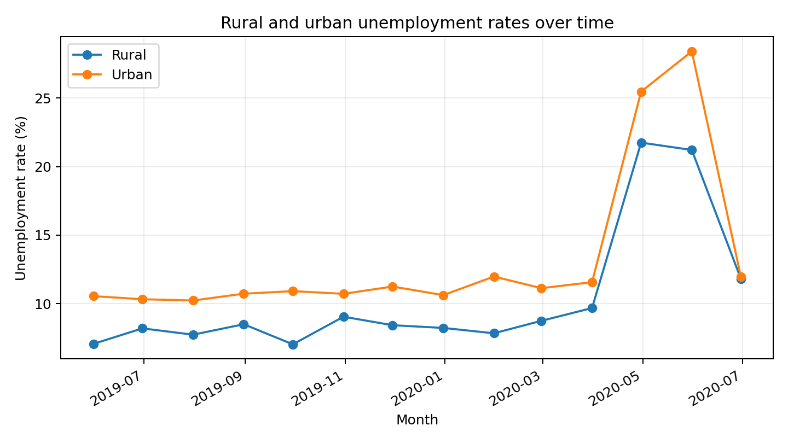
Across the full period, the simple average was 13.2% in urban areas and 10.3% in rural areas. Urban unemployment was higher overall and rose to about 28.4% in May 2020, compared with about 21.2% in rural areas. Both areas experienced a sharp increase during April and May, followed by a decline in June.

6. Regional Patterns
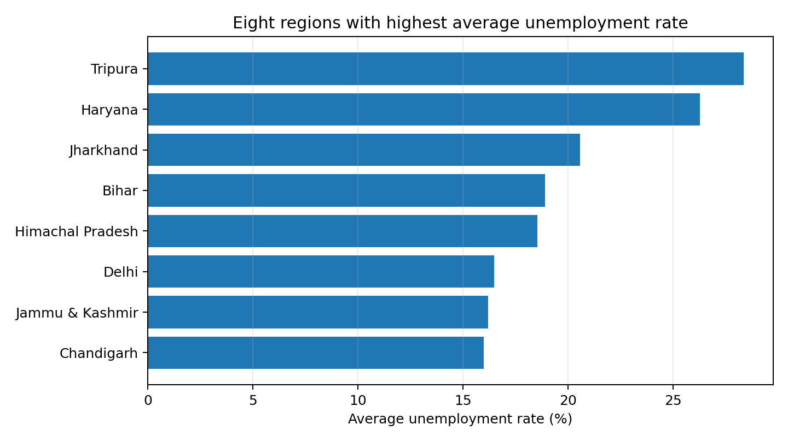
Across the observations in the first file, the highest average rates were recorded in Tripura (28.4%), Haryana (26.3%), Jharkhand (20.6%). The lowest averages were recorded in Meghalaya (4.8%), Odisha (5.7%), Assam (6.4%). Regional differences suggest that unemployment was not evenly distributed across the country.

7. Seasonal Trends and Limitations
The dataset covers only about 14 months in the first file and 10 months in the second. This is not enough to identify a reliable repeating seasonal pattern, which normally requires several years of comparable monthly data. The most visible pattern is the exceptional April–May 2020 increase rather than a proven seasonal cycle. There are also unequal numbers of observations across some months and regions, and the monthly averages are not weighted by each region’s labour force. The analysis therefore describes patterns in the supplied sample and should not be treated as an exact official national unemployment estimate.

8. Policy Insights and Recommendations
- Prioritize temporary employment support, wage assistance and job-placement programmes during major economic disruptions.
- Support small businesses and informal workers so that they can retain workers and resume operations after restrictions or economic shocks.
- Develop targeted skills training and employment programmes in regions with persistently higher unemployment averages.
- Improve access to employment opportunities in urban areas, where the dataset records a higher overall average and a larger May 2020 peak.
- Collect consistent, population-weighted monthly data over several years to monitor recovery and identify genuine seasonal trends.

9. Conclusion
The Python analysis identifies a relatively stable unemployment pattern before 2020, a major increase during April and May 2020, and a decline from June onward in the available observations. Urban areas had a higher average rate than rural areas, while regional averages varied considerably. The findings highlight the importance of rapid employment support during economic shocks, targeted regional interventions and better long-term labour-market data.

Appendix: Python Libraries and Main Operations
The analysis uses pandas to load, clean, group and summarize the CSV data; matplotlib to create the trend and comparison charts; and numpy for numerical calculations. Key operations include read_csv(), dropna(), to_datetime(), groupby(), pivot_table() and plot().

