# Unveiling Global Drinking Habits: An Econometric Exploration of Socio-Economic Influences on Alcohol Consumption

# Shamik Bhattacharjee*, Arunava Bhattacharya* ,Priyam Banerjee*, Bajrang Mishra*

*Chemical Engineering, IIT Kharagpur

***Abstract*-**This study delves into the intricate relationship between alcohol consumption and various socio-economic factors on a global scale. Employing robust econometric methods, we analyze extensive datasets to uncover patterns and correlations, shedding light on how economic, demographic, and cultural variables intertwine with alcohol consumption behaviors. Our findings reveal nuanced insights into the multifaceted nature of this relationship, providing valuable implications for public health policies and socio-economic development strategies worldwide..

***Index Terms***- About four key words or phrases in alphabetical order, separated by commas. Keywords are used to retrieve documents in an information system such as an online journal or a search engine. (Mention 4-5 keywords)

1. Introduction

Alcohol consumption is a prevalent behavior worldwide, influenced by a myriad of socio-economic factors. Understanding the intricate relationship between alcohol consumption and these factors is crucial for informing public health policies and interventions. This research seeks to conduct an econometric analysis to explore how various socio-economic factors shape patterns of alcohol consumption on a global scale.

By examining the interplay between income levels, education, employment status, regional disparities, and policy interventions, this study aims to shed light on the complex dynamics underlying alcohol consumption behaviors. Through a comprehensive review of existing literature, attendance at relevant conferences, and engagement with scientific terminology, this research endeavor is poised to contribute valuable insights to the field.

.

During research on the econometric analysis of alcohol consumption and its relationship with various socio-economic factors globally, it's essential to ask and answer a range of questions to ensure a comprehensive investigation. Here are some key questions:

* What socio-economic factors influence global alcohol consumption?
* How do Government policy interventions impact alcohol consumption trends globally?
* What role does demographics play in alcohol consumption patterns?
* How does employment status correlate with alcohol consumption?
* Are there regional variations in alcohol consumption based on socio-economic factors?
* How do beer, spirit, and wine servings vary across countries?
* Which is a better option among beer, spirit, and wine?

The following sections will delve into the methodology employed, data sources utilized, key findings, and implications of this econometric analysis. Ultimately, this research endeavors to provide a nuanced understanding of alcohol consumption patterns and inform evidence-based strategies for addressing alcohol-related issues on a global scale

1. Methodology

## Research Design:

## This study employs a mixed-methods approach, combining quantitative analysis of statistical data with qualitative examination of socio-economic indicators.

## The research design is justified by the need to comprehensively explore the relationship between alcohol consumption and socio-economic factors.

## Data Collection:

## The primary source of data for this study is the Kaggle dataset on global drinking demographics, supplemented by additional socio-economic indicators sourced from reputable sources such as alcohol.org.

## Data collection involved extracting relevant variables from the datasets, ensuring data quality and consistency.

## Variables and Measurements:

## The study includes a range of variables related to alcohol consumption (e.g., beer servings, spirit servings, wine servings, total liters of pure alcohol) and socio-economic factors (e.g., GDP per capita, unemployment rate, tax burden).

## These variables are measured using standard units and scales provided in the datasets.

## Econometric Analysis:

## Econometric techniques, including regression analysis, are employed to analyze the relationship between alcohol consumption and socio-economic factors. Multiple regression models are constructed to assess the impact of various independent variables on alcohol consumption, while controlling for potential confounding factors. Correlation plots and R2-scores were utilized to find the top features that influence Alcohol Consumption. KDE plots and Hist-plots were also used

## Use of softwares:

## The data analysis was don using Python language in a local jupyter notebook. Various libraries like Pandas, Numpy, seaborn, matplotlib, plotly were used for data analysis and visualization..Geopandas was also used for regional visualisations

## Limitations:

## Limitations of the study include potential biases inherent in observational data and the reliance on publicly available datasets.

## The study acknowledges the limitations of cross-sectional data in establishing causality and suggests avenues for future research, such as longitudinal studies or qualitative investigations into cultural factors influencing alcohol consumption patterns.

1. Key Findings

This section presents the core discoveries stemming from our global analysis of alcohol consumption and its interplay with socio-economic factors. By exploring income, education, employment, and cultural influences, we uncover key insights into drinking behaviors. From income affecting beverage preferences to policy impacts on consumption, each finding offers valuable implications for public health and socio-economic development. This synthesis aims to inform evidence-based strategies for promoting responsible drinking and addressing alcohol-related harm on a global scale. Here we are going to answer the major questions raised in the Introduction section with the help econometric analysis tools.

## What socio-economic factors influence global alcohol consumption?

## After merging datasets and conducting correlation analysis, we identified several key features strongly correlated (with a benchmark of 0.35) with total alcohol consumption. Notably, these features encompass a wide range of socio-economic indicators including demographic trends such as 'Median Age' and 'Fertility Rate', governance quality indicators like 'Property Rights', 'Judicial Effectiveness', and 'Government Integrity', as well as economic stability measures such as 'Tax Burden', 'Business Freedom', 'Trade Freedom', 'Investment Freedom', 'Financial Freedom', and 'Tax Burden % of GDP'.

## Understanding the impact of these indicators is crucial for effectively addressing alcohol-related issues on a global scale. For instance, demographic trends can shed light on the age distribution of alcohol consumers, influencing targeted interventions and policies. Governance quality indicators provide insights into the legal and institutional frameworks governing alcohol production, distribution, and consumption, while economic stability measures offer perspectives on the affordability and accessibility of alcohol within different socio-economic contexts.By comprehensively analyzing these indicators and their relationships with alcohol consumption, policymakers and public health officials can devise evidence-based strategies to mitigate the negative consequences of excessive alcohol consumption, promote responsible drinking behaviors, and improve overall public health outcomes..

## How does Government policies affect alcohol consumption habits?

The pie chart highlights several key factors with significant impacts on alcohol consumption: 'Tax Burden', 'Business Freedom', 'Trade Freedom', 'Investment Freedom', 'Financial Freedom', and 'Tax Burden % of GDP'. 'Tax Burden' denotes the direct influence of taxes on alcohol prices, potentially curbing 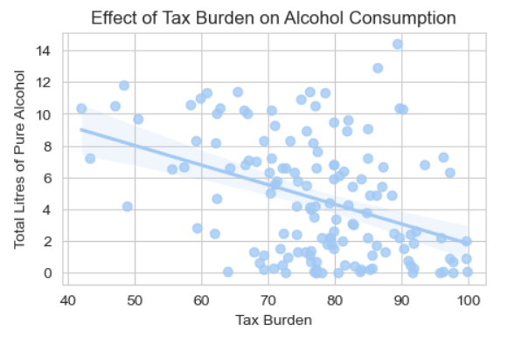consumption.

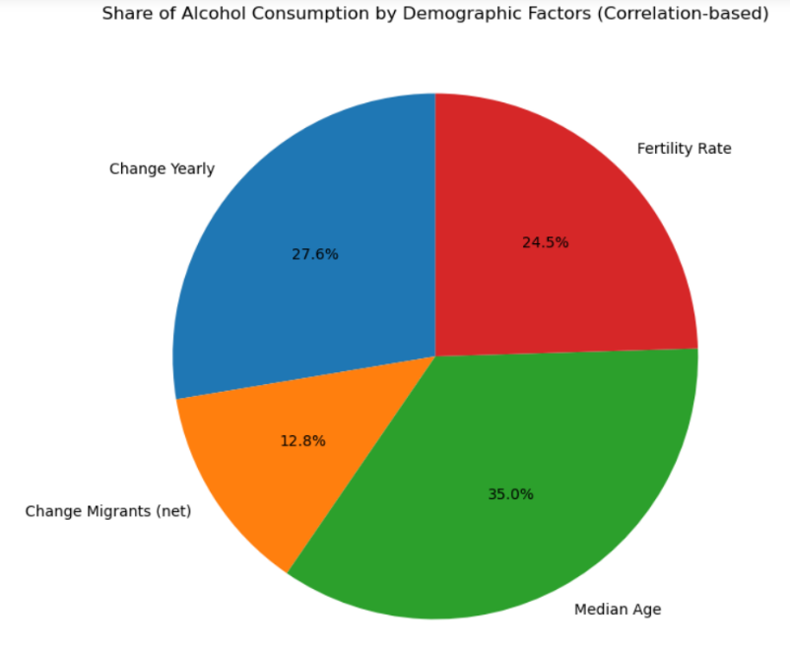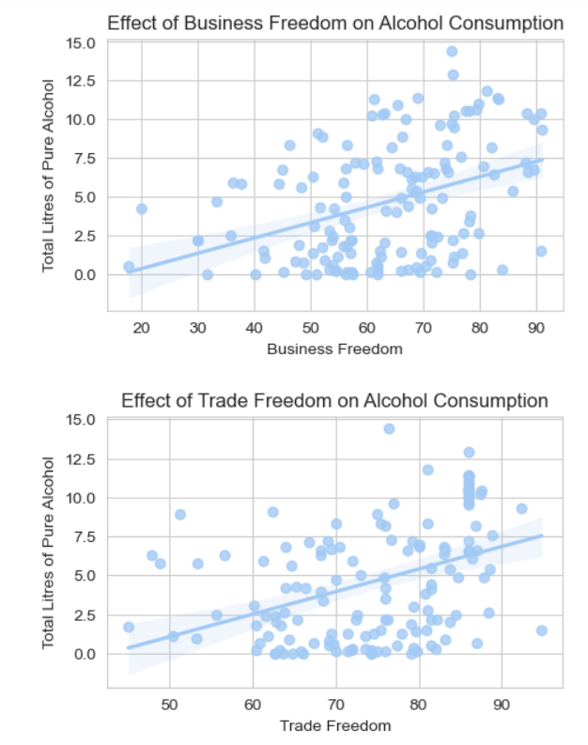 'Business Freedom' affects market competition and innovation, altering alcohol availability and marketing strategies. 'Trade Freedom' dictates access to diverse alcoholic beverages, shaping consumption patterns.

'Investment Freedom' influences alcohol industry growth and infrastructure development. 'Financial Freedom' impacts purchasing power and economic conditions, influencing alcohol consumption levels. Lastly, 'Tax Burden % of GDP' reflects government revenue from alcohol taxes, guiding regulatory policies that further influence consumption. Together, these factors sculpt the regulatory landscape, market dynamics, and economic circumstances, all shaping alcohol consumption trends.

## What role does demographics play in alcohol consumption patterns?

Alcohol consumption is mainly correlated with four major demographic factors namely median age, fertility rate, migration and annual change in population. Alcohol consumption tends to be higher in populations with a younger median age, as young adults often engage in social drinking and have more disposable income. Additionally, cultures with higher fertility rates may integrate alcohol into social events. Migration can introduce new drinking habits to different regions, impacting alcohol consumption patterns. Economic development and urbanization, associated with population growth, often correlate with increased alcohol consumption due to greater disposable income and changing lifestyles.

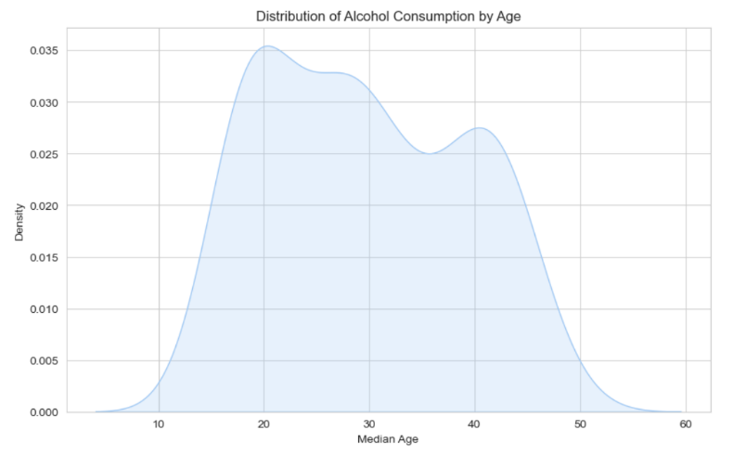We can see from the KDE plot of Alcohol Consumption vs Median age that the section of population in the age group of 20-30 years has highest alcohol intake and we can also infer that there is a induction of alcohol consumption habits during the teenage years and hence there is steep slope in the age group of 10-20 years.After 50s there is a decline in alcohol intake due to various health related issues.

## Alcohol consumption can indirectly influence fertility rates through various channels. Heavy alcohol intake can impair reproductive health, leading to issues like decreased sperm quality and irregular menstrual cycles. Excessive alcohol use is also linked to increased risk of infertility and higher rates of miscarriages, stillbirths, and birth defects. Risky sexual behaviors resulting from alcohol consumption, along with associated socioeconomic factors, can further impact fertility rates in populations with high alcohol consumption levels.

## The KDE plot and regression analysis of alcohol consumption versus fertility rate suggest that as alcohol consumption increases, fertility rates tend to decline, aligning with the null hypothesis proposed earlier. Specifically, regions with higher alcohol consumption exhibit a peak fertility rate of less than 2. This supports the notion that elevated alcohol consumption correlates with decreased fertility, potentially due to various factors such as reproductive health effects and lifestyle choices..

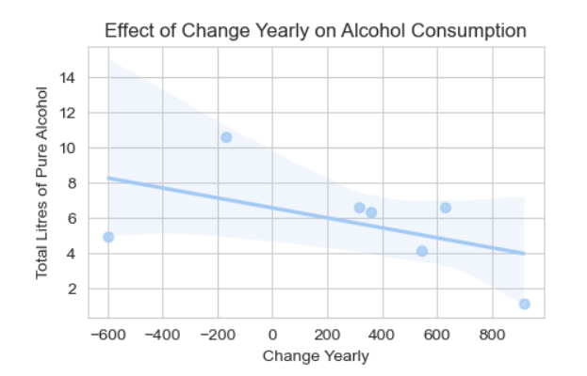

From the above plot we can infer that with increasing population, alcohol consumption levels decrease to some extent. This trend may stem from increased regulatory measures and evolving social attitudes toward drinking, especially in densely populated areas. Urbanization accompanying population growth brings diverse recreational options, reducing reliance on alcohol for leisure. Moreover, in larger populations, there may be greater public health awareness campaigns highlighting the risks of excessive drinking, contributing to moderation

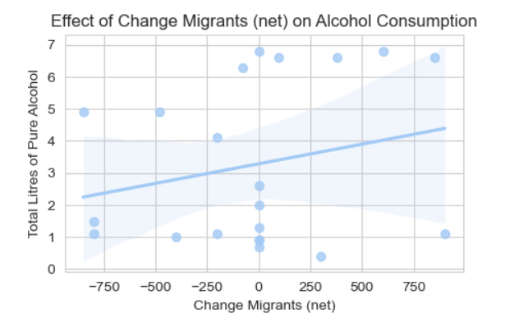

From the regression analysis of Migration rate vs Alcohol consumption, we can infer that with higher migrant inflow there is increase in alcohol consumption rates likely due to a combination of cultural influences, social integration challenges, economic opportunities, and stressors associated with migration. Migrants often bring drinking habits from their home countries, and alcohol may serve as a coping mechanism or social bonding activity. Economic improvements and increased availability of alcohol within migrant communities may also contribute to higher consumption rates.

## How does employment status correlate with alcohol consumption?

The modest rise in alcohol consumption amid rising unemployment likely stems from several intertwined factors. Financial strains and the need for coping mechanisms during job loss may prompt individuals to seek solace in alcohol, despite reduced affordability due to decreased income. Social disruptions can exacerbate this trend, leading to increased isolation or changes in social activities involving alcohol. Moreover, heightened free time during unemployment offers more opportunities for drinking. However, the relatively small increase suggests that individual coping methods and social support 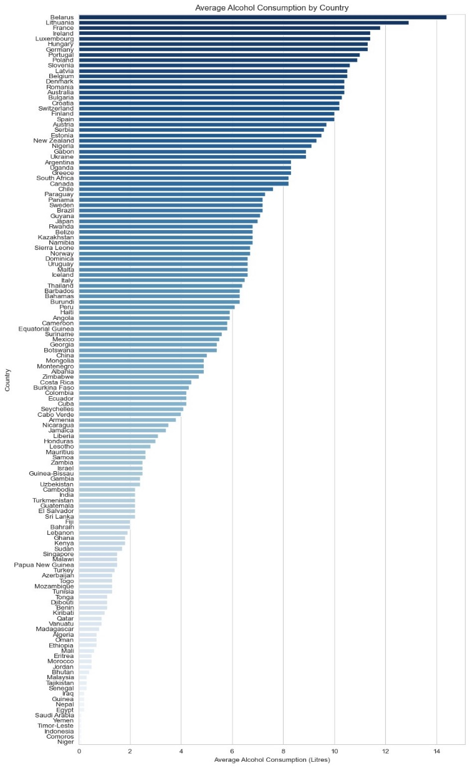networks also significantly influence alcohol consumption behaviors during these periods, contributing to a nuanced interplay between economic factors and social behaviors.

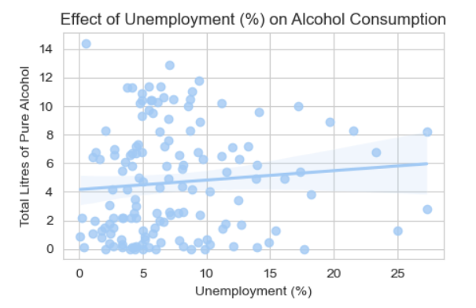

The slight increase in alcohol consumption amidst rising unemployment can be attributed to reduced affordability. As unemployment leads to decreased income, individuals may find it more challenging to afford discretionary expenses like alcohol

## Are there regional variations in alcohol consumption based on socio-economic factors?

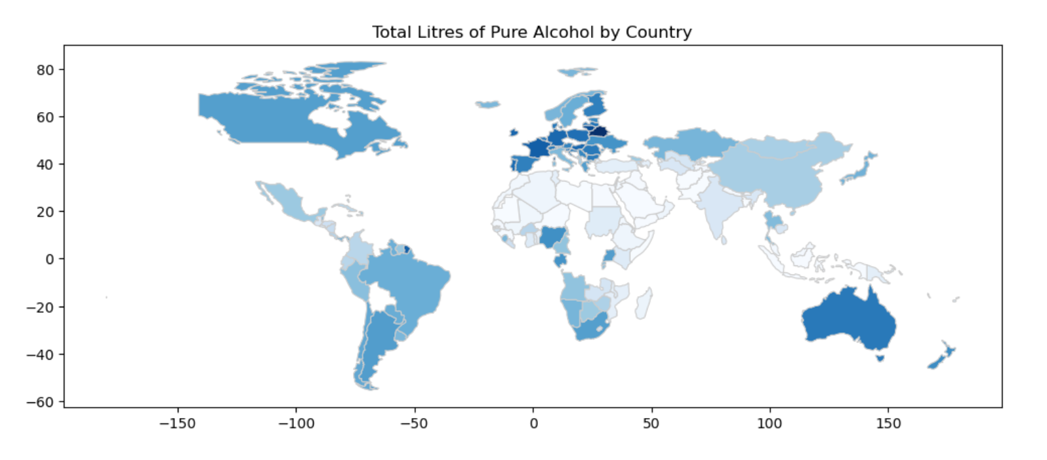Regional variations in alcohol consumption often correlate with socio-economic factors. Wealthier regions or countries tend to have higher alcohol consumption rates due to greater disposable income and access to alcohol. Additionally, cultural attitudes towards alcohol play a significant role. For example, regions with a strong drinking culture may exhibit higher consumption rates regardless of economic status. Moreover, factors such as urbanization, education levels, and access to healthcare can influence drinking patterns. In regions with lower socio-economic status, alcohol consumption may be influenced by stress, unemployment, and limited access to resources for substance abuse treatment. Overall, socio-economic factors interact with cultural norms and individual circumstances to shape regional differences in alcohol consumption.

The significant variation in alcohol consumption levels among countries can be attributed to a myriad of factors, ranging from cultural norms and economic conditions to regulatory environments and social attitudes. Countries with deep-rooted drinking cultures, such as Belarus, Lithuania, and Ireland, often exhibit higher consumption rates, where alcohol is deeply embedded in social and cultural practices. Wealthier nations, including France, Germany, and Luxembourg, tend to have higher consumption levels due to greater affordability and accessibility of alcoholic beverages. Additionally, differences in alcohol policies and regulations influence consumption patterns, with countries having stricter regulations typically experiencing lower consumption rates. Social attitudes towards alcohol, historical traditions, and religious beliefs also play crucial roles in shaping consumption behaviors. In contrast, countries like Yemen, Timor-Leste, Indonesia, Comoros, and Niger demonstrate lower consumption levels, possibly due to cultural or religious prohibitions, legal restrictions, or limited availability of alcohol. Understanding these multifaceted factors provides insight into the complex dynamics driving alcohol consumption patterns globally.

From the geopandas plot displaying alcohol consumption by country, it's evident that Europe and Australia exhibits a higher density of countries with relatively high alcohol consumption levels compared to other regions. This observation aligns with existing data and cultural perceptions, as many European countries have a rich history of alcohol production and consumption, and drinking is often deeply embedded in social customs and traditions across the continent. The clustering of countries with high alcohol consumption in Europe underscores the region's significant cultural and historical relationship with alcohol. Northern African countries and middle-east generally show lower levels of alcohol consumption, which could be attributed to cultural, religious, and regulatory factors prevalent in this region. Islam, the predominant religion in many Northern African and middle east countries, prohibits the consumption of alcohol, which significantly influences drinking habits. In contrast, Southern African countries exhibit more significant alcohol consumption, likely influenced by cultural practices, socioeconomic factors, and historical contexts. Factors such as colonial legacies, socioeconomic disparities, and differing cultural attitudes towards alcohol contribute to this regional variation in alcohol consumption within Africa.

## How do beer, spirit, and wine servings vary across countries?

Beer, spirit, and wine servings vary significantly across countries, reflecting cultural, economic, and social factors unique to each region.

Beer servings tend to be high in countries with strong beer-drinking traditions, such as Germany, Czech Republic, and Ireland, where beer is deeply embedded in the culture and often consumed in large quantities during social gatherings and festivals.

Spirit servings show variability based on regional preferences and traditions. Countries like Russia, Poland, and South Korea are known for their high consumption of spirits like vodka, soju, and whisky respectively.

Wine servings are influenced by factors such as climate, grape cultivation, and cultural practices. Countries like France, Italy, and Spain are renowned for their wine production and consumption, where wine is often enjoyed with meals and considered an integral part of the culinary experience.

Overall, the variation in beer, spirit, and wine servings across countries reflects the diverse cultural and social landscapes worldwide, highlighting the multifaceted nature of alcohol consumption behaviors.

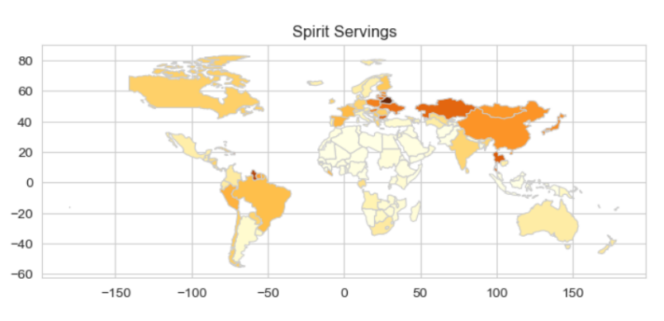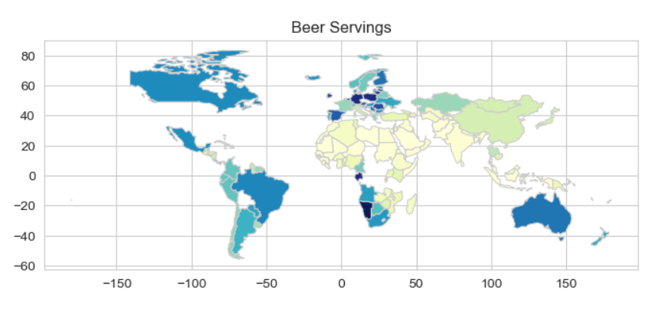

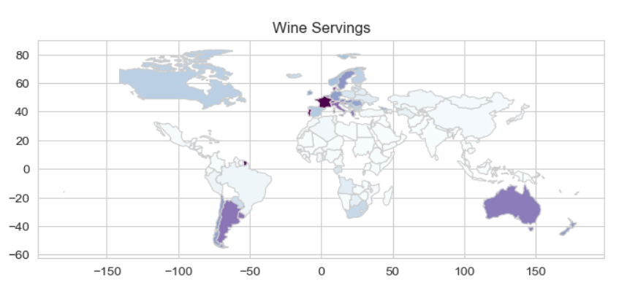

From the analysis of data we obtained the following results:

Top 5 Countries for Beer Servings:

Country beer_servings

94 Namibia 376.0

47 Gabon 347.0

50 Germany 346.0

107 Poland 343.0

79 Lithuania 343.0

Top 5 Countries for Wine Servings:

Country wine_servings

46 France 370.0

108 Portugal 339.0

127 Switzerland 280.0

34 Denmark 278.0

119 Slovenia 276.0

Top 5 Countries for Spirit Servings:

Country spirit_servings

13 Belarus 373.0

57 Haiti 326.0

56 Guyana 302.0

36 Dominica 286.0

129 Thailand 258.0

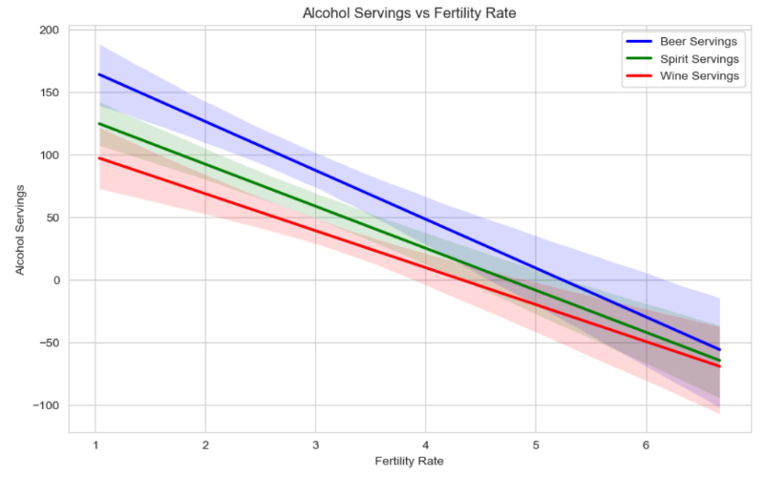The top-ranking countries in beer, wine, and spirit servings offer insights into the diverse factors influencing global drinking habits. Namibia and Gabon's high beer consumption reflects the prevalence of beer culture in African societies, possibly influenced by social traditions and accessibility. Germany's prominent beer culture, epitomized by events like Oktoberfest, contributes to its significant beer servings. France's leadership in wine consumption is unsurprising given its esteemed wine-making heritage, while Portugal closely follows with its rich wine culture. Belarus' dominance in spirit consumption may be attributed to the popularity of vodka in Eastern Europe, while Haiti, Guyana, and Dominica likely have historical and cultural reasons for their high spirit consumption. Thailand's inclusion in spirit servings may reflect its vibrant nightlife and the popularity of local spirits and rum-based drinks. These variations underscore the complex interplay of cultural, historical, and socio-economic factors shaping drinking patterns worldwide.

*Which is a better option among beer, spirit, and wine?*

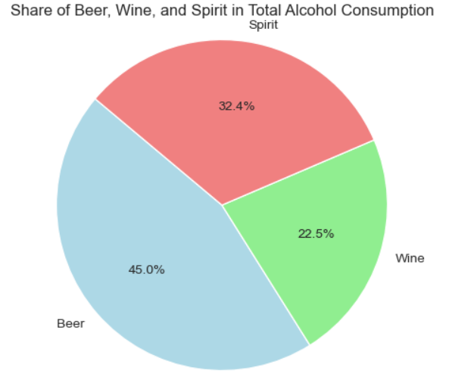Beer's dominance in consumption can be attributed to its deep cultural significance, widespread availability, affordability, and social context. It's ingrained in traditions and rituals, easily accessible, and favored for casual gatherings. Extensive marketing efforts further enhance its appeal. On the other hand, spirits surpass wine in consumption due to their higher alcohol content, longer shelf life, mixing versatility, and cultural significance. Marketing emphasizes their premium nature, attracting consumers seeking luxury experiences. These factors collectively contribute to the popularity of beer and spirits over wine.

From a health perspective, moderate wine consumption may offer some benefits due to its antioxidant content, potentially reducing the risk of cardiovascular disease. Wine typically contains fewer calories and carbohydrates than beer and many spirits-based drinks, which may aid in weight management and blood sugar control. However, excessive alcohol intake, regardless of type, can lead to various health issues, including liver disease, cancer, addiction, and mental health problems. Moderation and mindful consumption are essential for minimizing health risks associated with alcohol consumption. Consulting a healthcare professional can provide personalized advice based on individual health needs and goals.

The regression analysis indicates that wine servings have the smallest slope compared to beer and spirit servings concerning the fertility rate. This suggests that the increase in wine consumption has the least adverse effect on the fertility rate among the three types of alcohol. Lower adverse effects on fertility rate could be attributed to various factors, including the potential presence of antioxidants in wine, such as resveratrol, which may have protective effects on reproductive health. Additionally, cultural and lifestyle factors associated with wine consumption, such as moderation and dietary patterns, could contribute to its relatively lower impact on fertility rates compared to beer and spirits. However, it's important to note that alcohol consumption in excess can still have detrimental effects on fertility and overall health, emphasizing the importance of moderation and individualized health considerations.The disparity in the distribution of wine and spirit servings across age groups compared to beer can be explained by several factors. Firstly, wine and spirits enjoy a broader cultural acceptance, appealing to a diverse range of tastes and preferences across different age demographics. Their availability in various styles, flavors, and price points contributes to their accessibility among a wider audience. Additionally, wine and spirits are often perceived as sophisticated or upscale beverages, attracting individuals of all ages seeking diverse and refined drinking experiences. Moreover, their association with social gatherings, celebrations, and formal events makes them prevalent across different age groups. In contrast, beer consumption, while also enjoyed socially, tends to be more concentrated among younger individuals, particularly those in their 20s, possibly due to its casual and commonplace perception. Overall, the broader appeal and versatility of wine and spirits contribute to their consumption across a wider age spectrum, whereas beer consumption remains. Additionally, health factors such as perceived health benefits associated with moderate wine consumption may influence its consumption patterns across age groups.

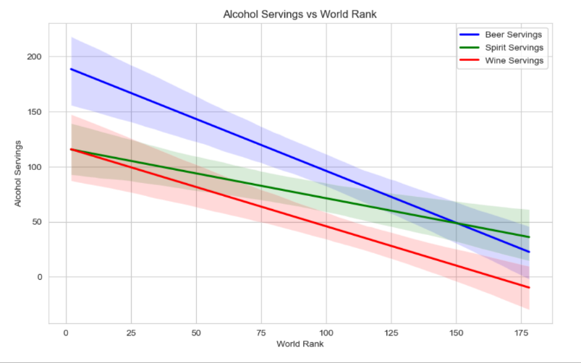

Countries with greater alcohol servings tend to have better world ranks, suggesting a correlation between alcohol consumption and societal indicators. This association may stem from various intertwined factors. Firstly, nations with higher alcohol consumption often exhibit robust economic stability. Citizens in economically prosperous countries typically have greater disposable income, enabling them to indulge in alcoholic beverages more frequently. Secondly, alcohol consumption often serves as a social lubricant, fostering stronger community ties and cultural cohesion. Countries where alcohol plays a prominent role in social interactions may consequently exhibit a more vibrant social life, potentially enhancing their global reputation and world ranks. Moreover, nations with better world ranks often boast well-developed healthcare systems and infrastructure. These countries may effectively mitigate the adverse health effects associated with alcohol consumption, resulting in healthier populations and less strain on healthcare resources. Finally, countries with higher world ranks typically wield greater global influence and diplomatic power. Their favorable standing on the world stage could facilitate advantageous trade relations and diplomatic alliances, indirectly influencing alcohol consumption patterns. Overall, while the precise mechanisms underlying this correlation warrant further investigation, the observed trend underscores the complex interplay between alcohol consumption and societal dynamics on a global scale.

High-ranking countries tend to exhibit higher beer servings compared to other alcoholic beverages such as wine and spirits. This observation reflects several underlying factors contributing to this trend. Firstly, beer often holds a central place in the social fabric of many societies, especially in countries with strong beer-drinking traditions. Its widespread availability, lower cost, and cultural significance make it a preferred choice for social gatherings and recreational activities. Additionally, beer consumption is deeply ingrained in various cultural festivities and celebrations, further solidifying its popularity in high-ranking countries. Furthermore, the brewing industry in these nations may be well-developed, offering a diverse range of beer options to cater to different consumer preferences. Conversely, while wine and spirits also enjoy popularity, they may not have the same level of cultural ubiquity or accessibility as beer in these high-ranking countries. Therefore, the preference for beer over other alcoholic beverages among high-ranking countries can be attributed to a combination of cultural, economic, and social factors that shape drinking habits on a national level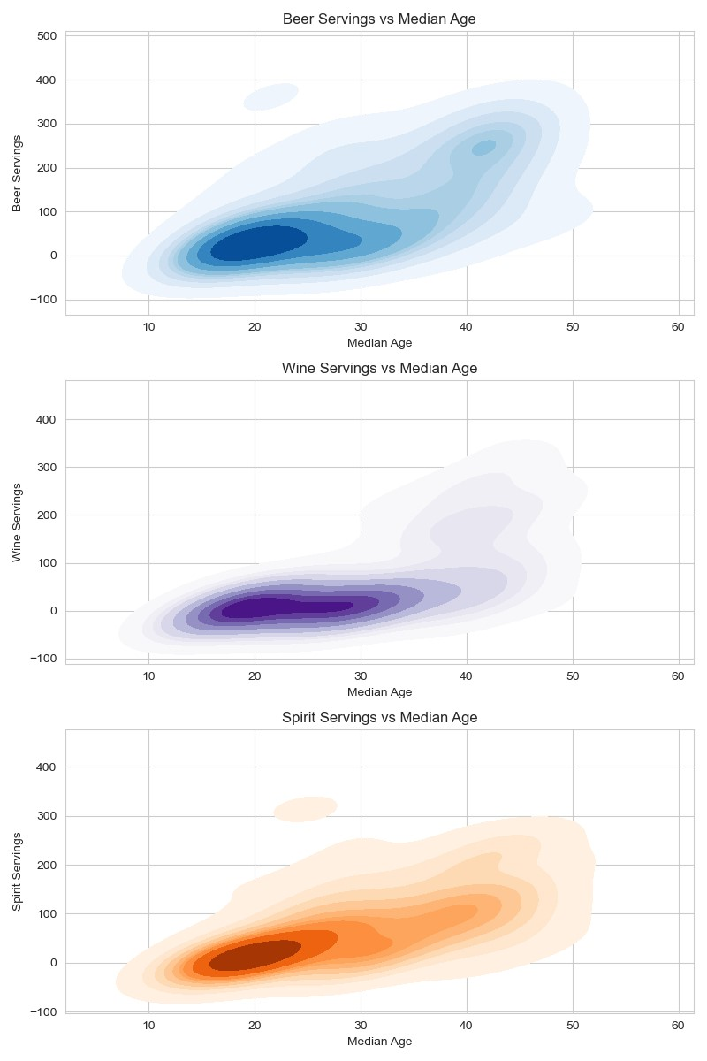

1. CONCLUSION

In conclusion, our comprehensive analysis of global alcohol consumption and its intricate relationship with socio-economic factors has revealed valuable insights into drinking behaviors worldwide. Through the examination of income, education, employment, governance quality, economic stability, and demographic trends, we have identified key determinants shaping alcohol consumption patterns on a global scale.

One of the central findings of our study is the significant influence of socio-economic factors on alcohol consumption. Demographic trends, such as median age and fertility rate, offer valuable insights into the age distribution of alcohol consumers and the integration of alcohol into social events. Governance quality indicators shed light on the legal and institutional frameworks governing alcohol production, distribution, and consumption, while economic stability measures provide perspectives on the affordability and accessibility of alcohol across different socio-economic contexts.

Furthermore, our analysis highlights the profound impact of government policies on alcohol consumption habits. Factors such as tax burden, business freedom, trade freedom, investment freedom, financial freedom, and tax burden as a percentage of GDP play crucial roles in shaping regulatory landscapes, market dynamics, and economic circumstances, ultimately influencing alcohol consumption trends.

Moreover, we have elucidated the role of demographics in alcohol consumption patterns, demonstrating correlations between alcohol consumption and factors such as median age, fertility rate, migration, and annual population change. These insights underscore the complex interplay between individual characteristics and societal trends in shaping drinking behaviors.

Our findings also emphasize regional variations in alcohol consumption based on socio-economic factors, cultural norms, and historical contexts. From Europe's rich beer and wine cultures to the religious and regulatory influences shaping alcohol consumption in the Middle East, our analysis underscores the diverse landscapes of drinking habits across different regions.

Furthermore, the dominance of beer and spirits over wine in global consumption patterns highlights the multifaceted nature of alcohol preferences, influenced by cultural traditions, marketing strategies, and health perceptions.

Overall, our study provides a nuanced understanding of the complex dynamics driving alcohol consumption behaviors worldwide. By leveraging econometric analysis tools and empirical data, we have unveiled critical insights that can inform evidence-based strategies for promoting responsible drinking, addressing alcohol-related harm, and fostering socio-economic development on a global scale. Moving forward, it is imperative for policymakers, public health officials, and stakeholders to collaborate in implementing targeted interventions and policie

aimed at mitigating the negative consequences of excessive alcohol consumption and improving overall public health outcomes..

Appendix

1.The Economic Freedom Index Dataset [://www.kaggle.com/datasets/lewisduncan93/the-economic-freedom-index](//www.kaggle.com/datasets/lewisduncan93/the-economic-freedom-index)

2.Drinks: <https://github.com/fivethirtyeight/data/blob/master/alcohol-consumption/drinks.csv>

3. World Bank Data: <https://data.worldbank.org/>

4. WHO Global Status Report on Alcohol and Health: <https://www.who.int/publications/i/item/global-status-report-on-alcohol-and-health>

Acknowledgment

The preferred spelling of the word “acknowledgment” in References

1. Woolridge, J. M. (2019). Introductory Econometrics: A Modern Approach (7th ed.). Boston, MA: Cengage Learning..
2. Gujarati, D. N., & Porter, D. C. (2018). Basic Econometrics (6th ed.). New York, NY: McGraw-Hill Education.
3. Maddala, G. S. (2001). Introduction to Econometrics (3rd ed.). Chichester, England: Wiley.

[4] World Bank. (2022). World Development Indicators 2022. Retrieved from <https://datacatalog.worldbank.org/dataset/world-development-indicator>

[5] Alcohol consumption in India: a systematic review and modelling study for sub-national estimates of drinking patterns by Ankit Rastogi, Jakob Manthey, Veronika Wiemker, Charlotte Probst

Authors

**First Author** – Shamik Bhattacharjee, B.Tech in Chemical Engineering, IIT Kharagpur ,shamikbhattacharjee03@gmail.com

**Second Author** – Arunava Bhattacharya, B.Tech in Chemical Engineering, IIT Kharagpur ,

**Third Author** –.Priyam Banerjee, B.Tech in Chemical Engineering, IIT Kharagpur ,

**Fourth Author** –.Bajrang Mishra, B.Tech in Chemical Engineering, IIT Kharagpur ,