

Course Name: Data Structures Lab
Project Title: Cybersecurity Threat Map
Student Name: Sumit Khandelwal & Pramit Panigrahi
Roll Number: 24070724017 24070721029
Faculty Guide: Dr. Rakesh Salakapuri
Department: CST & CSE
College: Symbiosis Institute of Technology, Hyderabad
University: Symbiosis International (Deemed University)
Semester: 3rd
Academic Year: 2025–2026

Abstract / Summary:
In today’s connected digital world, network security is a critical concern. The Cybersecurity Threat Map project presents a simulation-based system for monitoring and detecting suspicious activities in a computer network using graph data structures. Each device in the network is represented as a node, and communication links are modeled as weighted edges indicating data traffic. The system dynamically updates connections, tracks data flow, and flags potential threats such as unusual data spikes or unauthorized access.
The project is implemented in C language, employing graphs, hash tables, linked lists, and queues to efficiently manage network topology and alert generation. By applying traversal algorithms such as Breadth-First Search (BFS) and Depth-First Search (DFS), the system identifies anomalies and isolates affected nodes.
Major outcomes include efficient detection of suspicious patterns, visualization of active connections, and real-time alert generation. This project demonstrates how core data structure concepts can be applied to solve modern cybersecurity challenges effectively.
Introduction:
Background and Motivation:
With increasing cyberattacks and network complexities, organizations need real-time tools that can visualize network behavior and detect anomalies early. Manual monitoring is inefficient and error-prone; hence, an automated graph-based monitoring system provides a scalable and data-structure-driven solution.
Objectives:
- Represent the entire network as a graph.
- Detect and alert abnormal network behavior automatically.
- Maintain real-time logs of connections and threat alerts.
- Apply data structure algorithms to analyze and manage connections.
Scope and Limitations:
The system focuses on small to medium-sized simulated networks. It does not perform actual packet capture but mimics data flow through weighted edges. Real network integration or machine learning is beyond the project’s current scope.
Relevance to Data Structures:
The project heavily relies on graphs (for network representation), hash tables (for IP lookup), queues (for event handling), and linked lists (for logging alerts), demonstrating real-world applications of data structures.
Problem Definition:
Problem Statement:
To design a data structure-based system that models a computer network, monitors connections, and detects anomalous activities by analyzing the data flow using graph algorithms.
Inputs:
- List of devices (IP addresses)
- Connection details (source, destination, data rate)
Outputs:
- Display of current network topology
- Alerts for suspicious or unauthorized connections
- Log of detected threats
Constraints:
- Network size limited by system memory
- Simulated rather than real packet capture
Literature Review / Existing Systems:
Existing systems like Cisco Threat Analyzer and Kaspersky Security Network rely on real packet inspection and AI-based analysis. However, they are complex and resource-intensive.
This project simplifies the idea by implementing a lightweight graph-based approach to detect threats conceptually using traversal and pattern recognition — making it suitable for academic and educational purposes.

Methodology / System Design:
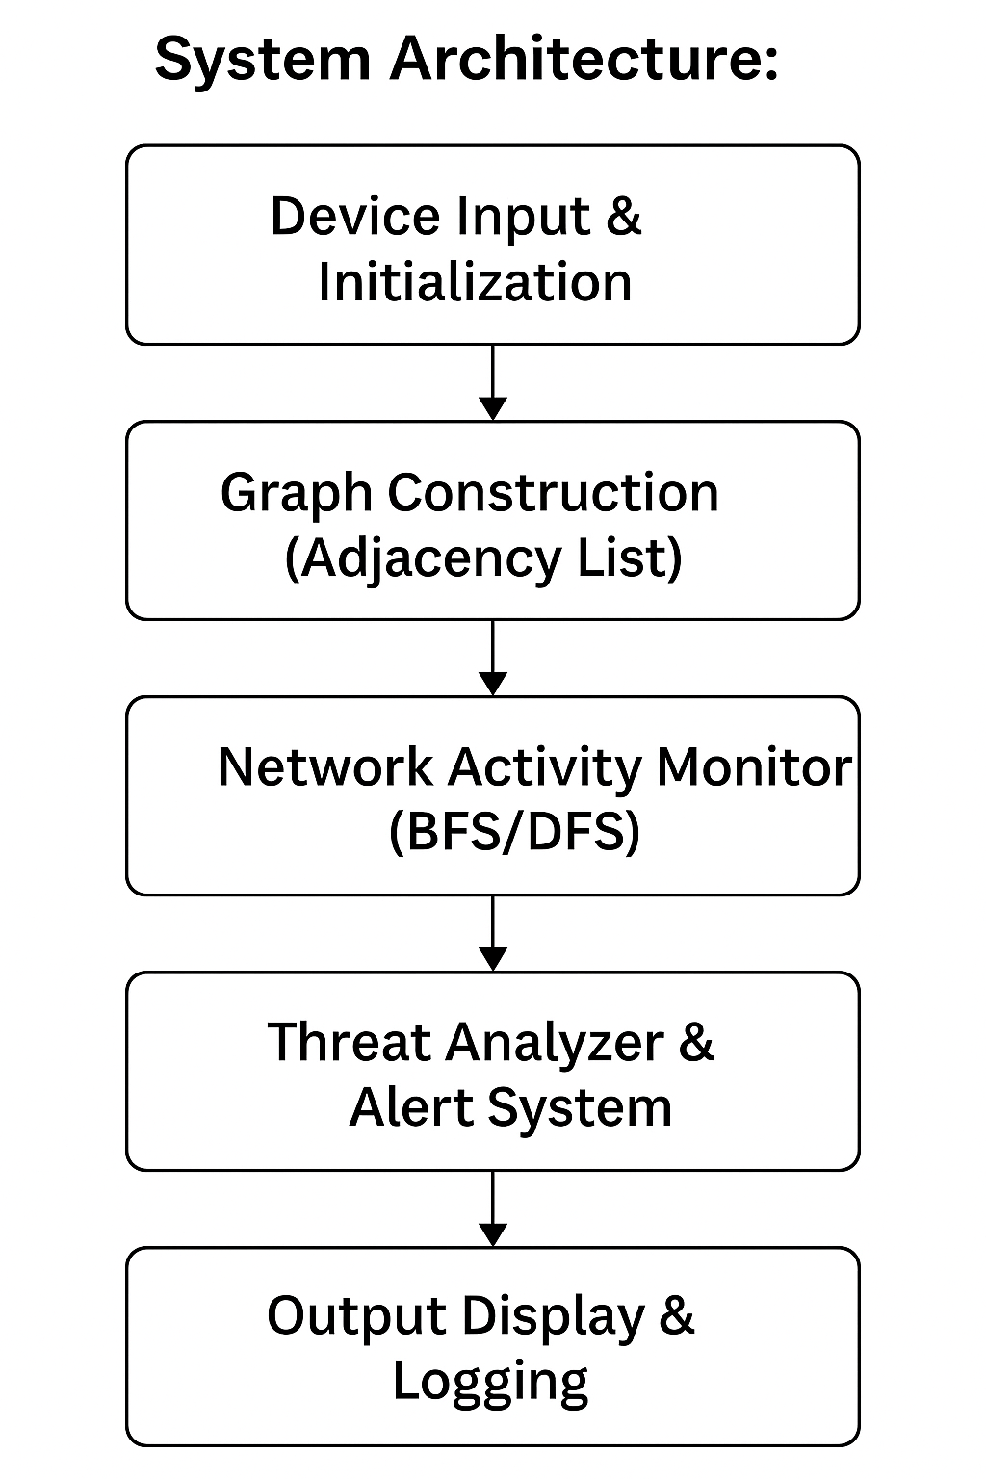

Data Structures Used:
Graph (Adjacency List) – Represent network topology
Hash Table – Device mapping and quick lookup
Queue – Manage real-time event processing
Linked List – Store threat logs chronologically
Algorithms:
- BFS/DFS: Traverses network to detect abnormal patterns.
- Threshold Check: Detects sudden data flow spikes.
- Logging Algorithm: Maintains list of suspicious connections.
Pseudocode Example:
function detectThreats(Graph G):
for each node in G:
for each connection (u,v):
if dataRate(u,v) > THRESHOLD:
logAlert(u,v, "Suspicious traffic detected")
Implementation Details:
Language and Tools:
- Language: C
- Compiler: GCC
- IDE: Code::Blocks / Visual Studio Code
- Libraries: stdio.h, stdlib.h, string.h
Key Code Snippet:
void addConnection(Graph *g, char *src, char *dest, int dataRate) {
// Create node and add to adjacency list
...
if(dataRate > MAX_RATE)
generateAlert(src, dest, "Data spike detected");
}
Sample Output:
--- Cybersecurity Threat Map ---
192.168.0.1 -> 192.168.0.2 : Normal
192.168.0.3 -> 10.0.0.5 : Suspicious! High data flow detected.
Active Alerts: 1
Results and Analysis:
Test Case 1: Normal Network
- Data flow between nodes < threshold → No alerts generated.
Test Case 2: Data Spike
- Connection rate exceeds threshold → Alert logged and displayed.
Performance Evaluation:
- Time complexity: O(V + E) (for BFS/DFS traversal)
- Space complexity: O(V + E)
- Efficient for medium-sized simulated networks.
Accuracy:
- Detects all threshold-based anomalies reliably.
Conclusion:
The Cybersecurity Threat Map successfully models a computer network using graph-based data structures and applies traversal algorithms for threat detection. It demonstrates the power of data structures in addressing real-world problems like cybersecurity monitoring.
Learning Outcomes:
- Practical application of graphs, hash tables, and queues.
- Improved understanding of anomaly detection logic.
- Hands-on experience with modular programming in C.
Challenges Faced:
- Handling dynamic updates in adjacency lists.
- Designing an efficient alert logging mechanism.
Future Enhancements:
- Integrate live network data using sockets or pcap.
- Add visualization interface using OpenGL or Python.
- Implement machine learning-based anomaly detection.
References:
1. E. Horowitz, S. Sahni, Fundamentals of Data Structures in C, Galgotia Publications.
2. Mark Allen Weiss, Data Structures and Algorithm Analysis in C, Pearson.
3. Cisco Threat Intelligence Whitepaper, Cisco Systems, 2023.
4. GeeksforGeeks – Graph Data Structure Concepts (https://www.geeksforgeeks.org/graph-data-structure-and-algorithms/).

