**Debugging**

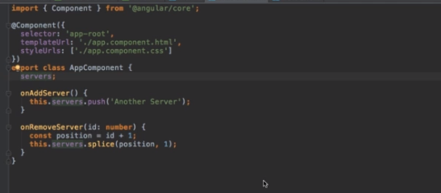

**Debugging Code in the Browser Using Sourcemaps**

