**Observables**

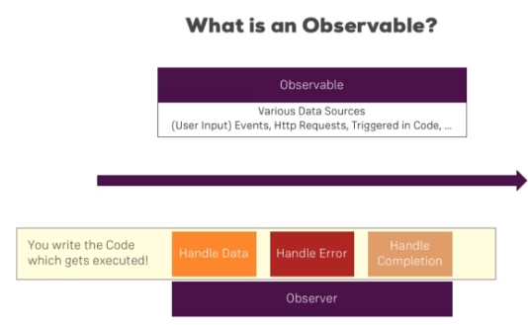

**Install RxJS**

In order to follow along smoothly with the course examples, make sure you install RxJS v6 by running

    1. npm install --save rxjs@6

In addition, also install the rxjs-compat package:

    1. npm install --save rxjs-compat