**Routing**

**Why do we need a Router?**

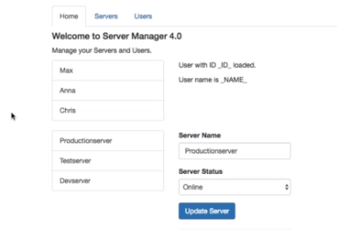

**Understanding the Example Project**

In our app, we got three sections:

* Home
* Servers
  + View and Edit Servers
  + A Service is used to load and update Servers
* Users
  + View Users

This app will be improved by adding routing but definitely feel free to play around with it - besides routing, everything should be working fine.

**Setting up and Loading Routes**

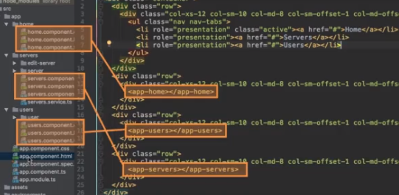

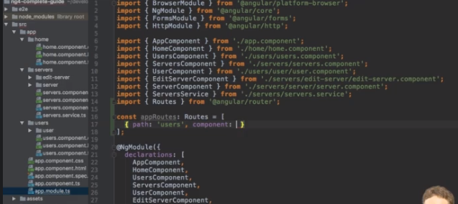

**Navigating with Router Links**

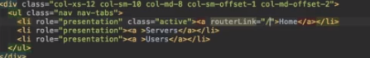

**Navigating Programmatically**

