**Node.js Introduction**

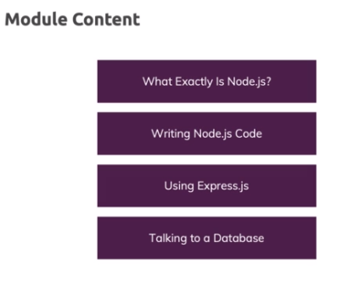

**JavaScript is a Hosted Language**

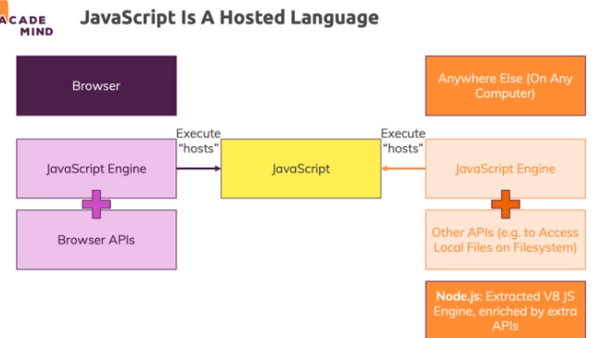

**Working with Incoming Http Requests**

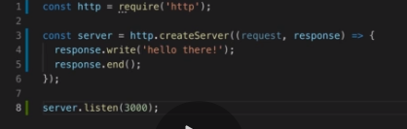

**Sending Responses (HTML Data)**

