**Numbers & Strings**

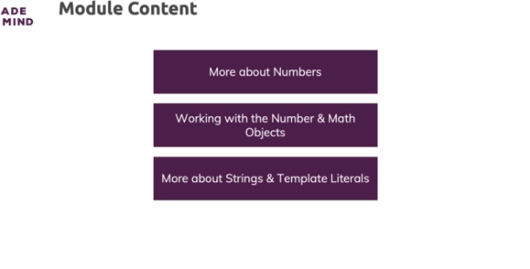

**How Numbers Work & Behave in JavaScript**

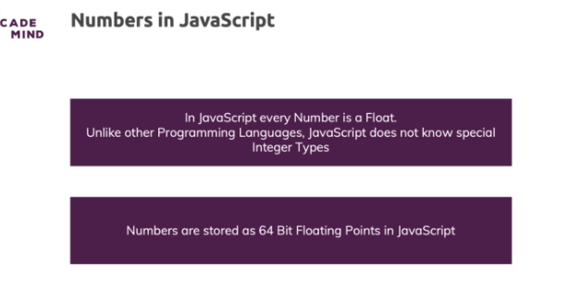

* so there are 64 bits available to internally represent a number, bits are these things which can be either 0 or 1
* One bit is reserved for the sign, so if it's a positive or negative number and the other bits are basically there to represent the digits of the number and where the dot is
* there are certain limits in Javascript, there is a maximum and a minimum number
* and there also is only a certain amount of precision we can get regarding the decimal places of a number
* so you can't represent every number in Javascript and there are of course certain ways around that

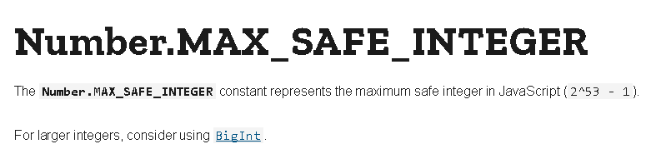

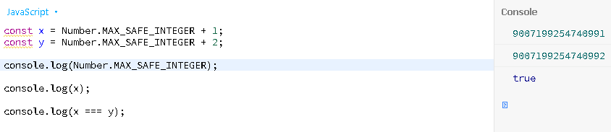

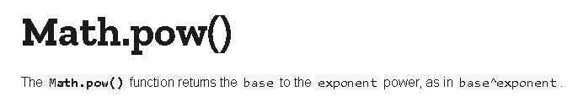

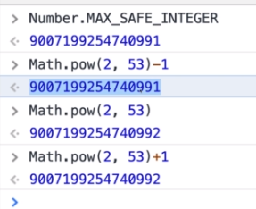

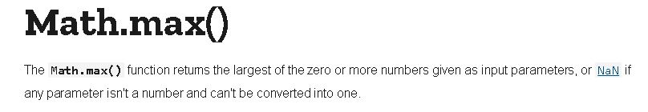

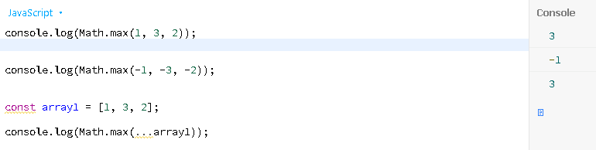

**Floating Point (Im)Precision**

* Javascript internally as you learned works with the binary system
* Javascript converts this number to the binary system for doing the calculation and then basically converts it back to give us an output that makes sense to us humans because we rather work with the decimal system than with the binary system

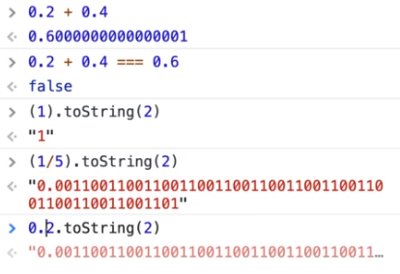

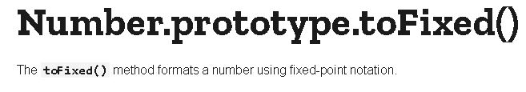

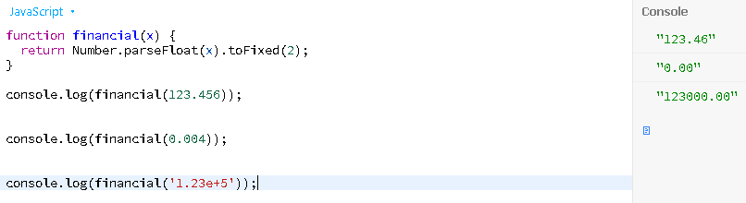

**The BigInt Type**

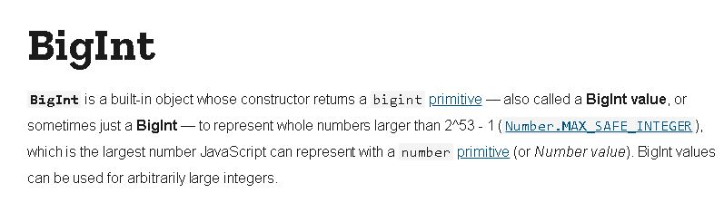

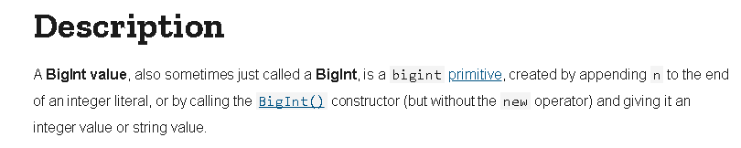

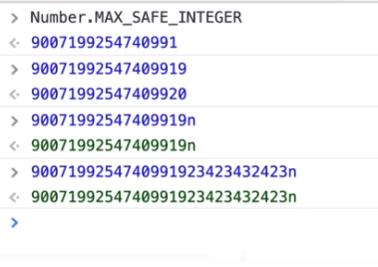

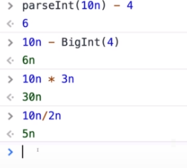

**The Global "Number" and "Math" Objects**

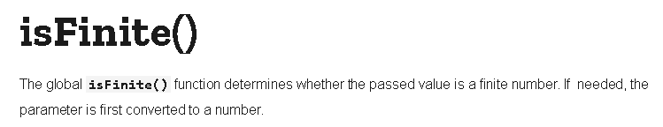

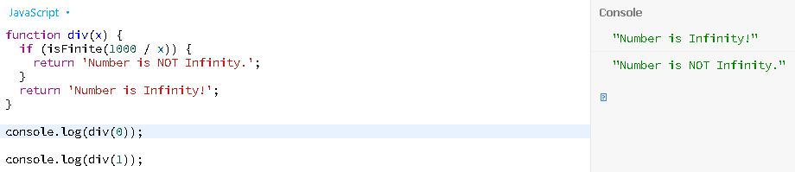

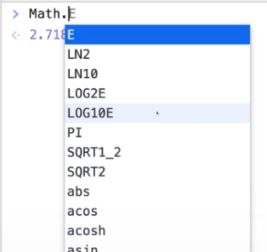

**Example: Generate Random Number Between Min/ Max**

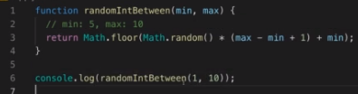

**Tagged Templates**

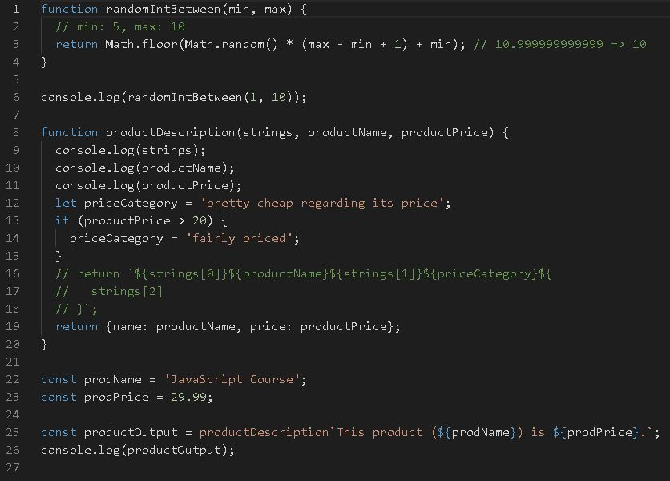

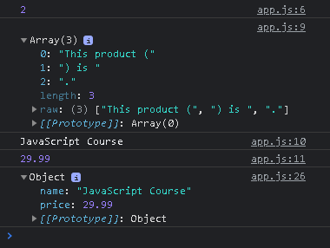

**Introducing Regular Expressions ("RegEx")**

* Regular expressions don't just exist in Javascript, they exist in most programming languages and they help you search for patterns in strings

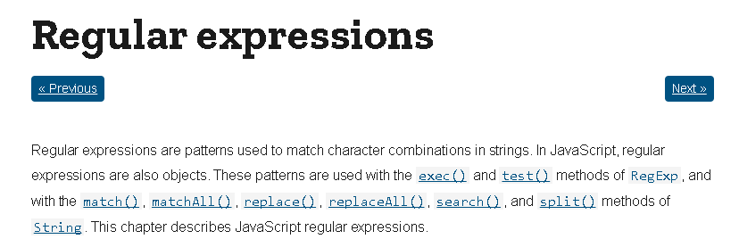

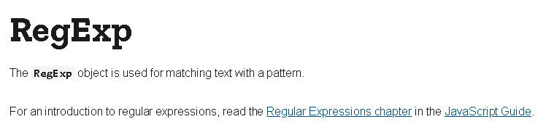

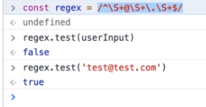

**More on Regular Expressions**

