**Security**

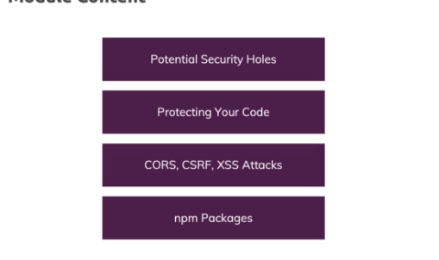

**Security Hole Overview & Exposing Data in your Code**

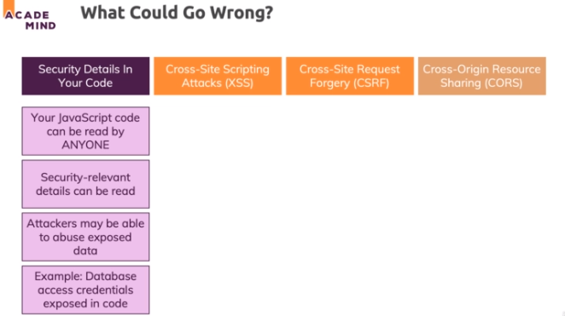

**Cross-Site Scripting Attacks (XSS)**

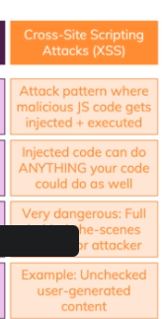

**CSRF Attacks (Cross Site Request Forgery)**

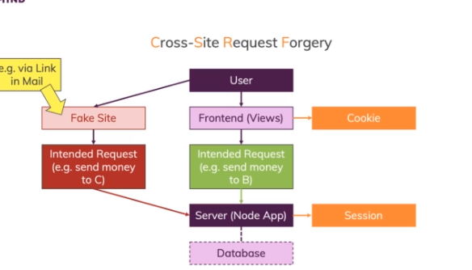

**CORS (Cross Origin Resource Sharing)**

