Task 2: one children start school, teachers have more influence on their intellectual and social development than parents. To what extent do you agree and disagree ?


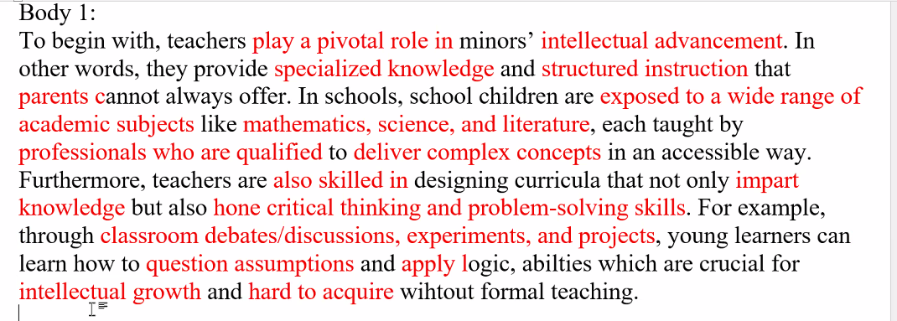
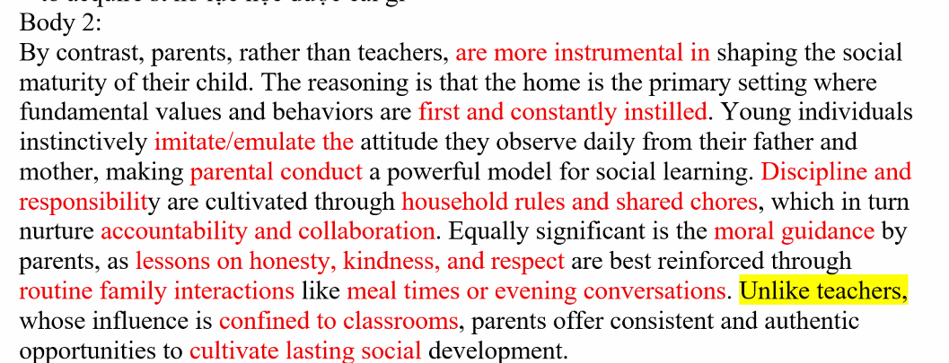

Introduction (đã cho sẵn trong ảnh)
It is claimed/argued that when juveniles enter formal education, teachers exert a stronger influence than parents on their intellectual and social growth. While I acknowledge that teachers are more essential for fostering the cognitive development, I contend that it is parents who primarily shape their children’s social maturity.

Body 1
To begin with, teachers play a pivotal role in minors’ intellectual advancement. In other words, they provide specialized knowledge and structured instruction that parents cannot always offer. In schools, school children are exposed to a wide range of academic subjects like mathematics, science, and literature, each taught by professionals who are qualified to deliver complex concepts in an accessible way. Furthermore, teachers are also skilled in designing curricula that not only impart knowledge but also hone critical thinking and problem-solving skills. For example, through classroom debates/discussions, experiments, and projects, young learners can learn how to question assumptions and apply logic, abilities which are crucial for intellectual growth and hard to acquire without formal teaching.

Body 2
By contrast, parents, rather than teachers, are more instrumental in shaping the social maturity of their child. The reasoning is that the home is the primary setting where fundamental values and behaviors are first and constantly instilled. Young individuals instinctively imitate/emulate the attitude they observe daily from their father and mother, making parental conduct a powerful model for social learning. Discipline and responsibility are cultivated through household rules and shared chores, which in turn nurture accountability and collaboration. Equally significant is the moral guidance by parents, as lessons on honesty, kindness, and respect are best reinforced through routine family interactions like meal times or evening conversations. Unlike teachers, whose influence is confined to classrooms, parents offer consistent and authentic opportunities to cultivate lasting social development.

Conclusion (thiếu, mình viết thêm cho bạn)
In conclusion, although teachers are vital for children’s intellectual development by providing knowledge and skills that parents cannot fully deliver, it is parents who have a deeper and more lasting impact on shaping their children’s social maturity. Therefore, both teachers and parents play indispensable but complementary roles in the overall growth of a child.

