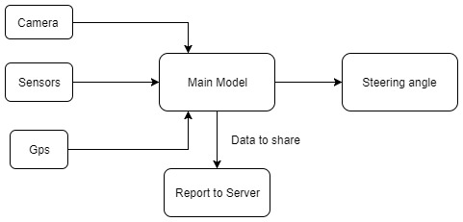

References

* Driving model using single camera is prepared by mimicking human decision-making approach for efficient and autonomous driving.
* Dataset was recorded while vehicle was driven by human.
* A small-scale prototype for driving model was prepared using microprocessor “Raspberry pi” with RTos implemented.
* Basic algorithm has been implemented for PoC.
* Our vehicle shall use Lithium batteries which will make it eco-friendly.

1. Sebastian Thrun. “Path Planning for Autonomous Vehicles in Unknown Semi-structured Environments”.
2. Kaijun Zhou. “Local Path Planning of Driverless Car Navigation Based on Jump Point Search Method Under Urban Environment”.
3. Mariusz Bojarski. “End to End Learning for Self-Driving Cars”.

Corresponding Mentor:

**Dr. NS Rajput (nsrajput.ece@iitbhu.ac.in)**

The financial support, in part, received from the NCC LAB, Department of Electronics Engineering, IIT (BHU), India (Grant no. IS/ST/EC-13- 14/02), from IBM, India (Grant no. R&amp;D/IBM/SBApp/Electronics/15/16/07)and Nvidia, USA for grant of Tesla K 40 GPU under Hardware Support Grant, is gratefully acknowledged.

Acknowledgement

The autonomous E-rickshaw will have a major impact on the society as a whole. The technology will reduce road accidents, free up large amounts of parking space, reduce traffic problem and decrease carbon emissions. It will increase safety and convenience by finding shortest routes, hence minimizing the extra time taken while driving. By eliminating unnecessary driving, we can reduce carbon emissions to a great extent. Key features –

* Stakeholders- Automobile industry, driver community, academia, public.
* Institutional Arrangements- Fully- equipped labs, servers for processing big-data, high-quality cameras and sensors.
* Social risks- Acceptance by the Government, acceptance by the public and the industry.

Social Impact

For local navigation, time stamped video from the cameras is captured simultaneously. The image is split into YUV planes and passed to the network. We use an NVIDIA DevBox and Torch 7 for training. The neural network consists of 9 layers, including a normalization layer, 5 convolutional layers and 3 fully connected layers. The convolutional layers are used to perform feature extraction. The fully connected layers are designed as a controller for steering. After selecting the ﬁnal set of frames, we augment the data by adding artiﬁcial shifts and rotations to teach the network how to recover from a poor position or orientation.

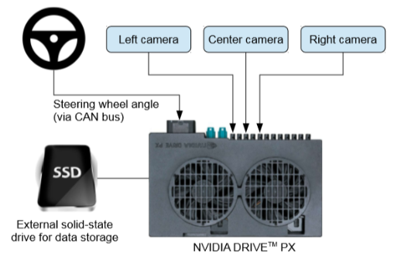

We build two GPS databases, comprising a GIS database and a special route database. The GIS database stores the general road GPS data and the special route database stores the GPS data of the route. We search a route through the road network by the Dijkstra algorithm and build the network analysis tool of the ArcGIS Engine-interface of INASolver. Then, the Jump Point Search algorithm is adopted for local path planning.

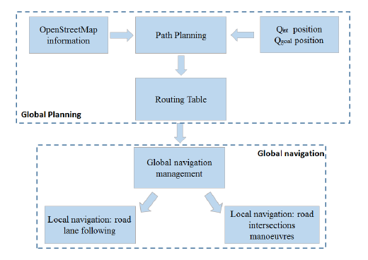



Indian Institute of Technology (BHU) Varanasi

1Dept. of Electronics Engg., 2Dept. of Electronics Engg.

1Kartik Anand, 2Shreyas Tripathi

**Autonomously Navigating E-Rickshaw using Global and Local Navigation.**

Basic Plan for navigation-



ABSTRACT- Path planning is a critical problem for autonomous vehicles. Here a novel method for navigation in such vehicles has been proposed. This method makes use of global path planning to get an optimal path to a destination and local path planning to avoid obstacles on the road and manoeuvre the vehicle properly on crowded roads. The global path planning makes use of GPS data and network analysis tool to search for an optimal route by a certain frequency. The data from the cameras is used for local path planning which is fed to a convolutional neural network (CNN) to map raw pixels to steering commands.

Motivation and Objectives

Progress made