ARCHITECTURAL DIAGRAM

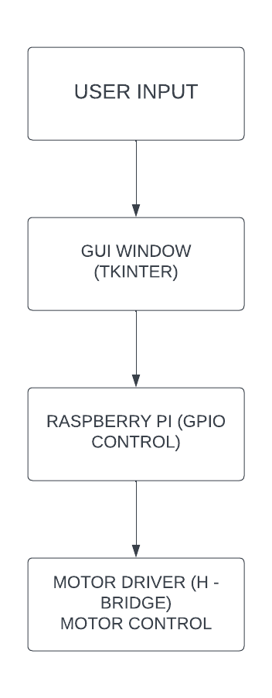

In this diagram:

1. The user provides input through the keyboard, such as pressing keys to control the robot car.

2. The GUI window captures the keyboard inputs and sends them to the Raspberry Pi.

3. The Raspberry Pi handles the inputs, interacts with the GPIO pins for motor control, and communicates with the motor driver.

4. The motor driver receives the signals from the Raspberry Pi and controls the motors of the robot car to perform the desired movements.

This architecture demonstrates the flow of control from user input to the GUI, Raspberry Pi, GPIO control, and finally the motor driver, which results in the physical movement of the robot car.
WIRING

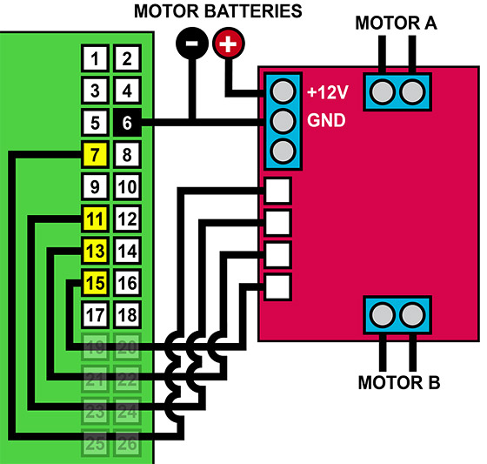
RASPBERRY PI PINS
