Python Concepts implemented
Importing Modules:
The project utilizes various modules by importing them at the beginning of the code. For example:

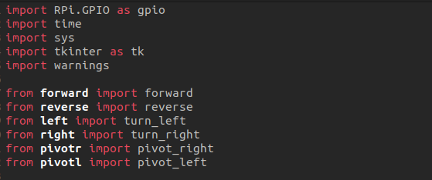
Built-in modules:
RPi.GPIO:
RPi.GPIO is a module specifically designed for Raspberry Pi to control its General Purpose Input Output (GPIO) pins. It provides functions to configure the GPIO pins, set their mode (input/output), read input values, and control output values. In the project, RPi.GPIO is used to interact with the GPIO pins connected to the motor controller, enabling control over the robot car's movements.

time:
The time module in Python provides various functions related to time measurement and manipulation. It allows access to functions for retrieving the current time, adding delays, measuring time intervals, and formatting time values. In the project, the time module is used to introduce delays between motor movements, measure execution time, and display timestamps.

sys:
The sys module provides access to some variables and functions that interact with the Python interpreter. It allows for interaction with the system-specific parameters and functions, such as reading command-line arguments, terminating the program, and accessing system-specific configurations. In the project, sys is used to handle program termination in response to a KeyboardInterrupt exception

tkinter:
The tkinter module is the standard Python interface to the Tk GUI toolkit. It provides functions and classes for creating graphical user interfaces (GUIs) and handling user inputs through widgets like buttons, labels, and text boxes. In the project, tkinter is used to create a GUI window and capture keyboard inputs from the user.

warnings:
The warnings module in Python provides a way to handle and control warning messages issued by the interpreter or other modules. It allows users to control how warnings are displayed or ignored. In the project, the warnings module is used to suppress RuntimeWarning messages that may arise from GPIO operations.

These imported modules provide the necessary functionalities for interacting with the Raspberry Pi hardware, managing time-related operations, handling system interactions, creating GUI interfaces, and controlling warning messages in the project.

Function Definition and Invocation:
The project defines multiple functions in separate modules and invokes them based on specific actions. For example:
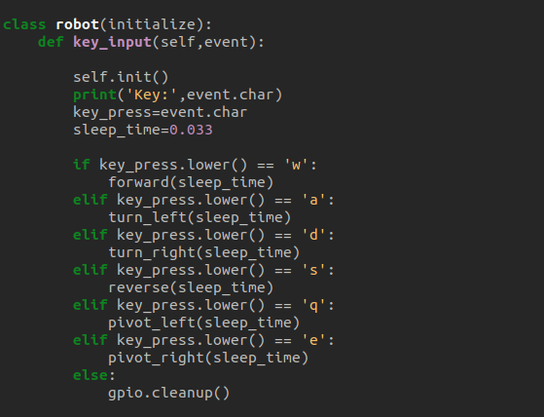
Function invocation fig 2.a

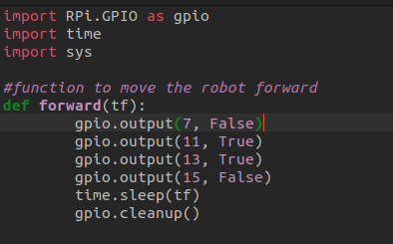

Function definition fig 2.b

Function definitions encapsulate specific actions or behaviors, promoting modularity and code reusability. The functions are then invoked when required, passing the necessary parameters.

Decorators

Decorators in Python are a way to modify the behavior of functions or methods without changing their actual implementation. They allow you to wrap a function with additional code and functionality. In the project, the @show_time decorator is used to measure and display the execution time of specific functions. Here's a more detailed explanation of how decorators are implemented in the project:

Applying the decorator:
The @show_time decorator is applied to the myrobot method within the robot class. This syntax is a shorthand way of applying the decorator to the function or method directly below it. By decorating myrobot with @show_time, the functionality defined in the decorator will be added to the myrobot method.

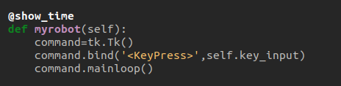

Applying the decorator 3.a

Decorator Definition:
The show_time function is defined to act as a decorator. It takes a function (func) as an argument and defines an inner function (wrapper) within it. The wrapper function adds the desired functionality, in this case, measuring and displaying the execution time. It captures the start time, calls the original function (func), captures the end time, and calculates the uptime. Finally, it returns the result of the original function.

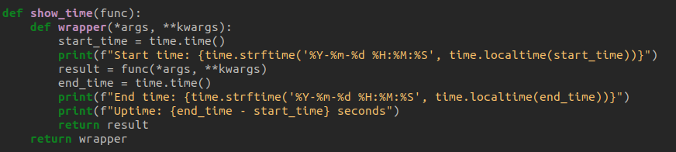
Decorator Definition fig 3.b

Execution with Decorator:
When the myrobot method is invoked on an instance of the robot class, the decorator comes into play. The wrapper function defined within the decorator will wrap around the execution of the myrobot method. It captures the start time, executes the original method, captures the end time, calculates the uptime, and displays the timestamps and execution time information.
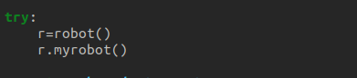

Execution with Decorator fig 3.c
By using the @show_time decorator, the project is able to automatically measure and display the execution time of the myrobot method without modifying its original implementation. This allows for easy monitoring and analysis of the method's performance.
Error Handling:
The project includes try-except blocks to handle specific exceptions and ensure proper cleanup. For example:
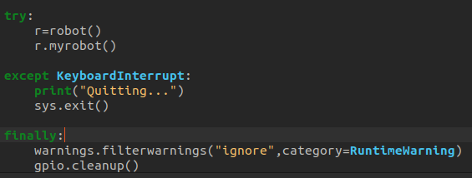
Error handling using try.....except....finally fig 4.a
The try block attempts to execute the code, while the except block catches the KeyboardInterrupt exception, which occurs when the user interrupts the program (e.g., by pressing Ctrl+C). The finally block ensures that GPIO pins are cleaned up properly before exiting the program.

Assertions
Assertions in Python are used to validate certain conditions and help with debugging by catching potential errors or inconsistencies. In the project, assertions are used to verify specific conditions related to GPIO pin configuration. Here's an elaboration on the assertions used in the project:
fig 5.a

These assertions are used within the init method of the initialize class. They check the current GPIO mode and ensure it is set to the expected value. The first assertion checks that the GPIO mode is set to gpio.BOARD, which means the pin numbering scheme is based on the physical pin numbers on the Raspberry Pi board. If the assertion fails, it will raise an AssertionError with the corresponding error message.
The second assertion checks that the GPIO mode is not set to gpio.BCM, which stands for Broadcom SOC channel numbering scheme. This scheme uses GPIO channel numbers, which may differ from the physical pin numbers. If this assertion fails, it will also raise an AssertionError with the associated error message.
fig 5.b
These assertions are used to ensure that specific GPIO pins are correctly configured as output pins. They check the GPIO function of the specified pins (11, 13, and 15) and verify that they are set to gpio.OUT. If any of these assertions fail, indicating that the pins are not set as output pins, an AssertionError will be raised along with the corresponding error message.
These assertions provide a way to validate the expected configuration of GPIO pins. If any of the conditions are not met, the program will halt with an AssertionError, helping to identify and fix potential issues during development and testing.

Inheritance
the concept of inheritance is used to implement code reusability and organize related functionalities. Specifically, the project utilizes single inheritance, where a derived class inherits the properties and methods of a single base class.
Here's an elaboration on the inheritance used in the project:
Base Class:
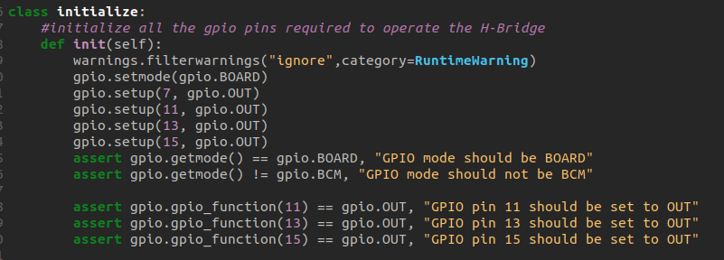
Base class fig 6.a

The initialize class serves as the base class in the project. It contains the init method, which initializes the GPIO pins required to operate the H-Bridge. This class provides a common set of initialization functionality that can be reused by any derived class.
Derived Class:
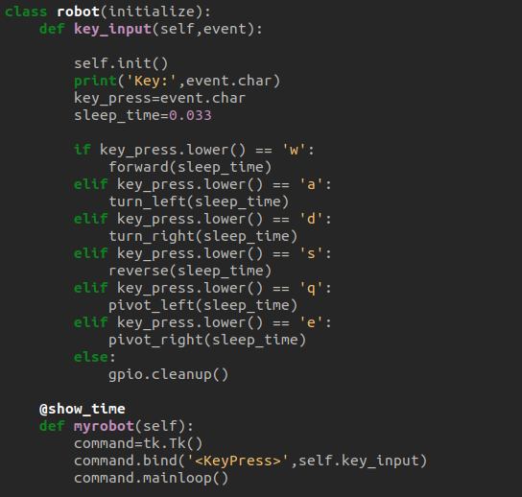
Deived class fig 6.b
The robot class is a derived class that inherits from the initialize base class. By including initialize in parentheses after the class name (class robot(initialize)), the robot class inherits all the properties and methods defined in the initialize class.
The derived class, robot, adds its own methods: key_input and myrobot. The key_input method handles keyboard inputs and performs corresponding actions. The myrobot method serves as the main function for controlling the robot car.

