TEST CASES

Test Case ID | Description | Expected Output | Actual Output | Status
1 | Move Forward | Robot car moves forward. | Robot car moves forward. | Passed
2 | Turn Left | Robot car turns left. | Robot car turns left. | Passed
3 | Turn Right | Robot car turns right. | Robot car turns right. | Passed
4 | Move Backward | Robot car moves backward. | Robot car moves backward. | Passed
5 | Pivot Left | Robot car pivots left. | Robot car pivots left. | Passed
6 | Pivot Right | Robot car pivots right. | Robot car pivots right. | Passed
7 | Assertion - GPIO Mode | Verify that the GPIO mode is set to BOARD. | GPIO mode is set to BOARD. | Passed
8 | Assertion - GPIO Pin Configuration | Verify that GPIO pins 11, 13, and 15 are set to OUT. | GPIO pins 11, 13, and 15 are set to OUT. | Passed
9 | Keyboard Interrupt | Simulate a keyboard interrupt during program execution. | Program handles the keyboard interrupt and displays "Quitting...". | Passed
10 | Clean Up after Keyboard Interrupt | Trigger a keyboard interrupt and then run  the program again. | GPIO pins 11, 13, and 15 are properly cleaned up after the keyboard interrupt. | Passed

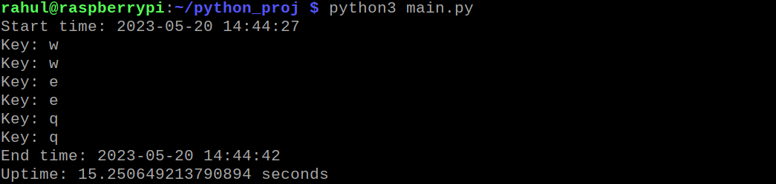
Normal Execution – No errors

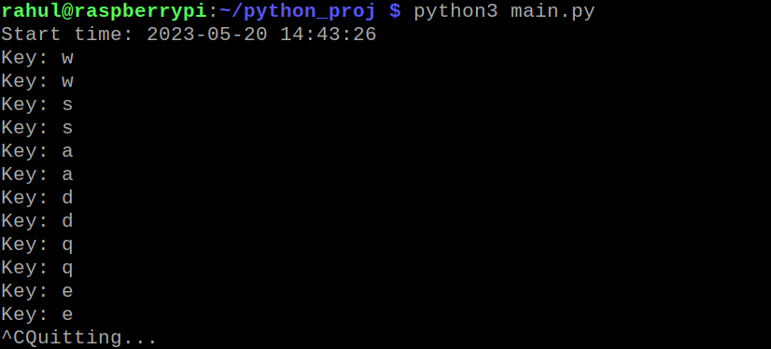
Keyboard Interrupt

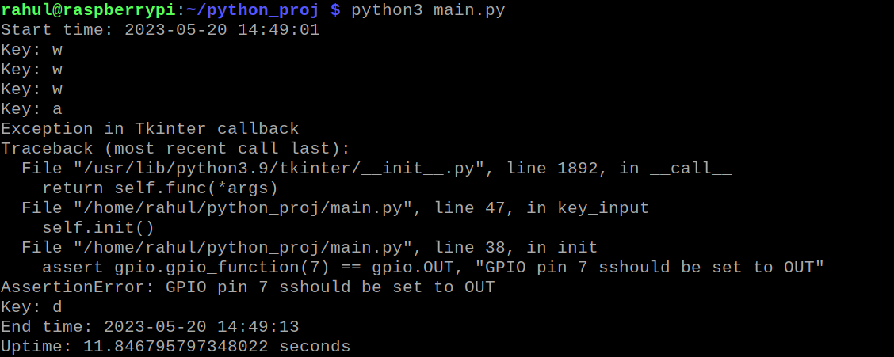
Assertion Error

