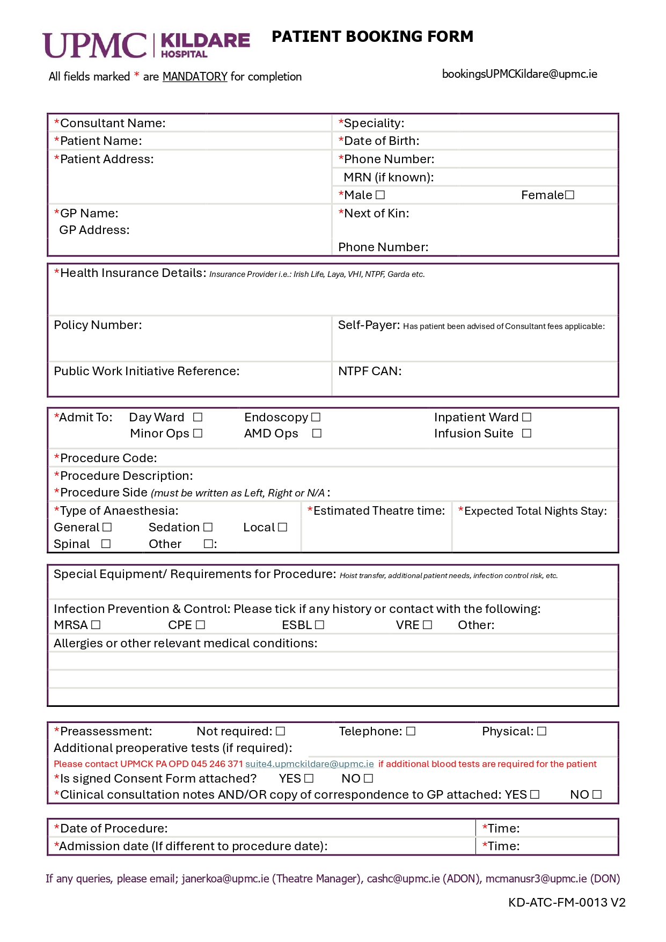

















































[OpTime]

[AdmTime]

[AdmDate]

[OpDate]





[OpType]

[OpCode]





[PolicyNo]

[Insurance]

[NextOfKinContact]

[NextOfKin]

[DoctorAddress1], [DoctorAddress2],[DoctorAddress3]

[DoctorName]

[Mrn]

[Mobile] 

[DOB]

[PatientName]