Apart from the previous task-list (which I mailed as subject : ***“Today's panga/updates KM”***), these are almost complete remaining one, but few add-on things might be notified later on.

1. Put name in each company pages respectively with city for example **Ola Cabs, Delhi** (in Berlin Sans FB Demi FONT)
2. In user’s profile page, arrange the booking section properly & sort them with time obviously recent one on top.

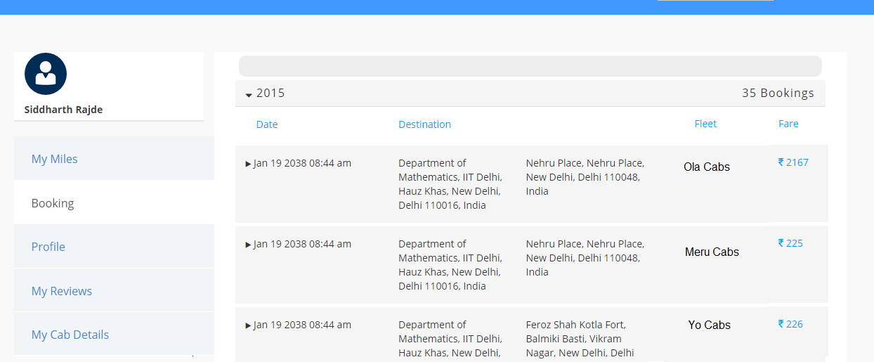

1. In user’s profile page, my review section mein, what-so-ever review user will write should be shown on dedicated company’s profile also along with the rating (star marked).
2. For cab company, create a different login/signup panel from where they can manage the profile page of company, by :
   1. Changing/adding **cover pic**
   2. Changing/adding **offer pic**
   3. Respond to the user’s feedback on their company’s profile page (& only company can respond to any feedback written by user)
   4. Comments thread can go on upto n comments/replies but in that thread only that particular user & that particular cab company can write/discuss the issues via comments.

***Continued………***

1. And jaise pic mein likha hai on cover pic ki 524 opinions 4.4 so apan ko aisa krna hai ki jaise tune & maine rate+reivew kiya bas, toh it should be shown as 2 opinions (apan dono ki average ratings) for example you did 4, I did 5 so "2 opinions 4.5"

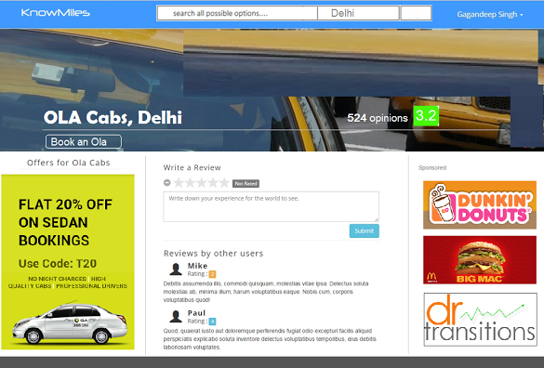

1. Cab user ko dusro k written- reviews ko upvote & down vote karne ki facility/option hona chahiye, so as witter review ki credibility prove ho. (Isme deign related pangaa hot oh talk to Gagan ddirectly & cc me in the mail u will be sending to him)
2. The city the user is in should be auto determined using ip address. The user still possesses option to selsct it form the drop down list, but by default his/her current city will be entered.
3. To narrow down the results of google search to specific city, just embed the city name (Which has been selected) to the results the user is typing in and send that result to google for searching. Add a comma after the city name.
4. Round off the cost results to rupees and not paisas. (Eg. 768 instead of 768.3)
5. Correct the cab specific logo – as non ac-sedan has logo of suv (as I mailed u with sub : filtering)
6. Also, if there are not cabs of a particular type or none choices is selected, then display a message – “No cabs of the selected categories available. Please reselect some more cab types.”
7. From to in the cab-listing page (2nd page) is empty, fill it with the from and to locations which the user has entered.
8. Add “Coming Soon” to the “Closest” section.
9. Add “Coming Soon” to the “Best-Rated” section.