**Software Requirement Specification**

**(SRS)**

**1) Project Information**

* **Title**

Stock Market Analyzer

* **Developer**

Adit Pathak (09bce053)

* **Objective:**

The objective is to allow stock market investors to view the historic data of the company which includes opening price , closing price , day high , day low etc. The system will also predict the chances of increment and decrement of particular stock price using the historic data.

* **Description:**

Stock market analyzer is an online application which will acquire recent stock market data online and analyze the data. According to the analysis , the application will predict the chances of increment and decrement in stock values.

**2) Scope:**

* The system will allow registered user to view the past 3 month’s stock market data in form of table and chart for various companies.
* The system will predict the chances of increment and decrement in stock price for the following day using the acquired past 3 month’s data. The prediction will be based on statistical analysis of the acquired data including probability theory. It doesn’t ensure the 100% hit. So the system is not at all responsible for investors’ loss in stock market.

**3) Project schedule**

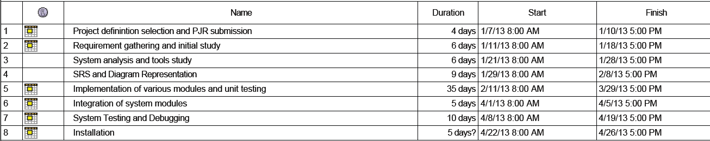

**4) Software testing/Quality assurance arrangements**

* **For live testing or quality assurance tools:**

Hardware : LAPTOP with windows 7 OS , 4 GB RAM

Software : wamp server , Browser like IE , Google Chrome and Mozilla Firefox

**5) Detail specification of the project**

* **Stock Market Analyzer:**

The stock market analyzer is an online application which will allow users to view the stock data and the result of prediction for the companies covered by application. The application will acquire stock data online using company ticker(Unique ID given to company for stock market listing e.g. WIPRO.BO for wipro BSE). The application has two modules:

1. **User Module :** 
   * Users must register themselves once before using this application.
   * During registration process user will choose a unique User Id for the application and a password(Min. of 6 characters) which will be useful for future log in process.
   * Having registered , user will have to log in using their unique Id and Password.
   * User can change their password for future.
   * Having logged in , user will be allowed to select the company name from the list of companies covered by the application.
   * Having selected the company , the stock data of past 3 months will be displayed which includes date , opening price , closing price , day high , day low and amount change. The data may be displayed using charts as well.
   * After performing statistical analysis on acquired data , the Buy value and Sell value will be displayed which will advise user the chances of increase or decrease in that share price.
   * The information regarding company stock prices will be collected online at a time.
2. **Admin Module :**
   * The administrator will have his/her user id and password . The administrator will log in as administrator.
   * He/She has the privilege to add and delete the companies to/from the list of companies which users see after logging in. So administrator has the privilege to upgrade or reduce the scope of application.

**6) System Limitation**

* The application predicts the increase or decrease according to the result of applying probability theory on acquired historical data. So the application doesn’t ensure 100% reliability of the prediction.
* The system is not responsible for any contradictory result from prediction.

**7) System Requirements (For Use of Application)**

* Internet web browser with internet connection. IE 8 and above recommended.
* Free disk space of at least 50 MB is recommended.

**8) Details of tool-sets for development**

* **Workstation specification**

Dell Laptop with Windows 7 OS , 4 GB RAM , 500 GB secondary memory space

* **Server Side Scripting:**

PHP (Hypertext Preprocessor)

* **Client Side Scripting:**

Javascript with AJAX

* **Back End**

MYSQL