An Early Warning System for Student Withdrawal in Online Higher Education: Software Requirements Specification

Isit Pokharel
Harrisburg University of Science and Technology
CISC 699: Applied Project in Computer Science
Dr. Mike Shahine
September 12, 2026
Revision 2, 2026-09-12. Three internal inconsistencies corrected: the evaluation metrics named in Section 1 and in UC11 now agree, the UC10 postcondition no longer contradicts UC04's exception flow, and risk band, advisory capacity and false negative rate — used throughout and previously undefined — are defined in Section 3.1.3. No requirement is added, removed or renumbered.

1. Problem statement
In the Open University Learning Analytics Dataset, 10,156 of 32,593 student registrations end in withdrawal, a rate of 31.2 percent across 22 presentations of seven modules (Kuzilek et al., 2017). A student who withdraws forfeits the tuition already paid and leaves without the credential the enrollment was meant to produce. The institution loses the remaining tuition for the presentation and, where funding is tied to completion, the portion of the subsidy attached to it.
Withdrawal is not spread evenly across the cohort. In OULAD it concentrates in the lower IMD bands: 37.2 percent of registrations in the most deprived IMD decile end in withdrawal, against 25.9 percent in the least deprived, and every decile below the median withdraws at a higher rate than every decile above it. These are the groups for whom retention support matters most, so a system that lowers the overall rate while leaving that gap unchanged has improved an average and helped no one at the margin.
Course Signals at Purdue and OU Analyse at the Open University both showed that early alerts change behavior (Arnold & Pistilli, 2012; Wolff et al., 2013). Their published evaluations report one model at one point in the term, scored with aggregate metrics. In the Course Signals case, Caulfield (2013) showed the headline retention comparison was confounded, because students who persisted longer had more terms in which to take a Signals course. Neither evaluation reports how the model behaves earlier in the term, and neither breaks accuracy down by student group. Those are the two things an advisor deciding whether to trust a week-4 score would want to know.
This project builds EarlyAlert, a web application that ranks the students in a presentation by predicted withdrawal probability and shows the features driving each score. It supports the workflow that follows a prediction: an advisor flags a student, records the contact made, and records the outcome. It trains and evaluates a separate model at week 4, week 8, and week 12, and reports AUC-ROC, AUC-PR, and Brier score at each, overall and for each student subgroup, together with the per-subgroup false negative rate at a fixed advisory capacity. The false negative rate is the measure this argument turns on: a false negative is a student who withdrew and was never put in front of an advisor. Predicting early has a cost. The evaluation measures it.
EarlyAlert does not send messages to students, does not integrate with a live virtual learning environment, and does not make or recommend enrollment decisions.

2. Requirements

2.1 Elicitation method
The OULAD schema establishes what the data supports. Seven linked tables, the fields in each, and the convention that dates are integer days relative to the first day of the presentation together determine what the system can ingest and what it can compute. That analysis produces FR-11, which fixes the seven-file input format, and FR-14, which fixes the derived weekly features. It also rules requirements out: nothing in the seven tables records message content or student replies, so no requirement depends on communication data.
Published early warning systems establish what functions a tool of this kind provides. OU Analyse contributes the ranked list as the primary cohort view. Course Signals contributes both the requirement that a score appear with the factors behind it and the flag-and-intervene workflow. Together they produce FR-4 through FR-8.
The course requirements fix the remainder. The login test case template attached to Assignment 5 implies FR-1 and, with it, the role model in FR-2 and FR-3. The rubric’s repeated reference to diverse learners produces FR-9 and FR-10. The requirement that test cases trace to numbered requirements is why every entry in the tables below carries an ID, and why the numbering is frozen at submission. A priority change does not renumber anything.

2.2 Functional requirements
ID | Requirement | Priority | Source
FR-1 | The system shall authenticate users by username and password. | Must | Rubric (login test case template)
FR-2 | The system shall enforce three roles: instructor, advisor, administrator. | Must | Design
FR-3 | The system shall restrict instructors and advisors to presentations assigned to them. | Must | Design
FR-4 | The system shall display students in a presentation ranked by predicted withdrawal probability. | Must | OU Analyse
FR-5 | The system shall display, for each scored student, the three features contributing most to the score. | Must | Course Signals
FR-6 | The system shall allow an advisor to flag a student for outreach. | Must | Course Signals
FR-7 | The system shall allow an advisor to record an intervention with type, date, and notes. | Must | Design
FR-8 | The system shall allow an advisor to record an intervention outcome. | Should | Design
FR-9 | The system shall display cohort-level risk distribution and subgroup breakdown. | Must | Rubric (diverse learners)
FR-10 | The system shall suppress any subgroup statistic computed from fewer than 20 students. | Must | Ethics
FR-11 | The system shall accept upload of the seven OULAD-format CSV files. | Must | OULAD schema
FR-12 | The system shall validate uploaded files against the expected schema before ingestion. | Must | Design
FR-13 | The system shall reject uploads exceeding 500 MB per file. | Must | Design
FR-14 | The system shall compute weekly engagement and assessment features from uploaded data. | Must | OULAD schema
FR-15 | The system shall train a classifier for each configured horizon on demand. | Must | Design
FR-16 | The system shall store evaluation metrics with each trained model version. | Must | Design
FR-17 | The system shall log every flag, intervention, upload, and retrain with user and timestamp. | Must | Design
FR-18 | The system shall export a risk ranking as CSV. | Could | Design

2.3 Non-functional requirements
ID | Requirement | Category | Priority
NFR-1 | Risk ranking pages shall load in under 3 seconds for presentations up to 2,000 students. | Performance | Must
NFR-2 | Feature rebuild for a full OULAD upload shall complete in under 10 minutes on the reference machine. | Performance | Should
NFR-3 | Passwords shall be stored using a salted adaptive hash. | Security | Must
NFR-4 | No user shall be able to view student data outside their assigned presentations. | Security | Must
NFR-5 | The system shall retain audit entries for the life of the deployment. | Reliability | Must
NFR-6 | Student identifiers shall be pseudonymous integers with no name or contact field stored. | Privacy | Must
NFR-7 | The system shall run on a single machine with 8 GB RAM. | Constraint | Must

3. Software Requirements Specification

3.1 Introduction

3.1.1 Purpose
This document specifies the functional and non-functional requirements for EarlyAlert, a web application that predicts student withdrawal from online course presentations and supports the advisor workflow that follows a prediction. It is written for the course instructor evaluating the project and for any developer who extends the system after it is built.

3.1.2 Scope
Risk scoring turns an uploaded cohort into per-student withdrawal probabilities at fixed points in the term, each shown with the features that drive it. The intervention workflow records an advisor’s decision to pursue a student, the contact made, and the outcome. Data administration covers upload, schema validation, and feature construction. Model administration covers retraining and the audit log. The exclusions in Section 1 apply: no messaging, no live VLE integration, no enrollment recommendations. The benefit is allocation: support staff have limited outreach capacity, and the system directs that capacity toward the students most likely to leave.

3.1.3 Definitions
Term | Definition
OULAD | Open University Learning Analytics Dataset; seven linked CSV tables covering 32,593 student registrations, 2013–2014.
VLE | Virtual learning environment; the online platform hosting course materials, and the source of the daily click records in studentVle.csv.
Module | A course, identified by a code such as AAA. One module runs in several presentations.
Presentation | One offering of one module in one term, identified by module code and presentation code, such as AAA/2013J.
Cohort | The set of students registered for one presentation. All scoring and reporting is scoped to a cohort.
Horizon | The week of the presentation at which a prediction is made. EarlyAlert uses week 4, week 8, and week 12.
IMD band | Index of Multiple Deprivation band; a decile range describing deprivation in the student’s home area, recorded as a string such as “20-30%”.
Withdrawal | A registration whose final_result is Withdrawn; in OULAD this coincides with a non-null date_unregistration before the end of the presentation, and the model label uses final_result. Failing means completing without passing.
Feature set | A named collection of derived per-student-per-week variables used as model input, stored with each model version for reproducibility.
AUC-ROC | Area under the receiver operating characteristic curve; measures how well the model ranks withdrawers above non-withdrawers.
AUC-PR | Area under the precision-recall curve; the more informative of the two when withdrawal is the minority class.
Model version | One trained classifier, stored with its horizon, feature set, training date, and evaluation metrics.
Risk band | A student's position in the ranked cohort, in three bands: High is the top 10 percent by predicted probability, Medium the next 20, Low the remainder. Bands are relative to the cohort rather than fixed probability cutoffs, because the base rate falls with each later horizon and balanced class weights inflate predicted probabilities, so a fixed cutoff would band the same student differently for reasons unrelated to that student.
Advisory capacity | The share of a cohort a support team is assumed able to contact, fixed at the top 10 percent by predicted risk. It is the threshold at which the false negative rate is measured, and the same figure as the High risk band, so the students in the High band and the students an advisor is expected to reach are the same set.
False negative rate | Of the students in a group who withdrew, the share who scored below the advisory capacity threshold and were therefore never flagged. Reported per subgroup; lower is better.

3.1.4 References
Sources cited in this specification are listed in the References section following Section 5.

3.1.5 Overview
Section 2 states the requirements as numbered, individually testable entries in two tables, one functional and one non-functional. Section 3 restates them in the structure of the NYU sample: Section 3.2 describes the system in general terms, and Section 3.3 gives the detail a developer needs and groups requirement IDs by feature. Section 4 expands those requirements into twelve use cases, each citing the requirements it realizes. Every entry in Section 2 traces forward to a use case and, in the next assignment, to a test case.

3.2 Overall description

3.2.1 Product perspective
EarlyAlert is a standalone web application with no dependency on any external service at runtime. It has three tiers, shown in Figure 1: a browser client rendering server-generated HTML, a Django application server holding the views, the authorization layer, and the analytics pipeline, and a relational database holding cohort data, derived features, model versions, scores, and the audit log. The analytics pipeline runs inside the application tier. Jobs are administrator-triggered. A separate worker service would be the right answer at scale, but it adds a process to supervise and this deploys on one machine. Trained model artifacts are written to the application server’s filesystem and referenced by row in the ModelVersion table.
Figure 1
System Architecture
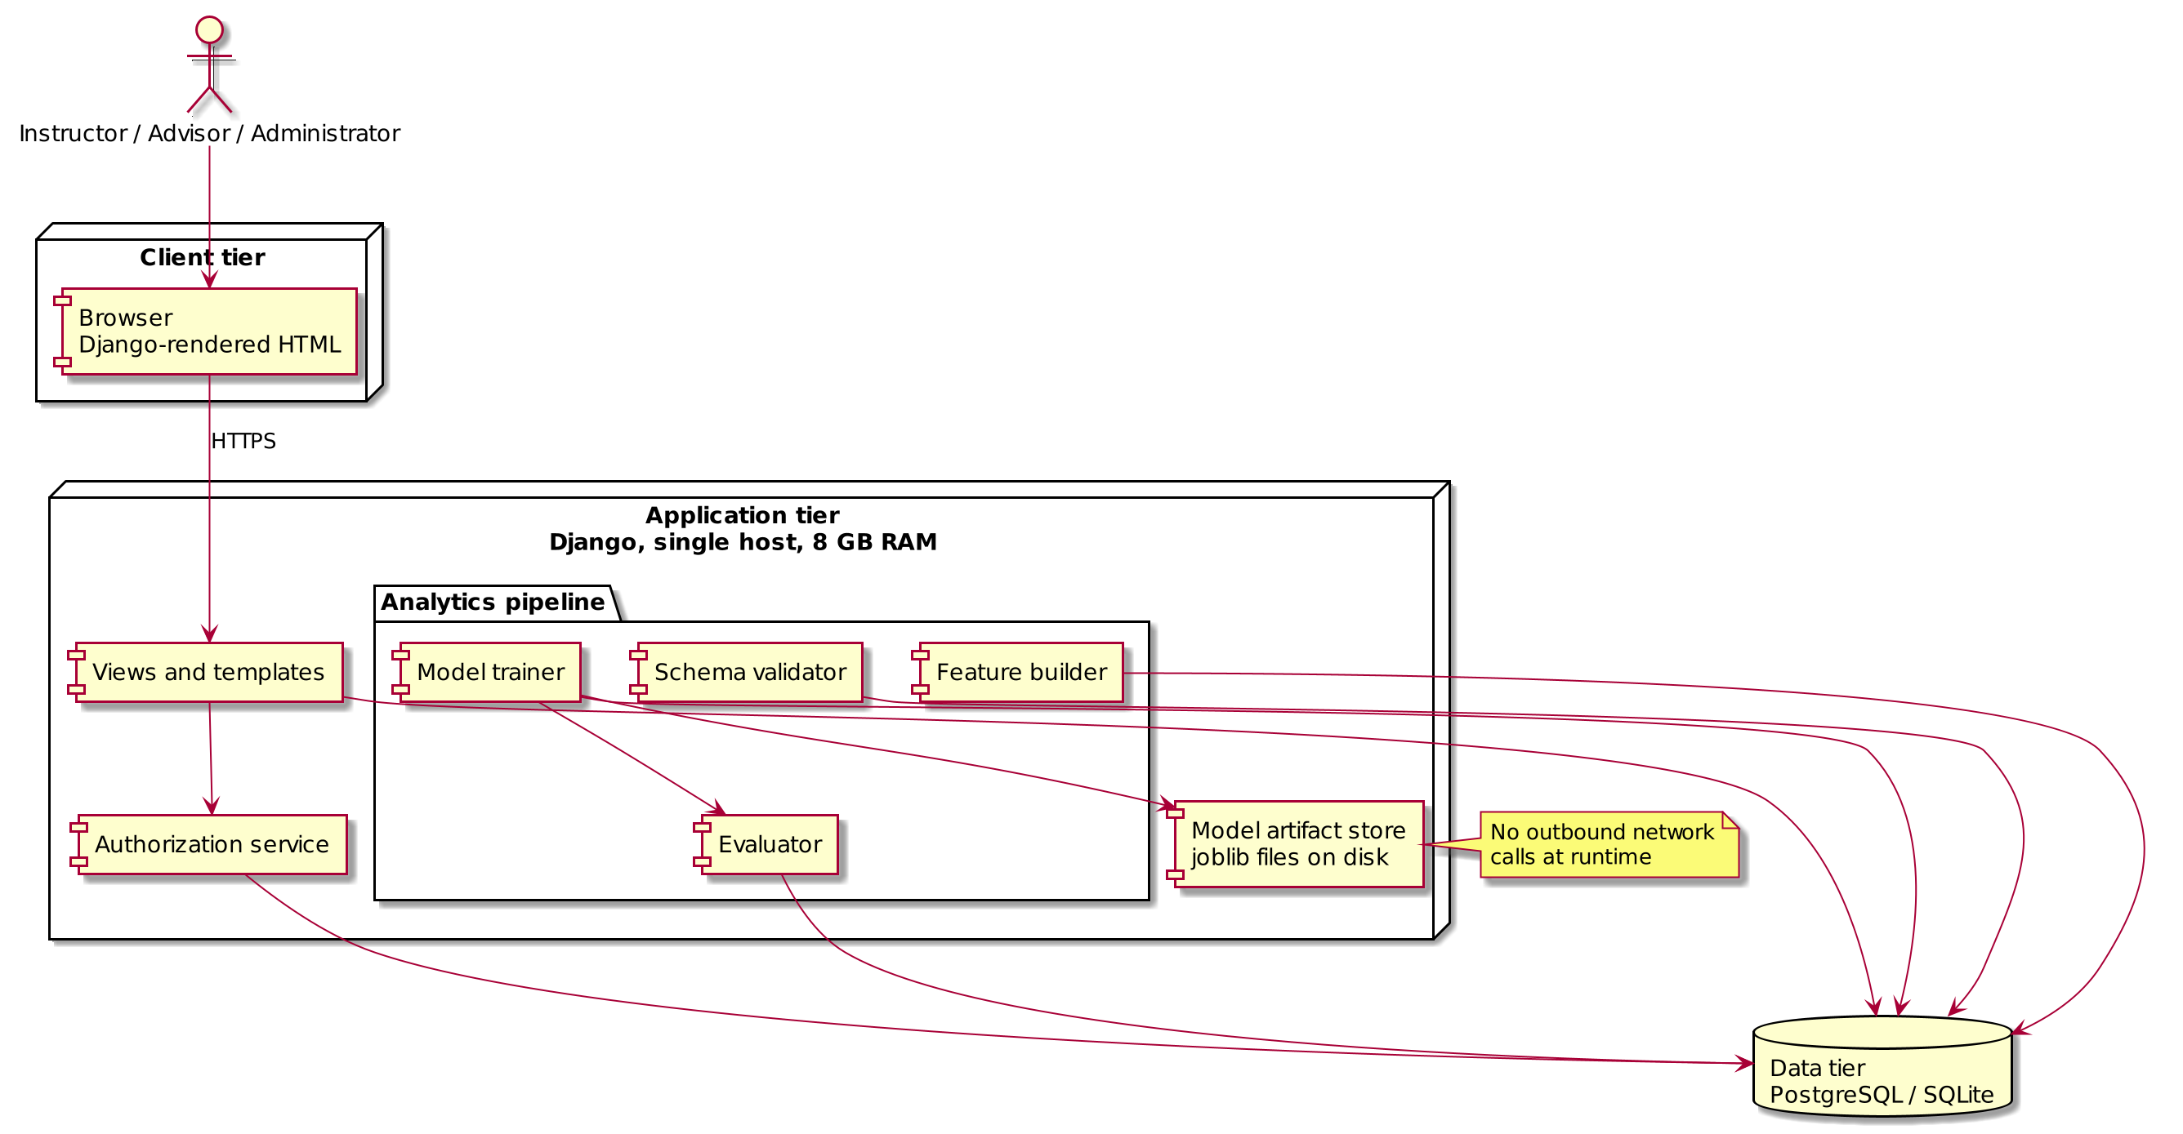

3.2.2 Product functions
Figure 2 shows the actors and their use cases.
- UC01 Authenticate a user and establish a session carrying their role.
- UC02 Set the presentation context for a session from the user’s assigned presentations.
- UC03 Display a cohort ranked by predicted withdrawal probability at a chosen horizon.
- UC04 Display one student’s score, contributing features, engagement history, and flag history.
- UC05 Flag a student for outreach.
- UC06 Record an intervention against an open flag.
- UC07 Record the outcome of an intervention and close the flag.
- UC08 Display cohort risk distribution and subgroup breakdown with small cells suppressed.
- UC09 Upload and validate a seven-file OULAD-format cohort.
- UC10 Rebuild weekly features from the current upload.
- UC11 Train a model for a horizon, evaluate it, and regenerate scores.
- UC12 Review and filter the audit log.

3.2.3 User characteristics
Instructors are academic staff. They know their subject and their cohort, and no technical skill is assumed; they need a ranked list they can read at a glance and an explanation of each score expressed as student behavior rather than model internals.
Advisors are student-support staff who act on the list. They contact students and record what they did, and they need the flag and intervention history.
Administrators are technical staff. They load cohort files, trigger feature rebuilds and model training, and read the audit log. Only this role is assumed to understand evaluation metrics.

3.2.4 Constraints
- Single-machine deployment with 8 GB of RAM (NFR-7), which rules out holding the full studentVle table in memory and forces chunked reads during feature construction.
- Python and Django are fixed technology choices; all database access goes through the Django ORM.
- The OULAD seven-file schema is the only supported input format.
- No outbound network calls at runtime: no hosted model API, no telemetry, no external lookup.
- The deployment must be reproducible from the environment description in the project synopsis.

3.2.5 Assumptions and dependencies
- Cohort data arrives as complete seven-file sets; partial and incremental uploads are not supported.
- Presentations follow the OULAD day-numbering convention with day 0 as the start date, so negative values indicate pre-start activity.
- Users are provisioned and assigned to presentations by an administrator; there is no self-registration.
- The id_student values in an upload are stable within a presentation.
- The reference machine matches the specification in the synopsis.
- Missing values in the OULAD source files are encoded as the literal string “?”, not as empty fields. The schema validator (UC09) and feature builder (UC10) map that string to missing; left alone it becomes an eleventh IMD category.
- An assessment that is unsubmitted after its due date is treated as a score of zero. Non-submission is evidence of disengagement and the weekly features (UC10) count it that way. Whether this penalizes students holding approved extensions is listed in Section 3.3.7.

3.3 Specific requirements

3.3.1 External interfaces
User interface. A browser interface rendered from Django templates with a responsive stylesheet and no client-side framework beyond the JavaScript needed for table sorting and form confirmation. Every page that displays student data shows the active presentation and horizon in a fixed header.
Hardware interfaces. None beyond the reference machine described in NFR-7.
Software interfaces. PostgreSQL in deployment and SQLite in development, both reached only through the Django ORM. Training uses scikit-learn, with fitted estimators serialized to disk by joblib. CSV parsing uses pandas with chunked reads.
Communication interfaces. HTTP on localhost in development; HTTPS with HSTS in any deployment. No outbound connections.

3.3.2 Functional requirements
The requirements are stated in Section 2.2 and are grouped here by feature.
Authentication and authorization (FR-1, FR-2, FR-3). The system establishes who a user is, which of the three roles they hold, and which presentations they may see, and it enforces that last restriction on every request. Hiding a link is not access control.
Risk presentation (FR-4, FR-5, FR-9, FR-10, FR-18). The system presents a scored cohort as a ranked list, as one student’s explained score, and as an aggregate distribution broken down by subgroup with small cells suppressed, and exports the ranking as CSV.
Intervention workflow (FR-6, FR-7, FR-8). The system records the three steps that follow a prediction: the decision to pursue a student, the contact made, and the result.
Data management (FR-11, FR-12, FR-13, FR-14). The system accepts a seven-file OULAD cohort, validates it against the expected schema and size limits before storing anything, and derives the weekly engagement and assessment features the models consume.
Model management (FR-15, FR-16). The system trains a classifier per horizon on demand and stores each trained version with the metrics it earned. Any score on screen traces back to the model version and the evaluation that produced it.
Audit (FR-17). The system writes an append-only record of every flag, intervention, upload, and retrain, with the acting user and a timestamp.

3.3.3 Performance requirements
NFR-1 requires that a ranking page load in under 3 seconds for a presentation of up to 2,000 students, so the ranking query reads pre-computed RiskScore rows and nothing is scored at request time. The 3-second figure follows the landing-page target in the SMASH reference report provided for this course. NFR-2 requires that a full feature rebuild finish within 10 minutes on the reference machine described in NFR-7, and it is the binding constraint on the only job that reads all ten million rows of studentVle. Ten minutes is a budget, not a measurement; the first full rebuild replaces it with an observed time.

3.3.4 Logical database requirements
Figure 3 shows the entities and relationships. A Presentation has many Students. A Student row is one registration. A person who takes two modules appears twice, sharing an id_student across both rows. A Student has many WeeklyFeatures rows, one per week of the presentation, carrying the derived engagement and assessment variables. A RiskScore links a Student to a ModelVersion with a probability and the top contributing features, and the pair is unique. A Flag links a Student to the User who raised it and carries a reason, a status, and a creation time; an Intervention belongs to a Flag and records type, date, and notes, and may have one InterventionOutcome. User is joined to Presentation by a many-to-many assignment table; FR-3 is enforced against that table. DataUpload and AuditEntry record administrative actions, the first with a filename, checksum, and row count per file, the second append-only with an action, a target, a user, and a timestamp.

3.3.5 Design constraints
NFR-7 fixes the deployment target at a single machine with 8 GB of RAM, which constrains the feature pipeline to chunked processing and rules out any in-memory join across the full clickstream. The build must also be reproducible from the environment description in the project synopsis: pinned dependencies, a fixed random seed on every train-test split, and a documented migration path for the schema. Any result reported in the final paper must be regenerable from a clean checkout and the same upload.

3.3.6 Software system attributes
Security. Passwords are stored as salted adaptive hashes (NFR-3). Authorization is enforced in a single service layer rather than per view, and no route can serve student data outside the caller’s assigned presentations (NFR-4). No name, email address, or other direct identifier is stored (NFR-6). A database disclosure therefore exposes pseudonymous behavior data and nothing that identifies a person.
Reliability. Audit entries are retained for the life of the deployment and are never updated or deleted (NFR-5). The pipeline is idempotent: a feature rebuild or a retrain rerun with the same input produces the same rows and supersedes the previous result. A failed or interrupted job is rerun.
Maintainability. The project is under version control from the first commit, with a commit per requirement group. The analytics pipeline sits in its own module with no Django imports, so the pipeline and the web layer change independently and the pipeline can be exercised without a running server. A pytest suite covers schema validation, feature construction against a small fixture cohort, the suppression rule in FR-10, and the authorization check in NFR-4.

3.3.7 Open issues
Questions the specification leaves unsettled. Each one changes either a number in Section 2 or a result in the evaluation. These are the questions as they stood at specification. Evidence gathered during the build, and the decisions it settled, are recorded in DECISIONS.md in the repository; items 2 and 5 now have measurements against them.
1. I have not settled where the n < 20 suppression threshold should come from, or whether it should scale with cohort size. A fixed floor suppresses most of the region breakdown on a 300-student presentation and almost nothing on a 2,000-student one.
2. Is week 4 a meaningful horizon? I expect this to be the weak point of the evaluation. OULAD registration dates run negative, and a student who registers on day 20 has one week of clickstream at the first horizon. Late registrants may need to be scored from their own registration date instead of the presentation start.
3. Should a flag closed as no response permit re-flagging at the next horizon with no cooldown? As specified it does. An advisor could re-flag the same unresponsive student three times in a term.
4. Does treating an unsubmitted assessment as zero bias the model against students with approved extensions? OULAD carries no extension field, so the two cases are indistinguishable in the data.
5. How is module CCC evaluated under the year-based split, given it has no 2013 presentation? See UC11.

3.3.8 Rejected alternatives
Authorization in one service layer.
Django’s documented pattern is a permission decorator on each view, and it reads well: the rule sits next to the code it protects. The problem is what happens when a view is added without one. Nothing fails. The page renders, the query runs, and student data from a presentation the caller is not assigned to comes back with no error anywhere. Twelve use cases touch student data in this specification and the number will grow, so the odds of one route going undecorated over the life of the project are not small. A single authorization check that every data query passes through inverts that: forgetting it means the query does not run at all. That is the property I want, and it is why the decorator pattern was rejected even though it is the one the framework recommends.
One machine, no worker process.
A Celery worker with a message broker would keep the web tier responsive during a ten-minute rebuild. It also doubles the environment the synopsis has to describe, for a job that runs a handful of times per term on a machine NFR-7 fixes at 8 GB.
Year-based train/test split.
The alternative was a stratified random split across all 22 presentations, which gives every module training data and a smoother class balance. It was rejected because it lets a presentation contribute rows to both sides, so the test metrics measure how well the model memorized that presentation and not how it performs on a cohort it has never seen. The cost is module CCC, addressed in UC11.

4. Use cases
Each use case gives ID and name, actor, preconditions, postconditions, related requirements, main flow, alternate flows, and exception flows. An alternate flow is the actor taking a different valid path. An exception flow is the system handling a failure.

UC01: Authenticate
Actor: All users
Preconditions: The user account exists and is not locked.
Postconditions: A session is established carrying the user’s role, and the login is written to the audit log (FR-17).
Related requirements: FR-1, FR-2, FR-17, NFR-3
Main flow
- User requests a protected page; system redirects to the login form.
- System displays fields for username and password.
- User submits credentials.
- System hashes the submitted password with the stored salt and compares the result to the stored hash.
- System resets the failed-attempt counter, creates a session carrying the user’s role, and writes an audit entry recording the login with the username and timestamp.
- System redirects the user to the page originally requested, or to the presentation selector if there was none.
Alternate flow: user requests a password reset
3a. User selects “I can’t sign in.”
3b. System displays the instruction to contact an administrator and does not disclose whether the username exists, since there is no self-service reset.
3c. Administrator sets a new password out of band; the reset appears in the audit log (UC12) and the user resumes at step 3.
Alternate flow: session already active
1a. A valid, unexpired session cookie is present.
1b. System skips the login form and serves the requested page.
Exception flow: credentials rejected
4a. The username exists but the hash comparison fails.
4b. System increments the failed-attempt counter for that account, writes an audit entry with action login_failed, and redisplays the form with the message “Username or password not recognized.” No session is created and the password field is cleared.
4c. The submitted username matches no account.
4d. System writes an audit entry with action login_failed and redisplays the form with the same message used in 4b. The response must not reveal which usernames exist. No counter is incremented, because there is no account to lock.
Exception flow: account locked after five failures
4e. The failed-attempt counter for the account has reached five.
4f. System sets is_locked, refuses the login whether or not the password was correct, writes an audit entry with action login_locked, and displays “This account is locked. Contact an administrator.” The account stays locked until an administrator clears it. Five is a convention borrowed from common institutional password policies; nothing in this project tested it.

UC02: Select presentation
Actor: Instructor, Advisor
Preconditions: Authenticated. At least one presentation assigned.
Postconditions: The presentation context is set for the session.
Related requirements: FR-3
Main flow
- User opens the presentation selector.
- System queries the assignment table and lists only the presentations assigned to this user, each with module code, presentation code, start date, and enrolled count.
- User selects a presentation.
- System stores the presentation identifier in the session and opens the risk ranking for the default horizon (UC03).
Alternate flow: switch presentation mid-session
1a. User opens the selector from the header while a presentation is already active.
1b. System lists the assigned presentations with the current one marked.
1c. User selects a different one; system replaces the session context and clears any sort or filter state carried over from the previous presentation.
Alternate flow: single assignment
2a. Exactly one presentation is assigned to this user.
2b. System sets it as the context without displaying the selector.
Exception flow: no presentations assigned
2c. The assignment query returns no rows.
2d. System displays “No presentations are assigned to your account. An administrator can assign one.” No cohort data is served and the session carries no presentation context.
Exception flow: presentation has no scored students
3a. The selected presentation has students but no RiskScore rows at any horizon.
3b. System sets the context and displays the current week of the presentation together with the next horizon at which scores will exist, for example “This presentation is in week 2. Scores are generated at week 4.” The cohort dashboard (UC08) stays available, since its enrollment counts do not depend on scores.

UC03: View risk ranking
Actor: Instructor, Advisor
Preconditions: A presentation is selected.
Postconditions: None; read-only.
Related requirements: FR-4, FR-3, FR-18, NFR-1, NFR-4
Main flow
- User opens the ranking for the active presentation.
- System asks the authorization service whether the presentation is assigned to this user, as shown in Figure 4.
- System reads the most recent ModelVersion for the default horizon of week 8 and retrieves the stored RiskScore rows for that version.
- System displays the students in descending order of probability (the default sort), one row each, showing pseudonymous id, probability, risk band, the top contributing feature, and any open flag.
- System paginates at 50 rows, which holds a 2,000-student presentation (the NFR-1 ceiling) to 40 pages, and displays the horizon, the model version date, and that version’s AUC-PR above the table.
- User reads the ranking, or opens a student row to see the detail view (UC04).
Alternate flow: change horizon
3a. User selects week 4, week 8, or week 12 from the horizon control.
3b. System reads the latest ModelVersion for the chosen horizon and returns to step 4 with those scores, updating the header so the displayed horizon is unambiguous.
Alternate flow: change sort column
4a. User sorts by risk band, by the top contributing feature, or by flag status.
4b. System reorders the rows already retrieved and redisplays without querying scores again. That is what keeps the page inside the 3-second budget in NFR-1.
Alternate flow: export to CSV
4c. User selects “Export CSV” (FR-18).
4d. System returns the currently displayed ordering as a CSV attachment containing pseudonymous id, probability, risk band, and the top three features, and writes an audit entry recording the export.
Exception flow: no model trained for this horizon
3c. No ModelVersion exists for the selected horizon.
3d. System displays “No model has been trained for week N,” lists the horizons that do have models, and offers a link to UC11 for administrators or an instruction to contact one for other roles. Any previously displayed ranking stays on screen.
Exception flow: permission denied
2a. The presentation is not assigned to the caller.
2b. System returns HTTP 403 with the message “You do not have access to this presentation,” serves no student rows, and writes an audit entry with action denied and the target presentation identifier. This is the branch on the right of Figure 4.

UC04: View student detail
Actor: Instructor, Advisor
Preconditions: A ranking is displayed.
Postconditions: None; read-only.
Related requirements: FR-4, FR-5, NFR-4, NFR-6
Main flow
- User selects a student row from the ranking.
- System confirms the student belongs to a presentation assigned to the caller.
- System retrieves the current RiskScore and its top_features JSON, the student’s WeeklyFeatures history, and every Flag and Intervention on record.
- System displays the probability and risk band, then the three largest contributing features with their values and the direction of their effect, expressed as behavior (“no VLE activity for 11 days”).
- System displays the weekly engagement history as clicks and active days per week, and the assessment history as submissions with scores.
- System displays the flag history and, beneath it, the intervention history, each entry with its date and the advisor who created it.
- System displays the flag control if the user is an advisor and the flag rules in UC05 permit a new flag.
Alternate flow: navigate within the cohort
4a. User selects “next student.”
4b. System advances to the next row in the current ranking order and returns to step 3.
Exception flow: student outside the caller’s presentations
2a. The authorization check fails.
2b. System returns HTTP 403 with the same message used in UC03, serves no student data, and writes an audit entry.
Exception flow: no engagement data yet
3a. The student has a registration but no WeeklyFeatures rows, the normal state in week 1 of a presentation and also the state of a late registration.
3b. System displays the demographic and registration fields, states “No engagement data recorded yet,” and shows no probability. It does not display a score computed from missing values, because a student with no data is not the same as a student with no activity.

UC05: Flag student for outreach
Actor: Student support advisor
Preconditions: Advisor is authenticated (UC01). Advisor has selected an assigned presentation (UC02). A risk ranking exists for the current horizon (UC03).
Postconditions: An open flag record exists for the student, linked to the advisor, with a timestamp. The action is written to the audit log.
Related requirements: FR-6, FR-17, NFR-4
Main flow
- Advisor opens a student’s detail view from the ranking.
- System displays the student’s risk score, top three contributing features, and any existing flags.
- Advisor selects “Flag for outreach.”
- System prompts for an optional reason.
- Advisor enters a reason and confirms.
- System creates the flag, records the audit entry, and returns to the detail view showing the flag as open.
Alternate flow: advisor cancels
5a. Advisor dismisses the prompt without confirming.
5b. System discards the input and returns to the detail view unchanged.
Exception flow: student already flagged
3a. System detects an open flag for this student.
3b. System displays the existing flag with its date and owner and offers “Add note to existing flag” instead of creating a second.
3c. If the most recent flag is closed, the check depends on how it closed: a flag closed as no response (UC07) permits a new flag without warning, while a flag closed as student re-engaged suppresses the control for the rest of the presentation and displays the closure date in its place.
Exception flow: student has withdrawn
2a. System detects a non-null unregistration date.
2b. System displays the withdrawal date, disables the flag control, and shows “Student withdrew on day N; outreach not available.”
Exception flow: permission
1a. Student is not in a presentation assigned to the advisor.
1b. System returns 403 and writes an audit entry recording the denied attempt.

UC06: Record intervention
Actor: Advisor
Preconditions: An open flag exists for the student.
Postconditions: An Intervention record exists, linked to the flag and to the advisor; the audit entry is written.
Related requirements: FR-7, FR-17, NFR-4
Main flow
- Advisor opens the student detail view showing an open flag.
- Advisor selects “Record intervention.”
- System displays the intervention form with a type list of email, phone call, meeting, and referral, a date defaulting to today, and a notes field.
- Advisor selects a type, confirms or changes the date, enters notes, and submits.
- System validates that a type was selected, that the date is not later than today, and that the date is not earlier than the flag’s creation date.
- System creates the Intervention linked to the flag, writes an audit entry with the advisor and timestamp, and redisplays the detail view with the intervention shown in the flag’s history.
Alternate flow: second intervention on the same flag
1a. The flag already carries one or more interventions and no outcome.
1b. Advisor repeats steps 2 to 6; the system appends. A flag often involves several contacts before an outcome is known.
Alternate flow: advisor cancels
4a. Advisor leaves the form without submitting.
4b. System discards the input. No record is created and no audit entry is written.
Exception flow: no open flag
2a. The flag was closed by an outcome, or none was ever created.
2b. System does not render the “Record intervention” control and displays the flag control instead (UC05), directing the advisor to the step that has to come first.
Exception flow: intervention type not selected
5a. The form is submitted with no type chosen.
5b. System rejects the submission, redisplays the form with the date and notes preserved, and marks the type field with “Select an intervention type.” No record is created.
Exception flow: date in the future
5c. The submitted date is later than the server’s current date.
5d. System rejects the submission, redisplays the form with the entered values preserved, and shows “An intervention cannot be dated in the future.”
Exception flow: date precedes the flag
5e. The submitted date is earlier than the flag’s creation date.
5f. System rejects the submission and displays the flag’s date as the earliest permitted value.

UC07: Record outcome
Actor: Advisor
Preconditions: An Intervention record exists on an open flag.
Postconditions: An InterventionOutcome is linked to the intervention; the flag is closed; the audit entry is written.
Related requirements: FR-8, FR-17
Main flow
- Advisor opens a student detail view showing an open flag with at least one intervention and no outcome.
- Advisor selects “Record outcome” on the most recent intervention.
- System displays the outcome options: student re-engaged, student responded and withdrew, no response, referred elsewhere.
- Advisor selects an outcome and submits.
- System creates the InterventionOutcome, sets the flag status to closed, writes an audit entry, and redisplays the detail view with the flag shown as closed and its full history intact.
Alternate flow: outcome recorded as “no response”
4a. Advisor selects “no response.”
4b. System closes the flag with status closed_no_response and leaves the student eligible for a new flag at the next horizon without the duplicate-flag warning from UC05. A flag closed as “student re-engaged” suppresses that warning for the rest of the presentation instead, so the two closures produce different behavior downstream.
Alternate flow: advisor cancels
4c. Advisor leaves the form without submitting.
4d. System discards the input and the flag remains open.
Exception flow: no intervention on record
2a. The flag is open but carries no intervention.
2b. System does not render the outcome control and displays “Record an intervention before recording an outcome,” with the control from UC06 in its place.
Exception flow: outcome already recorded
2c. The selected intervention already has an outcome.
2d. System displays the recorded outcome with its date and offers no edit control. A correction is made by recording a new intervention and its outcome, so the history stays append-only.

UC08: View cohort dashboard
Actor: Instructor, Advisor
Preconditions: A presentation is selected and scores exist.
Postconditions: None; read-only.
Related requirements: FR-9, FR-10, NFR-4
Main flow
- User opens the cohort dashboard for the active presentation.
- System confirms the presentation is assigned to the caller.
- System retrieves every RiskScore for the latest model version at the current horizon.
- System displays the distribution of predicted probability as a histogram, the count of students in each risk band, and the counts of open and closed flags.
- System displays a subgroup breakdown for the default dimension, IMD band, giving the count and the mean predicted probability at each level.
- Before rendering any subgroup row, system applies FR-10 and checks the count at that level against the threshold of 20.
Alternate flow: select a different subgroup dimension
5a. User selects gender, age band, disability, highest education, or number of previous attempts.
5b. System recomputes the breakdown for that dimension and returns to step 6.
Alternate flow: change horizon
3a. User selects a different horizon.
3b. System retrieves that horizon’s scores and returns to step 4.
Exception flow: subgroup below the suppression threshold
6a. One or more levels hold fewer than 20 students.
6b. Under FR-10, system displays the level’s name with “suppressed (n < 20)” in place of both figures, and a footnote stating the threshold. The level is named so the reader sees it exists without seeing statistics computed on a handful of students. Twenty is a common small-cell floor in institutional reporting; the value is a convention and is revisited in Section 3.3.7.
Exception flow: every level suppressed
6c. All levels of the selected dimension fall under 20, which happens on small presentations for a high-cardinality dimension such as region.
6d. System suppresses the whole table and displays “This presentation is too small to break down by region.” The distribution from step 4 is still shown.
Exception flow: fewer than ten students in the presentation
3c. The presentation has fewer than 10 scored students.
3d. System declines to render both the distribution and the breakdown, displaying only the enrollment count and “This cohort is too small for aggregate reporting.”

UC09: Upload cohort data
Actor: Administrator
Preconditions: Authenticated as administrator.
Postconditions: Seven files are stored with checksums; one DataUpload record exists per file; the audit entry is written.
Related requirements: FR-11, FR-12, FR-13, FR-17
Main flow
- Administrator opens the upload page.
- System lists the seven expected files: courses, assessments, vle, studentInfo, studentRegistration, studentAssessment, studentVle.
- Administrator selects all seven and submits.
- System checks that all seven names are present and that no file exceeds 500 MB (FR-13).
- System reads the header row of each file and compares column names and order against the expected schema (FR-12).
- System computes a SHA-256 checksum and a row count for each file.
- System stores the files only after every check in steps 4 to 6 has passed, creates a DataUpload record per file, writes an audit entry, and displays a summary with the row count per file for the administrator to check against the source. The upload, rebuild, and retrain sequence appears in Figure 5.
Alternate flow: replace the previous upload
3a. A non-superseded upload already exists for the same presentations.
3b. System warns that continuing will supersede it and that features and scores derived from it will become stale.
3c. Administrator confirms; system marks the earlier DataUpload rows superseded rather than deleting them, and proceeds from step 4.
Exception flow: file missing from the set
4a. Fewer than seven files were submitted, or a required name is absent.
4b. System rejects the whole upload, names the missing files, and writes an audit entry with action upload_rejected. Nothing is stored, and any previous upload remains the current one.
Exception flow: schema validation failure
5a. A file has an unexpected column name, a missing column, or columns in a different order.
5b. System rejects the upload and names the specific column at fault, for example “studentVle: expected column sum_click at position 6, found clicks,” alongside the expected header and the header found. Nothing is stored.
Exception flow: file exceeds 500 MB
4c. Any single file is larger than 500 MB. The limit is set from the data: studentVle.csv, the largest of the seven, is roughly 430 MB uncompressed, so 500 MB admits it with headroom and rejects anything unexpected. An earlier draft set the limit at 200 MB, which would have rejected the core data file on every upload.
4d. System rejects the upload before reading the file, names the file and its size against the limit, and writes an audit entry. Nothing is stored.
Exception flow: caller is not an administrator
1a. The caller’s role is instructor or advisor.
1b. System returns HTTP 403 and writes an audit entry.

UC10: Rebuild features
Actor: Administrator
Preconditions: A complete, non-superseded upload exists.
Postconditions: WeeklyFeatures rows exist for every student with recorded VLE activity, for every week from that student's first recorded week to the end of the presentation, and the row count written is recorded in the audit entry and displayed to the administrator. A student with no activity at all has no rows, which is the state UC04 reports as no engagement data recorded yet.
Related requirements: FR-14, FR-17, NFR-2, NFR-7
Main flow
- Administrator opens the data management page and selects “Rebuild features.”
- System confirms a complete, non-superseded upload exists and that no rebuild is already running.
- System takes a job lock and begins reading studentVle in chunks sized to the memory limit in NFR-7, displaying progress as the chunk number, the rows processed so far, and the elapsed time.
- System aggregates each chunk to per-student, per-week totals: total clicks, active days, clicks per active day, and days since last activity.
- System joins studentAssessment to assessments to add submissions and mean score per week, treating an assessment unsubmitted past its due date as a zero.
- System writes the WeeklyFeatures rows, replacing any rows from a previous rebuild for the same presentation.
- System releases the lock, writes an audit entry with the row count and elapsed time, and displays both.
Alternate flow: rebuild a single presentation
1a. Administrator selects a single presentation.
1b. System restricts every read in steps 3 to 6 to that presentation and leaves other presentations’ features untouched.
Where this can fail. The chunk size in step 3 is the number that matters. studentVle has 10,655,280 rows; a pandas frame of one million rows costs several hundred megabytes once indexed, so chunks of 500,000 rows are the starting point on an 8 GB machine and the first full run will show whether they hold. The per-week aggregation also needs every row for a given student to land in the same week bucket, which means either sorting the file first or accumulating partial sums across chunks and merging at the end. The second is chosen; sorting a 430 MB file on this machine costs more than the aggregation itself.
Exception flow: no complete upload
2a. The most recent upload is missing a file or has been superseded.
2b. System refuses to start, names which of the two conditions applies, and links to UC09. No lock is taken.
Exception flow: job already running
2c. The job lock is held.
2d. System displays the running job’s start time and current progress and does not queue a second run.

UC11: Retrain model
Actor: Administrator
Preconditions: WeeklyFeatures exist and are no older than the current upload.
Postconditions: A new ModelVersion exists with its stored metrics; RiskScores for that horizon are regenerated; the audit entry is written.
Related requirements: FR-15, FR-16, FR-10, FR-17
Main flow
- Administrator opens the model management page and selects “Retrain.”
- System displays the configurable options: horizon of week 4, 8, or 12; feature set; and classifier.
- Administrator accepts the defaults or changes them and submits.
- System builds the training cohort, excluding students whose date_unregistration falls on or before the horizon week, since a student who has already withdrawn is not a prediction target.
- System splits by presentation year, holding out the most recent year as the test set. No student contributes to both sides, and the model is always evaluated on a cohort it has not seen.
- System fits the classifier and evaluates it on the held-out presentations, computing AUC-ROC, AUC-PR, and Brier score overall and again for each subgroup above the threshold in FR-10, and the false negative rate of each such subgroup at the advisory capacity threshold. One threshold is computed across the whole test set and shared by every subgroup; a threshold computed per subgroup would give each group its own bar and make the rates incomparable.
- System creates the ModelVersion row holding horizon, feature set, classifier, training timestamp, and every metric from step 6, and serializes the fitted estimator to disk.
- System scores every current student at that horizon, writes RiskScore rows with probability and the top three contributing features, writes an audit entry, and displays the metrics beside the previous version’s for comparison. The full sequence appears in Figure 5.
Alternate flow: different feature set or classifier
3a. Administrator selects an alternative feature set, such as engagement-only, or an alternative classifier.
3b. System proceeds from step 4 with that configuration. The new ModelVersion records both, and the previous version remains available for comparison.
Alternate flow: train all horizons
3c. Administrator selects “all horizons.”
3d. System repeats steps 4 to 8 for weeks 4, 8, and 12 in sequence, creating one ModelVersion per horizon.
Where this can fail. The year-based split assumes every module has a presentation in both years. Per the courses table, module CCC runs only in 2014B and 2014J, so under a strict split it has no training data and is evaluated by a model that has never seen it. The options are to drop CCC from the evaluation, to report it separately as a transfer case, or to fall back to a presentation-level split for that module alone. The first is the default; the choice is recorded in Section 3.3.7 because it changes the headline numbers.
Exception flow: features older than the current upload
4a. The most recent WeeklyFeatures rows predate the most recent non-superseded DataUpload.
4b. System refuses to train, displays both timestamps, and links to UC10. No ModelVersion is created.
Exception flow: too few training rows
4c. After the exclusion in step 4, the training cohort holds fewer than 500 students or fewer than 50 withdrawals.
4d. System refuses to train and reports both counts against both minimums, since a model fitted on that little data would return metrics no one should act on. Both floors are chosen so a 20-student subgroup can exist inside the test split; neither comes from a power calculation.
Exception flow: subgroup below threshold in evaluation
6a. A subgroup in the test set holds fewer than 20 students.
6b. The subgroup name is recorded with a suppressed metric. Omitting the row would hide the fact that the fairness evaluation has a hole in it.
Exception flow: training fails
6c. The fit raises an error, or evaluation returns a degenerate result such as a single predicted class.
6d. System writes no ModelVersion, leaves the existing scores untouched, and writes an audit entry with the error and the configuration that produced it.

UC12: Review audit log
Actor: Administrator
Preconditions: Authenticated as administrator.
Postconditions: None; read-only.
Related requirements: FR-17, NFR-5
Main flow
- Administrator opens the audit log.
- System retrieves entries from the last 30 days in reverse chronological order; thirty days spans the interval between two horizons, so the default view covers everything since the last retrain.
- System displays timestamp, user, role, action, and target for each entry, paginated at 100 rows.
- Administrator reads the entries.
Alternate flow: filter by user, action, or date range
2a. Administrator sets a filter on username, action type, or a start and end date.
2b. System applies the filter, returns to step 3, and shows the active filter and the matched row count above the table.
Exception flow: filter yields nothing or is invalid
2c. No entries match the filter.
2d. System displays the active filter and “No entries match this filter.” The filter controls stay populated so they can be adjusted.
2e. The end date precedes the start date, or a date cannot be parsed.
2f. System rejects the filter, keeps the previous result set displayed, and shows the expected format, YYYY-MM-DD.
Exception flow: caller is not an administrator
1a. The caller’s role is instructor or advisor.
1b. As in UC09: HTTP 403 and an audit entry, which is itself visible in this log.

5. UML diagrams

Figure 2
Use Case Diagram
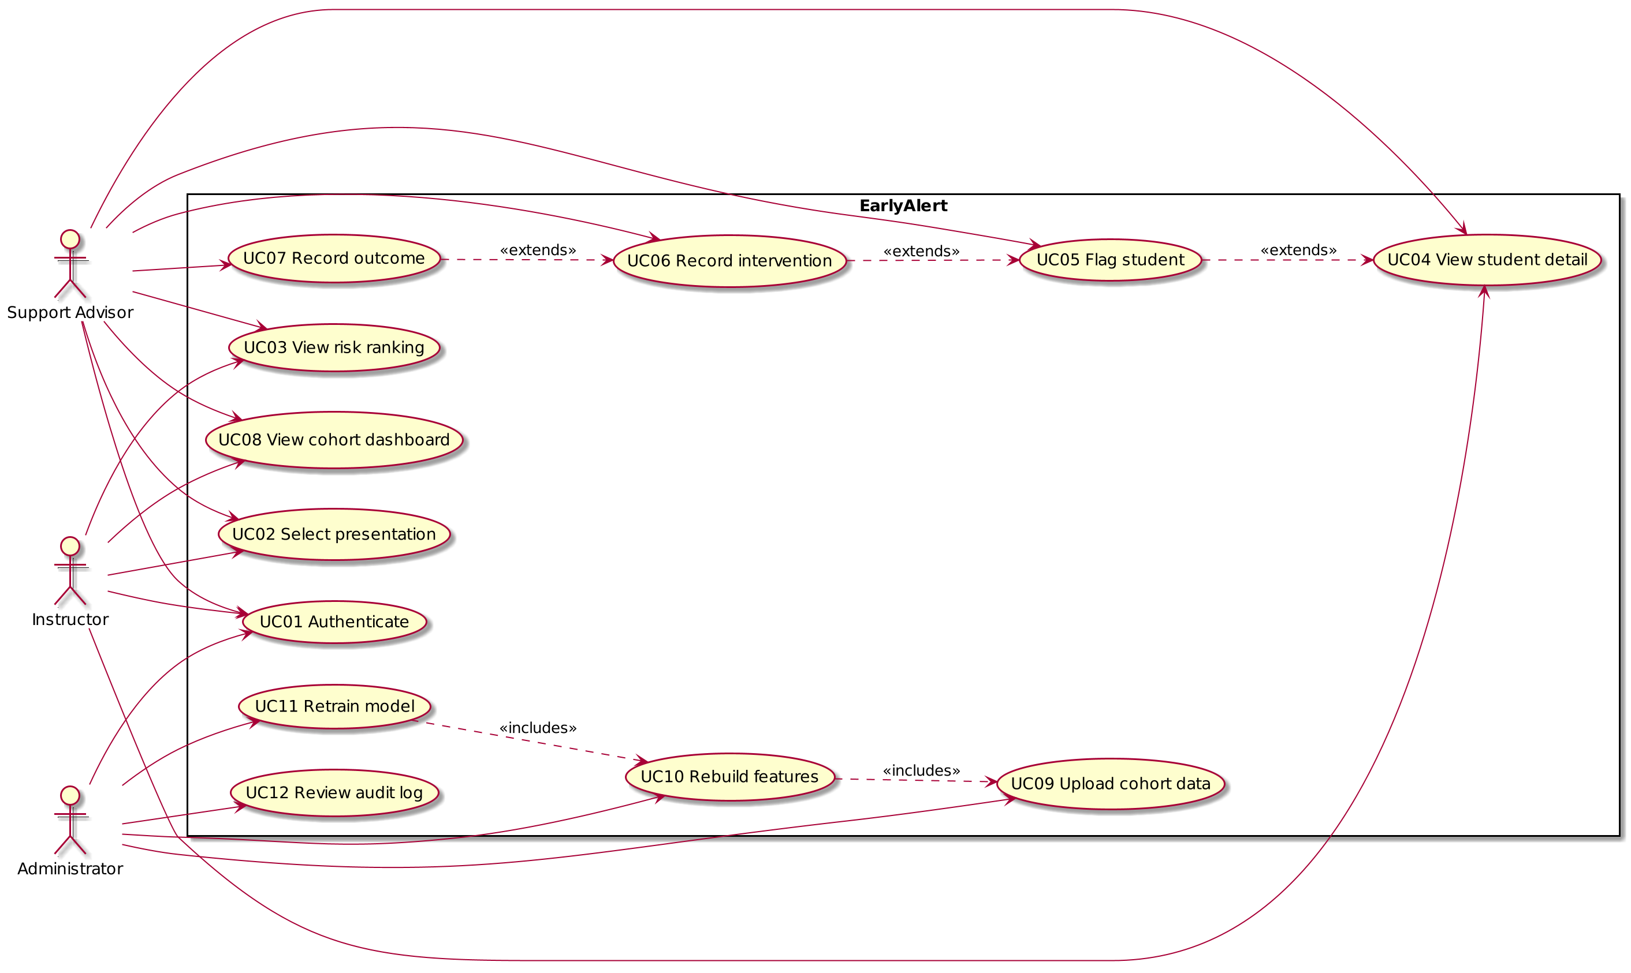

Figure 3
Class Diagram
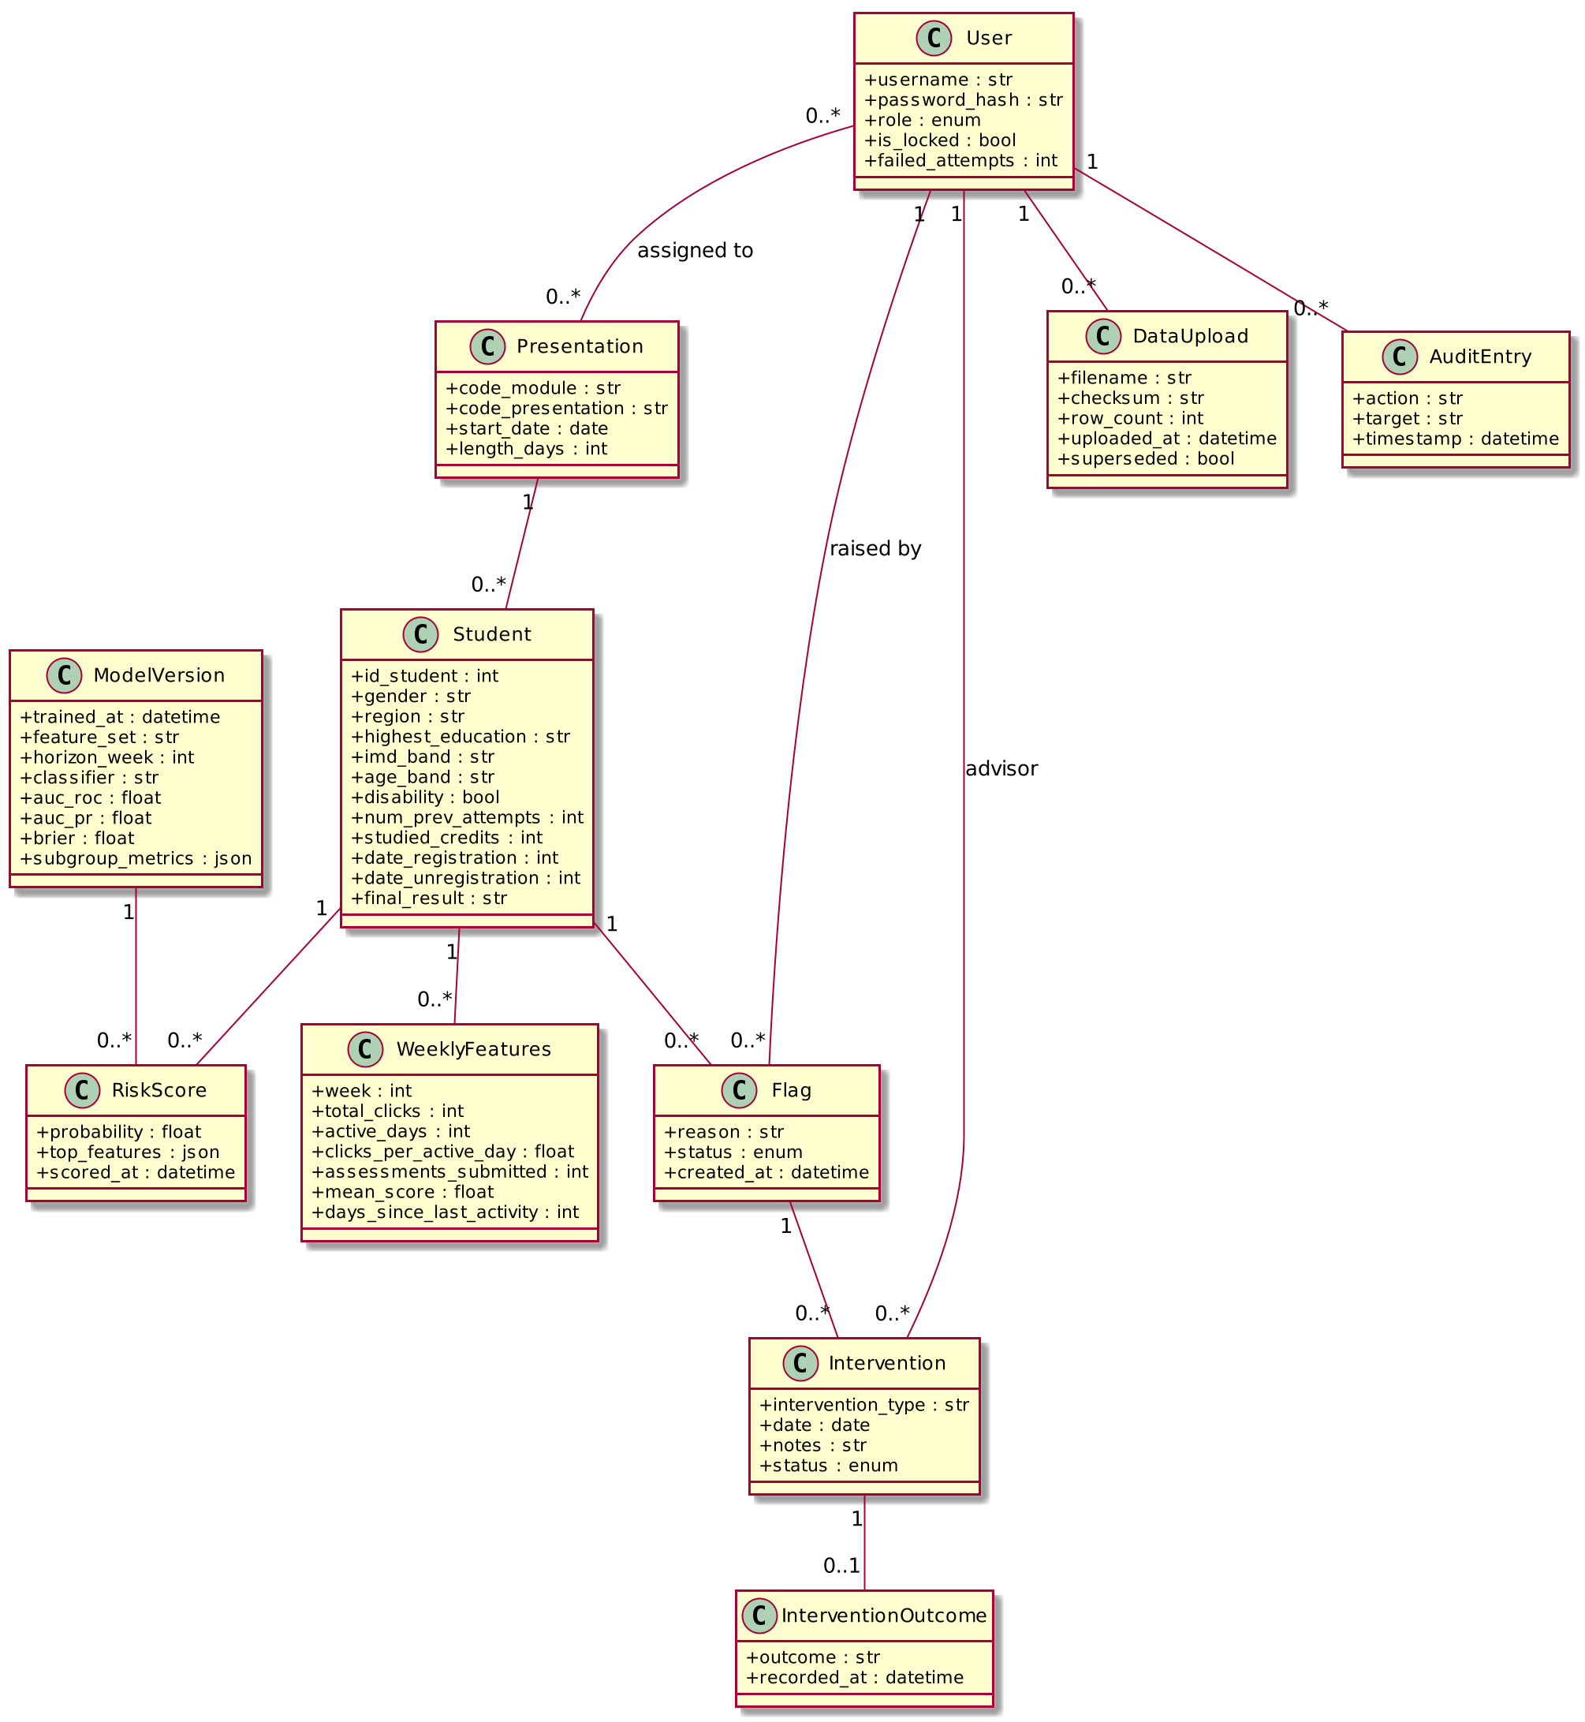

Figure 4
Sequence Diagram for UC03
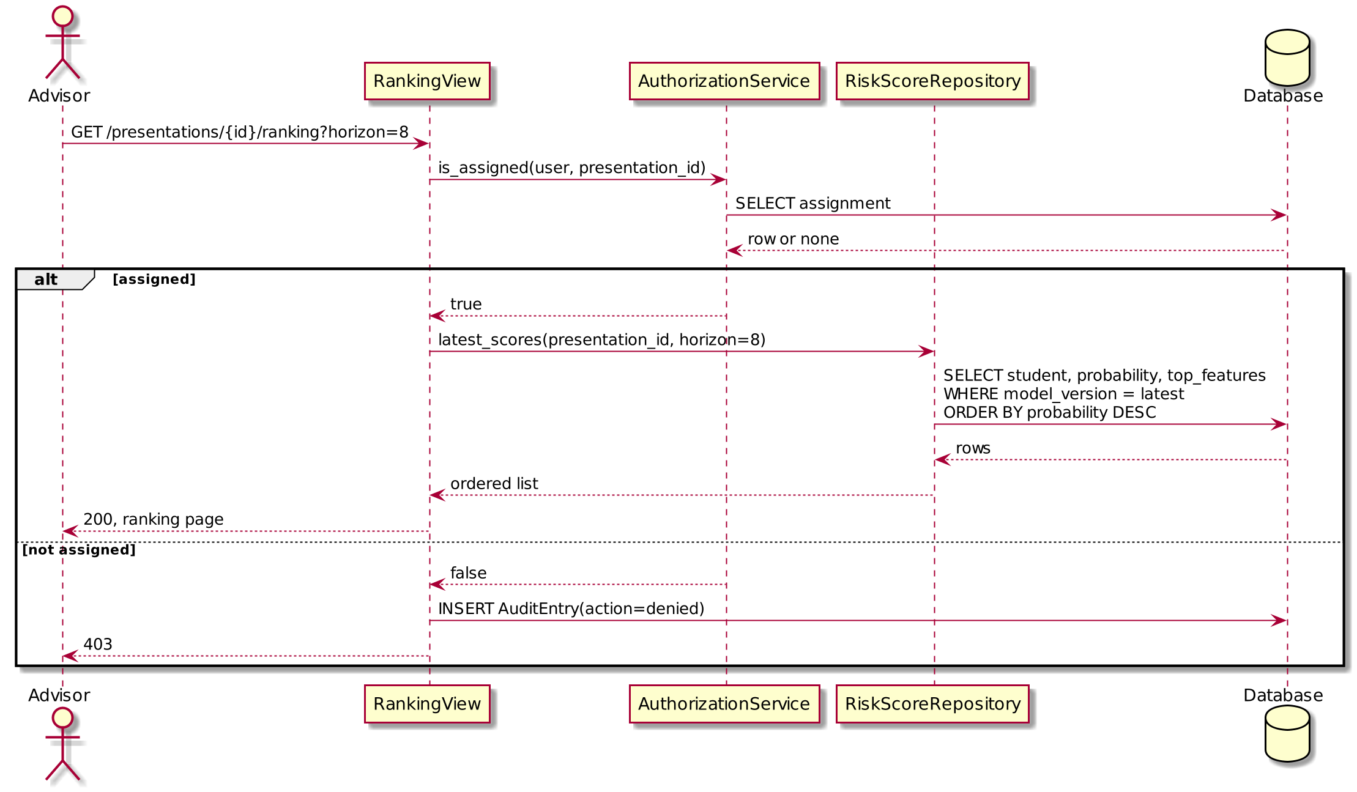

Figure 5
Sequence Diagram for UC09 to UC11
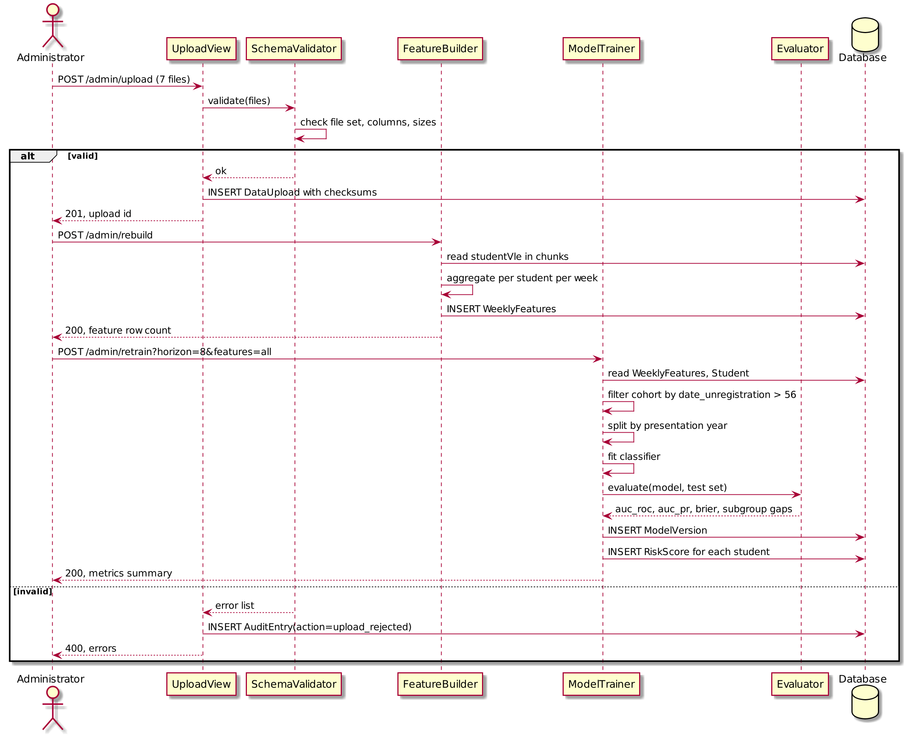

References
Arnold, K. E., & Pistilli, M. D. (2012). Course Signals at Purdue: Using learning analytics to increase student success. In Proceedings of the 2nd International Conference on Learning Analytics and Knowledge (pp. 267–270). ACM. https://doi.org/10.1145/2330601.2330666
Caulfield, M. (2013, November 12). Purdue Course Signals data issue explainer. e-Literate. https://eliterate.us/purdue-course-signals-data-issue-explainer/
Django Software Foundation. (n.d.). Django documentation (Version 5.x). https://docs.djangoproject.com/
Kuzilek, J., Hlosta, M., & Zdrahal, Z. (2017). Open University Learning Analytics dataset. Scientific Data, 4, Article 170171. https://doi.org/10.1038/sdata.2017.171
New York University. (n.d.). Sample software requirements specification [Course handout]. https://www.nyu.edu/classes/jcf/g22.2440-001_sp07/handouts/Assignment1SampleSolution.pdf
Wolff, A., Zdrahal, Z., Nikolov, A., & Pantucek, M. (2013). Improving retention: Predicting at-risk students by analysing clicking behaviour in a virtual learning environment. In Proceedings of the 3rd International Conference on Learning Analytics and Knowledge (pp. 145–149). ACM. https://doi.org/10.1145/2460296.2460324

Appendix A: Requirements traceability
Requirement | Use cases
FR-1 | UC01
FR-2 | UC01
FR-3 | UC02, UC03
FR-4 | UC03, UC04
FR-5 | UC04
FR-6 | UC05
FR-7 | UC06
FR-8 | UC07
FR-9 | UC08
FR-10 | UC08, UC11
FR-11 | UC09
FR-12 | UC09
FR-13 | UC09
FR-14 | UC10
FR-15 | UC11
FR-16 | UC11
FR-17 | UC01, UC05, UC06, UC07, UC09, UC10, UC11, UC12
FR-18 | UC03
NFR-1 | UC03
NFR-2 | UC10
NFR-3 | UC01
NFR-4 | UC03, UC04, UC05, UC06, UC08
NFR-5 | UC12
NFR-6 | UC04
NFR-7 | UC10

