Unity的渲染管线图

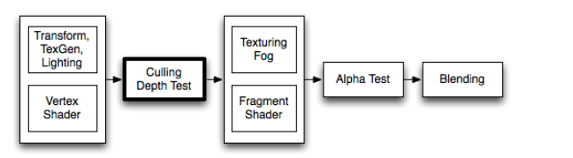

1. Legacy Lighting (Materail Block)

The material and lighting parameters are used to control the built-in vertex lighting. Lighting on turns it on. Lighting is affected by Material block, ColorMaterial and SeparateSpecular commands. Material/Lighting commands have no effect when [vertex programs](http://docs.unity3d.com/Manual/SL-ShaderPrograms.html) are used; as in that case all calculations are completely described in the shader.

link：<http://docs.unity3d.com/Manual/SL-Material.html>

1. The full color of lights hitting the object is:

Ambient * Lighting Window’s Ambient Intensity setting + (Light Color * Diffuse + Light Color * Specular) + Emission

1. Culling And Depth Test

Culling is an optimization that does not render polygons facing away from the viewer. All polygons have a front and a back side. Culling makes use of the fact that most objects are closed; if you have a cube, you will never see the sides facing away from you (there is always a side facing you in front of it) so we don’t need to draw the sides facing away. Hence the term: Backface culling.

The other feature that makes rendering looks correct is Depth testing. Depth testing makes sure that only the closest surfaces objects are drawn in a scene.

1. Texturing

After the basic vertex lighting has been calculated, textures are applied. In ShaderLab this is done using SetTexture command.

Note: SetTexture commands have no effect when fragment programs are used; as in that case pixel operations are completely described in the shader. It is advisable to use programmable shaders these days instead of SetTexture commands.

Fixed function texturing is the place to do old-style combiner effects. You can have multiple SetTexture commands inside a pass - all textures are applied in sequence, like layers in a painting program. SetTexture commands must be placed at the end of a Pass.

1. Alpha Test
2. Alpha Blending
3. sdfsdf