Agile Scrum in Practice

Agile Scrum Learning Outcomes
Software development using Agile practices have become the new normal. As a result, there is a significant rise in fulfilling customer needs, meeting budget, time and scope constraints, completing projects that drive innovation and market share, adding new features and functionality.
By the end of the course you will be able to work meaningfully in a project following Scrum.

As a development team member you will be able to
- Write good user stories, prioritize, and estimate them using story points
- Participate in the ceremonies of a sprint (sprint planning, stand-up, grooming, review and retrospection)
- Focus on creating working software
- Work collaboratively with customers, teams and stakeholders
- Adopt technical practices to sustain and accelerate sprints

As a Scrum master you will be able to
- Onboard team with right composition
- Conduct release planning activities - user story writing, prioritization, estimation and arrival at release date
- Conduct Scrum ceremonies and update Scrum artifacts
- Play the role of a servant leader and guide the team to execute the project and adoption of technical practices

Values and Principles of agility
What is Agile Framework?
In all the instances of project mentioned earlier, changes are a given and responding to it quickly to ensure quick ROI(return on investment) is the key.
Agile is a time boxed, iterative approach to software delivery that builds software incrementally from the start of the project, instead of trying to deliver it all at once at the end.
Agile is governed by the four values and twelve principles as provided in the Manifesto for Agile software development
The four values are listed below.
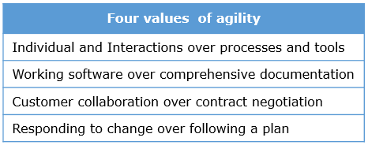
Let us understand the four values
Individual and Interactions over processes and tools
Promotes conversation between team members, teams & customers/stakeholders. There will be processes and tools to support the development, however, the conversations will be given more emphasis supported by processes and tools. Processes will not override the people aspect and they would be allowed to innovate, not just follow a fixed process.
Working software over comprehensive documentation
How much working software produced that can be used by customers is the measure of progress and not just the effort of the team. This means that teams will focus on producing working software supported by documentation. This principle does not mean that there is no documentation. Just enough documentation that will evolve across iterations should be focused by the team. Ex. A skeleton code that proves the design is working software supported by a design document. The latter in itself is not working software
Customer collaboration over contract negotiation
This calls for business users and teams working together. There would be contracts, however, teams will focus on value driven development which would be reflected in the contract.
Responding to change over following a plan
There would be planning and not just plans. This would be dynamic and would be done at micro level for each iteration and at a high level for the entire project duration. This means that planning must be done frequently (say for every iteration) to adapt to changes.

Twelve principles of the manifesto for Agile software development (1 of 3)
Let us look at the 12 principles in the manifesto for Agile software development
1) Our highest priority is to satisfy the customer through early and continuous delivery of valuable software.
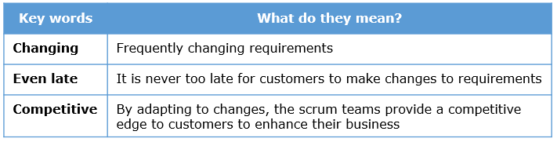

2) Welcome changing requirements, even late in development. Agile processes harness change for the customer's competitive advantage.


3) Deliver working software frequently, from a couple of weeks to a couple of months, with a preference to the shorter timescale.
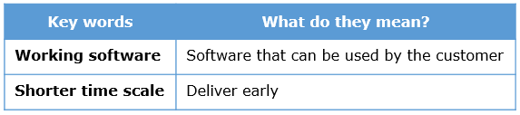

4) Business people and developers must work together daily throughout the project.
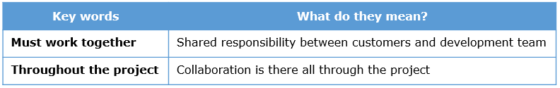
Twelve principles of the manifesto for Agile software development (2 of 3)
5) The most efficient and effective method of conveying information to and within a development team is face-to-face conversation.
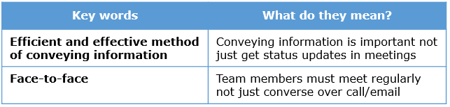

6) Build projects around motivated individuals. Give them the environment and support they need, and trust them to get the job done.
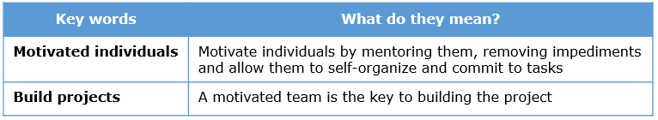

7) Working software is the primary measure of progress.
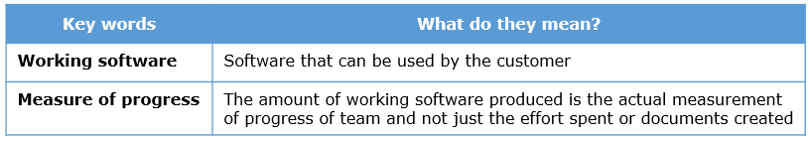

8) Agile processes promote sustainable development. The sponsors, developers, and users should be able to maintain a constant pace indefinitely.
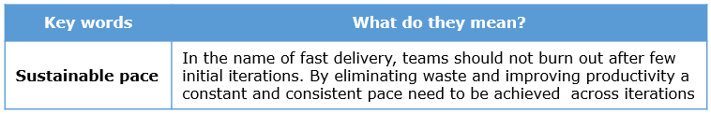
Twelve principles of the manifesto for Agile software development (3 of 3)

9) Continuous attention to technical excellence and good design enhances agility.
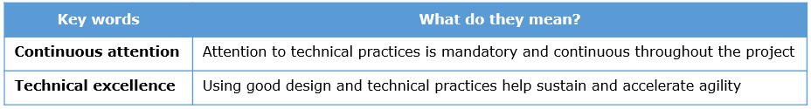

10) Simplicity--the art of maximizing the amount of work not done--is essential
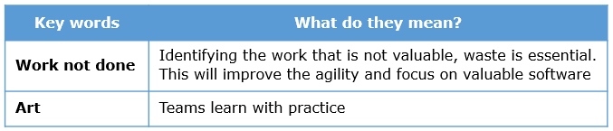

11) The best architectures, requirements, and designs emerge from self-organizing teams.
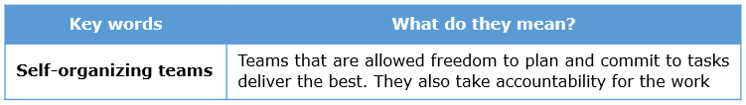

12) At regular intervals, the team reflects on how to become more effective, then tunes and adjusts its behavior accordingly.
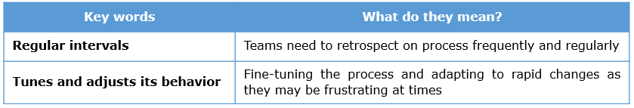

Additional reading :
Evolution of Agile practices

Achieving Agility – The flavors
For all the project instances discussed, agility can be achieved by choosing one the given methodologies. The applicability of different agile flavors and its salient features are listed below.
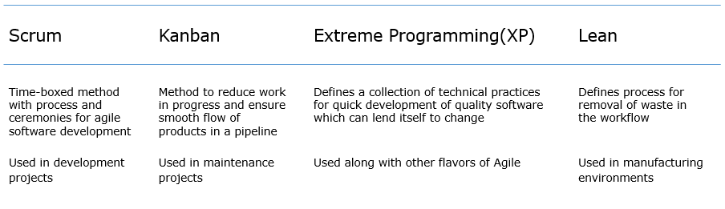

Values and Principles of agility - Quiz 1
Q1 of 2) A team at Infosys is executing a project for a customer, using agile software development approach. For every activity, they take a sign-off from the customer as per the clause present in the contract. The requirements are also being developed as per what was agreed upon in the contract during the start of the project with minimal interactions with the customer. As per the manifesto for Agile Software Development, which value is being violated here?
- Working software over comprehensive documentation
- Customer Collaboration over Contract Negotiation check
- Individuals and Interactions over Processes and tools
- Responding to Change over following a plan
Q2 of 2) Which among these represents the Primary Measure of Progress?
- Requirements Signoff from Customer
- Base lined Architecture
- Code for a validation which is reviewed and approved
- Registration feature which was released to customer’s demo check

Agile Vs Waterfall
Drawbacks of Waterfall Model
Waterfall model cannot be used to address the market needs for the reasons given below.
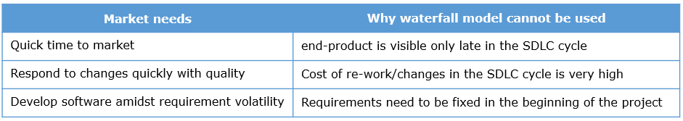
We can conclude that waterfall model cannot address the market needs and hence we need the Agile approach to software development.
Agile vs Waterfall
In the waterfall model, each software development life cycle(SDLC) phase has a specific deadline and deliverable that flows into the next phase. Hence all requirements are collected, then designed, code written, tested ,integrated and deployed at the end.
In Agile, the requirements are broken down into small parts and all the SDLC phases are completed for it. Hence small pieces of working software get released frequently.
This difference is illustrated in the figure below.
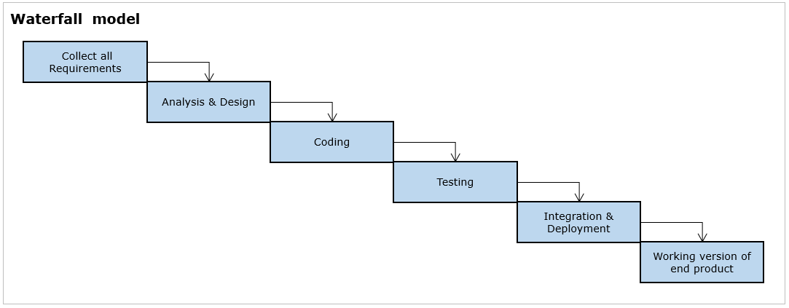

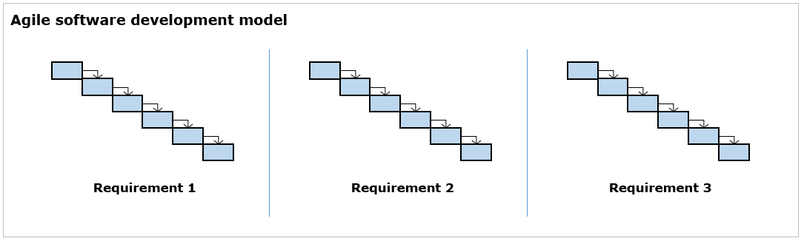

Summary
The differences between the two software development approaches with respect to key parameters is given below.
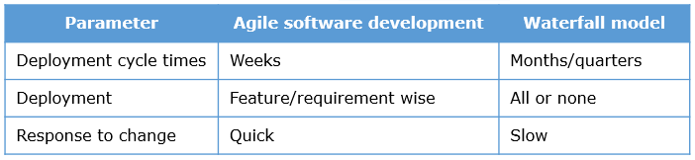

Agile adoption in projects and its impact

Projects at Infosys
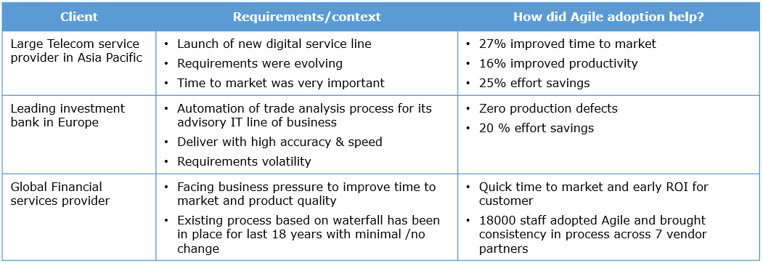

Projects in Industry
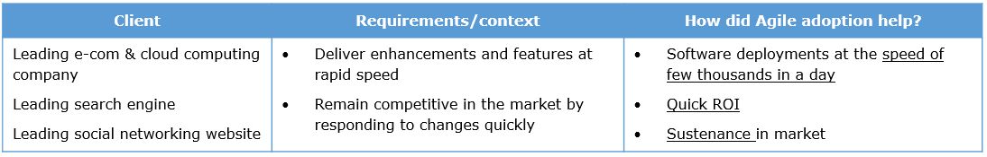
The drivers for Agile adoption as inferred from the case studies is as follows
- Quick time to market
- Respond to changes quickly with quality
- Develop software amidst requirement volatility

Discovery Phase
Sprint 0
The two major areas of focus in scrum is Sprint 0 and subsequent sprints (Sprint 1 to N) which would be discussed in detail in due course.
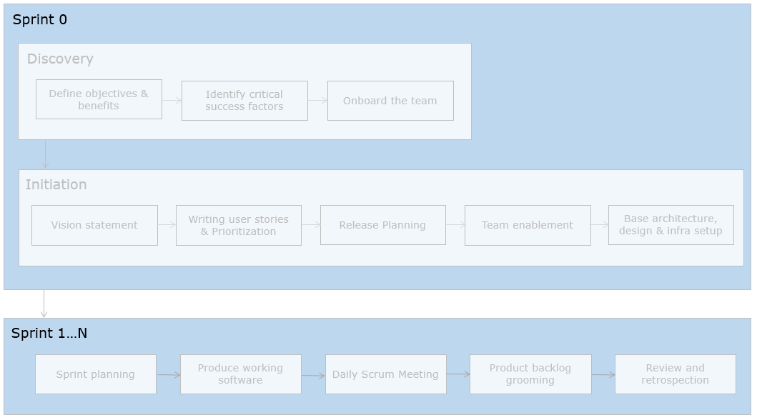
Sprint 0 involves high level planning. This spans for 2-4 weeks. The release plan is arrived at and the planning for the team and infrastructure is also done. This is followed by execution of the sprints.
Note : The above flow is recommended and followed by a few large companies who are transitioning to Agile. This can be taken as a recommendation from experience and can be adopted as appropriate.
Discovery Phase
The first section under Sprint 0 is the Discovery Phase.
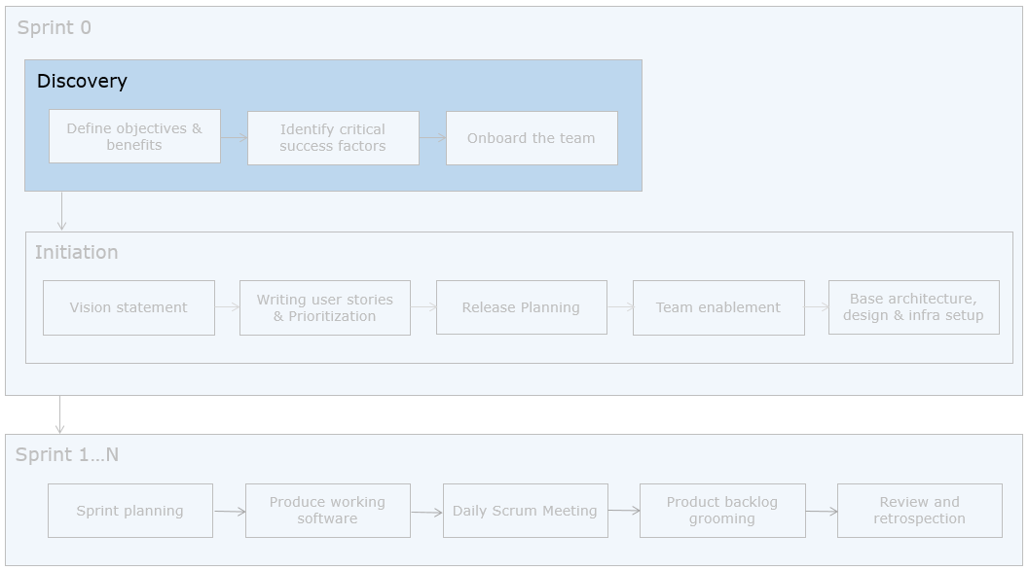

Define objectives and benefits
The discovery section begins with defining objectives and benefits. The technical officer now goes on to define the objectives and benefits of the online solution.
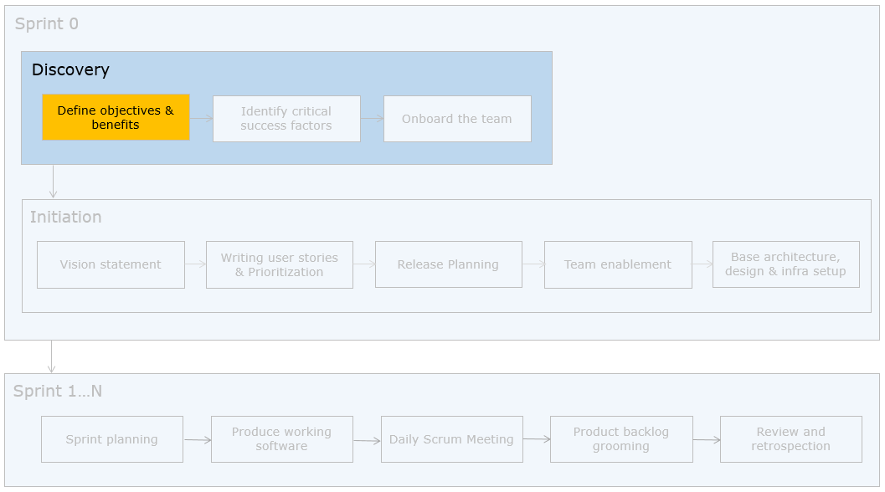
The online solution for EasyGarb will
- place the company as a global player in the retail market
- undergo enhancements based on demand and feedback.
- provide user friendly system in major Asian languages
- fetch revenue of $10 million mark by 2020.
The internal technical team would be identified and the work would not be outsourced to service providers. The online payment gateway would provided by Paypal and that is the only external dependency in this project.
You can see that the following has been defined in this phase
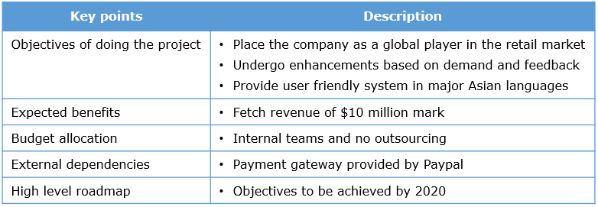
Identify critical success factors
Let us now focus on how to identify the critical success factors.
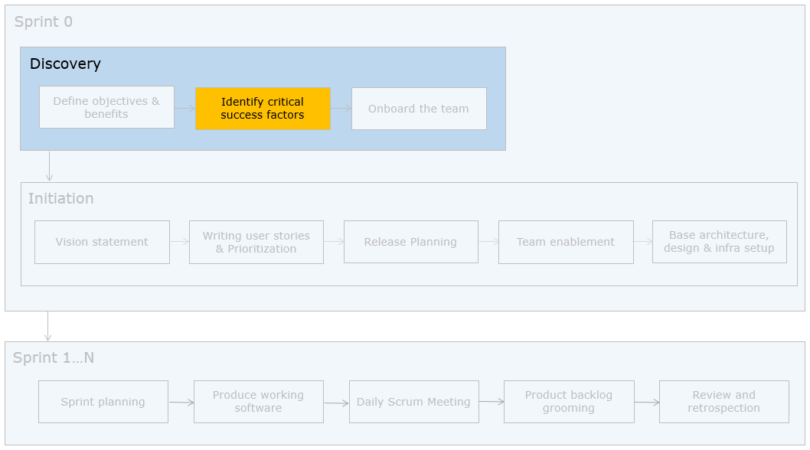
The technical officer lays down the following metrics representing critical success factors to measure the benefits of using Scrum and its constant improvement across sprints.
- Velocity
- Value per sprint (Throughput)
- Defect Density
- Cycle Time
The list of metrics and their formula as provided by the quality team at Infosys is given below for your reference.
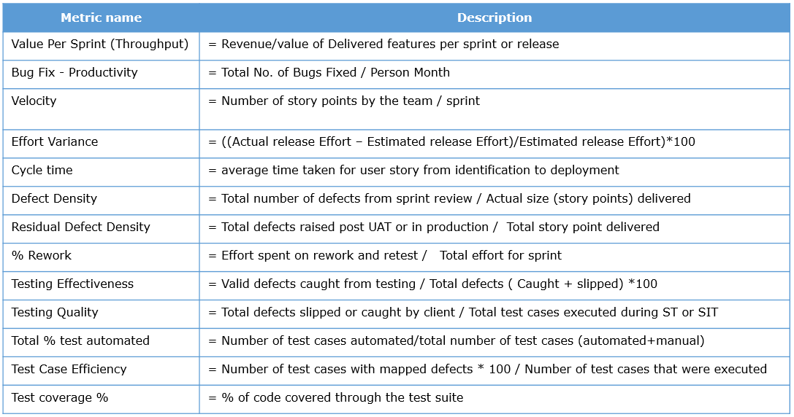
Arriving at the metrics to be tracked will help development teams identify the right tools, fine tune the processes so as to meet them.
Onboarding the team
Having identified the critical success factors, the next step is to onboard the team as part of discovery phase in sprint 0.
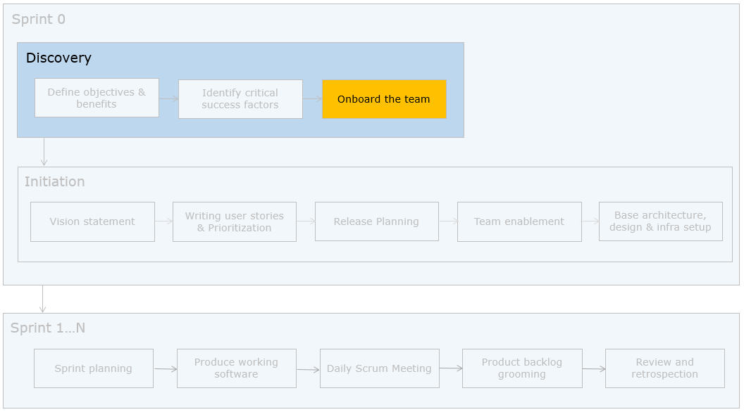
Here is the composition of the team that is available for onboarding for the EasyGarb project as provided by the technical officer. He also mentions that the project requires a lot of development and testing effort, is UI intensive and "just enough" documentation is sufficient.
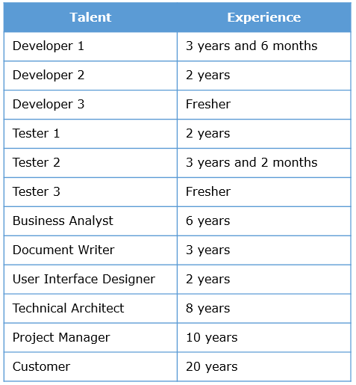
From the above talents, we shall try to decide how to map these talents to the roles prescribed by Scrum.
Here are the roles prescribed by Scrum.
- Development Team
- Scrum Master
- Product Owner
To do this mapping, let us understand the roles and their responsibilities.
Development Team
The following table provides the development team's size, responsibilities and the eligible candidates.
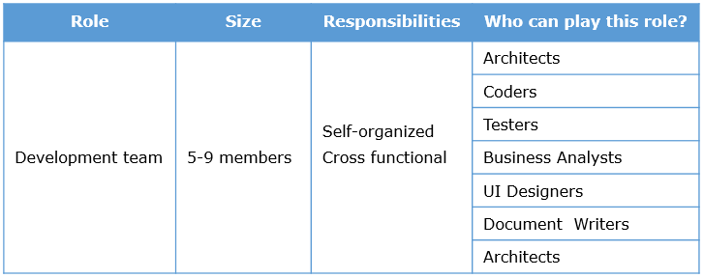
From the list of talents available, let’s identify the members for the development team.
Let us choose three developers, two testers, an architect and a UI designer as part of the team, keeping in mind the requirements provided.
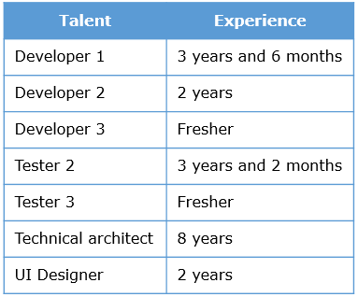
The above team is the core team that would be available across sprints and is preferred for the following reasons.
- good mix of experienced and freshers
- technical architect to help in design and mentoring the team
- adequate number of testers and developers
Talents like document writer can be brought in to the team as and when needed.

Scrum Master
The following table provides the Scrum Master's responsibilities and the eligible candidates.
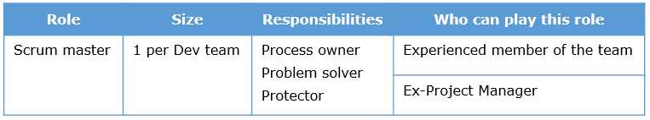
The scrum master is responsible for the 3 P's
Process Owner - responsible for ensuring that the ceremonies are timeboxed and process is followed
Problem solver - ensure that the team impediments / blocks are removed and the team is progressing as per plan
Protector - ensure that there is no loss of focus on the sprint activities, protect the team from undesired sprint disruptions
From the list of talents available, let’s identify a Scrum master. Here are the list of talents with good work experience.
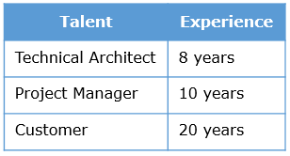
The customer cannot play this role as it is a good idea to have the scrum master from the same vendor team who constitute the development team. Either the technical architect or project manager can play this role. In addition to experience and technical capability they posses, they should be able to manage the team and perform the responsibilities of the scrum master.
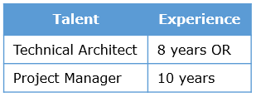

Key points to consider
- The scrum master can also contribute to the Scrum work if there is time available
- The project managers need to play the role of a servant leader ie. Mentor the team by giving them freedom, but take control when situation demands it ex. Negotiating/convincing the customer on certain team decisions

Product Owner
The following table provides the Product Owner's responsibilities and the eligible candidates.
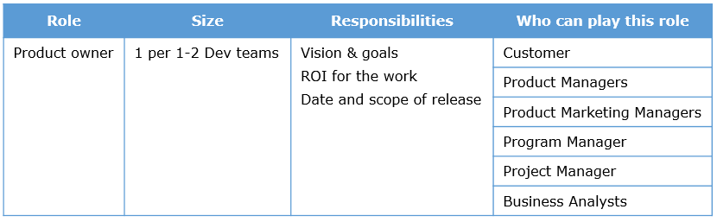
From the list of talents available, let’s identify a product owner. Here are our choices.
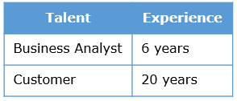
Customer is the best choice for a product owner. If the customer and the Dev teams are in distributed locations, a business analyst can be the proxy product owner.

Key points to consider
- A proxy product owner should be in good touch with the actual customer and should be able to take appropriate product decisions
- Availability of product owner is a must for Scrum to succeed
- It is a good idea to have one product owner identified for a team rather than have multiple people playing that role to avoid confusions and conflicts in requirements

On similar basis, the technical officer can onboard the other teams or ramp them up in a phased manner.
Discovery Phase - Responsibilities of Scrum Master and Development Team

Scrum master
As per project requirements -
a. Identify the skill sets required
b. Onboard a stable and cross-functional team
c. Ensure availability of product owner or identify a proxy product owner if customer and team is not co-located

Development team
a. Ensure that you are cross-skilled. For example, if you are a programmer you may develop skills for automated testing and participate in design too

Discovery Phase - Tips, Recap and Additional References

Practical tips
- A cross functional team(involves team members with a cross section of skills required for software development and deployment) will help get the perceived benefits of Agile
- Defining the success factors would provide “what is expected” from the project to the team members and the management

Quick recap
- Sprint 0 involves the Discovery and Foundation phases
- Discovery phase sets the high level objectives, benefits, critical success factors and onboarding the team
- A Scrum team consists of the product owner, scrum master and development(Dev) team with well-defined responsibilities

Additional references
Tips for new Scrum masters
Qualities of a Scrum Master
Product Owner Role

Scrum Roles - Activity - Exercise

ProblemStatement:
You have a new client SmartMart who is an ecommerce outfit. They are currently looking to start India operations soon. They want a country specific solution with its own front-end, inventory and logistics. Because of the steep deadline you have decided to move forward with Agile methodology for development, specifically Scrum. The following team is at your disposal.
The client wants frequent releases with minimal documentation. Please create a scrum team from the following people.
- Customer – James (Busy, has critical opinions and good business knowledge )
- Customer Representative – Angella (Agile enthusiast and available for clarification of queries )
- Business analyst – Peter (Has good business expertise)
- Project Manager – Jacob (Respected by people)
- Technical Architect – Katie (Sound technical and domain expertise)
- Programmer – Richard (experienced developer)
- Programmer – Shelly (Fresher)
- Programmer – Gordon (experienced developer)
- Tester – Kent (experienced)
- Tester – Rose (Fresher)
- Content / technical Writer – Alex
- User interface designer – Thomas
- Architect – Martin (Strong technical expertise)

Of the above, identify ideal candidate for the following roles
- Product Owner
- Backup Product Owner
- Scrum Master
- Backup Scrum Master
- Development Team – size 5

Note: You can download this activity as a document here

Discovery Phase - Part 2
Here is a possible solution to the activity.
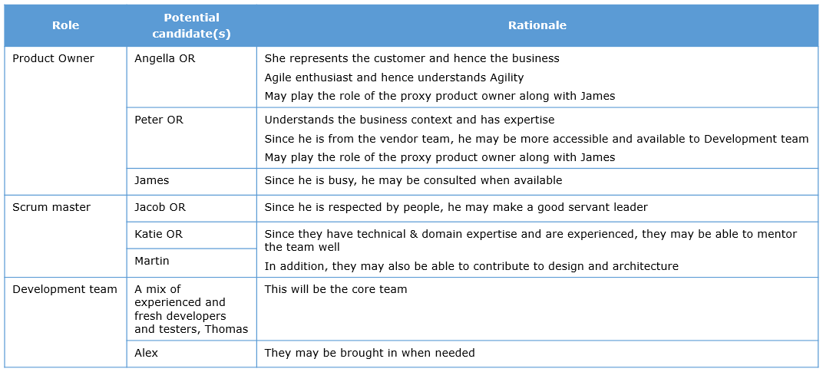

Vision Statement
Initiation Phase
We have seen the Discovery phase so far. Let us know look at the initiation phase, the second section under Sprint 0.
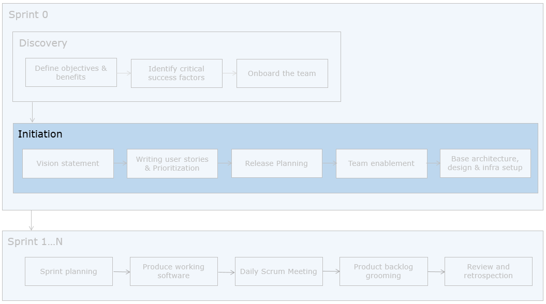
The managing director allots budget for an offsite meeting of the EasyGarb technical team led by the technical officer and the development team at their main office for two weeks to conduct the initiation phase activities. The technical officer would play the product owner role. 5 teams consisting of 9 members each and five scrum masters for each team have been onboarded.

Vision Statement
The first step in initiation phase is for the product owner to set the vision which reveals in an “elevator pitch” as to why this undertaking. A vision statement reflects the essence of the project/product that is being undertaken by the customer.
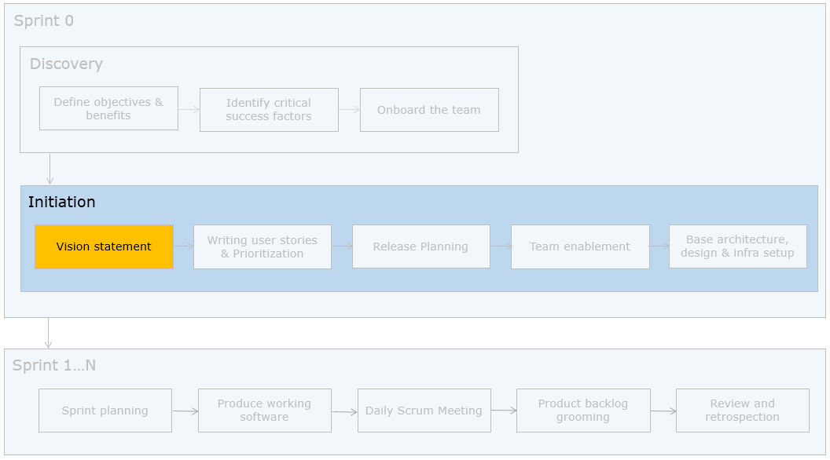
The managing director of EasyGarb addresses the team who have assembled for the offsite meeting. Here is the vision statement
“We intend to provide our customers across Asia with the best online shopping experience end to end, with a smart website compatible across different mobile devices, easy-to-follow instructions, clear and secure payment methods using mobile money ensuring excellent customer experience. Unlike contemporary online stores, we will offer huge variety of products yet unique collections. We also accept orders for customized products at competitive prices. With our effective distributed warehouse, we are able to take the products to the customers at an optimal time and cost. We want to reach the $10 million mark by 2020 and want to be the “most sought” e-commerce portal. We also want to cater to the Europe market by 2018”
From this example we can infer the following components and its values of the vision statement
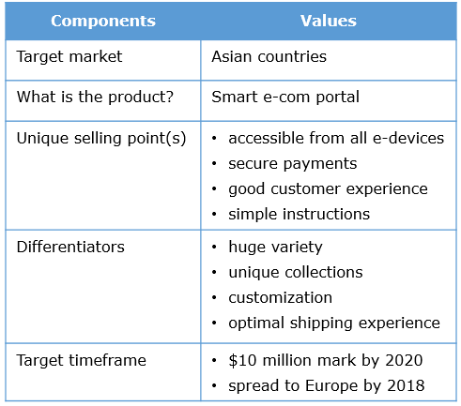
Understanding the vision statement and objectives is very critical for the team who is going to work on the solution so that they are clear with what the priorities are from time to time, while building the product. From the vision statement for EasyGarb, the team may infer the following.
- Product/application is UI intensive
- Language aspects need to be looked at(Asia and Europe)
- Application has to scale and performance has to be really good, given the distributed nature
The managing director of EasyGarb conveys the vision to the team. A face-to-face communication is always better than an email stating the vision. This brings lot of seriousness and importance to the entire initiative. The vision statement can be created by having discussions with stakeholders, technical teams, marketing team etc.
Let’s look at the Scrum’s recommendation about the vision statement.
- The product vision statement is shared by the product owner/customer representative with the team
- Co-location works better for this phase
- If co-location is not possible, use a form of face-to-face communication (video conferencing)

Vision Statement - Recap and Additional References

Quick recap
- Vision statement to be communicated face-to-face by customer/customer representative
- Provides an “elevator pitch” for teams to understand the need for the undertaking
Let us now look at user stories and the need to write them

Additional references
The Product Vision statement

Vision Statement - Activity 1

ProblemStatement:
Given the following vision statement, identify the components and its values.
For corporate unit heads who want to manage the mailbox size due to the sheer number of emails that they receive during long travels, this e-mobile solution provides a sync up of the mail box with their computer email for sending and receiving messages. Unlike other email solutions, this solution is secure and ensures real time connectivity via internet. We want to make this available in the next two months to our existing corporate customers.

Vision Statement - Possible Solution
The components and values for the vision statement are as follows.
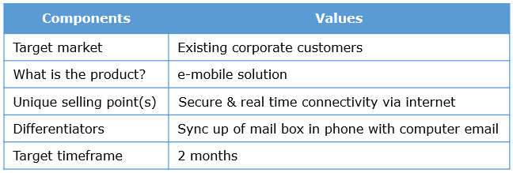

User Stories
User Stories
Once the vision statement is explained and understood, the focus shifts to writing user stories.
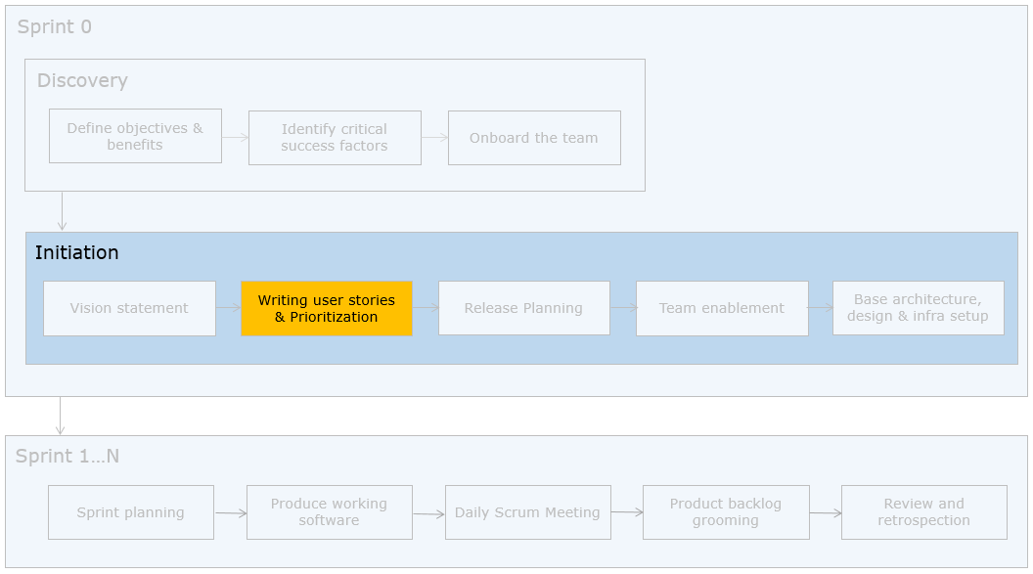
The technical officer at EasyGarb and the scrum teams collect inputs from the stakeholders and make a list of required features categorizing them into modules. The technical officer arranges for a user story writing workshop with all the 5 scrum teams. Here is the first story written based on the product cancellation feature.
“As an EasyGarb online customer who has booked a product, I want to cancel my product booking, so that I can receive refund”
Observe the components in the user story. Let us now look at the need for user stories and how to write them.

Need
Ambiguity in requirements is a common problem bothering all development teams. One among the several reasons is the natural language issue.
Let us take the “Mary had a little lamb” heuristic from Gause and Weinberg’s book.
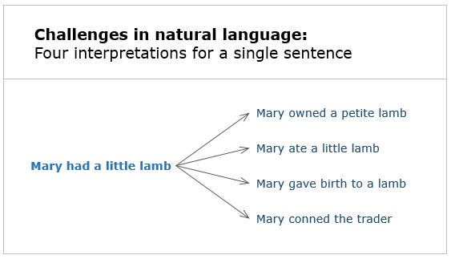
‘Mary had a little lamb’ - All the above interpretations are technically correct.
Many projects fail because customers don’t get what they wanted. User stories tend to bridge the gap between business language and technical language.
User Story – 3Cs

What are user stories?
User stories are short, simple descriptions of a feature told from the perspective of the business user who desires the new capability. To implement the above example story, we need to know the following.
What is the logic for cancellation and refund?

Components of a user story
User stories have three C’s associated with them.
- Card
- Confirmation
- Conversation
Card
User stories are often written on index cards or sticky notes and arranged on walls or tables to facilitate planning and discussion. They strongly shift the focus from writing about features to discussing them.
Confirmation
Each user story has a set of acceptance criteria provided by the product owner in consultation with the development team, tagged to it. These should be met for the user story to be considered as “done”.
For the story written above, here is the acceptance criteria.
- Verify that there is user, product and purchase authentication before cancellation
- Verify that product price is refunded without any deduction to the payment source
- Verify that confirmation email is sent to the customer
- Verify that the stock is updated for the product
Conversation
User stories serve as a promise for conversation.
Development teams should have a conversation with the product owner in understanding the expectations about the user story before implementing it.
Note: Pertinent points about the user story / non functional requirements that need to be taken into account while implementing it, are called constraints. They can be recorded on the reverse-side of the user story card.
Example of a constraint
The system must work with all latest versions of IE, Chrome and Firefox browsers.

When and who writes user stories?
In general, a workshop lasting from a few hours to a few days where a diverse team comprising of product owner, development team, scrum master collectively brainstorms desired business value and creates user story placeholders for what the product or service is supposed to do. User stories can be written and refined by anyone of them however, the final call on the story is the onus of the product owner. User stories can be groomed and written across the sprints.

Product Backlog
At the end of the user story workshop, 200 stories were written which constitute the product backlog for the scrum teams at EasyGarb. A snapshot of it is shown here for your reference.
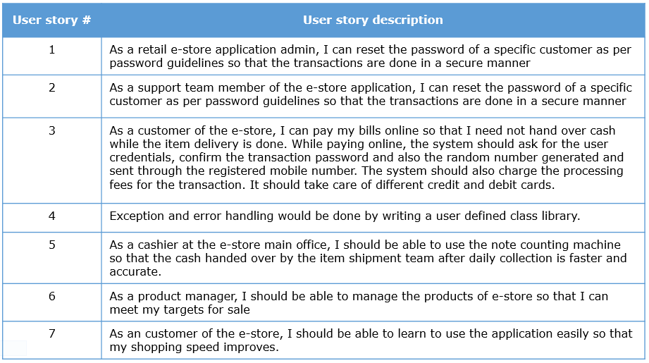
Product Backlog is a pending list of items to be developed. This is owned by the product owner. The items are generally represented in the form of user stories. The product backlog can undergo changes anytime during the project and groomed across the sprint.
Let us see if these stories are written well and meet the purpose for which it is written.

INVEST principles
The INVEST principles coined by Bill Wake can be used for writing good user stories and reviewing them.
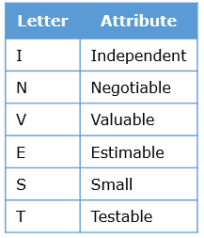
Let us take few user stories from the EasyGarb product backlog and analyze if they meet the INVEST principles and rewrite them if not.

Independent
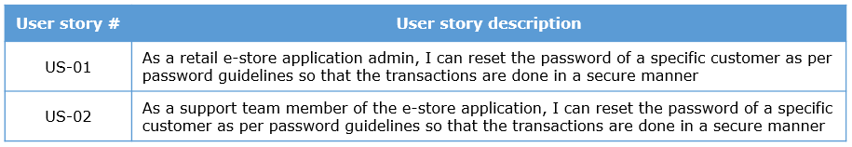
The stories given do not satisfy the INDEPENDENT attribute because they are interdependent and overlapping
A story is independent if it can be developed, valued and delivered on its own. Stories are written to be independent of each other as far as possible.
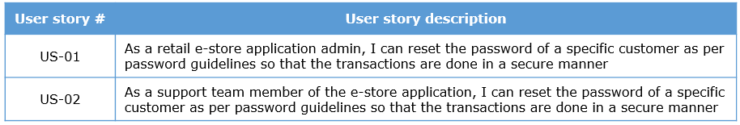
Revised Story: As a e-store application admin and support team member of the e-store application, I can reset the password of a specific customer as per password guidelines so that banking is done in a secure manner.

Negotiable
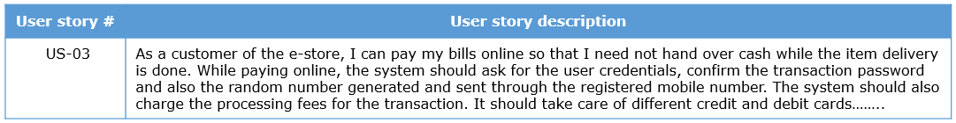
This user story has more details in addition to the basic structure making the user depend on the text of the story itself rather than promoting conversation. Hence it doesn’t satisfy the NEGOTIABLE attribute.
A negotiable story should promote conversation with customer as they are not written contracts but only reminders to have a conversation with them. Details can be annotated or written as tests at the back of the user story card.
Negotiable also indicates that the customers should be ready to discuss on the story if new aspects come out while taken for development which may not be immediately visible when the story is written.
Revised Story: As a customer of the e-store, I can pay my bills online so that cash payments can be avoided.
Note on the back of the user story card: The customer must be able to pay using credit and debit cards of local and global banks

Valuable
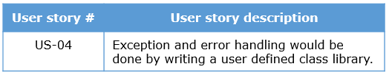
This user story is not written from a business user perspective and hence does not satisfy the VALUABLE attribute.
Stories must always deliver value to the End Users and Purchasers of the software, the customer. User stories should not reflect technical language.
Revised Story: As an online user, I would be able to receive error messages and exceptions in a simple and understandable manner so that I can handle them.

Estimable
Example
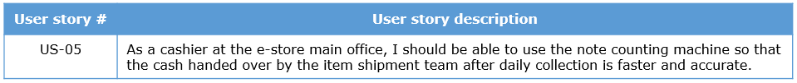
The details about note counting machine, and how the interfacing with software would happen is beyond comprehension at this point of time and hence the story does not meet the ESTIMABLE attribute.
Being able to assess a user story and provide an approximate estimation of its size is required.
When can a user story go inestimable? Look at the following.
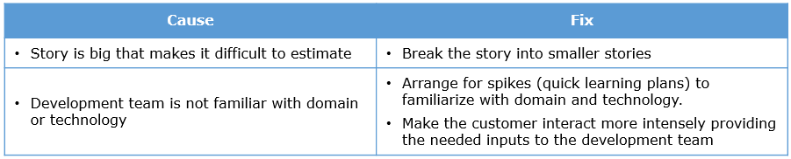
Technical inputs pertaining to how the interfacing happen between software and the device has to be provided ,post which the development team can attempt estimation. The team can also aim at splitting this story further.

Small
Example
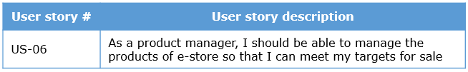
The above story is too huge. There may be several products and managing each in itself may result in several user stories. It violates the SMALL attribute.
A good user story should be small. What defines the size of a story?
- Capability of the team
- Technology being used
The thumb rule for the user story sizing is “one to two developers should be able to finish the story in 1-2 days.”
A user story can be made small by reducing
- Size of the story
- Complexity of the story
Revised stories:
As a product manager, I should be able to list the products and their schemes of e-store so that I can so that I can view the schemes available
As a product manager, I should be able to view the popular products in the e-store so that I can suggest options to provide discounts
….

Testable
Example
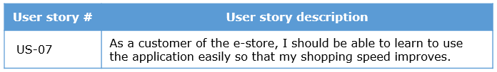
‘easily’, ‘speed improves’ are very relative terms and cannot be translated into proper test cases unless they are quantified and become well defined.
A good user story should be testable. The testers must be able to verify the story. Automated tests are usually employed. The user stories can go untestable if the stories are covering non-functional requirements or if they are dependent on other stories.
Revised story: As a customer of the e-store from China, I should be able to purchase an item without needing to use help of the support team or online help.
The INVEST (Independent, Negotiable, Valuable, Estimable, Small, Testable) principles help in identifying if a user story is written well.
Other terms related to user stories
Other than user stories, the requirements may be expressed in the following formats.
Epic – A user story that has the potential to be broken down into several user stories that takes more than one sprint to develop.
Example
As a product manager, I should be able to manage the products of e-store so that I can meet my targets for sale
This is a story at a high level and can be broken down into several stories pertaining to listing the products, monitoring the stock and sales of the products.
Themes – It is a collection of related user stories. Represent an area of focus and may express the focus of a couple of sprints.
Example
A theme could be named as “Product Listing”. Stories contributing in this aspect can be collectively referred to as stories themed “Product Listing”. Stories under this theme could be like as follows.
As a marketing manager, I must be able to see the list of products added in the last one month, so that I can do a market analysis.
As a sales manager, I must be able to see the list of products sold week-wise, so that I can comprehend the sales pattern
As an EasyGrab online customer, I must be able to see the products I have purchased along with the timelines of purchase, so that I understand the frequency at which I buy specific products.
Features – It can be broken down into tasks and can be expressed in the form of user stories.
Example
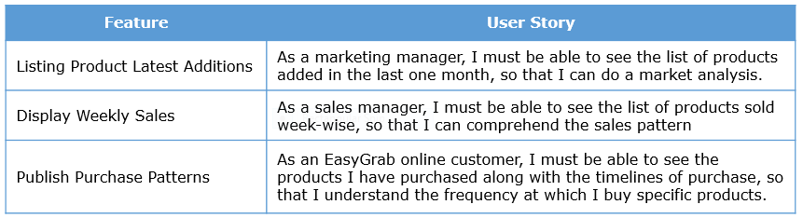
User Stories – The one we have been discussing all along sticking to the format “As a user…I want…So that”. Typical choice for iterative estimation and development.

User Story - Advantages and Limitations

Advantages
- Helps provide business perspective to requirements
- Very simple format

Limitations
- Is not a standard form of documentation
- For some requirements (back-end for example), it may not be possible to write user stories
- Has a slight learning curve for beginners
User Story writing - Responsibilities of Scrum Master and Development Team

Scrum Master must ensure
a. PO availability to answer queries on user stories
b. teams speak up and ask questions on user stories to bring clarity
b. If possible, do the user story writing workshop together with the PO and teams

Development team
a. If writing or reviewing user stories, adhere to INVEST principles
b. Ask questions to get clarity on user stories
c. Ensure that the acceptance criteria are written well and is complete
d. Allow conversation to happen with team and PO on user stories to get clarity
e. Write notes behind the card and record conversations if required
f. Write user stories from business user perspective and NOT from technical perspective

User Story writing - Tips, Recap and Additional References

Practical tips
- If the development team writes user stories, ensure to vet it with the customer and ensure the conversation part is fulfilled
- Tools maybe used to record the user stories if teams are distributed
- Ensure that the development team has the acceptance criteria clearly written
- If user stories are given by the product owner, ensure to review it and split it if required
- All user stories need not be detailed out in the initial user story writing workshop, two sprints worth would be enough to get started
- User stories are written and groomed throughout the project

Quick recap
- User stories are a promise for a conversation

Additional References
- "User stories Applied" Mike Cohn, Addison Wesley
- User Stories: Story Cards
User Story Activity 1

ProblemStatement:

Objective
User stories can be derived from requirements/goals collected from end-users/stakeholders etc. This activity helps to identify user stories from the goals and sub goals provided by the product owner for a business scenario.

Business Scenario
In a retail application, the following goals are to be achieved.
Primary goal: To allow an online user to purchase items from the online shop and pay money through the credit card

Sub goals
- Online user should be able to search for items details based on parameters like category of item, price, name, brand etc.
- Online user should be able to maintain my shopping cart
- Online user should be able to do a credit card payment

Task
Identify one epic, theme and user stories from it. Convert the goals and sub goals into appropriate user stories.

Note: You can download this activity as a document here

User Stories - Activity 1- Possible solution
Epic
As an online user, I must be able to newly add and modify existing products in my cart as per my choice and make payment, so that I can purchase the products online.
Theme
“Product Search” could be a theme that has the following user stories as part of it.
As an online user, I should be able to search for items based on category of items so that I can find items of my purchase interest
As an online user, I should be able to search for items based on category and advanced search parameters like name, brand and price so that I can find items of my purchase interest
User Stories
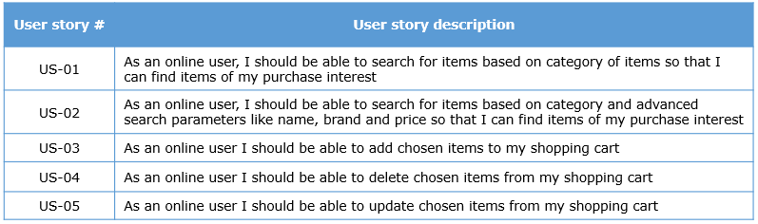
Payment through credit cards may be a huge story and maybe split along the lines of credit, debit card payments, global, local card payments, online account payment etc. If the payment is outsourced to a banking gateway or a third party, then those stories need not be considered. This clarity will come during conversation with the product owner.

User Story Activity 2
User Story Activity 2

ProblemStatement:

Objective
Based on INVEST principles identify good user stories from the given list of user stories.
1) As an online user, I can run the retail application on Windows and Linux systems to do online shopping
2) The retail application will have the user interface developed using a third party library
3) The retail application needs to be developed using the “Fast” framework internally available for meeting performance related requirements
4) As an online user, I would be prompted to save the work in the word processor application every 5 minutes to avoid loss of data
5) The user should be able to use the system easily
6) As an online user, I can log into the retail application
Task
Consider the user stories given above. Identify whether they are good user stories. If they are not, please specify which INVEST principle(s) is/are violated.

Note: You can download this activity as a document here

User Stories - Activity 2- Possible solution
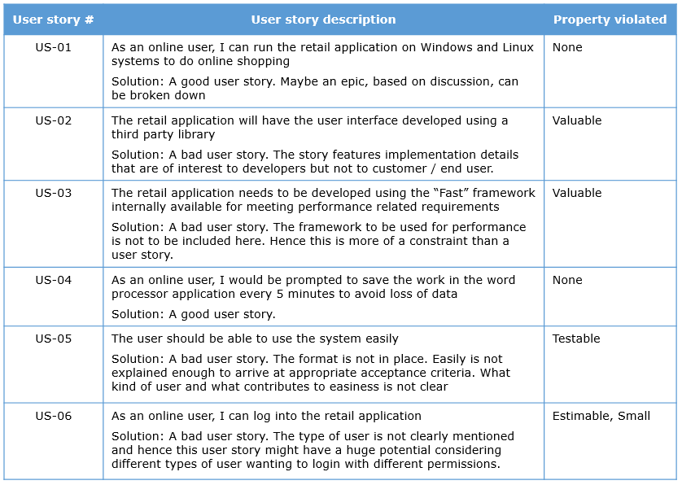

User Story Activity 3

ProblemStatement:

Objective
Rewrite user stories based on INVEST principles.
- As an online user, I can pay the ticket cost online so that I can book my tickets according to my travel plan
- Consider stories written for an automated assessment system for evaluation of code(say written in Java) submitted by students in an automated fashion
  - As a student, I should be able to write classes so that I can solve the problem given during the exam
  - As a student, I should be able to create .java files so that I can solve the problem given during the exam
  - As a student, I should be able to compile .java files so that I can solve the problem given during the exam
  - As a student, I should be able to execute a java program so that I can solve the problem given during the exam
- Consider stories written for an automated assessment system for evaluation of code(say written in Java) submitted by students in an automated fashion
As a student, I should be able to write classes so that I can solve the problem given during the exam.
The classes written should follow the coding standards. The access specifiers written against the classes must be checked. The number of instance variables in a class must be checked. The prototype of the methods written need to be verified.
- Consider a stories written for an automated assessment system for evaluation of code (say written in Java) submitted by students in an automated fashion.
As a student I should be able to add, update or delete code submitted in the system so that I can debug my code.
Task
Consider the user stories given above. Identify whether they are good user stories. If they are not, please specify which INVEST principle(s) violated and re-write them.

Note: You can download this activity as a document here

User Stories - Activity 3- Possible solution
User Story Activity 3 - Possible Solution

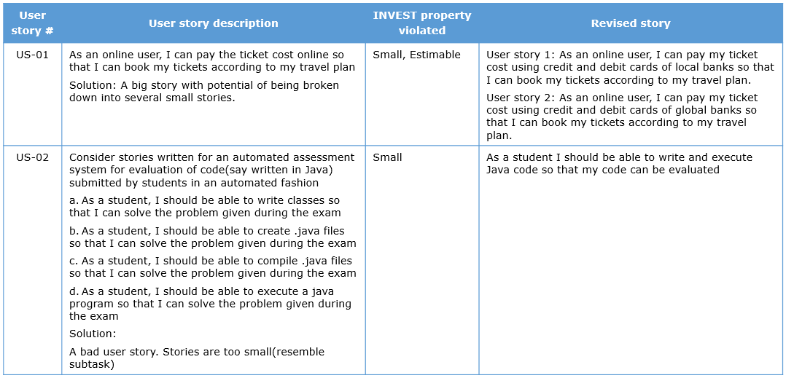
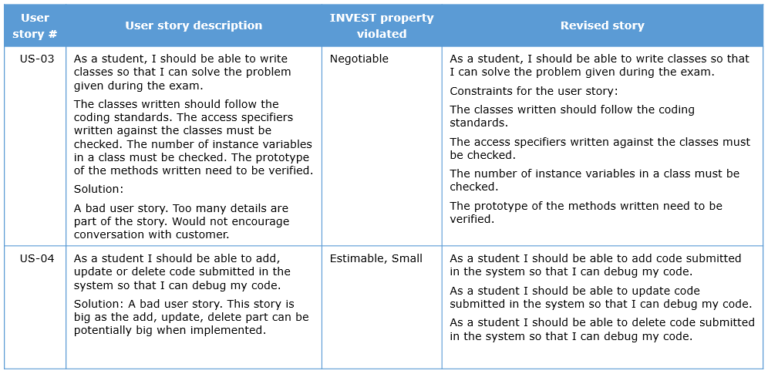

User Story Activity 4

ProblemStatement:

Objective
Write acceptance criteria for given user stories
User Story 1
As a researcher, I want to be able to submit research papers online, so that I can track the status of acceptance.
Task
For the above story, arrive at the conditions that can serve as acceptance criteria. On these conditions getting satisfied, the user story can be considered as accomplished.

User Stories - Activity 4- Possible solution
The acceptance criteria for the above user story could be as follows.
- Verify that the mandatory fields(Name, affiliation, conference name, category of paper submitted) are filled
- Verify that an error message is displayed if the mandatory fields are not entered
- Verify that a success error message is displayed with a reference number if the details are stored in the research paper database
- Verify that an acknowledgment email is sent to the user etc…..

Prioritization of User Stories
Prioritization of user stories
Once the user stories are available, they need to be prioritized for deciding the order for development.

The technical officer at EasyGarb and the team brainstorm on the product backlog regarding the priorities for the items. The remarks based on the conversations is recorded and a snapshot of the same is given here.

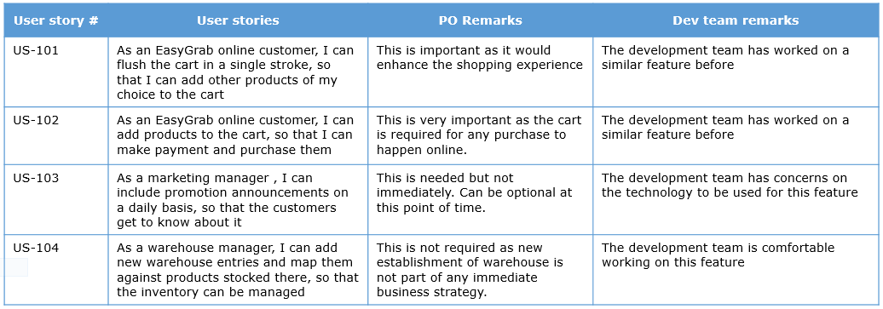
The scrum teams at EasyGarb now need to know techniques to prioritize the product backlog and how it helps in delivering value to the product owner.
Prioritization of user stories - Why, What & When?

Need
Here are the differences between traditional software development and feature driven development.
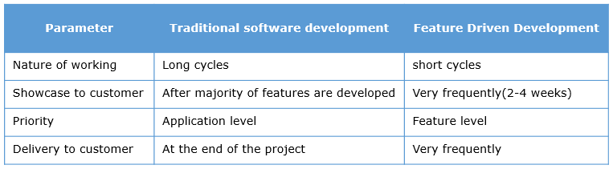
You can infer that feature driven development helps deliver valuable features frequently based on priority decided by the product owner.

What is prioritization?
Prioritization helps product owners identify what is valuable at that point in time so that value driven development can happen. This is inline with the principle “Simplicity the art of maximizing the amount of work not done is essential”.

When is prioritization done and who does it?
Prioritization is initially done in sprint 0 and is repeated every sprint to see if priorities need to be revisited at that point in time. This activity is carried out by the product owner in the presence of the Scrum master and the development team.

Prioritization Factor - Feature Urgency

Factors
Here are the factors to consider for prioritization and their respective techniques.
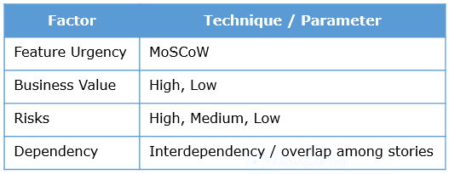

Feature Urgency – MoSCoW
Feature urgency is about determining how critical a user story is to the application being developed.
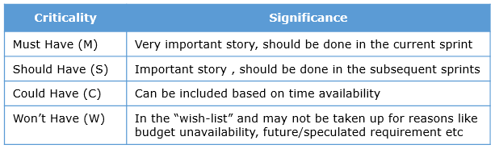
The technical officer at EasyGarb now provides input on the urgency of the product backlog items, a snapshot of which is given here.
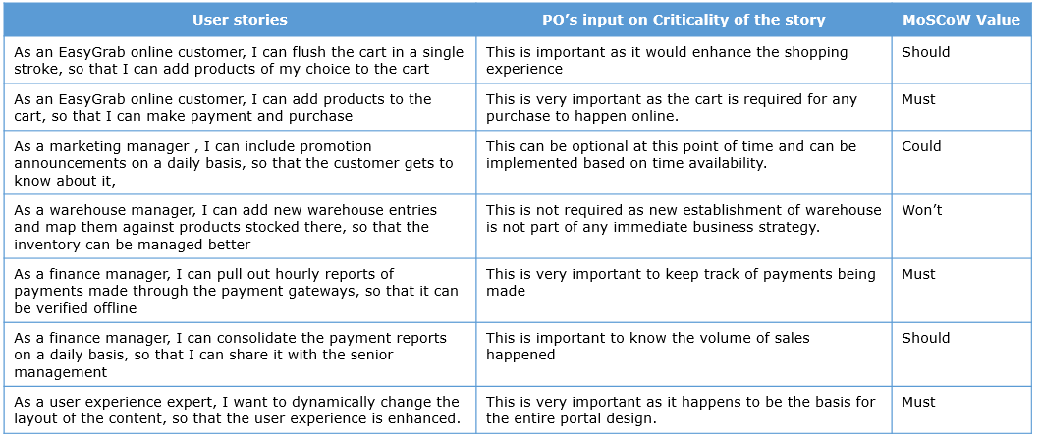
Prioritization Factor - Business Value
There may be a business value associated with every user story representing the revenue that would be generated for EasyGarb.
The technical officer, who is also the product owner, provides the business value in USD for the product backlog items. A snapshot is given here.
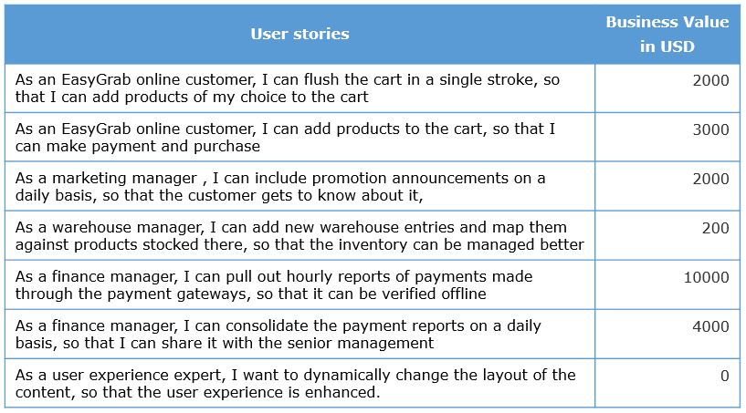
Based on the revenue generated, the stories may be prioritized, high gain first followed by the lower gain ones. However, there may be other technical/operational factors considered in arriving at the ranking.
Prioritization Factor – Risks
The key members of all the five development teams working on EasyGarb, analyze the user stories in the product backlog and come up with the risks involved for each of it. A snapshot is given here.
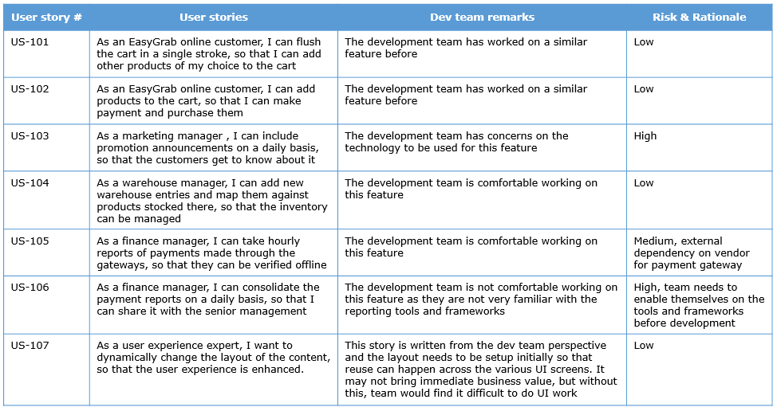

In general, there are two types of risk involved.
- The Risk of not including a user story in the product backlog
- The Risk in implementing a user story
- Any external dependencies for example dependency on a third party payment gateway
Risks are categorized as “High”, “Medium” and “Low”.
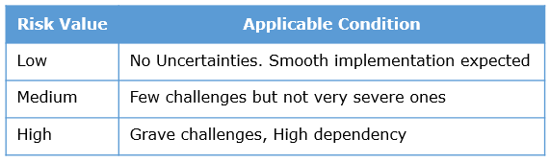
Prioritization Factor – Dependency
The scrum teams come up with dependencies between the stories in the product backlog. A snapshot is shown in the table.
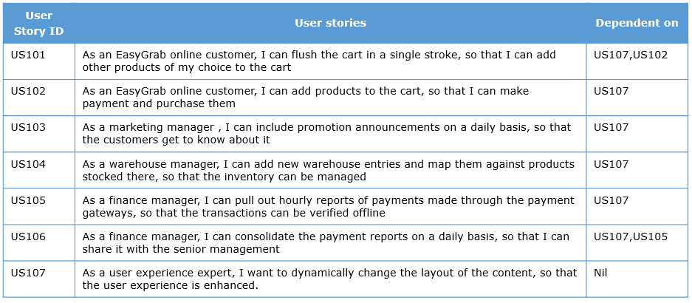
In the above product backlog,
- all the user stories are dependent on US107 as the layout of the content of the portal has to be decided before any content could go into it
- US101 is seen dependent on US102. Without adding products to the shopping cart, flushing it won't be possible
- US106 is dependent on US105 as getting the reports from the third party payment gateway has to happen before it could be consolidated to arrive at the reports
As discussed in the context of INVEST properties of user stories, dependency could mean one user story is dependent on another for its implementation or could also mean overlapping user stories. Such cases are identified and accordingly placed in order.
Arriving at the priority based ranking
The scrum teams come up with the order of development of stories striking a balance among the four prioritization factors. The snapshot of it is available here.
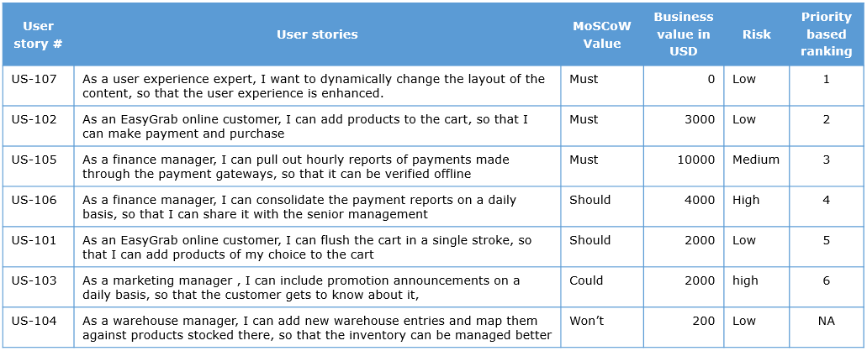
Rationale
Rank 1 is given to US107 as it talks about designing the layout before proceeding with the rest of the features. It may be noted that the business value in USD is zero for this story yet it is ranked one.
Rank 2 is given to US102 because it is an essential feature to be implemented. It is ranked higher than US105 with the same criticality and even higher business value because of the challenges present in implementing it are quite high.
Rank 3 is given to US105. It is strategically placed after US102 in order to cover for the high risk this user story poses to the developers.
Rank 4 is given to US106. The dependent story US105 would have been already implemented and hence US106 can also be implemented without any glitches.
Rank 5 is given to US101. Though there is no business value in USD, the user story is of significance to the product.
Rank 6 is given to US103. Though it has a reasonable business value, the product owner is not very keen about having this user story and hence it is placed here.
US104 has been marked by the product owner as won’t have and hence it is placed as the last item in the product backlog. There is no priority involved.
The prioritization of user stories would depend on balancing all or a combination of some of the 4 factors mentioned in the earlier section. What is represented is a sample solution. The final call on prioritization lies with the product owner. However, the development team provides the dependency, technical constraints in prioritizing the stories. Hence this is done as a team activity with the PO,Dev Team, stakeholders and Scrum master present.

Prioritization of user stories - Responsibilities of Scrum Master and Development Team

Scrum Master must ensure
- PO commitment to provide decisions on the priorities(based on techniques) of stories and not declare all stories as important
- Play the role of leader and express technical/team constraints which might impact ranking of stories
- Promote conversation among teams and PO to bring clarity on priorities

Development team
- Analyze the technical / skill constraints while ordering the stories
- Identify risks
- Speak up on the constraints and seek clarity on user stories

Prioritization of user stories - Tips, Recap and Additional References

Practical tips
- If teams are distributed and/or product owner is not co-located, prioritization can happen in individual groups and representatives can sync up with respect to priority
- This activity promotes a lot of conversation between PO,Teams and stakeholders and hence it is good to have co-location for this phase

Quick recap
- Prioritization promotes value driven development
- Methods are based on
  - Feature urgency(MoSCoW)
  - Business Value
  - Risk
  - Dependency
- The product owner always takes the final call about priorities of items.

Additional References
Prioritization of user stories

Prioritization of User Stories - Quiz 1
Q1 of 5) State true or false with respect to the actions taken in the given scenario.
The customer categorizes all the user stories in the product backlog as very important. The scrum master proposes to add a few more teams as and when required to develop the user stories in parallel.
- True
- False check
Q2 of 5) State true or false with respect to the actions taken in the given scenario.
The customer feels a particular story needs to be developed immediately. However, the development team has concerns on doing it. The Scrum master stop from mentioning it to the customer.
- True
- False check
Q3 of 5) State true or false with respect to the actions taken in the given scenario.
For a set of user stories, the development team feels that they need to scale up and have concerns on developing it immediately. They place these stories under “High” risk items.
- True check
- False
Q4 of 5) State true or false with respect to the actions taken in the given scenario.
The customer mentions about a feature that they have in mind, but may not have budget in this quarter to have it developed. The Development team puts this under “Wont have” category.
- True check
- False
Q5 of 5) State true or false with respect to the actions taken in the given scenario.
For a user story, the customer feels that it needs to be developed immediately whereas the development team does not want to take it up due to technical incapability. The Scrum master tries to convince the customer on deferring it, but due to business value factor, the customer is keen on having it. The Scrum master forces the team to pick up the story.
- True
- False

Prioritization- Activity 2

ProblemStatement:

Objective
User story is ranked for its significance based on two critical parameters – the effort needed to implement it and the business value it provides to the customer on implementation. This activity helps us in deciding the significance of a user story by considering the effort and business value.
Task
For the given list of product backlog items, arrive at a ranking based on the effort and business value provided.

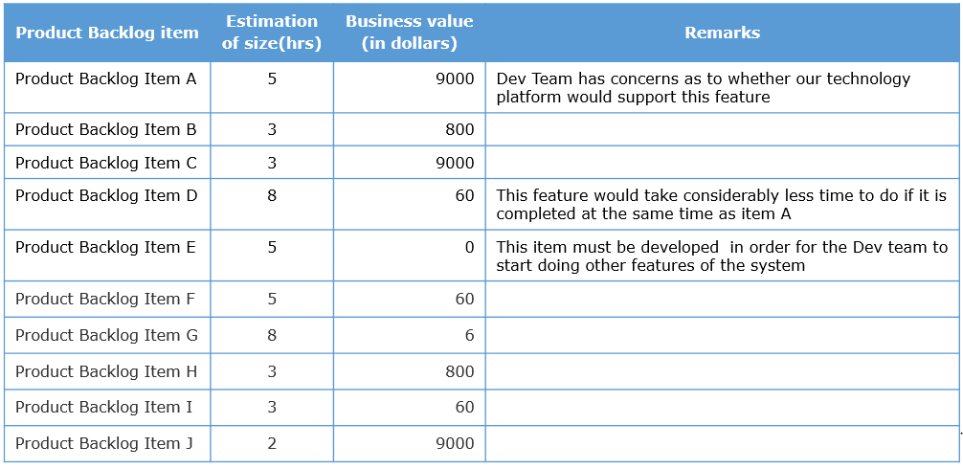
Note: You can download this activity as a document here

Prioritization of User Stories - Activity 1- Possible solution
The following is one of the possible solutions that can bring a win-win situation to both product owner and the development team.
MoSCoW values are identified by taking clues from the remarks on how important is the user story to the application.
Risk values are also decided based on the remarks. As mentioned earlier while understanding the concepts, the challenges in implementing the user story is assessed and the risk is accordingly categorized into “High”, “Medium” and “Low”.
The prioritization could be in the following order.

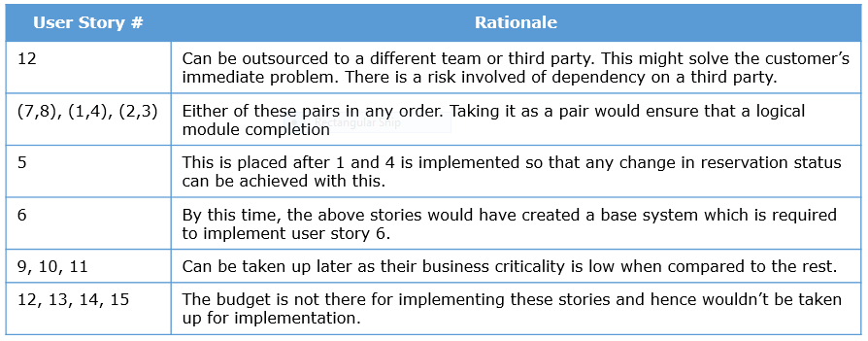


ProblemStatement:

Objective
Beyond the business value, there are other factors that help in arriving at the priority order for user stories. The factors are feature urgency, risks and dependency. This activity helps in prioritizing the user stories based on these parameters.
Task
For the given list of product backlog items, arrive at the priority order based on MoSCoW, risk and dependency factors. Fill in the columns MOSCOW, Risk, Dependency and then arrive at the priority number (serial numbers 1 onwards, 1 with the top priority item) in the priority column.

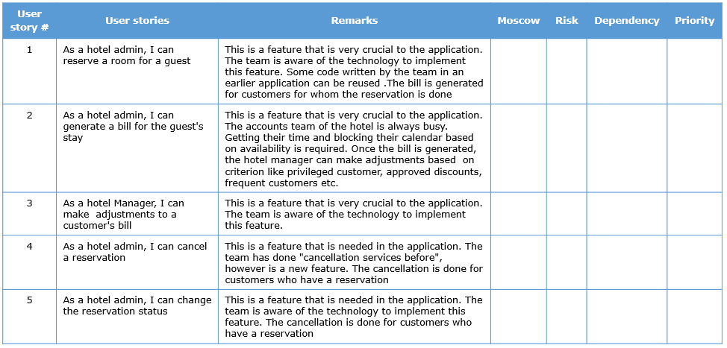

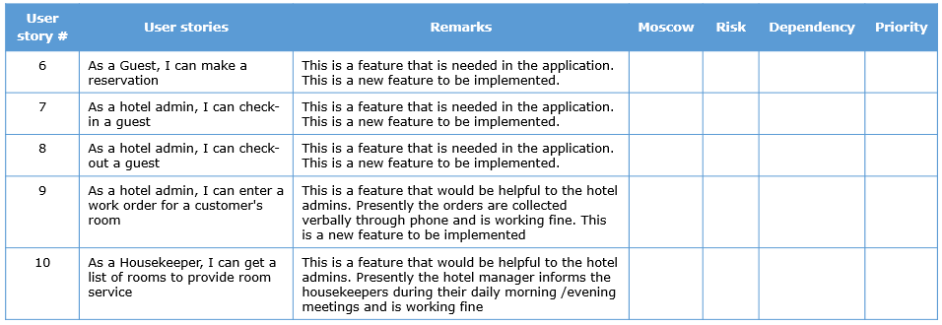
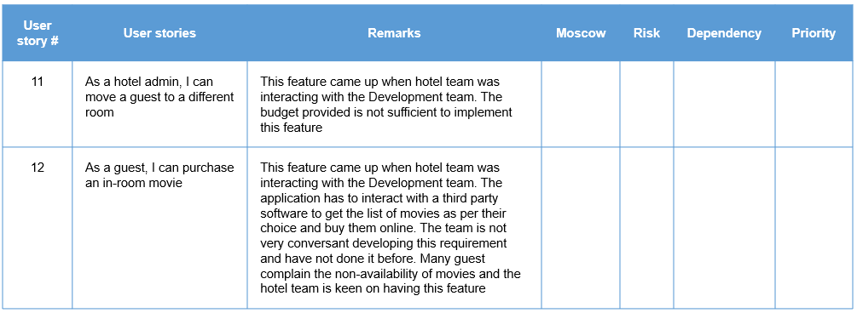
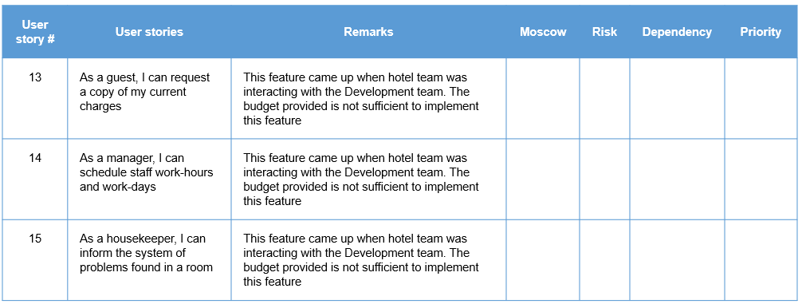
Note: You can download this activity as a document here

Prioritization of User Stories - Activity 2- Possible solution

Here are the possible solutions representing the order of development of stories.
- Possible solution 1 : E,J,C,B,H,A,I,F,D,G (placing risky item 'A' in the lower order and taking low risk and high value items in the beginning. 'A' and 'D' are also not done together.)
- Possible solution 2: E,J,C,B,H,A,D,I,F,G (Same as solution 1 but 'A' and 'D' are done together.)
- Possible solution 3: E,A,J,C,D,B,H, I,F,G(Placing risky item 'A' earlier in the order)

Story Point Estimation
Release Planning
Once the user stories have been created and prioritized, the release planning is done in order to arrive at a tentative release date for the project and share it with the customer.
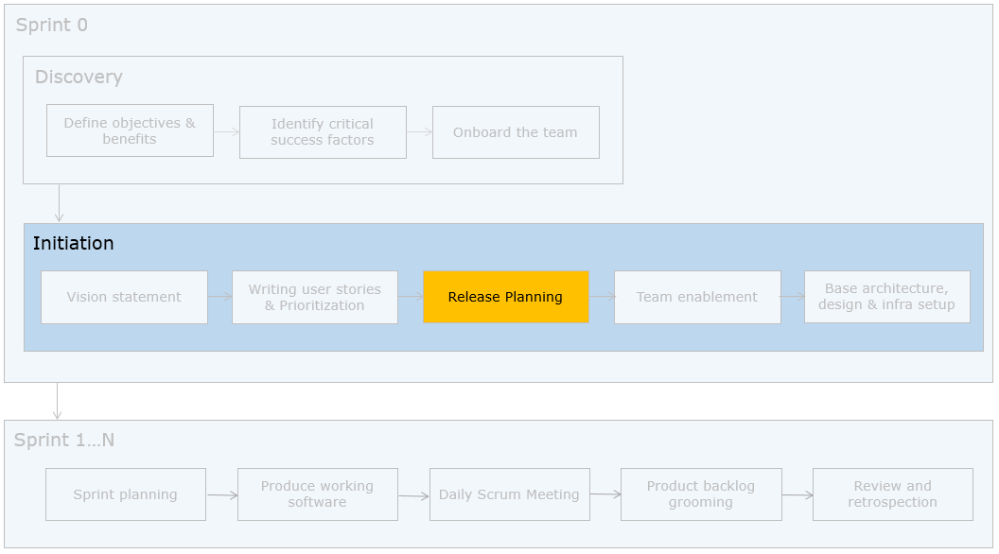
The development team along with the technical officer of EasyGarb, wants to get an idea of the release date for the product backlog created. They need to execute the release planning exercise to achieve this.

Steps in Release Planning
Release Planning comprises of the following steps that are explained in detail subsequently.
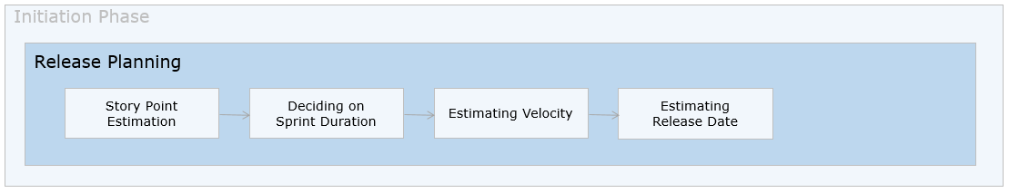

Story Point Estimation
The first step in release planning is to estimate the story points for user stories.
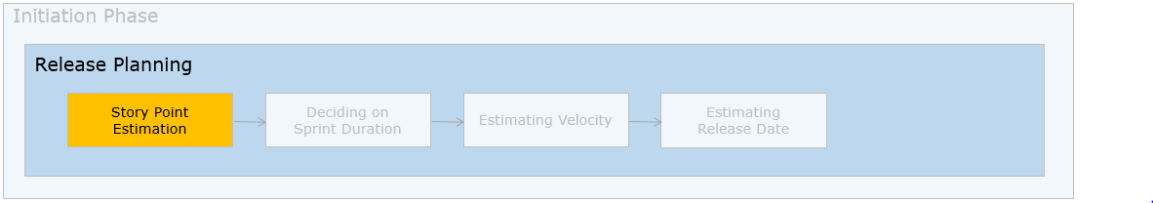
The development team along with the technical officer of EasyGarb application have to estimate the user stories. Since user stories at initial stages are not detailed enough, Scrum proposes a relative estimation technique - story points, for estimation.

Need
As per Steve McConnel's cone of uncertainty (Book: Software Project Survival Guide,McConnell 1997) the estimates done in the beginning of project can be way off from 60% to 160%. This may be due to lack of clarity in requirements during that phase.
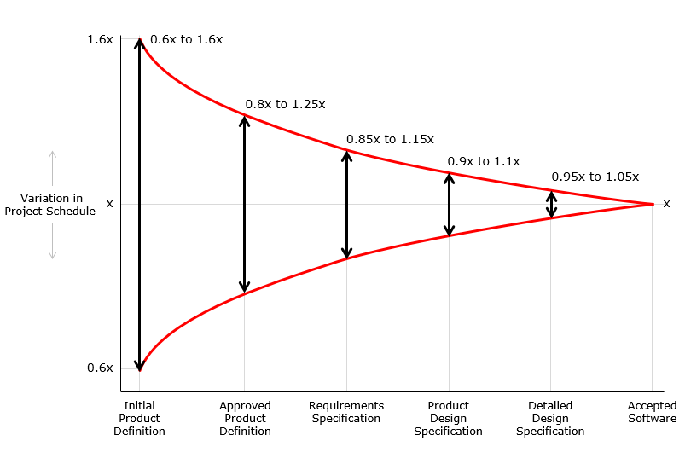
Hence we need an abstract way of representing the estimates and story points help in achieving accurate though not very precise estimates.

What are story points?
Story Point is a size associated with a story and it is NOT the effort in days. It is influenced by the amount of work, complexity, risk and uncertainty but not very precisely. Story points are provided using relative estimation technique.

Relative Estimation
Let us understand the term 'relative' with an example.
Mark walks into the residence of Steve and Elma.
“Hey Mark, Glad to have you at my place!! I shall walk you through our new house”
“Steve, the living hall is very comfortable…looks like it’s two times bigger than that in your previous home”
“Right Mark!! Even the bed rooms are one and half times bigger. The walk to the supermarket however takes twice than that of my previous place"
The size of the rooms and the distance to the supermarket were gauged by comparison and not by measuring it precisely. This is relative estimation and sizing.

How do we estimate in story points?
Story points for a given story is estimated by comparing with a relative baseline of stories.
The technical officer provides the estimated product backlog used for a similar UI intensive application called CasperStay for purchase of mobile phones online. This will serve as the baseline against which the current backlog would be estimated.
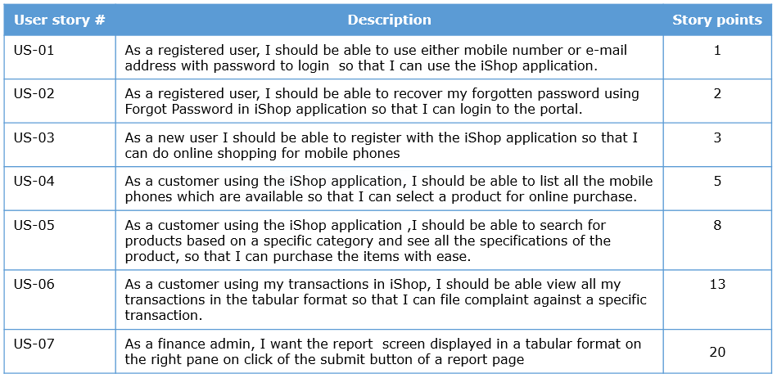

Story Point - Relative Estimation
The team then picks up the following story and tries to compare this with the relative baseline.
This story is similar to US-05 of the baseline with an additional complexity of advanced search. So it may be given 13 points.
Let us take another example
This story is similar to US-01 of the baseline and maybe given 1 story point
Additionally, wireframes may be provided of an earlier & similar application or for the new application. The teams can get a better view. The wireframes for login and search are shown below for your reference.
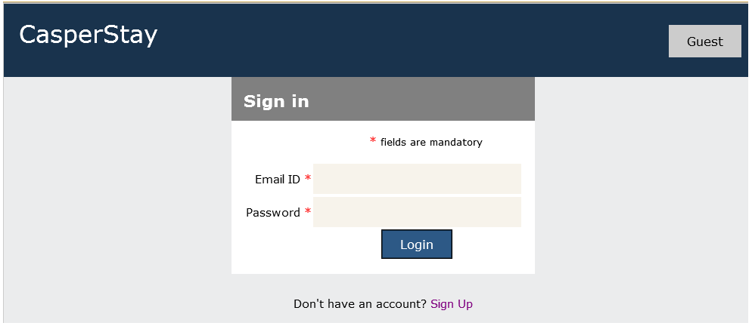
When we estimate with story points, we assign a point value to each item. A story that is assigned a 2 should be twice as much as a story that is assigned a 1. It should also be two-thirds of a story that is estimated as 3 story points.
Because story points represent the effort to develop a story, a team’s estimate must include everything that can affect the effort. That could include:
- The amount of work to do
- The complexity of the work
- Any risk or uncertainty in doing the work
Experienced team members can arrive at the relative baseline based on experience. This baseline expected to be reasonable and correct
Planning Poker Cards
The product owner, entire development team and scrum master participate in estimating the stories in the product backlog.
Planning poker game is used for estimation. A planning poker card set has cards with the following numbers and symbols and is used for playing the game.
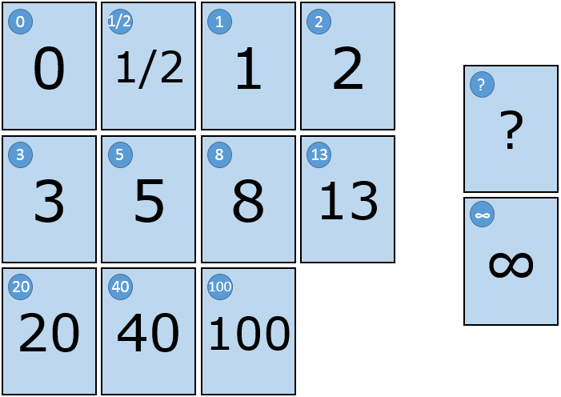
What do the numbers mean?
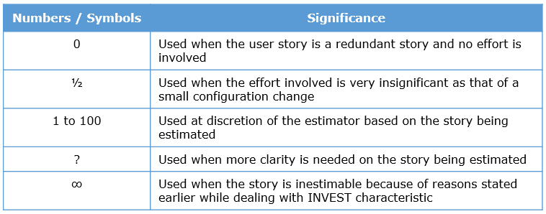
If you observe, the numbers shown above are of a modified Fibonacci sequence. It helps in bringing additional buffer considering the detailing that might happen to the story in its later stages.
For example, John is estimating a story and is contemplating on 8 as the story point for it. But subsequently he is convinced that it is worth more than 8 and the next option available with him is only 13. Though he might actually want to give it a 10 point, he ends up awarding 13 points thereby adding a buffer of 3 points to cover for the future potential changes that might happen to the story.
As an alternate to Fibonacci numbers, the following may also be used:
- Numeric Sizing (1 through 10)
- T-shirt sizing (XS, S, M, L, XL XXL, XXXL)
- Dog Points (Chihuahua,………,Great Dane)

Planning Poker Game

The Steps Involved
- Product Owner or representative will read out a story to the entire team
- Product Owner will clarify questions if any
- Each team member privately estimates and chooses a poker card with a point value
- All team member will simultaneously turn over his/her poker card for all members to see
- In case of consensus, the story point is recorded against the story
- If no consensus, the high and low estimators provide explanation and polling is conducted again
- Continue this process until consensus is reached, up to maximum of three (3) iterations
- If no consensus, Scrum master will decide the value

Story point estimation - Responsibilities of Scrum Master and Development Team

Scrum master must ensure
a. Relative baseline and story points are agreed upon by PO. Else, frequent conflicts on award of specific story points would happen
b. Participation of each Dev team member to provide story points without bias
c. Discussion among team members and clarification from customers on user stories

Development team
a. Participate in the poker planning game
b. Speak up on the concerns
c. Listen to the points provided by team members on the rationale for rating a story
d. Do not award story points due to bias with a specific team member
e. The discussions and story points are awarded to stories and not to individuals, do not take these personally

Story Points - Tips, Recap and Additional References

Practical tips
- All team members must participate
- Arriving at story points can be based on
  - Comparing the story being estimated with the baseline story in terms of the amount of work to be done
  - The complexity of the story being estimated
  - The challenges in implementing the story
- Product owner availability to resolve queries on the user stories is mandatory
- Less experienced team members can gain by listening to the team and should be allowed to give an unbiased opinion
- Planning poker can be anonymously played using websites like planningpoker.com
- If teams are distributed, the planning poker can be conducted at individual locations and representatives can sync up the results
- Offshore teams also should be involved in this activity

Quick recap
- Story point estimation is based on relative estimation technique
- Deciding story points can be based on
- The amount of work to be done
- The complexity of the work
- Any risk or uncertainty in doing the work

Additional References
- Video 1
- Video 2

Story Point Estimation - Quiz 1
Q1 of 3) Here is a scenario. Which of the option represents the most suitable reason?
The development team arrives at story points for the stories using Fibonacci sequence. The customer feels that the stories are overrated and is not happy with the estimation.
- The baseline for the estimation has not been vetted with the customer check
- The development team is incapable
- The Fibonacci sequence is not the right method and the team should try other techniques like t-shirt sizing
- The team should not be using story points, rather use effort in hours
Q2 of 3) Here is a scenario. State whether the action is true or false and correct if the action is false.
The development team finds it difficult to understand story points. So they create a pattern of mapping effort in hours to story points. Ex.a one story point will take one hour and hence a 5 story point will take 5 hours to develop. This is going to be used for across multiple development teams.
- True
- False check
Q3 of 3) One of the very experienced development team member is not convinced with the need for story point estimation. Which of the following statement(s) best describes the need for adoption of story point estimation method?
- Function and use case points are obsolete.
- During the initial phase requirements are not clear and the team capabilities may not be known and hence it is difficult to precisely estimate the effort for a user story in hours. check
- Scrum follows story points
- They allow the team to think on just enough things to estimate rather than go into too much detail on the effort part. check
- Relative estimation with a team helps normalize the estimates check

Story Point Estimation - Activity 1

ProblemStatement:

Objective
Estimate user stories as one of the development team member.
Note
To arrive at story points, in reality, the team consensus is needed. But as an individual learner you can do this assignment to try estimating the individual stories without the team and cross check with the possible solutions.
Task
Estimate the given product backlog using story points against a relative baseline.
Note
The first story is given 5 story points which can be used as a baseline for estimation of the other stories. You may also use the sample baseline provided earlier.
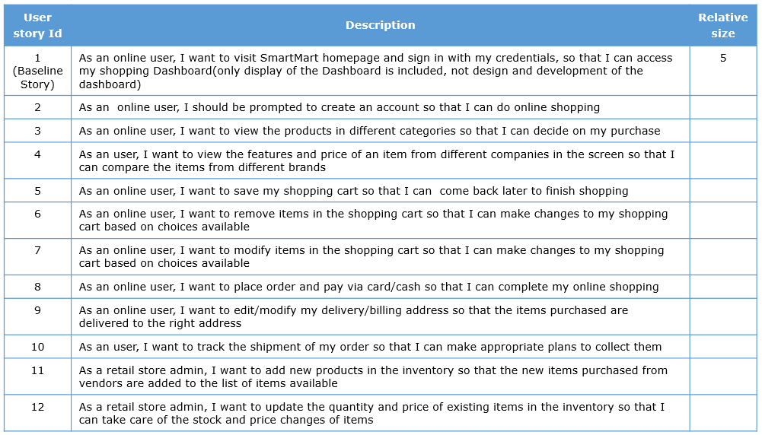

Note: You can download this activity as a document here

Story Point Estimation - Activity 1- Possible solution
Each individual may come up with his own number which are correct with respect to the individual. When the same is done as a team, every member would come up with estimation and the scrum master would facilitate in arriving at a decision on what could be the story point for the story.
A sample estimation is given below. Please note that the points provided here are subjective based on the assumed conversation to have happened with the customer.
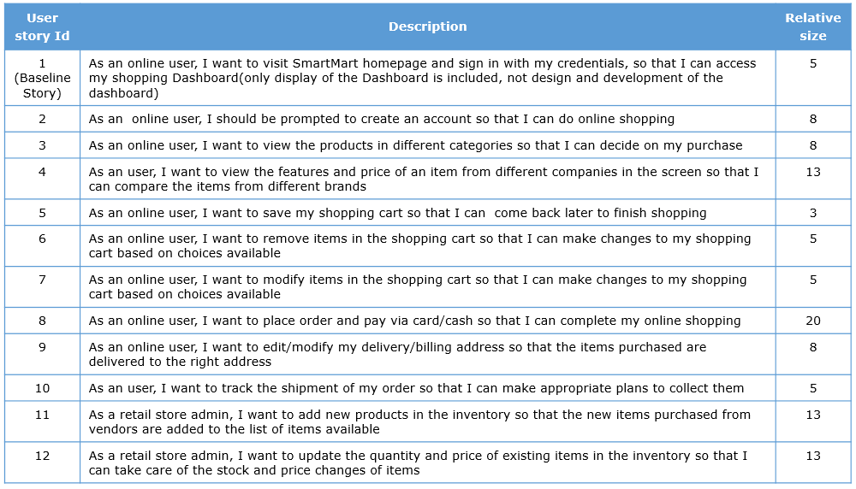

Sprint Duration
Sprint Duration
Once the user stories are estimated using story points, the length of the sprints are to be decided.
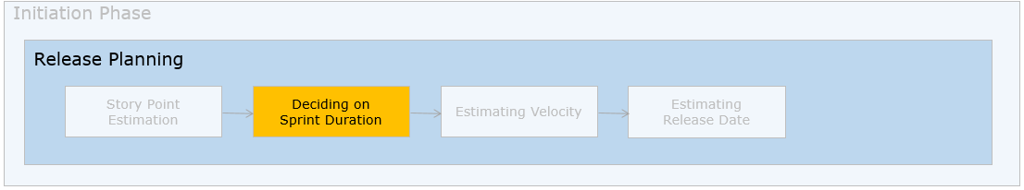
The scrum teams and the technical officer now want to decide the duration of a sprint. For EasyGarb here are the parameters to be considered.
- The technical officer is available for clarification of queries and reviews
- Dynamic changes can be expected
- Early release and early feedback is expected
- There are no overheads or dependencies with other teams except Paypal
- The project is expected to be completed in about 6 months time
Hence they decide on a 2-week duration for the sprint. Let us now try and understand how to decide on the sprint duration.

Sprint Duration - Factors to consider

Need
This is required to set the cadence of development for the development teams and also help arrive at the release date.

What can be the sprint duration?
The sprint duration has to be apt to deliver increments as expected by the customer. In general, the sprint duration is usually fixed between 2 to 4 weeks.

How to arrive at the apt sprint duration?
Here are the inputs to deciding the sprint duration:
Product owner availability
The technical officer at EasyGarb is available to clarify queries and is ready to come every two weeks for sprint review.
Inference : PO availability is there
Project duration
Application is expected to be rolled out in a maximum of six months’ time to leverage business benefits in a phased manner
Inference : Project duration is short and urgency of releases is high
Nature of project
Application is expected to evolve over a period of time as the team can expect a number of changes owing to the B2C nature and the inherent market competition
Inference: Uncertainties, priority and frequency changes can be expected to be high
Overhead in iterations
The entire lifecycle is taken care by EasyGarb team and there is no dependency on any external vendor. Also, the technology used supports automation and hence the overhead in iterations is minimal
Team
The team is new to Agile software development and B2C(Business to customer) kind of dynamic nature of applications
Inference: They are likely to go wrong and hence early feedback would help the team.
Given these inputs, the PO, Scrum master and Dev Team decide on two week iterations.

Rationale
Two week sprints/iterations represent a decent time frame to develop and deploy small features, help provide early feedback, incorporate changes in priority and features. Since PO is available for answering of queries, this would be a good duration to start with.

Factors influencing sprint duration
To decide 2, 3 or 4 weeks, the following factors are generally considered.

Factors influencing the sprint duration
- Longevity of the project/release
- Urgency of releases
- Uncertainties in the project
- Availability of stakeholders and easiness to get their feedback
- Overhead in iterations
- Frequency of priority changes
Once fixed, sprint duration is not changed during the life cycle of the project.
The sprint duration is not preferred outside beyond 2 to 4 weeks boundary for the following reasons.
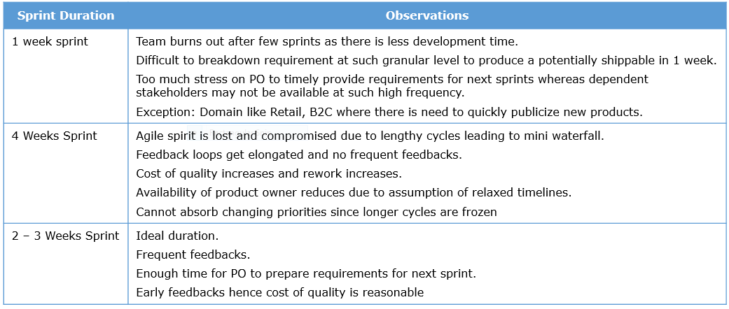

Velocity Computation
Velocity Estimation
The next step in release planning is to be able to gauge how much of work can a team produce in each sprint i.e., the velocity of the development team.
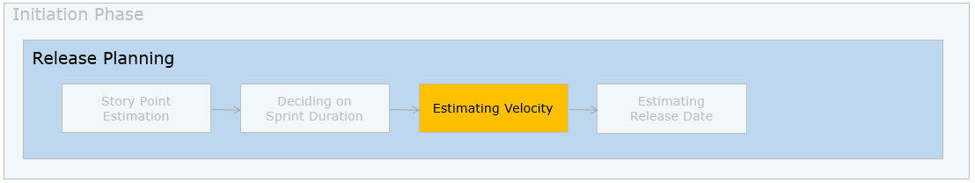
The PO played by the technical officer, Scrum masters and Dev teams at EasyGarb now want to arrive at the release date based on the story points estimated, sprint duration decided and the number of story points that the team can pick up in one sprint.

Need
The story points do not precisely provide the effort in days. The team therefore needs a metric that will help convert the abstract story points to effort metrics ie. the release date. This will also serve as a measure of progress for the team in terms of how many story points they burn in a sprint.

What is velocity?
The number of story points that the team can complete in one sprint is called velocity. Velocity of a team represents the speed at which teams are moving forward with agility. It is an important metric which is measured in Agile software development.
How to compute velocity of team?
The technical officer at EasyGarb, in the capacity of the product owner, is keen in knowing the capability of the development teams on job and get a projection of how much can they deliver in each iteration.
Here is the profile of the teams.
Development Team #1 profile (Size 9)
The team is highly matured with average experience of 8 years.
The same team has earlier worked in “SmartGold” project for a different customer but in the same PHP technology and e-commerce domain.
The team has been successfully doing their “SmartGold” project using scrum with a sprint duration of 2 weeks and an average velocity of 30.
The entire team works out of the same location – Chennai, India
Inference
Development Team #1 is highly matured, co-located and has the huge advantage of having worked in an earlier project of the same domain and technology. Hence their velocity in the earlier project, 30 is taken as the projected velocity in the current ‘EasyGarb’ project.
Development Team #2 profile (Size 9)
The team is matured with an average experience of 5 years.
The team has no prior experience of working in agile scrum framework projects.
However, as individuals, they have a good track record of living up to expectations of the customer and delivering as promised.
The entire team works out of the same location – Bangalore, India
Inference
Development Team #2 is reasonably matured, co-located and has proven track records as individuals. Going with their ability to commit work and honor them consistently, they are asked to simulate a sprint of 2 weeks, work on the team capacity planning for the sprint and commit as many stories as possible for that duration. The team was able to commit 7 user stories with their story points adding up to 25. Hence the velocity of Team #2 is projected as 20 to 25.
Development Team #3 profile (Size 9)
The team is relatively younger with majority of freshers and a couple of experienced members. Average experience is 3.5 years.
The team has not worked in projects of this size earlier.
Majority of the team being freshers, they are dependent on the seniors in the team to hand-hold them on several aspects of the project
The team is present across two locations – Mysore and Pune.
Inference
Development Team #3 is nascent in terms of skills and project experience. They are also distributed in their presence. Hence it is quite difficult to comment on their velocity at this point of time.
Though the three teams are about to work in the same – project, domain, technology with the same customer, their velocity could as well be different.
The product owner agrees to wait until couple of actual sprints to hear a commitment on their velocity.

Methods to compute velocity
Velocity is determined using one of the following three methods:
- Historical data – same team, same technology and domain
- From actual values – running few sprints
- Guessing velocity from effort – capacity planning
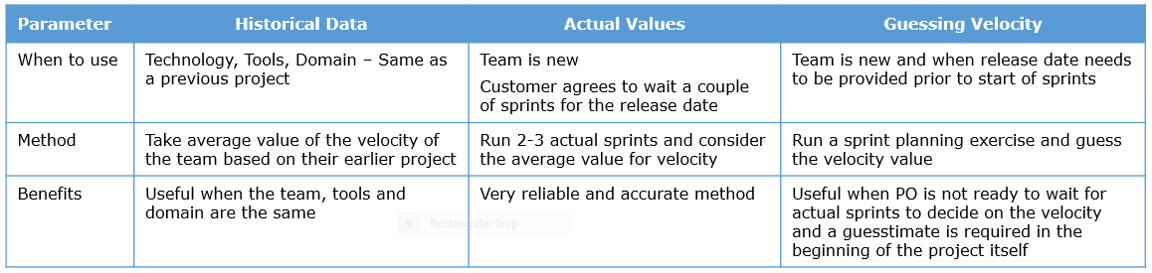

Practical tips
- Velocity is specific to a team and hence cannot be baselined or reused
- Velocity cannot be generalized across projects
- Velocity depends on the capabilities of the specific team

Release Date Computation
Release Date Computation
The final step in release planning is to arrive at the release date to be shared with the product owner.

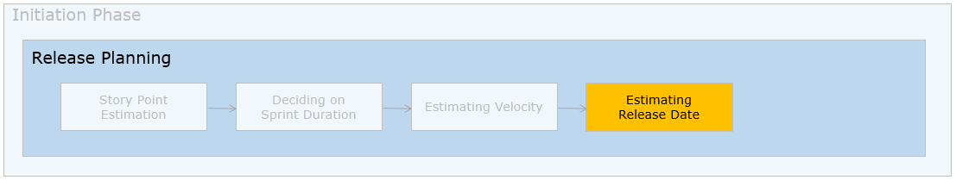
The PO, Dev teams and scrum masters at EasyGarb want to know the tentative release date for the project so that the senior management can accordingly strategize their business.
The following inputs are available with the technical officer.

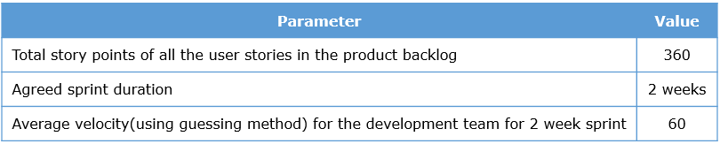
The tentative release date is calculated as follows.
Total Story Points (TSP) = 360
Number of sprints required = TSP / Velocity = 360/60 = 6 Sprints
25% Buffer = 2 Sprints
1 Pre-release Sprint = 1 Sprint
Total Number of Weeks = 9 Sprints X 2 Weeks each = 18 Weeks
Tentative Release Date: 18 weeks from 02-Apr-2017 = 04 Jul 2017 (Approximate)

Estimation of Release Date – The Process

Need
Release date provides the team a rough estimate of the completion of a given set of requirements.

Assumptions
To arrive at the tentative release date for a project, the following assumptions are made.
- The product backlog is estimated and each user story has been awarded story points
- The velocity of the development teams involved has been estimated
- Going by these assumptions, the Product Owner estimates the release date as per the following calculation
Step 1: Divide the total story points for the product backlog by the velocity to get the number of sprints
Step 2:Multiply the number of sprints by the sprint duration (in weeks)
Step 3:Add Buffer-
- Towards Uncertainty (for example: 15%)
- For Improvement and rework (for example: 10%)
Step 4:One Pre-release sprint (to go from potentially shippable to actually “shipped”)

Release Date Computation - Activity

ProblemStatement:
Consider the following data for a project
Total story points is 80
Velocity of team is 10
Sprint duration is 2 weeks
How many sprints/weeks does it take to complete this project ?

Release Date Computation - Possible solution
Total number of sprints=80/10=8 sprints
Add 25% buffer =2 sprints
Add pre-release sprint=1 sprint
Total no. of sprints =11 sprints
Release date =11x2=22 weeks from start date

Release Burndown Chart
Release Burndown Chart
The technical officer wants to track the progress of the team on a sprint on sprint basis. So they decide to draw a release burn down chart. Based on the release date computed, the release burndown chart is drawn.

Need
The release burndown chart is useful to the product owner and provides an idea of the progress

How is the burndown chart drawn?
On the X-axis, the number of sprints required are plotted. On the Y-axis, the story points to be burnt down are plotted. A line is drawn connecting the total story points planned on the Y-axis to the last sprint in the X-axis which represents the ideal line.
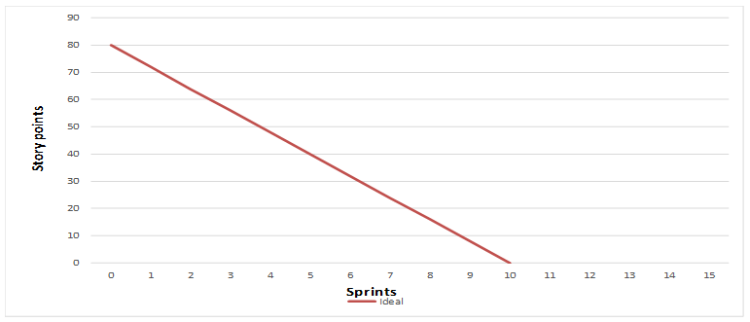

Inferences from the burndown chart
The above chart illustrates that 80 story points need to be burned down across 10 sprints (including 2 buffer sprints) after which the pre-release sprint would happen and finally the product would be released to the customer after 11 sprints.
As the actual sprints happen, the progress is kept track of at the end of each sprint and it is also marked in the release burn down chart as seen below.
Let us consider the burndown chart of a team whose progress is given.
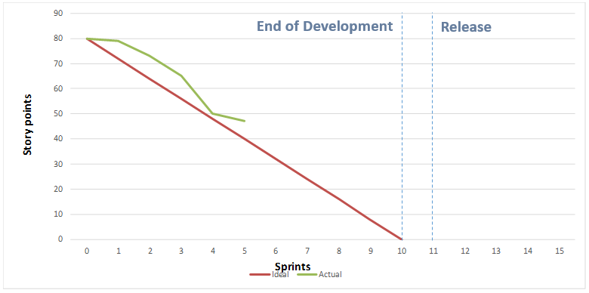
Observing the above chart, following are the inferences.
- The progress is behind schedule at the end of Sprints – 1,2,3
- The progress is on track at the end of Sprint 4
- The progress is again behind schedule at the end of Sprint 5
Having observed the performance of the development teams across 5 sprints and with only 5 more sprints left, the pattern is extrapolated to predict the further progress.
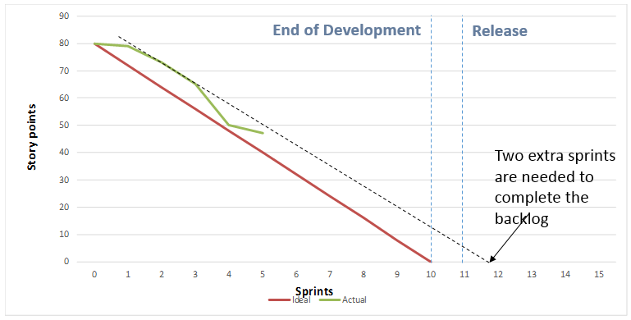
The above chart indicates the following.
- Going by the current trend, all the 80 story points can’t be delivered at the end of 10 sprints as projected earlier
- It would take 2 more sprints to deliver all the 80 story points (deferred by 2 sprints)
- The pre-release sprint would be after the 12th sprint
The current projection is disclosed to the Product Owner. The following decisions may be taken:
- Agreed deadline / release date cannot be changed and hence de-scoping of requirements can be done. If requirements in the form of user stories are prioritized properly (say MoSCoW), the stories that will be de-scoped will be those which are "could have" (C) or "won’t have"(W) items.
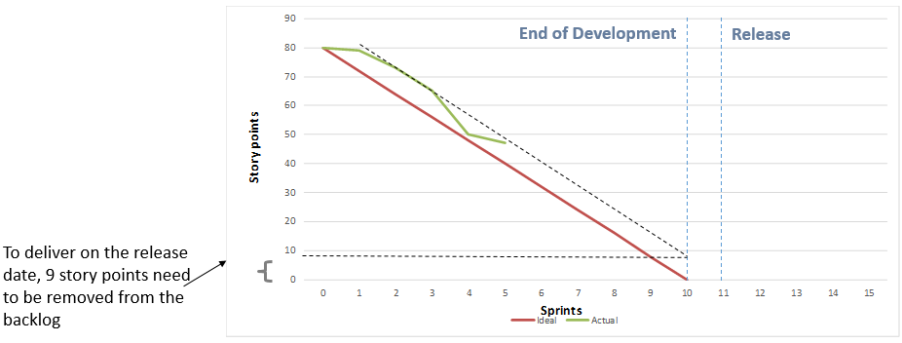
- The other option for the product owner is to extend the release date to ensure the completion of all the items.
This is how the release plan is handled and the projection is shared with the customer. The tracking part of it happens much later during the actual sprints.

Release Burndown Chart - Responsibilities of Scrum Master and Development Team

Scrum master must ensure
a. If there is scope creep, the release date cannot be the same
b. If release date needs to be the same, some story points need to be removed from the product backlog equivalent to those added new
c. Any changes suggested need to be measured and if they measure beyond a specific story point, need to be added as a new item in the product backlog

Development team
a. Focus on delivering high value items (based on balance of the prioritization techniques discussed) to the customer sprint on sprint
b. High risk items should not be pushed to the end of the project nor the beginning
c. Team can commit to items which they feel are convenient for them to develop first so that the morale is kept high

Guidelines and tips for release planning when teams are distributed
At Infosys, many of the large account projects run in distributed mode ie. Dev teams and or PO are in distributed locations. Teams are also ramped up slowly and steadily in projects.

Scrum practices for Sprint 0 when teams are distributed
1) Infrastructure and tooling investment/support
- Big room planning – bring stakeholders together physically or virtually together
- Usage of application life cycle management(ALM) tools like Rally, Jira, TFS
- Collaboration tools to promote conversation and communication – VOIP phones, Confluence, Lync based on demand video conference
2) PO is not co-located
- Availability of PO or proxy PO to clarify questions during time zone overlap
- Ensure commitment of PO to prioritization of product backlog
- Setup of PO time for calls with team to clarify questions
3) Teams are distributed
- Have local teams prioritize and estimate and arrive at a ranking
- The local team scrum masters to sync up on the ranking and then vet with the product owner
- Ensure team and PO meet (see each other) on regular basis through video conference
- Offshore teams equally participate in the release planning activities. Onsite teams do not decide priorities and story points and push the same to offshore teams
4) Metrics
- Standardization of metrics and cadence for performing the activities between the teams

Scaling Scrum
- Scaling of teams and ramp up is done slowly and steadily
- Team members who are matured can help in scaling and ramping up new teams
- Scrum masters are local, senior team members also double up as scrum masters

Additional references:
Best practices when teams are distributed - Case study

Team Enablement
Let us now move on and focus on how to do the team enablement.
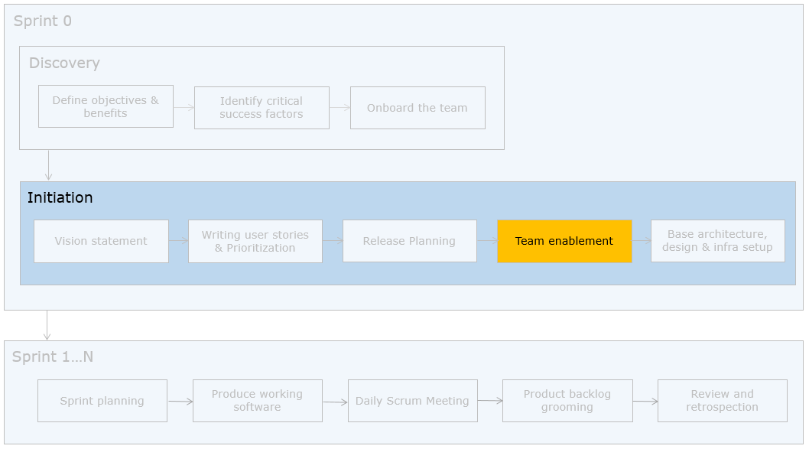
The scrum masters collaborate with the learning department of EasyGarb and formalize the training programs for the teams.

Need
This step is important because teams need to understand the philosophy of scrum. This will also remove unnecessary apprehensions (my job role will go away, my work will get exposed etc..) that the might have while moving to scrum.

How is the enablement done?
Teams can take up internal training programs and also certifications.
At Infosys, ETA conducts specific training programs in Scrum and related areas. There is also an internal certification available.

Base Architecture Design and Infrastructure Set up
Base Architecture, Design and Infrastructure Set up
Having enabled the team, let us understand the setting up of base architecture, design and infrastructure.
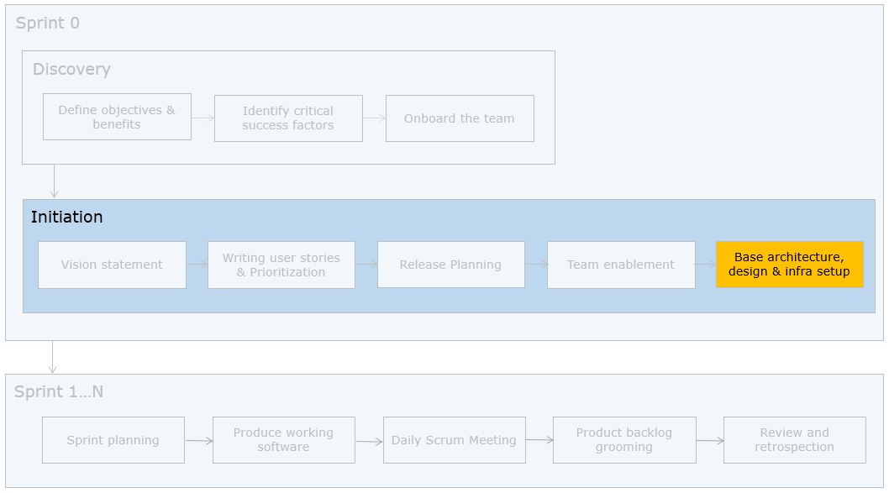
The team at EasyGarb feel that this project needs intensive architecture and design before proceeding to sprints. They also have few features for which they want to try out some new technologies. The technical officer feels the need to have infrastructure set up for communication as the teams are distributed.

Need
Teams may need to spend time on base architecture and design before proceeding to sprint. If it is very intensive, a couple of sprints may be spent on architecture and design also. However "Water scrumming" / "Scrum fall" is to be avoided. ie., creating a mini water fall with in the scrum (few sprints on requirements, then few sprints on design etc..)

How is this done?
Teams can use standard design practices (design patterns, emergent design etc.) to arrive at the base architecture and design. The design made however needs to lend itself to change.
The tooling and infra required (testing environments, communication etc..) need to be decided here. This becomes even more important when the teams are distributed.

Additional references:
Design and Agile

Release Planning - Summary
Release Planning - Practical Tips, Quick Recap and Additional References

Practical Tips
- It is good to do release planning as a co-located activity
- Both onsite and offshore teams should be involved in prioritization and estimation
- There is no baselined value for Velocity since it is very specific to the team
- If new items are added or major changes are suggested to existing user stories, they need to be measured and the release date should be revisited

Quick Recap
- Sprint 0 and Initiation phase does the just enough planning required for the project
- This phase can span about 2-3 weeks and it involves the following
  - Communication of vision statement and team onboarding
  - User Story writing
  - Prioritization
  - Story Point estimation
  - Computing the sprint duration, velocity and release date
  - Team enablement
  - Base Architecture, design and infrastructure set up

References
Traditional pricing models and contracts when used for Agile, need to be written with appropriate clauses. You can more about this here.
Video: Release Planning
We have completed the release planning for the Project. Now let us see how to execute the sprints (1 to N).

Sprint Planning
Sprint 1 to N
Let us revisit the big picture and activities in the sprint.
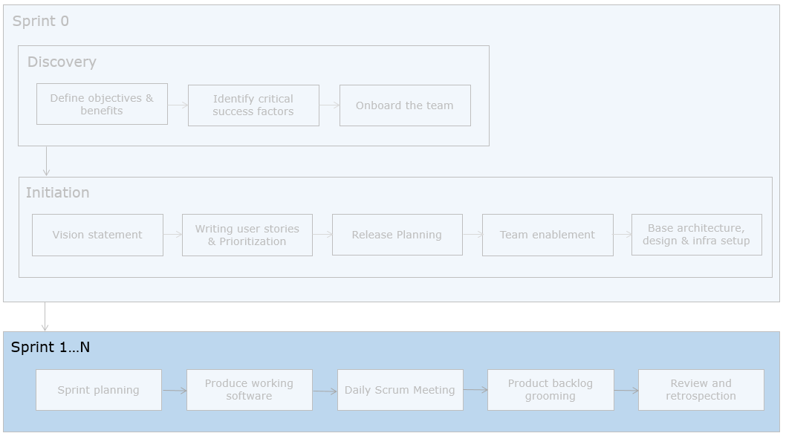
The development team at EasyGarb have come up with the release date. They are now ready to start the first sprint.

Sprint Planning
The first section in Sprint 1 to N is sprint planning. This is one of the four ceremonies of the sprint.
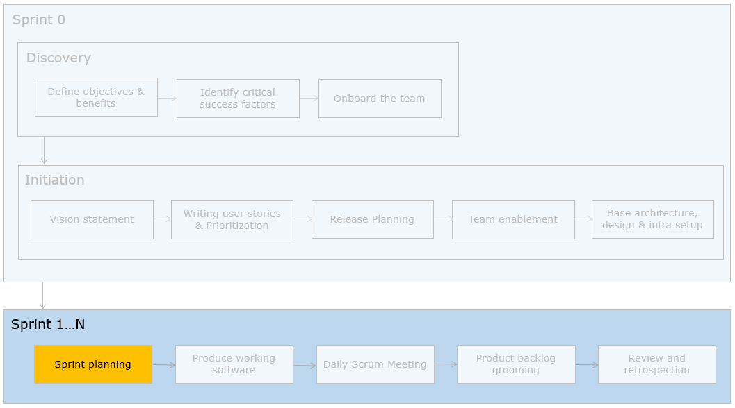
The EasyGarb Product backlog has been split and provided to the 5 scrum teams. They, with their respective scrum masters start the sprint planning meeting. They decide to do it in two parts. Part one, where the technical officer will be available. Part two, where they will arrive at the tasks and do the effort estimation.

Structure of a Scrum Cycle (Sprint)
The structure of a sprint / scrum cycle is as given below.
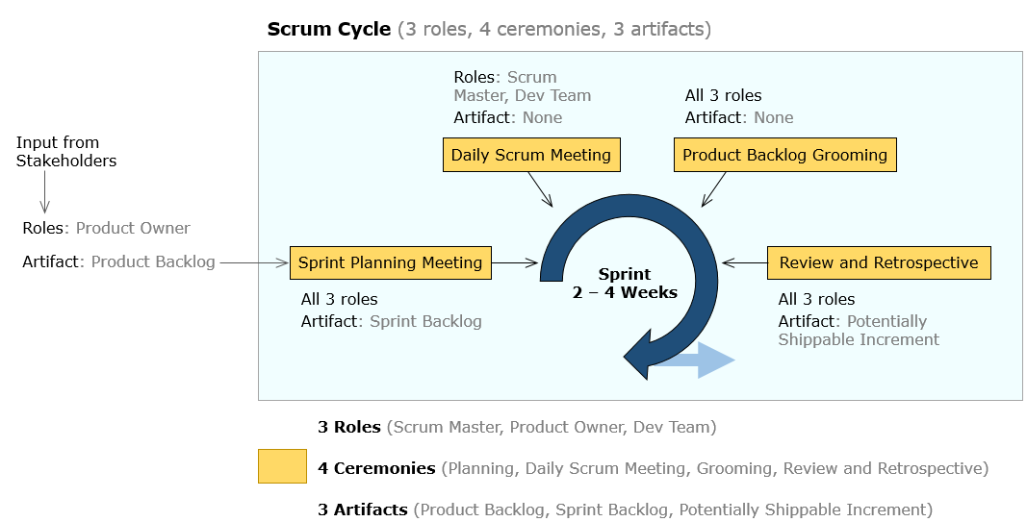

Let us walk through the sprint planning activities with one of the 5 scrum teams - Team 1.

Sprint Planning - The Need

Need
This is the planning done for a sprint. It involves micro level planning for the user stories that would be developed during the sprint based on the prioritized order. Planning in small pieces for what is in sight contributes to value driven development.

When who does sprint planning?
The sprint planning is done during every sprint and is an integral part of it. The scrum master facilitates the planning with the entire development team. The product owner needs to be available to clarify questions on user stories picked for that sprint.

How long is sprint planning?
The Scrum guideline says, half a day for a two-week sprint. This can be pro-rated as per sprint duration.

How is sprint planning done?
Here are the activities done as part of sprint planning.
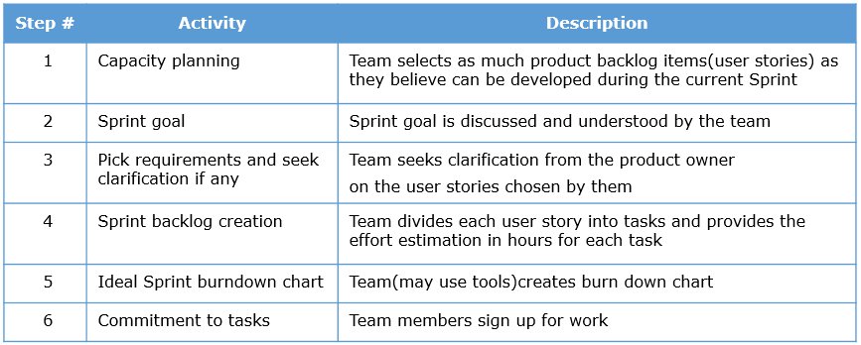

Capacity Planning
How much work is to be picked up in a sprint is decided using capacity planning based on team’s availability.
Consider the capacity of EasyGarb's Team 1.
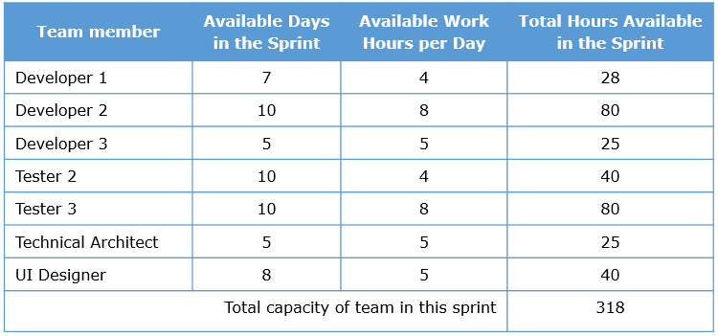
Can the team plan for 318 hours? No. Time needs to be deducted for scrum ceremonies, other official work, contingencies and rework.
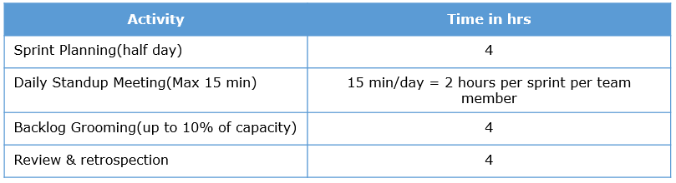
Time for other things (contingencies, rework and other official work)
A buffer of 5-10% is considered for this. However, the teams can alter this percentage based on the project and team context and in agreement with the PO.
For Team 1, here is the calculation
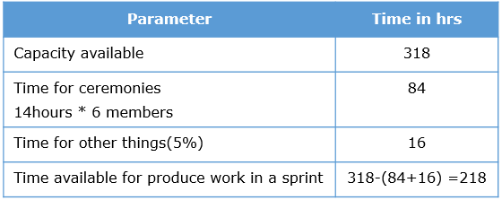
Therefore Team 1 can plan close to 218 hours of work in this sprint.

Key points to consider
- Wherever possible, consider actual availability. In the example considered–
  - The technical architect is a shared talent
  - Developer 1 is available only for 7 days, 4 hrs. a day
- Add more buffer for unplanned leaves, if teams are new to agile, fresh developers involvement and dependencies
- This effort estimate for tasks will get better with sprints
Sprint Goal

Sprint goal
The PO may have a sprint goal or a theme and hence the user stories meeting the sprint goal are picked up by the development team. This is generally a shared understanding and in alignment with prioritization done.

Pick requirements and seek clarification if any
The user stories are picked and if any clarification is required, the PO provides the same. The PO need not be available throughout the sprint planning activity. In case of distributed scrum, these queries can be answered during a pre-fixed overlap time period.

Sprint Backlog Creation
The sprint backlog is the deliverable of sprint planning. This consists of the list of tasks and the effort estimation in hours. An example sprint backlog item is shown here.
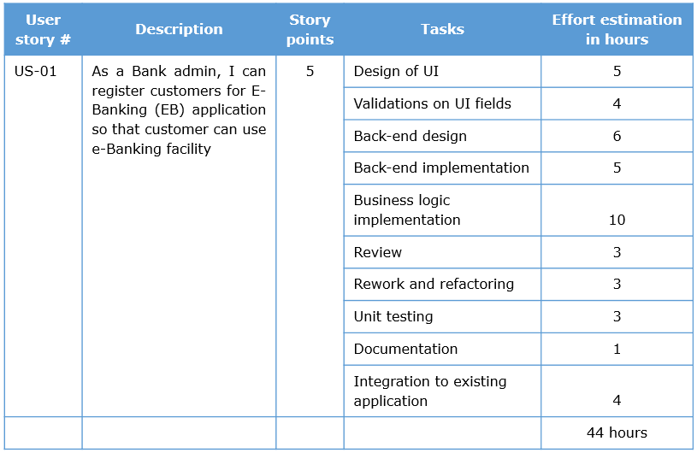

Task Splitting
This is based on -
- Analysis
- Business logic involved in the story and acceptance criteria
- Architecture changes, Design, UI, database changes, coding, testing, documentation activities
- Activities that need to be done to meet the “Definition of done”
- Other activities like meetings, reporting etc
- Debugging or fixing defects(of the code developed in the current /previous iteration/sprint)

Identification of how many user stories to commit in a sprint
- The total capacity is known, example 218 hours
- The first story is picked up, split into tasks and the total effort calculated
- This is subtracted from 218
- The next user story is taken up and the same is repeated
- This is continued till the effort for the user stories identified is close to 218
Example:
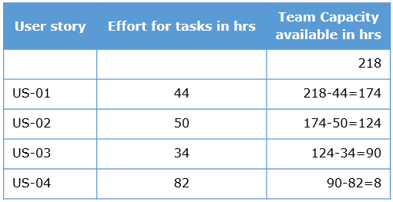
Total effort = 210 hours which is close to 218.
8 hrs. is added to the buffer time.

Task sizing
The size of a single task should not exceed 12 hours.
Ideal Sprint Burndown Chart
Based on the capacity available and the total number of tasks planned, an ideal sprint burndown chart is drawn/created using ALM(application lifecycle management) tools.
X-axis contains the number of days in the sprint and Y-axis represents the number of hours of effort pending. A line is drawn connecting the hours planned on the Y-axis to the last day of the sprint in the X-axis which represents the ideal line.
The burndown chart given below shows the number of hours planned as 210(close to 218 calculated earlier) against a two week sprint(10 working days).
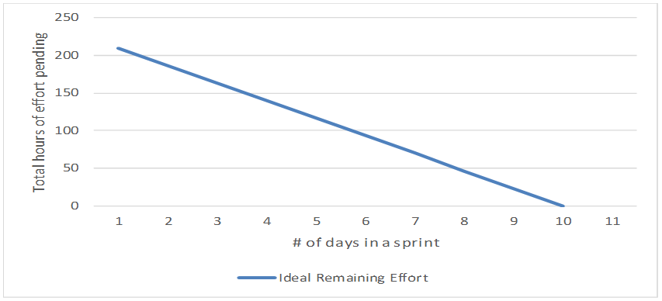
Inference: If the team burndown 210/10 ie. 21 hours per day, at the end of day 10 they will have 0 hours of pending work.
The team commits to the tasks identified in the sprint backlog as per their skills and need. It is good for the team to be cross-functional as there would be no team member who would be idle.

Sprint Planning - Responsibilities of Scrum Master and Development Team

Scrum Master
- Facilitation and closure of sprint planning as per time-box
- Ensure team participation and commitment
- Ensure PO answers queries on user stories
- Help team meet the sprint goal

Development Team
- Estimate and commit to tasks
- Modularize and split tasks to lowest level
- Provide reasonable estimates

Sprint Planning - Practical Tips, Quick Recap and Additional References

Practical tips
- Sprint planning should involve the whole team
- If team is distributed across time zones
  - Start the sprint during mid-week
  - If sprint has to start on a Monday, do the sprint planning for a sprint during the last working day of the previous sprint itself
- Estimates of freshers will get better with time
- Tasks and estimates should be committed by team members and not delegated to. This brings collective ownership
- Task sizing should be between 0.5 - 12 hours
- DOD, acceptance criteria and retrospection points are inputs to creation of sprint backlog
- No team member should be idle, task splitup should be done to keep all team members engaged during sprint to utilize full capacity
- Beginners find it difficult to split tasks to the micro level, scrum masters must ensure that sprint planning happens as per scrum guidelines
- If the scrum master participates in the sprint produce work, the capacity can be included.Otherwise the scrum master responsibilities are not included in the capacity planning

Quick Recap
- Sprint Planning meeting is the first ceremony to happen in a sprint
- It's a time-boxed activity
- It has 2 parts -
a) clarification from product owner on picked user stories
b) Splitting user stories into tasks and their effort estimation

Additional references
Sprinting ahead in Agile
Practical tips for sprint planning

Capacity Planning - Exercise

ProblemStatement:

Objective
Calculate the team's capacity in a sprint considering the availability of the team members.
Task
Calculate capacity of the following team in hours, for the upcoming 2 week sprint:
- The Company has a 5 day week and 8 working hours per day
- The team has 8 members
- 1 member is on vacation for a week
- 2 team members are in training for 2.5 days each
- 1 team member is being shared by another project so he is available for only 50% of the time
- 25% of the day time to respond to emails and meetings etc for all the team members

Note: You can download this activity as a document here

Sprint Planning - Part 2
Based on the values provided, the following solution is arrived at.
Answer: 390 hours
Rationale
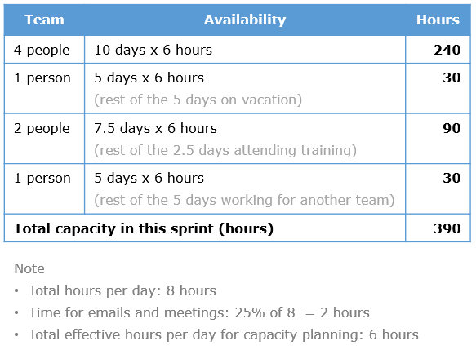

Split Stories Into Task and Estimate - Activity
Split Stories Into Task and Estimate

ProblemStatement:

Objective
Creation of a sprint backlog by splitting the user stories into tasks and also estimating it.
Task
For the product backlog given below, split the stories into tasks and provide the effort estimation for these tasks.
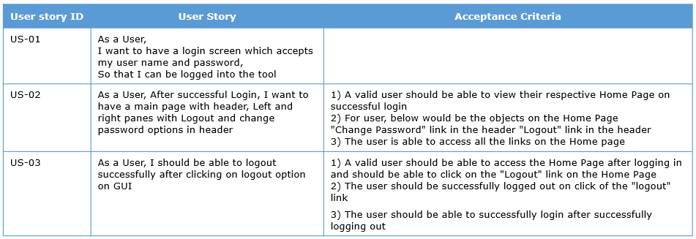

Sprint Planning - Possible solution
Split Stories into task and estimate – Solution
Following is a sample of US-01 split into tasks. Effort estimates depend on the individuals and hence is not given.
- Designing the UI
- Username Password Validation
- Backend Design
- Business Layer Implementation
- Review
- Rework and refactoring
- Unit testing
- Documentation
- Integration to existing application

Sprint Planning - Quiz 1
Q1 of 1)One of the programmers in a development team splits the user story into task of size 20 hours each. Is this correct?
- True
- False check

Produce Working Software
Producing the working software is the next step with the stories that have been committed for the sprint.
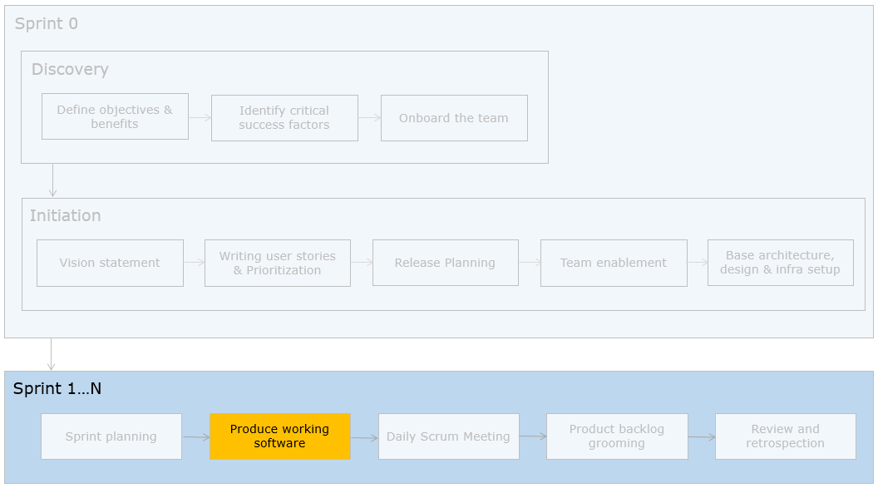
The EasyGarb team starts to develop, test and release user stories committed for the sprint. They use a visual board to track the progress. Let us discuss on the visual board and how to track the sprint progress.

Need
This represents the produce phase of the sprint. The development team need to execute the tasks committed in the sprint backlog to produce working increments of software.

When who produces software?
The development team produces the working software during the sprint as per the capacity calculated. The scrum master facilitates this activity by ensuring impediments are removed and the user story clarifications are resolved with Product owner.

How long is this phase?
This spans as per the actual capacity calculated, typically 7.5-8 days for a two week sprint

How is working software produced?
The development team uses a visual board to keep progress of the tasks. The initial visual board is shown below.
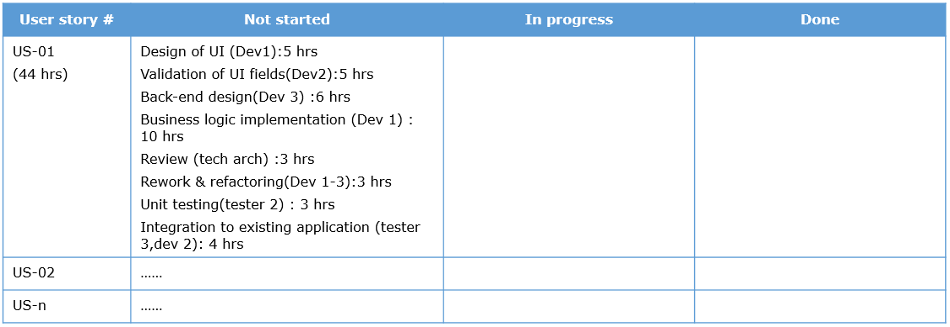
The Dev team members start working on the tasks and at the end of each day, they update the progress of the tasks. A sample after day 1 is shown.
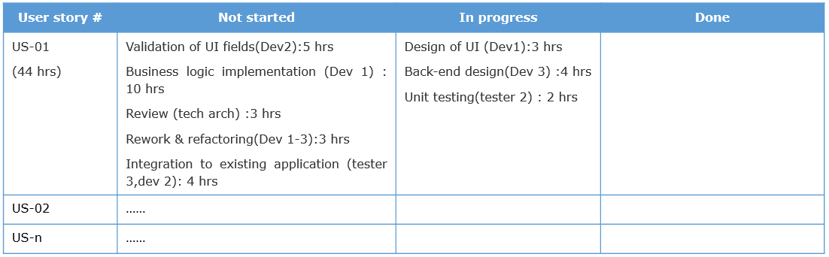
This way the development team members keep updating the tasks and the effort in hours pending against each task. Once the tasks are done, they are moved to the done column.

Deliverable
This phase results in a potentially shippable increment. Examples –
- POC to show that a concept is working
- Query to prove a database design
- Skeleton code to prove a design
- Designs following specific design patterns
- Working increment of some feature

Updating Burn down Chart
As the tasks get updated, the actual progress gets recorded in the sprint burndown chart. If the actual progress line is above the bench mark, the team is lagging. If it is below, the team is doing well and before time. The progress line should be around the bench mark. This chart provides a good idea of progress to the team, PO and scrum master. A sample is shown.
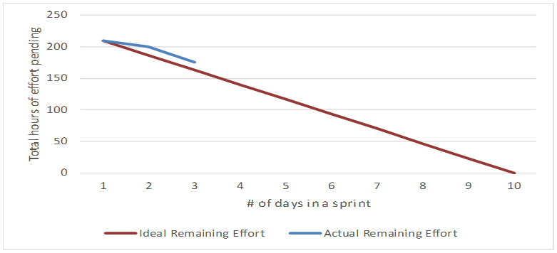

Tools Used

Tools used
If it is a co-located team, a white board with yellow sticky notes can be used to represent the visual board and the tasks respectively. If teams are distributed, ALM tools like Jira (from Atlassian) provide a similar interface. A sample Jira visual board is shown here.
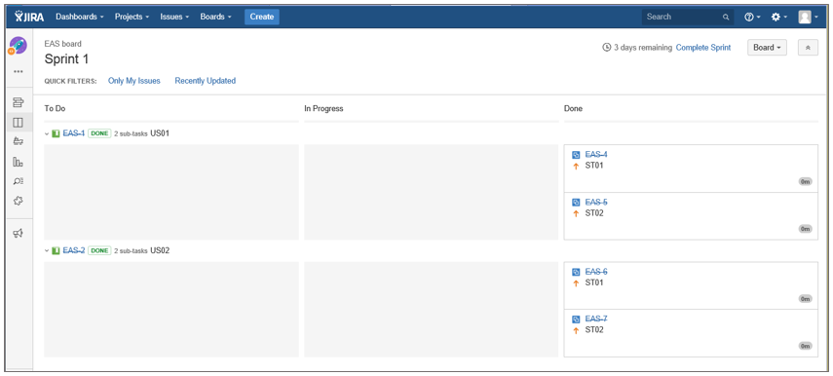
A sample sprint burn down chart generated in Jira is shown below.
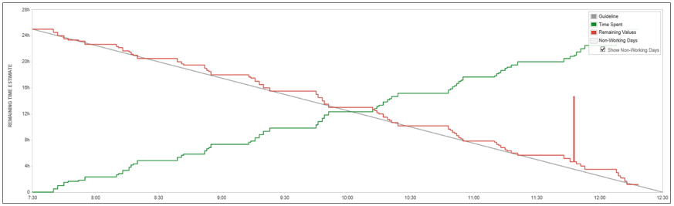

Produce working software - Responsibilities of Scrum master and Development Team

Scrum Master
- Ensure that team members update the tasks on regular basis
- Ensure that the data is correct and not manipulated
- Sensitize team members who do not update tasks on regular basis

Development Team
- Update tasks with correct effort
  - If a task takes more effort than estimated, mention the same
- Update tasks at the end of the day/ when completed whichever is earlier
- Task updation is for the entire team to know the progress and not to judge any single team member on their performance
- Focus on producing working versions
Produce working software - Practical Tips, Quick Recap and Additional References

Practical tips
- Scrum masters can look at the actual effort taken for a task and take corrective action when planning for next sprint
- Mentor team members on the importance of updating tasks
- Changes to the current sprint should not be accepted
- Every sprint may not result in deployable code, however, it should be an integrated and working increment
- If the team does not meet the commitments, the reasons need to be discussed during retrospective meeting. The sprint targets are only estimates and not a guarantee
- The pending items, if any, may be taken in the next or subsequent sprints based on inputs from the product owner

Quick Recap
- The team has to be self organized and produce good quality working software to meet the sprint goals
- Visual board is used to track the progress
- The sprint burn down chart is updated on a daily basis

Additional references
- Sprinting ahead in Agile

Produce Working Software - Quiz 1
Q1 of 3) One of the Scrum teams have created high level(HLD) and low level design documents(LLD) and brought it for sprint review. Choose the statements which are true with respect to this scenario.
- HLD and DLD documents do not represent working increments check
- These documents represent the deliverables at the end of design sprint
- A skeleton code / wireframes to prove the design represents a working increment check
- The PO can review the HLD and DLD as they represent working increment
Q2 of 3) One of the scrum teams planned for 240 hours of work in a sprint (10 days).
The team has been gradually progressing and completing the planned tasks.
But, their sprint burn down chart shows 240 hours pending across 9 days and 0 hours pending on the 10th day.
What could be the reason for this?
- The team members have not updated their work regularly and have updated it on the last day check
- The team members have to update their work only at the end of the sprint
- There may have been many changes during the sprint
- There is no problem with this sprint burndown chart
Q3 of 3) What action should the scrum master take if the team members do not update the task efforts?
- Sensitize and provide mild penalties, check the status before standup meeting check
- No action to be taken by scrum master
- Manipulate the sprint burndown chart to make it closer to ideal line

Daily Scrum Meeting
Daily Scrum Meeting
The daily scrum meeting is done during every day of the sprint to share the daily progress and impediments. This is one of the four ceremonies of the sprint.
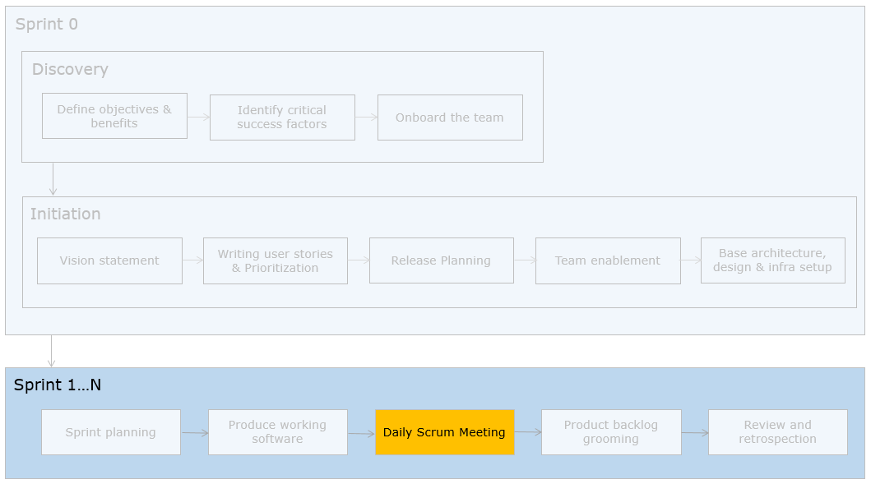
The scrum masters of the EasyGarb teams ask their team members to update their progress of their task and then participate in the daily scrum meeting. The meeting is done for 15 minutes everyday based on the convenience of the team members. Let us understand the details.

Need
The development teams, scrum master and the product owner need to be aware about the progress of the team and impediments (if any). A daily scrum meeting (aka daily standup meeting) brings the team together and each member updates the progress and the issues impeding it.

When is and who participates in a daily scrum meeting?
The entire development team participates in the daily standup which happens every day for 15 minutes. It is facilitated by the scrum master.

How is the standup meeting conducted?
The standup meeting is done for 15 minutes every day at a pre-decided time. The team members and scrum master stand in a circle. Each team member says three things –
- What did I do yesterday?
- What will I do today?
- What is blocking me?
Everybody listens and there are no discussions. The latter can happen post this meeting where the scrum master can work at removing the impediments

Daily Scrum Meeting - Responsibilities of Scrum Master and Development Team

Scrum master must ensure
- team members speak up during the standup
- standup meeting happens only for 15 minutes and there are no discussions
- penalties if team members do not turn up for the standup or are late

Development team
- Speak up the impediments and the progress
- Seek help if you are struggling with some piece of work

Daily Scrum Meeting - Practical Tips, Quick Recap and Additional References

Practical Tips
- This meeting brings out the progress and incapacities of the team
- PO may be present but not mandatory
- This meeting is not an individual status update meeting, so team members need to sensitized that it is for the team’s progress

Quick Recap
- Scrum meeting is done for 15 minutes everyday
- Team updates progress on tasks and impediments if any representing the team's progress on the sprint goal
- It is not an individualistic status update meeting

Additional References
Sprinting ahead in Agile
Practical tips for Daily Scrum Meeting

Daily Scrum Meeting - Quiz 1
Q1 of 2) One of the team members is absenting himself from the daily standup meeting inspite of sensitization by the scrum master. What could be the reasons for this?
- He has not completed the committed work and hence has nothing to say in the standup meeting check
- He has committed for a huge task(>12 hrs) and hence his task is in pending state check
- He is struggling with the task committed and is not confident of saying it in front of the team check
- He is worried that his performance appraisal would be affected if he says his tasks are not complete check
Q2 of 2) Here are the activities happening in a standup meeting of a scrum team. Choose the statements which align to the guidelines.
- Each team member discusses the solution to the impediments
- When a team member is updating, the others are having a private conversation
- The standup meeting is held for 1.5 hours
- The PO attends the standup meeting and comments on the incapacities and what the team should be doing
- The development team member shows a new method that he has developed to optimize the work of the team
- Each team member provides answers to the three questions and others listen check

Product Backlog Grooming
Product Backlog Grooming
Product Backlog Grooming helps in fine tuning the user stories for the upcoming sprint and also incorporate changes to priorities of user stories. This is one of the four ceremonies of the sprint.
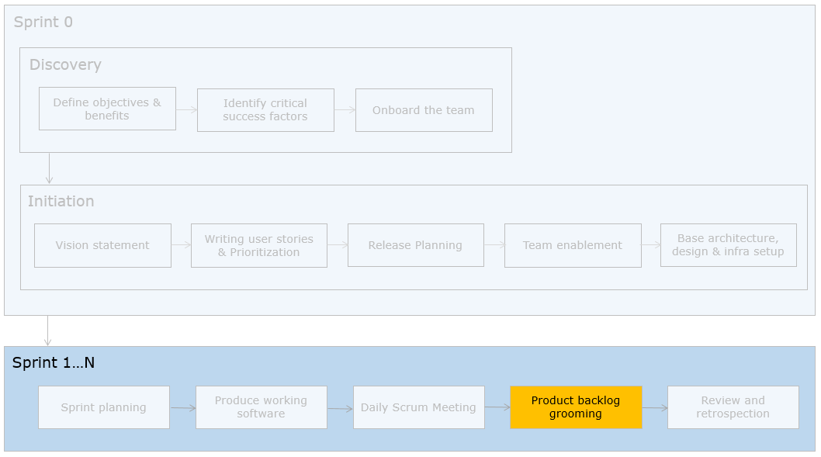
The team at EasyGarb is on the 7th day of the 10-day sprint. They invite the technical officer for the product backlog grooming session. Let us understand the grooming ceremony in detail.

Need
If development teams start on "what" stories to pick up during sprint planning, they would not be able to complete the same in the stipulated period. Hence the need to groom stories one sprint ahead. This is also called sprinting ahead sessions / product backlog grooming.

When is and who participates in product backlog grooming?
This is done for about half a day for a two-week sprint and is done every sprint. The entire development team participates and is facilitated by the scrum master. The PO needs to be available for clarification of queries.

How is the product backlog grooming done?
The development team grooms ie. writes acceptance criteria or understands the stories better. Three things may happen in the grooming –
- PO can revisit the priorities of the user stories, teams may revisit estimates for the user stories
- PO can add new user stories, however the timelines may have to be revisited
- Understanding of user stories for next sprint

Product Backlog Grooming - Responsibilities of Scrum Master and Development Team

Roles and responsibilities of scrum master
- Ensure that grooming sessions are done every sprint
- Time-boxing the ceremony

Roles and responsibilities of development team
- Participate and ask queries on stories to be picked up in the next sprint

Product Backlog Grooming - Tips, Quick Recap and Additional References

Practical tips
- It is important that the PO brings changes in this ceremony and not during the mid of the sprint
- If the product backlog is added with new items, the scrum master should measure the number of storypoints added. Accordingly the release date may be extended or a similar amount of stories are removed from the product backlog
- This is not a ceremony to overflow the product backlog with changes
- If this ceremony is not conducted, teams would lose time for produce during the sprint
- This ceremony can be done towards the end of the sprint or spend sometime everyday during the sprint

Quick Recap
- Represents a sprinting ahead session done every sprint
- Revisiting priorities estimate can be done here
- Grooming user stories for future sprints are also done here

Additional References
Sprinting ahead in Agile
Practical tips for grooming

Product Backlog Grooming - Quiz 1
Q1 of 1) A scrum team raises an issue that they do not have enough "produce time" in the sprint and that the planning is taking a lot of time. What could be going wrong here?
- The team is not sprinting ahead. They may be grooming stories during sprint planning check
- PO is not providing timely response to user stories and hence sprint planning is taking long check
- The product backlog grooming exercise is not happening properly check
- The team has a lot of freshers and hence they are taking more time for planning

Review and Retrospective
Review and Retrospective
During review, the product owner inspects the potentially shippable increment based on DOD and acceptance criteria. During retrospection, the team looks at ways of improving the process. This is the fourth ceremony carried out in a sprint.
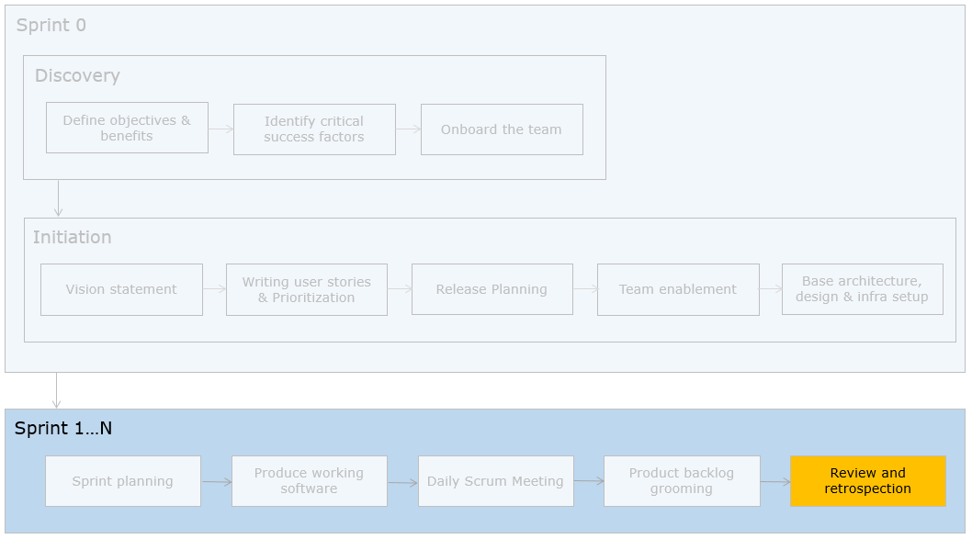
EasyGarb team invites the technical officer for the review The team members present the working software / increments. The technical officer declares some of the items "done" and some as "not done" based on DOD and acceptance criteria.
Then the team proceeds with the retrospective meeting. Let us now understand this ceremony in detail.
Review

Need
In order to produce and deliver valuable software frequently to customers, early feedback by the product owner is essential.

When is and who participates in a review?
This is done towards the end of the sprint for half a day. The PO, stakeholders participate the review. The development team demonstrates the working increment produced

How is the review done?
- The PO reviews the working increment against the acceptance criteria and definition of done.
- The PO declares “doneness” of items and provides feedback on what is not done
- The PO might provide changes. They are measured and then a call is taken to add it as a new item to the product backlog
- The stakeholders review the working increment and provide feedback to PO

Review - Responsibility of Scrum Master and Development Team

Scrum master
- Ensure that PO declares done-ness against DOD and acceptance criteria
- Time-boxing the ceremony

Development team
- Demonstrate the working increment after complete testing against the DOD and acceptance criteria

Review - Tips, Quick Recap and Additional References

Practical tips
- It is important that changes suggested by the PO are measured
- The stakeholders and PO decide on the changes and the team speaks to the PO only. This is to avoid confusion from multiple stakeholders
- Team members need to demonstrate their work. This brings confidence and accountability in them
- It is important to get the acceptance criteria and DOD clearly done prior to the start of sprints

Quick Recap
- Review provides early feedback on the increment produced by the team
- It is important that the product owner is available for the review every sprint

Additional References
Frequently asked questions
Practical tips for Sprint Retrospective

Review and Retrospective - Quiz 1
Q1 of 1) The review of one of the scrum teams is happening and is being attended by the PO and the end-users. Choose the statements which are not in line with the scrum guidelines.
- The stakeholders are providing inputs to the development team on the changes and features. Some of them are conflicting check
- The PO first declares items done. This is followed by end-user review.
- The changes suggested by stakeholders are discussed with PO and the latter provided the final list of changes to the team
- The scrum master accepts all the changes and marks the user story “not done” check
- The scrum masters compares the changes against agreed DOD and acceptance criteria. Those not present in the latter are measured and added to the product backlog.

Review and Retrospective - Part 2
Retrospective

Need
In order to bring about improvements and innovations in the working of the team and the process, retrospection is done

When is and who participates in a retrospection?
This is facilitated by the scrum master and the development team participates

How is the retrospection done?
Each team member mentions the following –
- What to start doing from next sprint?
- What to stop doing from next sprint?
- What to continue doing?
This provides a good scope for improvements in process.
Example:
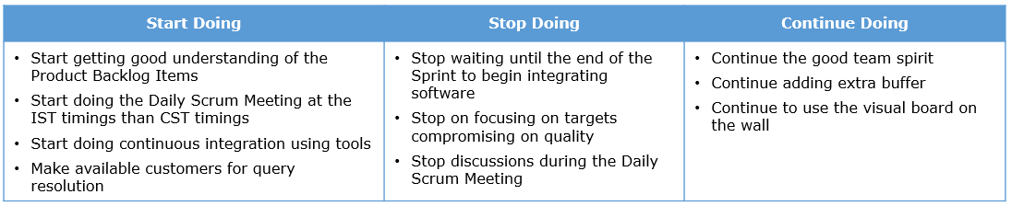
Retrospective - Responsibilities of Scrum Master and Development Team

Scrum master
- Ensure participation of every team member
- Use the inputs for next sprint planning and actionizing the items
- Time-boxing the ceremony

Development team
- Think on how to reduce overhead and improve processes
- Small little improvements done frequently should be the thought process
- Actionizing the retrospection points

Retrospective - Tips, Quick Recap and Additional References

Practical tips
- This is an important ceremony to bring about changes to the process
- Issues impeding progress like customer not available for query resolution need to brought up

Quick Recap
- Retrospection is the ceremony where frequent improvements to the process can be looked at
- Improvements made here will in turn increase productivity of teams
- Needs to be conducted every sprint and participation of all team members are mandatory

Additional References
Frequently asked questions

Review and Retrospective - Quiz 2
Q1 of 1) The development team feels that there is no need for retrospection to be done every sprint and they have nothing much to say. Which of the following statements are TRUE?
- Retrospection helps improve the process regularly and must be done check
- The dev team is correct, it can be done optionally
- Retrospection forces the team to make small improvements so that their productivity improves check
- Retrospection is for the PO and not for the team

Simple Design Principles
Road Ahead

Sustaining and accelerating agility - the issues
Scrum teams at EasyGarb have been proceeding with scrum and meeting the targets for the initial couple of sprints. Off late the following are observed to be occuring.
- Considerable delays in meeting targets
- Dip in their code quality
- Difficulty in integrating and modifying code
The technical officer feels that regression tests are not being run. The team seems to be burning out and frustrated and seems to have low morale. EasyGarb deploys an agile coach to propose a solution to these problems.

Sustaining and accelerating agility - the solution
- Code quality has to be built in to the process
- Productivity of teams need to improve to sustain the pace
- Code which passes all tests has to be continuously integrated
He mentions that technical practices need to be imbibed if the pace of agility has to be sustained across sprints.
So far, we have experienced agility and scrum in detail. We have also come across practical tips used by practitioners across Infosys.
Now let us focus on technical practices.

Technical practices to sustain and accelerate agility
Kent Beck's simple design principles and extreme programming technical practices help sustain and accelerate agility in projects. Here is a video on the need for technical practices and the description.
Let us explore the technical practices in detail.

Simple Design principles

Need
Kent Beck has defined the Simple Design principles which help in maintenance of code and ensure that it integrates well and lends itself to changes.

What are the principles?
Let us revisit the principles once again. Every time the code is written the increment should:
- Pass all the tests
- reveal the intention
- Not contain duplication
- have the fewest of the elements

How can they be implemented?
Refactoring help in ensuring there is no duplication and code reveals the intent of the programmer ,is simple and ensure that there is no lazy code(ensure fewest of the elements). Test automation helps in ensuring code passes all the tests.

Practical tips
- Use static code analyzer tools with rules designed to ensure that the simple design principles are followed
- Simple design should not be confused as simplistic design or design phase in Agile
- These principles should be inculcated as a habit rather than rules

Additional References
Here are some more practices that help achieve simple design for your reference reading
YAGNI- You aren't gonna need it
One and only once
Self-documenting code
"Clean code", Robert C Martin, Prentice Hall
If you are familiar with Java, you may go through the examples given in the appendix section of the course.

Refactoring
Technical practices – Refactoring

Need
- Technical debt needs to be reduced and software has to be robust
- Code should be readable and changes easy to comprehend and take less efforts to modify
- Need to produce modular, scalable and sustainable code

What is refactoring?
The process of changing a software system in such a way that it does not alter the external behavior of the code, yet improves its internal structure

How can refactoring be done?
Modern day IDE's have features that help programmers to refactor code. There are many refactoring patterns that need to be understood by developers and with the help of tools, use it in code.

Practical tips
- Buffer time for refactoring every sprint
- Do not refactor very close to release
- You may refactor code that is being newly developed rather than already existing code (legacy code)
- Sensitize customers on the need for time to be allocated for refactoring

Additional References
Read: “Refactoring: Improving the Design of Existing Code” by Martin Fowler
If you are conversant with fundamentals of Java programming language and object oriented principles, you may go through the examples of refactoring code and take the activity given in the appendix section of the course

The Why and What of refactoring
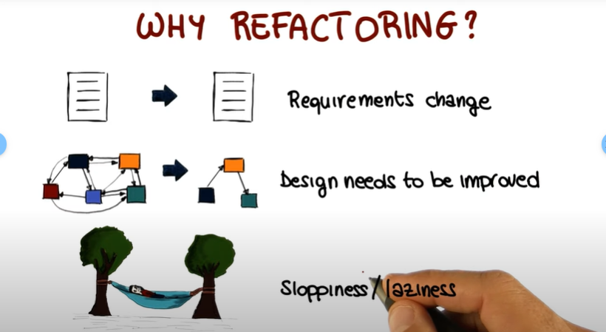

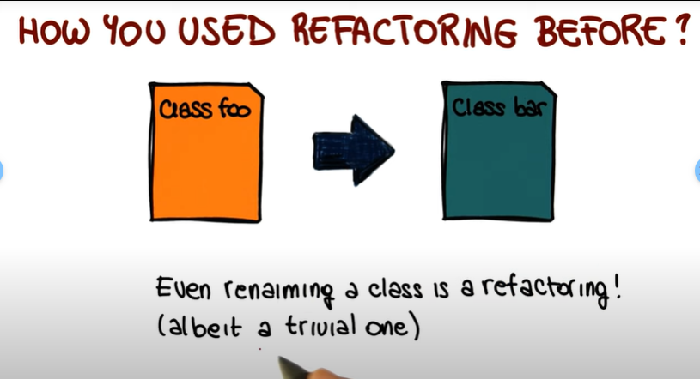

Test Driven Development
Test Driven Development & test automation

Need
It is required for the following reasons -
- Increased Code coverage
- Reduced duplication/redundancy
- Better consideration of reusability & design
- Modular and Stable Code

What is TDD?
Is a software engineering approach that involves short development iterations consists of writing failing test case(s) first covering a new functionality and then implementing the necessary code to pass the tests and finally refactor the code without changing external behavior.

How is it done?
The following picture illustrates how TDD works.
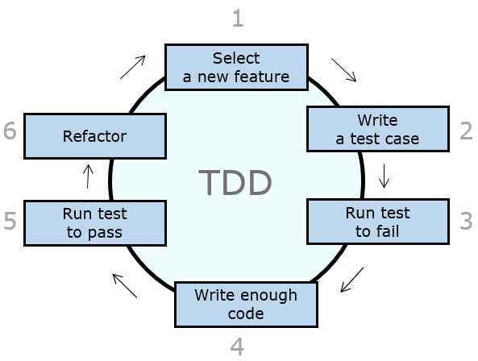
The steps involved are
- Select a feature / user story and write automated test cases for it
- Execute the tests, which will fail as there is no code
- Write enough code to pass the tests
- Execute the tests, which would pass
- Refactor the code and the tests
XUnit frameworks help in writing automated unit tests. Thus TDD includes both test automation and refactoring.

Practical tips:
- TDD takes 1.5 times more time than normal development, however helps in reduction of defects and produces good quality code
- May start with few modules and do pair programming with a tester and programmer
- Automated unit test cases help in implementing TDD

Additional References
Test driven development

Continuous Integration

Need
If valuable and quality software need to be delivered to customers frequently, the code needs to be integrated and tested continuously. This is achieved through the technical practice of continuous integration.

What is Continuous Integration (CI) ?
A software development practice that requires members of the team to integrate their work frequently. Integration is done at least daily. It leads to multiple integrations each day.
The workflow for CI is as given below.

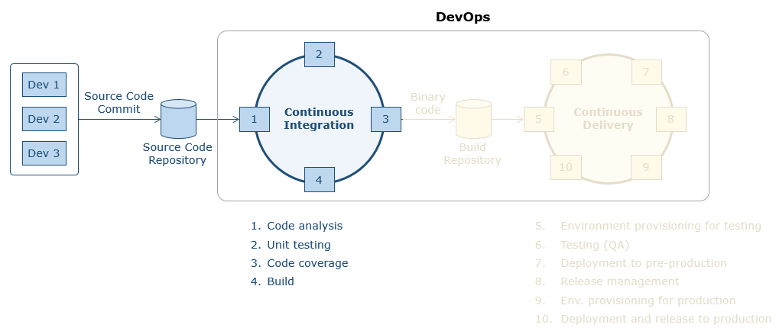

The developers(ex. Dev1 and 2 shown in figure) commit code to a source code repository. Post this the build phase activities of static code analysis, unit testing, code coverage by the unit tests and building the executable file are automated through tools and these steps are called in sequence by the continuous integration server. The executable file is placed in the artifact repository for further testing and release. The continuous integration server is configured to orchestrate frequently to ensure continuous integration of code.

Tools
Jenkins, Bamboo and TFS are examples of continuous integration tools that orchestrate the build and deployment activities which are in turn automated using respective tools

Practical tips
- You may use the IDP platform for implementing CI (http://sparshv2/portals/ToolsGroup/Pages/IDP.aspx)
- Automate the build activities to the maximum extent

Additional References
Continuous integration

Pair Programming

Need
Enables higher productivity and quality of work of the individuals doing pair programming than if done alone

What is pair programming?
Two programmers coding together on a single machine is called pair programming. One of the programmer plays the role of a driver who writes clean code, compiles and execute the code. The other plays the role of navigator who strategizes on design, tests, reviews and refactors code. These pairs self-organize and switch partners and roles during the day

Practical Tips
- Pairing can be done on code which is to be maintained
- Switching partners several times during the day helps
- Form natural pairs, no enforcement
- Allow lot of conversation
- Switch driver and navigator roles
- Good infrastructure for pairing stations
- Maintaining peer balance during pairing is essential (Pairing of senior and junior developers)

Additional References
Pair programming
Technical practices in Agile
The next section describes how continuous delivery of valuable software can be provided to customers through automation of the entire SDLC activities in a pipeline.

DevOps and Agile
Traditionally, software development, testing and deployments are considered separate activities. Deployments to customer environments are scheduled activities done on a yearly/half yearly basis. Hence customers need to wait long to see a working version of the software. DevOps is a set or practices and its adoption in projects provide the following:
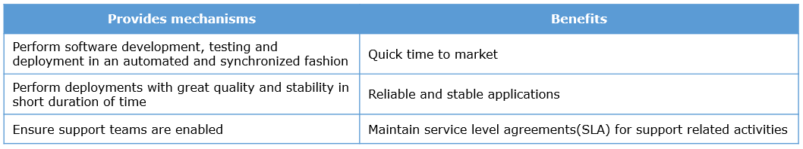
This leads to continuous delivery of valuable & quality software to customers ie. also helps realize the perceived benefits of Agility.
Continuous Integration (CI) and Continuous Delivery (CD) automated pipelines are constructed with the help of tools. Here is the view of the activities involved.
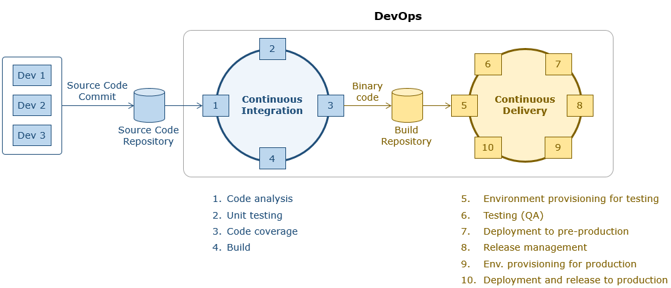
You can refer to the detailed course on DevOps for further details.

Technical Practices - Quiz 1
Q1 of 2) A team claims that they have started using Test Driven Development in their project. They have test automation in place and code coverage percentage is showing convincing percentages. However, the customers have raised concerns on the quality of code. What could have gone wrong here?
- Team would have skipped refactoring as part of TDD check
- The test cases may be flaky check
- Team should increase sprint duration
- Team could use a tool for checking code quality before releasing to client check
- Team should increase the duration for releasing software ie. decrease release frequency
Q2 of 2) A Scrum team is has completed 5 sprints. They now find the going difficult. The code quality is not good, there is patchy and duplicate code. They are finding it increasingly difficult to integrate code. What would you suggest to reduce these issues?
- TDD check
- CI check
- Refactoring check
- Adhering to Simple Design principles check

Agile Scrum Summary
Summary – Scrum
We have so far gone through the principles of Agility and Scrum in detail. The following table summarizes how the twelve principles of agility can be met.
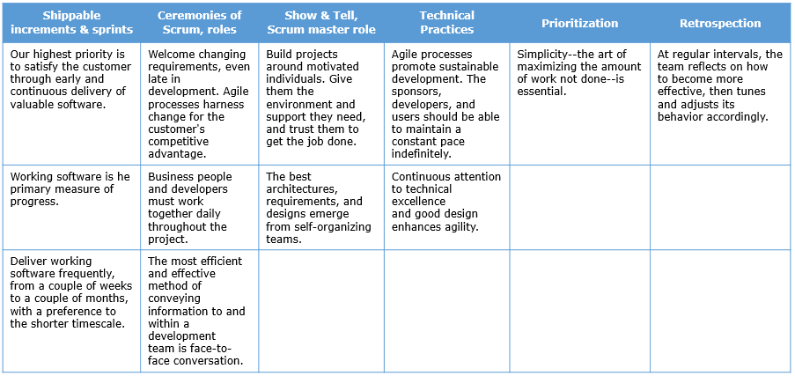

Conclusion:
The shopping cart was invented by Sylvan Goldman in 1937. Goldman’s carts were not immediately popular. The carts were unused in stores for a long time. What do you think he did as shopping carts are ubiquitous to shopping these days?
He deployed dummy shoppers to start using them in the shops and the other customers followed it. Similarly, the journey to agility need to started even though there may be objections and mind-set related issues. Once success is achieved and positive results shown, teams would start believing in it and follow suit.

Technical Practices - Code Examples
Appendix 1 : Refactoring - Example 1 (Optional)

Problem statement
Consider the code written for computing the marks scored by students in an exam. The part containing the validation of marks is shown.
Code:
1 class Student{
2 private double cutOffMarks,highestMarks;
3 public double getCutOffMarks(){
4 return cutOffMarks;
5 }
6 public double getHighestfMarks(){
7 return highestMarks;
8 }
9 public boolean validateMarks(int marks){
10 return (marks >=cutOffMarks && marks <=highestMarks);
11 }
12 }

Issues in the code
In Line number 10, you can see that the variables cutOffMarks and highestMarks are accessed directly which is against the encapsulation principles.

Refactoring technique to be used
This can be refactored using “Self-encapsulate field” technique which mentions that the private members of a class need to be used only through getter and setter methods.
The rules of self-encapsulate field technique is as follows:
- Direct accessing of a class attribute increases coupling
- Only get and set methods should be used for accessing them

Revised code
1 class Student{
2 private double cutOffMarks,highestMarks;
3 public double getCutOffMarks(){
4 return cutOffMarks;
5 }
6 public double getHighestfMarks(){
7 return highestMarks;
8 }
9 public boolean validateMarks(int marks){
10 return (marks >=getCutOffMarks() && marks <=getHighestMarks());
11 }
12 }
The getter methods are used to access the class variables in the revised code.
Note: The output of the code and revised code snippets are same in all the examples, the difference is only in the structure of the code.
Appendix 2 : Refactoring - Example 2(Optional)

Problem statement
Consider the code written for computing the fees for a student.
Code:

1 class Student{

2 private int studentID;

3 private String name;

4 private String batchName;

5 private char studentType;

6 public void setStudentID(int id){

7 studentID=id;

8 }

9 public void setName(String name){

10 this.name=name;

11 }

12 public void setBatchName(String batchName){

13 this.batchName=batchName;

14 }

15 public void setStudentType(char type){

16 studentType=type;

17 }

18 public int getStudentID(){

19 return studentID;

20 }

21 String getName(){

22 return name;

23 }

24 public String getBatchName(){

25 return batchName;

26 }

27 public char getStudentType(){

28 return studentType;

29 }

30 }

31 class Fee{

32 private Student;

33 private double fees;

34 public Student getStudent(){

35 return student;

36 }

37 public double getFees(){

38 return fees;

39 }

40 public void setStudent(Student student){

41 this.student=student;

42 }

43 public void computeFees(){

44 switch(student.getStudentType()){

45 case 'D': fees=40000;break;

46 case 'H': fees=80000;break;

47 }

48 System.out.println("Student Id:"+student.getStudentID());

49 System.out.println("Student Name:"+student.getName());

50 System.out.println("Student Batch:"+student.getBatchName());

51 System.out.println("Student Fees:"+getFees());

52 }

53 }

Issues in the code
Notice here that the computeFees method of the Fee class computes the fees and also displays the details.

Refactoring technique to be used
The “extract method” refactoring technique can be applied here. Here are the rules:
- Identify the section of the code that can be grouped together
- Make a method of the code section identified, such that its name explains its purpose

Revised Code:
1 class Student{
2 private int studentID;
3 private String name;
4 private String batchName;
5 private char studentType;
6 public void setStudentID(int id){
7 studentID=id;
8 }
9 public void setName(String name){
10 this.name=name;
11 }
12 public void setBatchName(String batchName){
13 this.batchName=batchName;
14 }
15 public void setStudentType(char type){
16 studentType=type;
17 }
18 public int getStudentID(){
19 return studentID;
20 }
21 String getName(){
22 return name;
23 }
24 public String getBatchName(){
25 return batchName;
26 }
27 public char getStudentType(){
28 return studentType;
29 }
30 }
31 class Fee{
32 private Student;
33 private double fees;
34 public Student getStudent(){
35 return student;
36 }
37 public double getFees(){
38 return fees;
39 }
40 public void setStudent(Student student){
41 this.student=student;
42 }
43 public void computeFees(){
44 switch(student.getStudentType()){
45 case 'D': fees=40000;break;
46 case 'H': fees=80000;break;
47 }
48 }
49 public void displayStudentInformation(){
50 System.out.println("Student Id:"+student.getStudentID());
51 System.out.println("Student Name:"+student.getName());
52 System.out.println("Student Batch:"+student.getBatchName());
53 System.out.println("Student Fees:"+getFees());
54 }
55 }

In the revised code,displayStudentInformation()has been extracted out to display the student information. Now the computeFees() computes the fees only.
Note: The output of the code and revised code snippets are same in all the examples, the difference is only in the structure of the code.

Appendix 3 : Refactoring - Example 3(Optional)

Problem statement
Consider the code written for storing the details of a Student like the student id, name and batch name.
Code:

1 class Demo{

2 public static void main(String args[])){

3 String student[3];

4 student[0]=”1001”;

5 student[1]=”Jennifer”;

6 student[2]=”Jun14LC1”;

7 }

8 }

Issues in the code
An array has been used to represent the attributes of the student class in line numbers 4,5,6.

Refactoring technique to be used
The “Replace array with object” technique can be used to refactor this. Here are the rules:
- When array handles many items, it is hard to distinguish them
- Array can be replaced with an object having each item fields

Revised code:
1 class Student{
2 private int studentID;
3 private String name;
4 private String batchName;
5 public void setStudentID(int id){
6 studentID=id;
7 }
8 public void setName(String name){
9 this.name=name;
10 }
11 public void setBatchName(String batchName){
12 this.batchName=batchName;
13 }
14 }
15 class Demo{
16 public static void main(String args[]){
17 Student student=new Student();
18 student.setStudentID(1001);
19 student.setName(“Jennifer”);
20 student.setBatchName(“Jun14LC1”);
21 }
22 }

An array is now being used to represent the attributes of the student class in the revised code.
Note: The output of the code and revised code snippets are same in all the examples, the difference is only in the structure of the code.

Refactoring Activity - Optional Exercise
Refactoring - Activity(Optional)

Problem statement
Consider a hospital management system. The following code is written by the developers. The Patient class contains the details about the patient and the Bill class computes the bill. The details about the computation of bill for out-patient(Type=’O’) and hospitalized patients(Type=’I’) is not shown in the code(replaced with a placeholder System.out.println statement). Identify parts of the code and the refactoring technique that can be applied.
Code

1 class Patient {

2 private int patientId;

3 private String patientName;

4 private String address;

5 private String illness;

6 private int pulseRate;

7 private int maxPulse;

8 private int minPulse;

9 private char patientType;

10 public int getPatientId() {

11 return patientId;

12 }

13 public String getPatientName() {

14 return patientName;

15 }

16 public String getAddress() {

17 return address;

18 }

19 public String getIllness() {

20 return illness;

21 }

22 public char getPatientType(){

23 return patientType;

24 }

25 public Patient(int patientId, String patientName, String address,String illness,char type,int mPulse,int miPulse) {

26 this.patientId = patientId;

27 this.patientName = patientName;

28 this.address = address;

29 this.illness = illness;

30 maxPulse=mPulse;

31 minPulse=miPulse;

32 patientType=type;

33 }

34 public void validateBloodPressure(){

35 int pulse[]=new int[2];

36 pulse[0]=130;

37 pulse[1]=80;

38 if(maxPulse>=pulse[0] || minPulse<=pulse[1]){

39 System.out.println("Treatment for fluctuation in Blood pressure");

40 }

41 else{

42 System.out.println("Blood presssure is normal");

43 }

44 }

45 }

46 class Bill{

47 private Patient;

48 private double amount;

49 public Bill(Patient patient){

50 this.patient=patient;

51 }

52 public double getAmount(){

53 return amount;

54 }

55 public Patient getPatient(){

56 return patient;

57 }

58 public void computeBill(){

59 switch(patient.getPatientType()){

60 case 'O':System.out.println("Treatment and computation of bill for outpatient");

61 break;

62 case 'I':System.out.println("Treatment and computation of bill for hospitalized patients");

63 break;

64 }

65 System.out.println("Patient id:"+patient.getPatientId());

66 System.out.println("Patient Name:"+patient.getPatientName());

67 System.out.println("Patient Address:"+patient.getAddress());

68 System.out.println("Patient Illness:"+patient.getIllness());

69 System.out.println("Patient type:"+patient.getPatientType());

70 patient.validateBloodPressure();

71 System.out.println("Amount to be paid by the patient:"+amount);

72 }

73 }

74 class Demo{

75 public static void main(String args[]){

76 Patient patient=new Patient(1001,"Esposito","California","Asthma",'I',90,120);

77 Bill obj=new Bill(patient);

78 obj.computeBill();

79 }

80 }

Task
Identify the lines which need to be refactored and the techniques that can be adopted based on what you have learnt.

Solution
14,17,20,23,38,53,56- getter method to be used
26-32,50- setter method to be used
computeBill() does computation of bill and display of patient details. A method to display patient details can be extracted out.

Technical Practices - Code Examples - Part 2
Appendix 4 : Simple design - Example(Optional)

Problem statement
Consider the requirements for validation of email id field in a web application.
Email id can have only numbers 0-9 and chars A-z and a-z, ‘.’ should come only after @’. Minimum one and maximum two ‘.’ are allowed after the ‘@’ as part of the email id. Presence of ‘@’ and ‘.’ are mandatory.
Code:
1 class Customer{
2 private String emailId;
3 public boolean validateEmailId(String string)
4 {
5 boolean flag=true;
6 int startIndex=0,lastIndex=0,counter=0,i,j;
7 for(i=0;i<string.length();i++){
8 if((string.charAt(i)>='a' && string.charAt(i)<='z')||(string.charAt(i)>='A' && string.charAt(i)<='Z')||(string.charAt(i)>='0' && string.charAt(i)<='9')||(string.charAt(i)=='@')){
9 flag=true;
10 }
11
12 if(flag==false){
13 System.out.println("not an allowed character");
14 break;
15 }
16 else if(flag==true){
17 if(string.charAt(0)>='0' && string.charAt(0)<='9'){
18 flag=false;
19 System.out.println("not a digit");
20 break;
21 }
22 else{
23 for(j=0;j<string.length() && string.charAt(j)!='@';j++,lastIndex++){
24 if(string.charAt(j)=='.'){
25 flag=false;
26 System.out.println(". not after @");
27 break;
28 }
29
30 }
31 for(j=lastIndex;j<string.length();j++){
32 if(string.charAt(j)=='.'){
33 counter++;
34 if(counter>2){
35 flag=false;
36 System.out.println("more than 2 dots ");
37 break;
38 }
39 }
40 }
41 if(counter==0){
42 flag=false;
43 break;
44 }
45 }
46 }
47 }
48
49 return flag;
50 }
51 }

Issues with the code
- Variable names do not reflect the intent(ex. Line 6)
- The charAt() is called multiple times (Line 8)
- Code is not elegant, very messy and does not indicate intent (ex. Line 22 onwards)
- Duplication of digit check code (ex. Lines 8 and 17)

Appendix 4 : Simple design - Example: Revised code (optional)
1 class Customer{
2 private String emailId;
3 public boolean validateEmailId(String string)
4 {
5 int loopCounter=0;
6 boolean flag=false;
7 char c;
8 //Checking for valid characters – characters, digits,@ and .
9 if(isDigit(string.charAt(0))){
10 return false;
11 }
12 for(loopCounter=0;loopCounter<string.length();loopCounter++){
13 c=string.charAt(loopCounter);
14 if (!(isCharacter(c)||isDigit(c)||isAttheRate(c)||isDot(c))){
15 return false;
16 }
17 else{
18 //Checking presence of @
19 if(c=='@'){
20 flag=true;
21 }
22 else{
23 if(isDotValidation(string)==false){
24 return false;
25 }
26 }
27 }
28
29 }
30 if(flag==false){
31 return false;
32 }
33 else{
34 return true;
35 }
36 }
37 private boolean isCharacter(char c){
38 if((c>='a' && c<='z')||(c>='A' && c<='Z')){
39 return true;
40 }
41 else{
42 return false;
43 }
44 }
45 private boolean isDigit(char c){
46 if(c>='0' && c<='9'){
47 return true;
48 }
49 else{
50 return false;
51 }
52 }
53 private boolean isDot(char c){
54 if(c=='.'){
55 return true;
56 }
57 else{
58 return false;
59 }
60 }
61 private boolean isAttheRate(char c){
62 if(c=='@'){
63 return true;
64 }
65 else{
66 return false;
67 }
68 }
69 private boolean isDotValidation(String string){
70 int loopCounter,countDot=0,loopCounter1,lastIndex=0;
71 for(loopCounter=0;loopCounter<string.length() && string.charAt(loopCounter)!='@';loopCounter++,lastIndex++){
72 if(string.charAt(loopCounter)=='.'){
73 return false;
74 } }
75 for(loopCounter1=lastIndex;loopCounter1<string.length();loopCounter1++){
76 if(string.charAt(loopCounter1)=='.'){
77 countDot++;
78 if(countDot>2){
79 return false;
80 }
81 }
82 }
83 return true;
84 }
85 }
86 class Demo{
87 public static void main(String args[]){
88 Customer obj=new Customer();
89 if(obj.validateEmailId("Richard")){
90 System.out.println("Valid email id");
91 }
92 else{
93 System.out.println("Invlaid email id ");
94 }
95 if(obj.validateEmailId("Richard@yahoo.com")){
96 System.out.println("Valid email id");
97 }
98 else{
99 System.out.println("Invlaid email id ");
100 }
101 }
102 }

Issues resolved
- Variable names reflect the intent(ex. Line 5)
- The charAt() part is made compact (Line 12)
- Code is not elegant, very messy and does not indicate intent (ex. Line 12-14)
- Duplication of digit check code (ex. Lines 12-14)

Simple Design Activity Optional Exercise
Simple Design - Activity 1(Optional)

ProblemStatement:
Here is the code for calculating scores for a bowling game. Identify the sections of the code which can be rewritten to follow simple design principles.
1 class BowlingGame {
2 private int arr[] = new int[21];
3 private int i = 0;
4 private int score=0;
5
6 public void spin(int var) {
7 arr[i++] = var;
8 }
9 public void compute(){
10 int m = 0;
11 for (int val = 0; val < 10; val++) {
12 if ((arr[m] +arr[m + 1]) == 10)
13 {
14 score += 10 + arr[m + 2];
15 m += 2;
16 }
17 else {
18 score += arr[m] +arr[m + 1];
19 m += 2;
20 }
21 }
22 }
23 public int calculate() {
24 compute();
25 return score;
26 }
27 }
28
29 class BowlingTest{
30 public void test1() {
31 BowlingGame game=new BowlingGame();
32 int n=20;
33 for (int i = 0; i < n; i++){
34 game.spin(0);
35 }
36 System.out.println("The score is "+game.calculate());
37 }
38
39 public void test2() {
40 BowlingGame game=new BowlingGame();
41 int n=20;
42 for (int i = 0; i < n; i++){
43 game.spin(1);
44 }
45 System.out.println("The score is "+game.calculate());
46 }
47 public void test3() {
48 BowlingGame game=new BowlingGame();
49 game.spin(5);
50 game.spin(5);
51 game.spin(3);
52 int n=17;
53 for (int i = 0; i < 17; i++){
54 game.spin(0);
55 }
56 System.out.println("The score is "+game.calculate());
57 }
58 }
59 class Demo{
60 public static void main(String args[]){
61 BowlingTest bowling=new BowlingTest();
62 bowling.test1();
63 bowling.test2();
64 bowling.test3();
65 }
66 }
Solution
- Variable and method names are not self- explanatory ie. they do not specify intent (ex. lines 2 and 3)
- calculate() method is dependent on compute()
- The for loop is duplicated in many places(ex. Lines 33,42,53)
- The object creation is duplicated(ex.31,40)
- This code is duplicated in many places and is not elegant/compact

