Email Writing Skills

Introduction to Email Writing
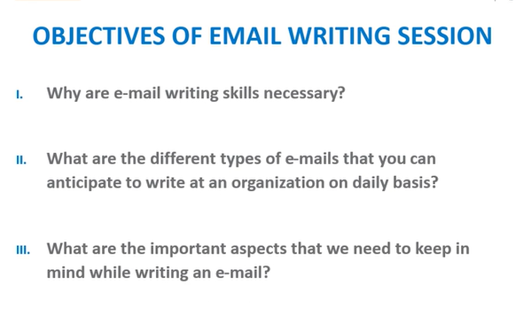
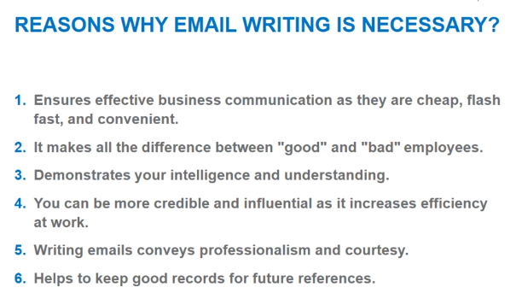
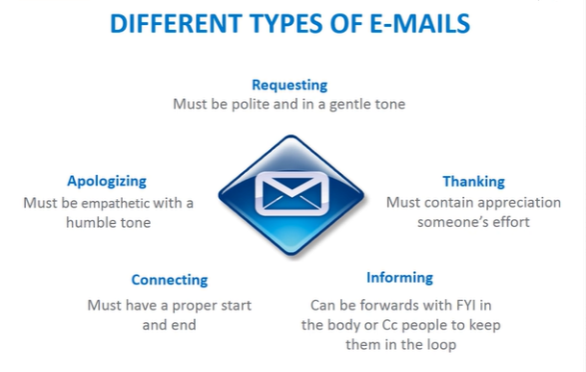
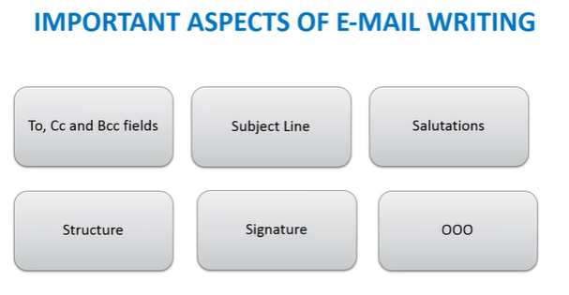
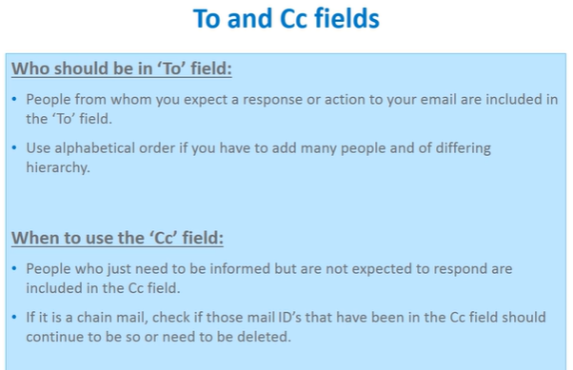
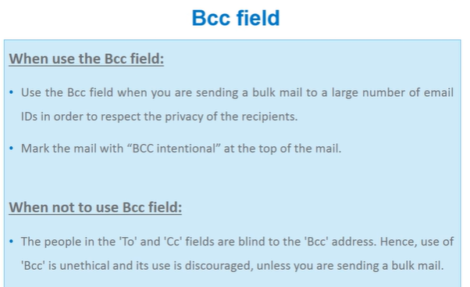
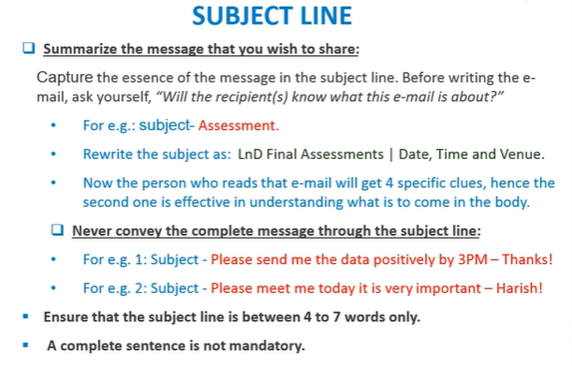
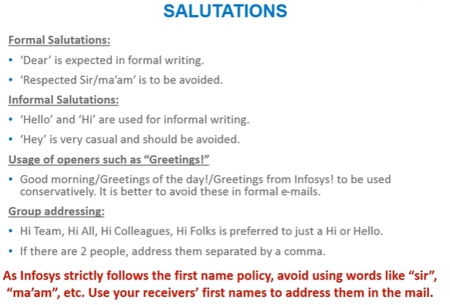

Introduction to Email Writing - Quiz
Q1 of 5) Mark wants to write an email to his colleagues. However, he wants his manager to be informed about the email. Which fields should Mark use?
- He must use the ‘To’ field for his colleagues and the ‘Cc’ field for his manager. check
- He must use the ‘To’ field for his colleagues and the ‘Bcc’ field for his manager.
- He must use the ‘Cc’ field for his colleagues and the ‘Bcc’ field for his manager.
- He must use the ‘Cc’ field for his colleagues and the ‘To’ field for his manager.
Q2 of 5) Adam wants to send an appreciation email to his colleague Bert. Which among the following types of email should he choose to write?
- Request email
- Thank you email check
- Information email
- Connect email
Q3 of 5) Clara wants to write an email on the status update of the SC project to her team members. Which of the following is an effective subject line to use?
- Project SC | Status update check
- Project SC
- Status update
- Both B and C
Q4 of 5) Which of the following is NOT true about salutation?
- ‘Dear’ is the most formal form of salutation.
- ‘Hello’ and ‘Hi’ is used for informal writing.
- ‘Hey’ must not be used.
- ‘Respected’ has to be used for seniors. check
Q5 of 5) Which of the following is TRUE about salutations in email?
- When writing to two recipients ensure that their names are in alphabetical order in salutation. check
- When writing to two recipients, address them as 'Both' in salutation.
- When writing to two recipients, address them as 'Team' in salutation.
- Both A and B

Structuring an Email
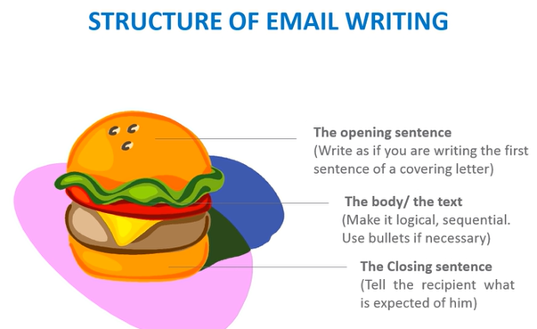

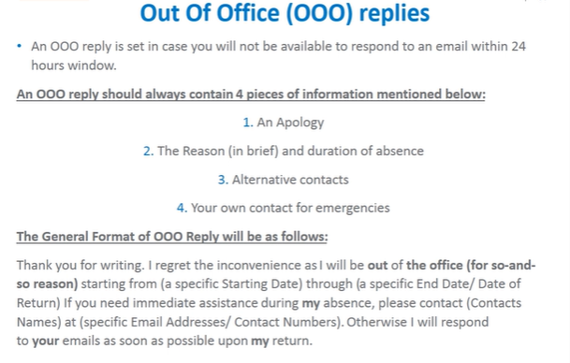

Structuring an Email- Quiz
Q1 of 5) George is trying to set a default signature. Which of the following information does not have to be added to his signature?
- Name
- Designation
- Project
- Email ID check
Q2 of 5) Which of the following should be avoided in your email signature?
- Graphics
- Catch phrases
- Special characters as substitutes for alphabets
- All of the above check
Q3 of 5) Which of the following need not be mentioned in an OOO (Out of Office)?
- Apology
- Alternative Contact
- Duration of absence
- Address check
Q4 of 5) Which of the following is NOT true about download size?
- Avoid sharing large files.
- Avoid graphical content.
- Compress the file if too large.
- Send the files by dividing it into smaller files. check
Q5 of 5) Mark has set a default signature for his email. This signature contains his name, his designation, the account he belongs to and his favorite quote. Which of the following must he remove from his signature line?
- His name.
- His designation.
- The account name.
- The quote. check

Email Etiquette
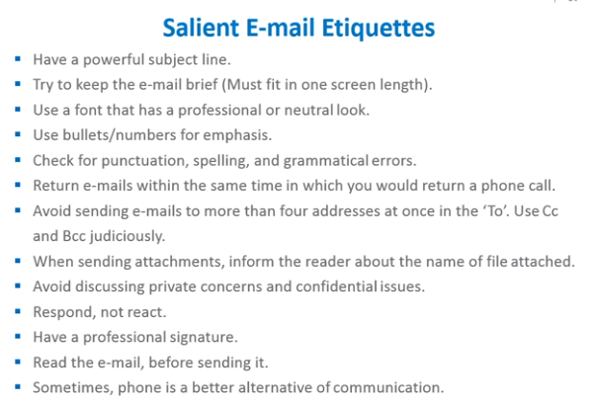

Email Etiquette Quiz
Q1 of 5) Which of the following can be used in a business email?
- Abbreviation. However it must be used in a restricted manner.
- Acronym. However it must be used in a restricted manner.
- Emoticons. However they must be used in a restricted manner.
- Both a and b check
Q2 of 5) Confidential information with necessary permissions can be shared through emails. True or False?
- True
- False check
Q3 of 5) It is recommended that a response to an email must be sent within 24 hours. True or False?
- True check
- False
Q4 of 5) If you have to send an invite for Christmas to the very large team, which mode of address would be the best to use?
- To
- CC
- Bcc check
- Any of the above
Q5 of 5) If you are given the responsibility of writing an email to your manager regarding your team's recent client interaction, what is the best measure of action you need to take before you send the mail?
- Fool proof the email by reading it multiple times by yourself and then send it across to your manager.
- Draft the email and send it across to the team members for their inputs based on which you can send the revised final version to your manager. check
- Send the mail you have written directly as only you have been considered worthy enough by the team to write to your manger.
- All of the are suited equally well.

TEST:
Q1 of 10) Which of the following does not best describe how standard signature must be in an email?
- Signature must have graphics and phrases to establish easy rapport.
- Signature should always contain your entire designation and qualification.
- Signature in multiple colors and different fonts make it attractive.
- All of the above. check

Q2 of 10) Context setting in an email is done _________?
- to ensure the receiver has a choice on whether they want to read your email or place it in the parking lot. check
- to make the receiver feels at ease.
- as a small talk, to break the ice, over an email.
- to ensure that both are on the same page regarding the background information, which in turn eliminates any unnecessary assumptions.

Q3 of 10) Which of the following is an incorrect statement?
- Use the Bcc field to send bulk emails in order to prevent mailboxes from getting spammed.
- Cc fields are used for people who need to be kept in loop without expecting direct replies.
- People marked in BCC can see everyone but no one can see them. check
- None of the above.

Q4 of 10) Choose the correct statement(s) from the following.
- All letters in the subject line may be capitalized to ensure legibility.
- The ‘Cc’ field includes the names of people from whom you expect a direct response.
- Signatures can vary with respect to context and the person it is being sent to. check
- All of the above

Q5 of 10) Which of the following is an outmoded salutation to write an official email?
- Dear Sir/Madam,
- Respected Sir/Madam,
- Whom so ever concerned,
- All of the above. check

Q6 of 10) Which of the following is the ideal way in which you could address more than one individual in your email?
- Dear colleagues,
- Hi team,
- Hello all,
- All of the above. check

Q7 of 10) Which of the following statement is incorrect about the subject line?
- Your subject line could contain around 4 to 7 words.
- Your subject line provides the context of the email.
- Subject line does need to be a sentence.
- Subject line is optional in case the body has one or two lines of information. check

Q8 of 10) What is the correct use of the ‘To’ field?
- To keep people in loop without expecting replies.
- To communicate with employees about who needs to work on what.
- To send it to the people who are expected to take measures and or reply. check
- None of the above.

Q9 of 10) Which of the following are important points needed in an out-of-office reply?
- Apology for having to make them wait.
- Specific reason of absence.
- Duration of your absence along with tentative date of return . check
- All of the above.

Q10 of 10) When is it best to make use of Bcc?
- To inform the recipients that the email has been sent to many others.
- To conceal from the recipients that the mail has been sent to many others. check
- to send mass emails to a group of unrelated people who may need to be provided the same information.
- All of the above are good reasons to make use of Bcc.

