**Lab sheet 6 - Data Extraction**

**Kavishka Gamage - 17000475**

**Twitter Developer account – Access for Twitter API**

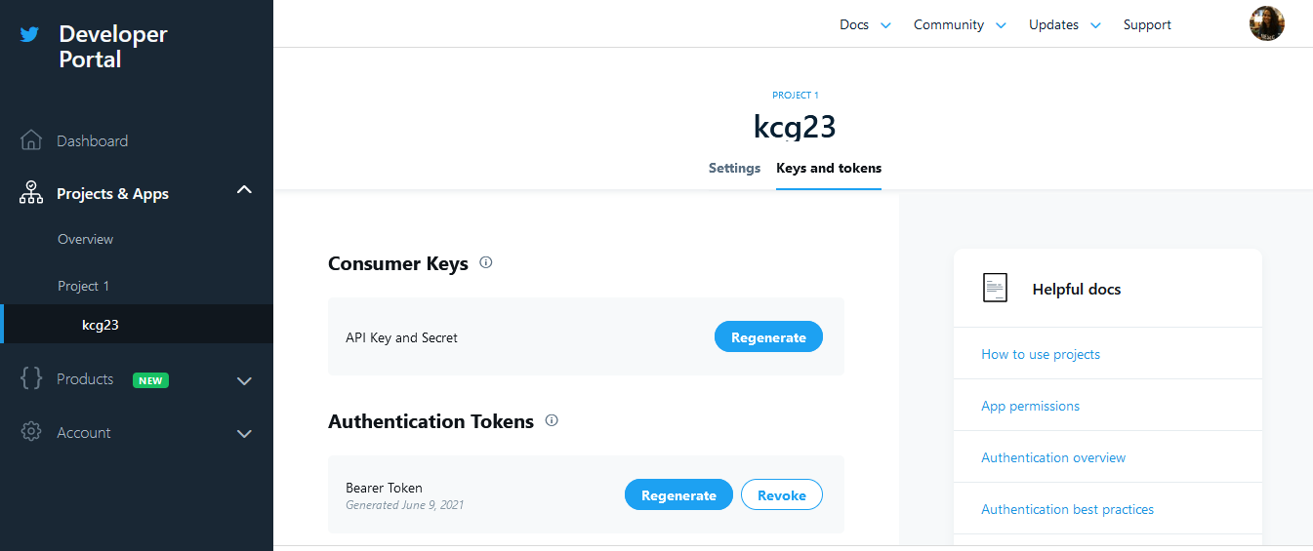

**Task 1 – Tweets extraction - Prettytable**

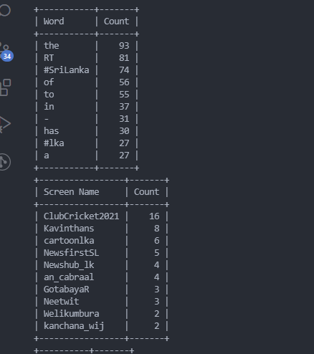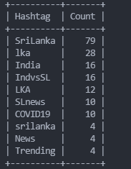

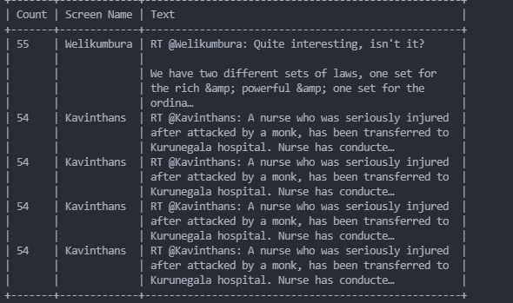

**Trending Hashtags – Pretty table screenshot**

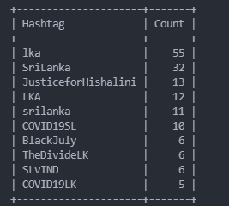

**Task 2 – Scrap Sinhala Wikipedia page**

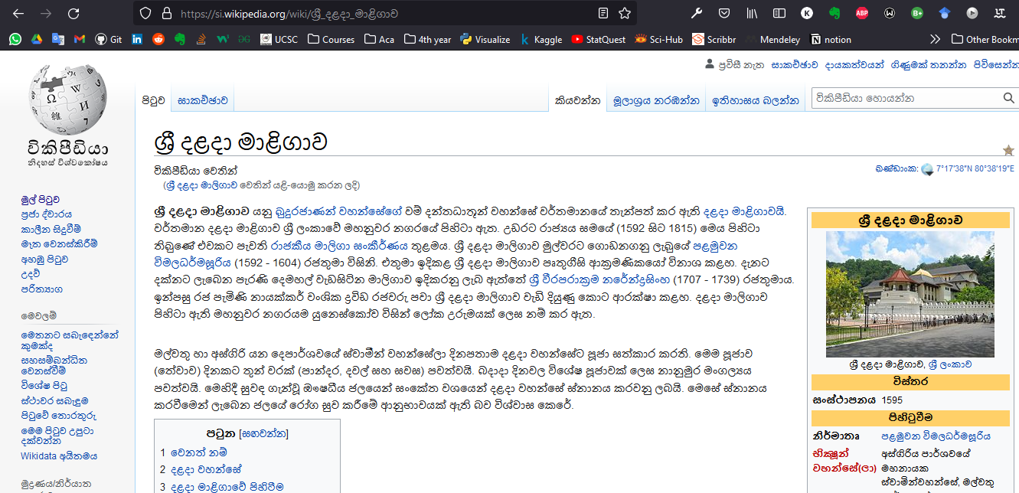

**Link.txt screenshot**

