Issues:

1. Postal Value Missing
   1. Entered Value:

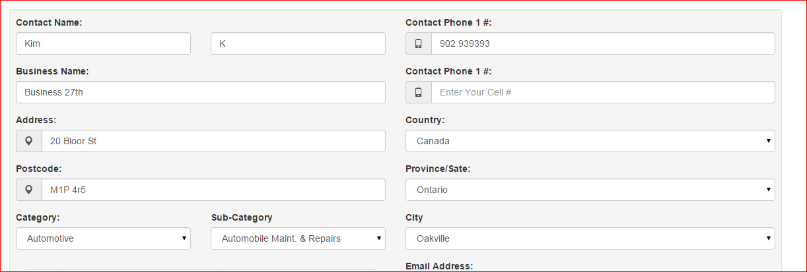

Postal Code is Missing and Saved as “0”

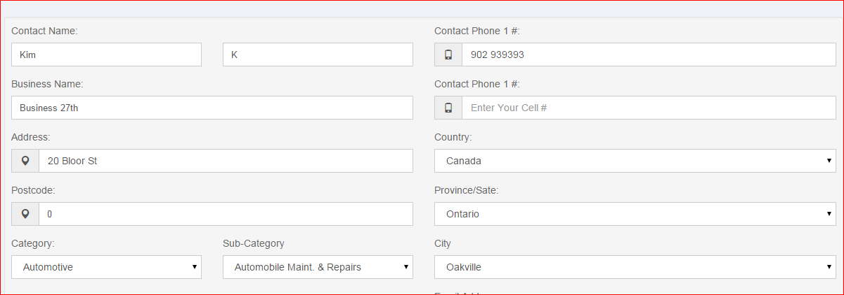

1. Missing default image for Vendor image.
   1. If there is no image uploaded then set a default one image as Vendor image.
2. Missing Edit Function for the Admin Profile. The Email Address for the Admin and profile setting page should be same. The Email alert should be used from Admin profile.

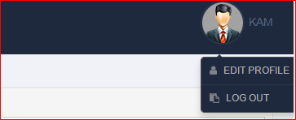

1. Missing the Vendor name when I add deals to a Vendor.

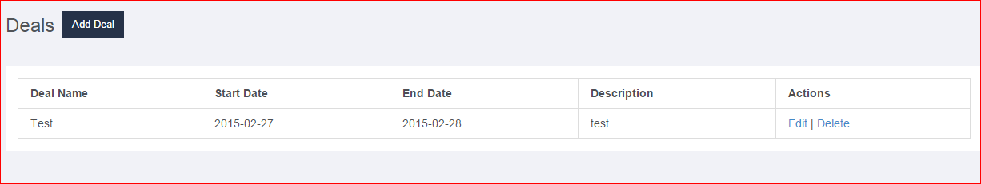

Can you please add another column and display the vendor name if when has been added to deals?

1. Can you please add “Promo Vendors” button Beside Manage Deals?
   1. It will be long list of Vendor if you want to select from drop down from “Add Promo Page” . I think I mentioned to have a search function to search and select a Vendor.

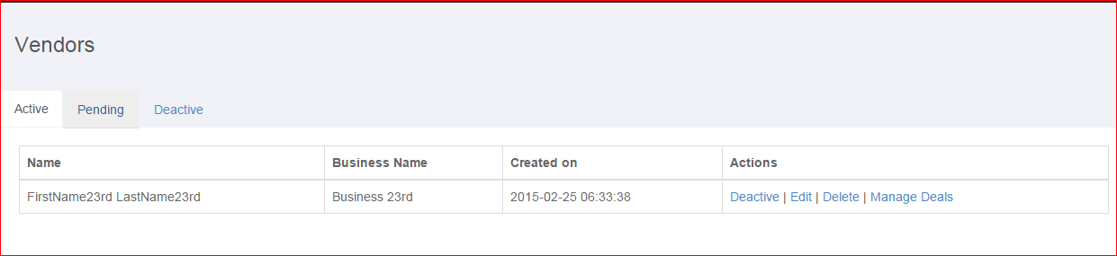

1. The View Mode page are missing for following pages:



* 1. 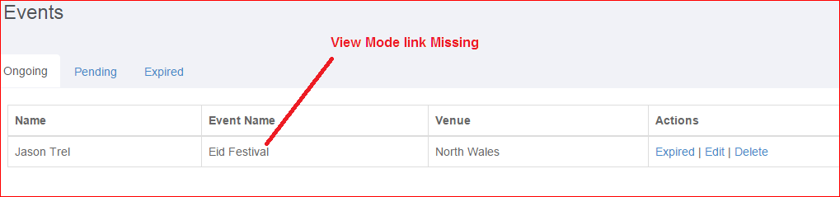
  2. 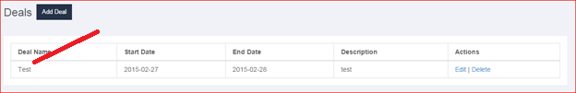

1. The scrolling links are not working .

