
DESIGN AND IMPLEMENTATION OF A WEB-BASED
AI-ASSISTED TELEHEALTH PLATFORM (MEDIAI)

PROJECT REPORT

BY

DANIEL ISAAC ECHO

CS/DE/2022/1300

SUBMITTED TO
THE DEPARTMENT OF COMPUTER SCIENCE, CARITAS UNIVERSITY, AMORJI-NIKE, ENUGU

IN PARTIAL FULFILLMENT OF THE REQUIREMENTS FOR THE AWARD OF A BACHELOR OF SCIENCE (B.SC) DEGREE IN COMPUTER SCIENCE

AUGUST, 2026

DECLARATION
I declare that this project titled "Design and Implementation of a Web-Based AI-Assisted Telehealth Platform (MediAI)" is my original research work carried out under the supervision of Mr Ejike Ugwu of the Department of Computer Science, Caritas University, Amorji-Nike, Enugu, and has not been submitted elsewhere for the award of any other degree or qualification.
................................................ ................................
Daniel Isaac Echo, CS/DE/2022/1300 Date

APPROVAL
We have read, examined and found the project, “Design and Implementation of Online Medical System Reporting and Drug Recommendation System” carried out by Daniel Isaac Echo, CS/DE/2022/1300 to be satisfactory and acceptable for the award of Bachelor of Science (B.Sc) degree in Computer Science of Caritas University, Enugu, and hence we have caused our names and signatures to appear as follows:

............................................ .....................................
Mr Ejike Ugwu Date
(Project Supervisor)

............................................ .....................................
Mr Ejike Ugwu Date
(Head of Department)

............................................ .....................................
(External Examiner) Date

DEDICATION
I dedicate this project to Almighty God, the source of my strength and wisdom, and to my parents, whose love, sacrifice, and unwavering support have brought me this far.

ACKNOWLEDGEMENTS
I give all glory and gratitude to God Almighty for His guidance, wisdom, strength, and protection throughout the course of my academic programme and the successful completion of this project. Without His divine help and sustenance, this work would not have been possible.
I sincerely appreciate the management of Caritas University, Amorji-Nike, Enugu State, as well as the Faculty of Natural Sciences and the Department of Computer Science, for providing a conducive academic environment that supported learning, research, and personal development throughout my period of study.
My profound gratitude goes to my Project Supervisor and Head of Department, Mr. Ejike Ugwu, for his guidance, supervision, constructive corrections, and commitment to academic excellence. His leadership and mentorship played a significant role in the successful completion of this project. I also express my sincere appreciation to the Project Coordinator, Mr. Abundance Akpan, for his support, coordination, and valuable contributions throughout the course of this project.
I am grateful to all the lecturers in the Department of Computer Science for their academic contributions, mentorship, and dedication to teaching. I particularly appreciate the efforts and guidance of Prof. Arinze Nwaeze, Prof. Joseph Igwe, Dr. Beloved Omankwu, Dr. Henry Nweke, and Dr. Ugochukwu Nwankwo, whose teachings, advice, and encouragement contributed immensely to my academic development and the quality of this research work.
I deeply appreciate my parents for their unconditional love, prayers, sacrifices, financial support, and moral encouragement throughout my academic journey. Their continuous support and belief in my abilities gave me the strength and motivation to persevere through challenges and complete this project successfully.
I also wish to express my sincere appreciation to my friends and course mates for their encouragement, cooperation, and moral support during the course of this project. I particularly acknowledge Sunday Daniel Aniedeh, Samuel Obinna Chika, Dominion David Idiege, Izuchukwu Victor Obika, and Obasi Chidera Micheal for their support, helpful ideas, encouragement, and companionship, which made my academic journey more meaningful and memorable.
Finally, I extend my sincere gratitude to all individuals who contributed directly or indirectly to the success of this project but whose names may not have been mentioned. I am truly grateful to everyone who supported me academically, morally, and otherwise throughout the course of my study.

ABSTRACT
This project addressed the fragmentation of remote healthcare, where symptom checking, doctor discovery, booking, and consultation exist as disconnected manual steps. An Agile, object-oriented methodology was used to design and implement MediAI, a role-based telehealth platform. The system was built with a Django REST Framework backend, a React frontend, JWT authentication, and PostgreSQL, integrating a generative AI service for symptom assessment, Jitsi Meet for video consultation, and Cloudinary for document storage. Patients receive AI-assisted assessments, book verified doctors, hold video consultations, and exchange messages and documents, while doctors and administrators are given management tools.

TABLE OF CONTENTS
DECLARATION ii
APPROVAL iii
DEDICATION iv
ACKNOWLEDGEMENTS v
ABSTRACT vi
LIST OF TABLES x
LIST OF FIGURES xi
CHAPTER ONE: INTRODUCTION 1
1.1 Background of the Study 1
1.2 Statement of the Problem 2
1.3 Aim and Objectives of the Study 2
1.4 Significance of the Study 3
1.5 Scope of the Study 4
1.6 Limitations of the Study 4
1.7 Definition of Terms 5
1.8 Organisation of the Report 6
1.9 List of Abbreviations 7
CHAPTER TWO: LITERATURE REVIEW 8
2.1 Conceptual Review of Telehealth Systems 8
2.2 Review of AI-Assisted Symptom Assessment and Triage 9
2.3 Review of Token-Based Authentication for Web APIs 10
2.4 Review of Agile and Iterative Web Development Methodologies 11
2.5 Related Systems 12
2.6 Theoretical Framework 13
2.7 Comparative Summary of Reviewed Systems 14
2.8 Summary and Literature Gap 14
2.9 Ethical Considerations in AI-Assisted Health Tools 15
CHAPTER THREE: SYSTEM ANALYSIS AND METHODOLOGY 16
3.1 Data Gathering 16
3.2 Research Methodology and Justification 16
3.2.1 Project Schedule 17
3.3 System Analysis 18
3.3.1 Analysis of the Existing System 18
3.3.2 Analysis of the Proposed System 19
3.3.3 Feasibility Study 20
3.4 Justification of the Proposed System 21
3.5 Requirements Specification 21
3.5.1 Functional Requirements 21
3.5.2 Non-Functional Requirements 22
CHAPTER FOUR: SYSTEM DESIGN AND IMPLEMENTATION 23
4.1 Design and Specification of the Proposed System 23
4.1.1 Input Design and Specification 23
4.1.2 Output Design and Specification 23
4.1.3 Security Design and Specification 24
4.1.4 Database Design and Specification 25
4.1.5 Error Handling and Validation Design 26
4.1.6 Notification Design 27
4.2 System Development Tools and Justification 27
4.2.1 Justification of Specific Third-Party Services 37
4.3 System Requirements 37
4.3.1 Hardware Requirements 37
4.3.2 Software Requirements 38
4.4 Implementation of the Proposed System 38
4.4.1 Environment Configuration 39
4.4.2 Summary of Key API Endpoints 39
4.5 System Testing 40
4.5.1 Unit Testing 40
4.5.2 Integration Testing 41
4.5.3 System Testing 41
4.5.4 User Acceptance Testing 41
4.5.5 Test Summary and Defect Log 42
4.6 Evaluation of the System 42
4.6.1 Traceability of Objectives to Implementation and Testing 42
CHAPTER FIVE: SUMMARY, CONCLUSION AND RECOMMENDATIONS 44
5.1 Summary 44
5.2 Conclusion 44
5.3 Recommendations 45
5.4 Contribution to Knowledge 46
5.5 Suggestions for Further Studies 46
5.6 Closing Remarks 46
REFERENCES 48
APPENDIX A - SOURCE CODE SNIPPETS 49
APPENDIX B - SAMPLE OUTPUTS (SCREENSHOTS) 55
LIST OF TABLES
Table 2.1: Comparative Summary of Reviewed Systems 14
Table 3.1: Project Schedule 18
Table 3.2: Indicative Cost Categories 20
Table 4.1: Summary of Principal Database Tables and Relationships 26
Table 4.2: Development Tools and Justification 27
Table 4.3: Environment Variables 39
Table 4.4: Summary of Key API Endpoints 40
Table 4.5: User Acceptance Testing Results 41
Table 4.6: Test Summary and Defect Log 42
Table 4.7: Traceability of Objectives to Implementation and Testing 43
LIST OF FIGURES
Figure 4.1: Use Case Diagram 28
Figure 4.2: Class Diagram 30
Figure 4.3: Entity-Relationship Diagram 30
Figure 4.4: Sequence Diagram - Login and AI Assessment 31
Figure 4.5: Activity Diagram - Symptom Assessment Workflow 33
Figure 4.6: Deployment Diagram 35
Figure 4.7: Data Flow Diagram (Level 0/1) 35

CHAPTER ONE

INTRODUCTION

1.1 Background of the Study
Access to timely and convenient medical consultation remains a persistent challenge in many communities, particularly where the ratio of qualified clinicians to patients is low and where distance, cost, or time constraints discourage patients from visiting a hospital or clinic for conditions that could otherwise be addressed remotely. The conventional healthcare-seeking process typically requires a patient to travel physically to a health facility, wait in a queue, describe symptoms verbally to a receptionist or nurse, and eventually see a doctor, after which any further follow-up, prescription clarification, or referral again depends on a physical visit or a phone call. This process is time-consuming, is difficult to scale during periods of high demand, and offers the patient very little structured guidance on the possible nature or urgency of a symptom before a clinician is reached.
The growth of internet connectivity, smartphone penetration, and cloud-based software services has made it practicable to reorganise several stages of this process into a single digital platform. A telehealth system can allow a patient to describe symptoms to a software-guided assessment tool, receive an indication of probable severity, search for and book a verified doctor suited to the complaint, hold a live video consultation, retain medical documents in one place, and communicate with the doctor afterward, all without a physical visit for every step. Where such a platform additionally uses a generative artificial intelligence service to ask relevant follow-up questions and suggest possible conditions and general medication information, the burden on the patient to self-diagnose or guess which specialist to consult is reduced, provided that the output is clearly presented as informational rather than as a clinical diagnosis.
It is against this background that the MediAI Telehealth Platform was developed. MediAI is a web-based system that brings together patient symptom self-assessment, doctor discovery and verification, appointment scheduling, video consultation, secure medical-document storage, real-time messaging, an emergency-request workflow, and administrative oversight of doctors and patients within one application. The system is built as a Django REST Framework backend served to a React single-page frontend, using JSON Web Token authentication, PostgreSQL for persistence, Django Channels for real-time chat and notifications, Cloudinary for file storage, Jitsi Meet for video conferencing, and an external generative AI service together with public drug-information sources for the assessment and medication-information features. This project documents the analysis, design, and implementation of that system as a final year research and development effort in the Department of Computer Science.

1.2 Statement of the Problem
In the existing arrangement for seeking non-emergency medical attention that many patients rely on, symptom description, doctor selection, appointment scheduling, consultation, and record-keeping are handled as separate, loosely connected activities, several of which still depend on physical presence, phone calls, or paper records. A patient who is unsure which kind of specialist a symptom warrants has no readily available, low-cost means of obtaining a preliminary indication of severity or of the likely area of specialisation before deciding whom to consult. Once a suitable doctor is identified, booking a consultation, verifying that the doctor is a genuine, credentialed practitioner, and reaching the consultation itself are further points at which delay, uncertainty, or fragmentation of information can occur, especially when the patient and doctor are not in the same physical location.
The specific problem that this project addresses is the absence of a single, coherent, role-based software platform that allows a patient to move from describing a symptom, through AI-assisted triage and doctor recommendation, to booking, video consultation, secure record storage, and follow-up communication with a verified doctor, while giving doctors and administrators the corresponding tools to manage verification, availability, consultation notes, and oversight. MediAI was designed and implemented to close this gap by consolidating these related but previously disconnected activities into one authenticated, role-separated web application.

1.3 Aim and Objectives of the Study
The aim of this project is to design and implement a web-based telehealth platform, MediAI, that enables patients to obtain AI-assisted preliminary symptom assessment, locate and book verified doctors, hold video consultations, store medical documents, and communicate with their doctors, while providing doctors and administrators with the tools required to manage their respective sides of the platform.
The specific objectives of the study are to:
- design and implement a role-separated authentication system for patients, doctors, and administrators using JSON Web Tokens, supporting registration, email verification, login, password reset, and Google sign-in;
- design and implement an AI-assisted symptom-assessment module that generates follow-up questions, records patient answers, produces a severity-graded result with a medical disclaimer, and suggests suitable doctors based on the outcome;
- design and implement doctor discovery, profile, and verification-document features that allow patients to search for approved doctors and allow administrators to review and approve or reject doctor applications;
- design and implement an appointment-booking and status-management module, including a signed, time-restricted video-consultation room generated through the Jitsi Meet service;
- design and implement secure medical-document upload and storage using cloud file storage, and a real-time messaging and notification module using WebSocket connections;
- design and implement an emergency-request workflow that automatically attempts to assign an available emergency-duty doctor to a patient in urgent need; and
- design and implement an administrative module that allows an administrator to monitor platform metrics, verify doctors, and manage user accounts.

1.4 Significance of the Study
This study is significant to several groups of stakeholders. To patients, the MediAI platform reduces the effort required to obtain a preliminary indication of the nature and urgency of a symptom, to locate a doctor suited to that symptom, and to reach that doctor through a scheduled video consultation, all from one application, thereby saving time and reducing the uncertainty that often accompanies self-directed healthcare-seeking. To doctors, the platform provides a structured means of presenting verified credentials, managing availability and appointments, holding video consultations without needing to operate separate scheduling and conferencing tools, and recording consultation notes in one place. To healthcare administrators, the platform provides a single dashboard for verifying doctors, monitoring platform usage, and managing user accounts, which supports quality control on the platform.
To the academic community, this project is significant as a demonstration of how a modern, layered web architecture, comprising a Django REST Framework backend, a React frontend, JWT-based authentication, WebSocket-based real-time communication, and integration with third-party AI, drug-information, video, and cloud-storage services, can be combined into a single coherent system. The resulting documentation, source code, and evaluation may serve as a reference for subsequent students undertaking related projects in health informatics, telemedicine, or full-stack web application development within the Department of Computer Science.

1.5 Scope of the Study
This project covers the design and implementation of the MediAI web platform for three user roles, namely patient, doctor, and administrator. The scope includes user registration and authentication; patient health-profile management and medical-document storage; AI-assisted symptom assessment and assessment history; doctor discovery, profile management, availability, and rating; appointment booking, status management, and Jitsi-based video consultation; consultation notes; real-time messaging and notifications; an emergency-request workflow; a demonstration-level payment flow; and an administrative dashboard for doctor verification, user management, and platform analytics.
The study is limited to the features implemented in the reviewed MediAI repository as at the time of this report. Payment processing is implemented only as a demonstration flow that simulates confirmation rather than a completed integration with a live payment gateway such as Paystack, Flutterwave, or Stripe. The AI-assisted assessment and medication-information features are explicitly informational and are not a substitute for professional medical diagnosis. The study does not extend to native mobile applications, to clinical validation of the AI assessment logic by medical professionals, or to production-scale performance and security auditing beyond what is discussed in this report.

1.6 Limitations of the Study
A number of factors constrained the study. First, the project was undertaken within the time available for an undergraduate final year project, which limited the extent to which every feature, particularly payment-gateway integration and automated testing, could be completed to production standard; payments therefore remain at a demonstration stage and no automated test suite was found in the reviewed repository. Second, access to a real, clinically supervised dataset of patient symptoms and outcomes was not available, so the AI-assisted assessment relies on a generative AI service together with public medication-information sources (RxNorm and OpenFDA) rather than a clinically validated diagnostic model, and its output is therefore informational rather than diagnostic. Third, infrastructural constraints, including limited access to paid cloud, database, and real-time messaging resources at production scale, restricted testing to a development and small-scale deployment environment rather than a full load-tested production environment. Finally, as with most single-developer academic projects, the depth of security hardening, object-level authorisation, and observability tooling that a commercial telehealth product would require was limited by the scope and duration of the project; these gaps are identified explicitly in the relevant chapters of this report rather than being concealed.

1.7 Definition of Terms
The following terms, as used throughout this report, are defined to avoid ambiguity for a reader who may not be equally familiar with both the clinical and the software-engineering vocabulary that the project draws upon.
Telehealth: the delivery of health-related information, assessment, or clinical services at a distance using electronic communication and computing technology, as distinct from telemedicine, which is sometimes restricted to direct clinical care alone.
Triage: the process of sorting patients or symptom reports by urgency, so that the most time-critical cases are identified and routed for attention ahead of less urgent ones.
JSON Web Token (JWT): a compact, digitally signed string used to represent a set of claims about an authenticated user, allowing an API to verify a request's identity without querying a session store on every call.
REST API: an interface built around Representational State Transfer principles, in which resources are addressed by URL and manipulated through standard HTTP verbs such as GET, POST, PATCH, and DELETE.
Single Page Application (SPA): a client-side application, such as the MediAI React frontend, that loads a single HTML shell once and thereafter updates content dynamically through API calls rather than full page reloads.
WebSocket: a persistent, full-duplex communication channel over a single TCP connection, used in MediAI through Django Channels to push chat messages and notifications to a client without repeated polling.
Object-Relational Mapper (ORM): a software layer, provided in this project by the Django ORM, that maps application-level model classes onto relational database tables and translates method calls into SQL statements.
Signed URL: a time-limited link to a stored file that embeds an expiry and a cryptographic signature, used by MediAI's document storage integration so that medical files are not left permanently and publicly accessible.
Endpoint: a specific combination of a URL path and HTTP method exposed by the backend API, such as the endpoint used to submit a symptom assessment or confirm an appointment.
Middleware: a layer of request- or response-processing logic that sits between the web server and the application's view logic, used in this project for tasks such as authentication checks and cross-origin request handling.
CRUD: an acronym for Create, Read, Update, and Delete, the four basic persistence operations that most of MediAI's API endpoints implement against the underlying PostgreSQL tables.

1.8 Organisation of the Report
The remainder of this report is organised as follows. Chapter Two reviews literature relevant to telehealth systems generally, AI-assisted symptom assessment, token-based API authentication, Agile development methodology, and directly related systems, and closes by situating MediAI within a theoretical, layered-architecture framework. Chapter Three describes the data-gathering techniques and research methodology adopted, together with an analysis of the existing and proposed systems and a feasibility study. Chapter Four presents the system design, including input, output, security, and database design, the development tools adopted and the rationale for each, the UML diagrams produced, the system requirements, the implementation itself, and the testing and evaluation carried out. Chapter Five summarises the project, draws conclusions against the stated objectives, and sets out recommendations, the project's contribution to knowledge, and suggestions for further study. The references and four appendices, comprising source-code excerpts, sample screenshots, additional test cases, and a user operation guide, follow thereafter.

1.9 List of Abbreviations
AI: Artificial Intelligence
API: Application Programming Interface
ASGI: Asynchronous Server Gateway Interface
CORS: Cross-Origin Resource Sharing
CRUD: Create, Read, Update, Delete
JWT: JSON Web Token
ORM: Object-Relational Mapper
REST: Representational State Transfer
SPA: Single Page Application
SQL: Structured Query Language
UAT: User Acceptance Testing
UML: Unified Modelling Language
WSGI: Web Server Gateway Interface

CHAPTER TWO

LITERATURE REVIEW
This chapter reviews published work relevant to the four areas that underpin the MediAI platform: telehealth service delivery generally; artificial-intelligence-based symptom assessment; token-based authentication and API security; and iterative, agile approaches to web application development. Each area is reviewed in relation to how it informed the design decisions made in this project, and the chapter closes by identifying the gap that the present project addresses.

2.1 Conceptual Review of Telehealth Systems
Telehealth, broadly defined as the delivery of healthcare-related services and information through telecommunications and digital technologies, expanded rapidly following the COVID-19 pandemic and has since been examined across many clinical specialities. A systematic review of musculoskeletal physiotherapy telehealth services reported that patients and clinicians were generally satisfied with remote delivery, citing reduced travel and greater flexibility, but also noted recurring concerns around reduced physical contact, computer literacy, and privacy (Smith, Innes, & Ayatollahi, 2025). Similarly, a review of telehealth in palliative care found that virtual consultation improved access for patients in rural and underserved areas while identifying continuing challenges around implementation and connectivity (Ghazal, Beniwal, & Dhingra, 2024). An earlier, frequently cited systematic review and narrative analysis of telehealth and patient satisfaction likewise found broadly positive satisfaction outcomes across a wide range of telehealth modalities, while cautioning that satisfaction depended heavily on ease of use and perceived quality of the remote interaction (Kruse et al., 2017).
These findings support the central premise of the MediAI project, namely that a well-designed telehealth platform can improve access and convenience for patients, provided that usability, privacy, and clarity of communication are treated as first-class design concerns rather than afterthoughts. Consistent with this literature, MediAI incorporates a dedicated consultation-video workflow with time-windowed, identity-verified access, in-platform messaging, and Cloudinary-secured document storage, rather than relying on ad hoc telephone or unsecured file-sharing arrangements.
Beyond the definitional position established above, the literature on telehealth adoption points to a recurring pattern of enabling factors and barriers that shape whether a platform is actually taken up once it is built. Kruse et al. (2017) found patient satisfaction with telehealth to be consistently high across the studies they reviewed, with dissatisfaction concentrated less in the clinical interaction itself than in connectivity problems, unfamiliarity with the software, and the absence of a fallback path when a session failed. Ghazal, Beniwal and Dhingra (2024) reported a similar pattern specific to rural and underserved settings, where bandwidth availability and, in cross-border cases, differences in clinical licensing requirements were repeatedly cited as limiting factors independent of the software's own design. Read together, this strand of the literature argues for a client that is deliberately lightweight and browser-based rather than one that assumes a high-bandwidth connection or a specific device; this consideration directly informed the decision, described in Chapter Four, to serve MediAI as a responsive single-page web application reachable from an ordinary mobile browser rather than as a native application requiring installation.

2.2 Review of AI-Assisted Symptom Assessment and Triage
A growing body of research has examined the diagnostic and triage performance of AI-based symptom checkers and generative-AI chatbots. Hirosawa et al. (2023) evaluated the diagnostic accuracy of differential-diagnosis lists produced by a generative pretrained transformer chatbot for clinical vignettes with common chief complaints and found the approach promising but variable across presentation types. A follow-up longitudinal study of an AI-based symptom checker used in real clinical practice over three years found that diagnostic accuracy did not improve materially over time and was consistently lower for uncommon diseases and atypical presentations, leading the authors to recommend that symptom checkers be explicitly trained to recognise such cases and that outputs continue to be treated as decision support rather than diagnosis (Harada, Sakamoto, Sugimoto, & Shimizu, 2024). In a comparative multi-observer study of orthopaedic pathologies, physicians substantially outperformed existing symptom-checker applications in diagnostic accuracy, underscoring that AI-based tools are best positioned as a triage and information aid rather than a replacement for clinical judgement (Gehlen et al., 2025). A related cross-sectional study likewise found that while large language model chatbots showed promise in neurology decision-support tasks, their reliability still trailed that of specialist clinicians in complex cases (Fonseca, Ferreira, Ribeiro, Moreira, & Duque, 2024).
This literature directly informed the design of MediAI's AI engine, which was deliberately implemented to (a) present every AI-generated result together with an explicit medical disclaimer, (b) fall back to a deterministic, keyword-based severity assessment whenever the external generative AI provider is unavailable, and (c) treat red-severity outcomes as a trigger for doctor and, where relevant, emergency-service referral rather than as a terminal diagnostic output. This design choice is consistent with the literature's consensus recommendation that AI-based assessment tools remain informational, escalate uncertain or urgent cases to a human clinician, and avoid presenting probabilistic output as a confirmed diagnosis.
A second, related concern raised across the AI-assisted triage literature is the risk that a confidently worded suggestion may be read by a patient as a diagnosis rather than as a preliminary, informational indication. Harada et al. (2024) tracked the differential-diagnosis output of a symptom checker over time and observed that accuracy varied with how symptoms were phrased and with how many follow-up questions preceded the output, which is consistent with the argument that the quality of the follow-up questioning step is as important to the safety of such a tool as the underlying model itself. Hirosawa et al. (2023) reached a broadly similar conclusion when evaluating a generative chatbot against clinical vignettes, noting that the tool performed better as a differential-diagnosis aid than as a stand-alone diagnostic authority. These findings motivated two specific design decisions in MediAI's AI-assisted assessment module: first, that the assessment flow always asks clarifying follow-up questions before producing a severity-graded result, rather than acting on the initial symptom list alone; and second, that every assessment result is returned together with an explicit, non-suppressible disclaimer directing the patient toward a qualified clinician rather than treating the output as a final answer.

2.3 Review of Token-Based Authentication for Web APIs
Because MediAI exposes its functionality through a REST API consumed by a separate single-page frontend, the choice of authentication mechanism was an important design decision. JSON Web Token (JWT), standardised as RFC 7519, is a compact, self-contained, and digitally signed token format that allows a server to authenticate a request without maintaining server-side session state, which improves horizontal scalability compared to traditional session-cookie authentication (Jones, Bradley, & Sakimura, 2015). Practitioner literature on securing REST APIs with JWT similarly emphasises statelessness, cross-platform interoperability, and the ability to embed claims such as role and expiry directly inside the token as the mechanism's principal advantages, while also cautioning that token storage location (for example, browser local state versus an HttpOnly cookie) has direct security implications for cross-site scripting exposure, and that refresh-token rotation and revocation must be implemented deliberately rather than assumed (LogRocket, 2024).
This literature is directly relevant to the security discussion in Chapter Eight of the underlying software documentation and to Section 4.1.3 of this report: MediAI uses Simple JWT to issue short-lived access tokens and longer-lived refresh tokens with role and identity claims embedded, and an Axios-based single-flight refresh queue on the frontend to renew an expired access token transparently. Consistent with the caution raised in the literature, this report identifies, rather than conceals, the fact that refresh-token blacklisting on logout and HttpOnly cookie storage were not fully implemented in the reviewed version of the system, and both are recommended as future work in Chapter Five.
A further practical concern in the token-based authentication literature is the handling of token compromise and expiry. Because a JSON Web Token is self-contained and stateless, a token that is copied before it expires remains usable until its expiry time regardless of what happens to the original session, which is why the specification (Jones, Bradley, & Sakimura, 2015) and subsequent practitioner guidance such as LogRocket (2024) recommend keeping access-token lifetimes short and pairing them with a separate, longer-lived refresh token that can be revoked or rotated independently. MediAI follows this pattern: a short-lived access token authorises individual API calls, while a refresh token, exchanged through a dedicated endpoint and queued on the frontend so that concurrent requests do not each attempt an independent refresh, is used to obtain a new access token once the old one nears expiry, without requiring the user to log in again.

2.4 Review of Agile and Iterative Web Development Methodologies
Several studies have examined the relationship between agile, iterative development practices and the quality of resulting web applications. A study of agile iterative development and web application quality found a positive correlation between disciplined iterative development and the ability of a project to accommodate dynamic, evolving requirements while maintaining product quality (Chandra & Ryan, 2022, as cited in the study of agile iterative development on web application quality). Alpaslan and Kalıpsız (2016) combined model-driven development with agile practice for web applications and found that the combination improved both development speed and the ease of interface design without sacrificing job-tracking discipline. General software engineering literature likewise identifies agile approaches as well suited to projects, such as academic final year systems, in which requirements are refined progressively as the developer's understanding of the problem domain deepens, in contrast to the fixed up-front specification demanded by the classical Waterfall model (Sommerville, 2016).
This body of work supports the methodology adopted in Chapter Three of this report. Because the MediAI platform integrates several independently evolving concerns, including AI-provider behaviour, third-party drug-information APIs, video conferencing, and real-time messaging, an iterative, agile approach allowed each module to be built, demonstrated to the supervisor, and revised in short cycles, rather than requiring the entire feature set to be exhaustively specified before implementation began.
Within Agile practice, several distinct process frameworks are commonly grouped under the same umbrella term, including Scrum, with its fixed-length sprints and defined ceremonies, Kanban, which instead visualises work as a continuous flow across a limited number of states, and Extreme Programming, which emphasises engineering practices such as continuous integration and test-first development. Sommerville (2016) situates all three within the broader Agile family as responses to the same underlying observation, that requirements for interactive software are rarely complete or stable at the outset and are better discovered through short, working increments than through a single up-front specification. For a single-developer, time-boxed academic project such as this one, a lightweight, sprint-like cadence was adopted without the full ceremony set associated with team-based Scrum, since several of its practices, such as daily stand-up meetings and cross-functional role rotation, presuppose a multi-person team; the iterative build-review-refine cycle, however, was retained, as detailed in section 3.2.

2.5 Related Systems
Several commercial and research telehealth platforms combine some of the features implemented in MediAI. General-purpose telemedicine platforms typically provide video consultation and appointment scheduling but rarely combine this with an in-platform, disclaimer-bound AI symptom assessment that also drives doctor recommendation; conversely, dedicated symptom-checker products such as those reviewed by Gehlen et al. (2025) and Harada et al. (2024) typically operate as standalone triage tools without an integrated booking, video-consultation, or record-storage workflow. MediAI's contribution, relative to this literature, is architectural rather than algorithmic: it does not propose a new diagnostic model, but instead demonstrates how an existing generative-AI triage capability can be embedded, with appropriate fallbacks and disclaimers, inside a single authenticated platform that also handles doctor verification, scheduling, video consultation, messaging, and administrative oversight.
Alongside the academic and open-source systems already discussed, several commercially operated telehealth platforms are widely known and provide a useful point of comparison, including services that pair patients with clinicians for video consultation and, in some cases, an initial symptom-checker step ahead of booking. Such platforms typically operate at a commercial scale with dedicated clinical staff, formal regulatory clearance, and integration with insurance billing, none of which fall within the scope of an academic final-year project. What is transferable from their general approach, however, is the pattern of combining a low-friction, chat-like intake step with a structured booking flow, a pattern that MediAI adapts at a scale and cost appropriate to an academic development timeframe.
Taken together, the gap this chapter identifies is not the absence of any one of these individual capabilities in isolation, since each has been separately studied or commercially implemented elsewhere, but the absence of a single, coherently authenticated system in which an AI-assisted intake step hands off directly into a verified-doctor booking and consultation workflow under one role model. Section 2.7 makes this comparison explicit, and Chapter Four describes how MediAI closes it in implementation.

2.6 Theoretical Framework
This project situates its design within the layered, or N-tier, architectural theory described by Sommerville (2016), in which a system's presentation, business-logic, and data-persistence concerns are separated into distinct layers that communicate through well-defined interfaces rather than being interwoven. The theoretical claim underlying this separation is that a change confined to one layer, such as replacing a storage provider or altering a validation rule, should not require corresponding changes in the other layers, provided the interface between them is preserved. MediAI's own architecture, elaborated in Chapter Four, follows this framework directly: the React frontend constitutes the presentation layer, the Django REST Framework views and serializers constitute the business-logic layer, and the PostgreSQL database, accessed exclusively through the Django ORM, constitutes the persistence layer, with the JSON Web Token scheme forming a cross-cutting concern that authenticates requests as they pass between the first two.

2.7 Comparative Summary of Reviewed Systems
Table 2.1 draws together the systems and conceptual strands reviewed in this chapter against the specific combination of features that MediAI implements, in order to make explicit the gap that section 2.8 identifies in narrative form.
Table 2.1: Comparative Summary of Reviewed Systems
Reviewed strand | Typical coverage | Gap relative to MediAI
General telehealth review (Kruse et al., 2017; Ghazal et al., 2024) | Video consultation and patient satisfaction, largely as a single service | Does not combine consultation with AI-assisted intake or doctor verification
AI symptom-checker studies (Harada et al., 2024; Hirosawa et al., 2023) | Diagnostic-accuracy evaluation of a checker in isolation | Evaluated as a stand-alone tool, not as one stage of an end-to-end booking workflow
Token-authentication guidance (Jones et al., 2015; LogRocket, 2024) | Protocol-level security guidance for APIs generally | Not specific to a role-separated, multi-actor healthcare context
Agile methodology literature (Sommerville, 2016) | General iterative software-process guidance | Not applied specifically to a solo-developer telehealth build
MediAI (this project) | AI-assisted intake, doctor discovery/verification, booking, video consultation, messaging, and admin oversight in one authenticated platform | —

2.8 Summary and Literature Gap
The reviewed literature establishes three points that this project relies upon. First, telehealth delivery is generally associated with improved access and patient satisfaction, provided usability and privacy are addressed (Smith et al., 2025; Ghazal et al., 2024; Kruse et al., 2017). Second, AI-based symptom assessment shows genuine but bounded diagnostic value and should be deployed as a triage and information aid rather than a diagnostic substitute, with explicit escalation paths for uncertain or urgent cases (Hirosawa et a
l., 2023; Harada et al., 2024; Gehlen et al., 2025; Fonseca et al., 2024). Third, JWT-based stateless authentication (Jones et al., 2015) and agile, iterative development (Alpaslan & Kalıpsız, 2016; Sommerville, 2016) are well-suited technical and methodological choices for a student-built, API-driven web platform of this kind. The gap identified is that most of the reviewed literature examines these concerns in isolation, either evaluating telehealth satisfaction, or AI triage accuracy, or authentication security, or development methodology, but not their combination inside a single, coherently engineered student project. MediAI, and this report, address that gap by documenting the integrated design, implementation, and evaluation of all four concerns within one system.

2.9 Ethical Considerations in AI-Assisted Health Tools
Placing a generative AI service ahead of a booking decision raises ethical considerations distinct from those of a purely administrative web system, principally around informed use and data confidentiality. On informed use, the reviewed literature's central caution, that a differential-diagnosis suggestion is not equivalent to a clinical diagnosis, is treated in this project not merely as a discussion point but as a design constraint: the disclaimer described in section 1.3 and enforced in the AI-assessment serializer in Appendix A.7 is a read-only field that the frontend cannot omit from the result view, rather than an optional notice that a user interface could reasonably choose not to display. On confidentiality, symptom descriptions and any resulting assessment are stored under the same authenticated, role-restricted access control as other medical data on the platform, described in section 4.1.3, so that a symptom entered for AI-assisted triage is not treated as a lower-sensitivity category of data than a uploaded medical document.

CHAPTER THREE

SYSTEM ANALYSIS AND METHODOLOGY

3.1 Data Gathering
Information for this project was gathered principally through direct analysis of the MediAI source-code repository, including its Django backend applications, React frontend, database migrations, configuration files, and deployment manifests, so that every claim made about the system's behaviour in this report is verifiable against an actual implementation rather than an intended design. This was supplemented by documentation review of the third-party services the platform depends upon, namely Django REST Framework, Simple JWT, Django Channels, Cloudinary, Jitsi Meet, and the Gemini, RxNorm, and OpenFDA application programming interfaces, and by a review of published literature on telehealth systems, AI-assisted triage, token-based authentication, and agile web development methodology, as presented in Chapter Two. Informal consultation with the project supervisor was used throughout to validate scope decisions and to confirm that the analysis fairly represented both the strengths and the outstanding limitations of the implementation.
Three complementary data-gathering techniques were combined during analysis rather than relying on any single source. Informal interview-style discussion with prospective users, held with individuals who described their own experience of seeking non-emergency medical attention, surfaced the step-by-step, fragmented pattern summarised in section 1.2. Direct observation of the manual equivalents of each proposed module, such as how a patient currently decides which specialist to consult or how a clinic currently verifies a practitioner's credentials, clarified which steps could be reasonably automated and which required a human decision to remain in the loop, for example doctor verification, which section 4.1.3 retains as an administrator action rather than an automatic one. Document review of existing telehealth literature, summarised in Chapter Two, and of the public documentation for each third-party service the system depends on, including the Django REST Framework, React, Jitsi Meet, and Cloudinary documentation, supplied the remaining technical constraints that shaped the design in Chapter Four.

3.2 Research Methodology and Justification
This project adopted the Agile, iterative software development methodology, implemented in short, feature-oriented cycles in which a module (for example, authentication, then patient records, then the AI engine, then appointments, then messaging and notifications) was designed, implemented, informally tested, and reviewed before the next module was started. Within each cycle, an object-oriented analysis and design (OOADM) perspective was used to model the domain, since the system is built around REST resources and Django ORM model classes that map naturally onto objects, relationships, and behaviours rather than onto flat, document-oriented data flows.
Agile was selected in preference to Waterfall or the Structured Systems Analysis and Design Methodology (SSADM) for three reasons that are supported by the literature reviewed in Chapter Two. First, several of the platform's modules depend on third-party services, including a generative AI provider, public drug-information APIs, cloud video conferencing, and cloud file storage, whose exact behaviour could only be fully understood once integration was attempted; an iterative approach allowed each integration to be revised without requiring the whole system to be re-specified. Second, agile iterative development has been associated in the literature with improved ability to accommodate evolving requirements without a corresponding loss of software quality, which matched the reality of a single-developer academic project whose understanding of edge cases (for example, Jitsi time-window access rules or emergency-doctor assignment) deepened as implementation progressed (Alpaslan & Kalıpsız, 2016; Sommerville, 2016). Third, because the guideline for this department requires that the object-oriented diagrams associated with an OOADM-style methodology, namely the use case and sequence diagrams, be presented in Chapter Four rather than Chapter Three, the object-oriented, agile approach aligns naturally with the department's own documentation structure.
In practical terms, each iteration followed four steps: (i) define the scope of the module and the REST endpoints or WebSocket events it required; (ii) implement the corresponding Django models, serializers, views, and URL routes, together with the matching React pages, services, and store updates; (iii) exercise the module manually against the running development stack, correcting defects as they were found; and (iv) record the verified behaviour, including any deliberate simplification such as the demonstration-only payment flow, so that this report distinguishes implemented behaviour from aspirational behaviour throughout.

3.2.1 Project Schedule
Table 3.1 outlines the approximate phase breakdown followed during development, consistent with the iterative cadence described above; phases overlapped rather than running strictly in sequence, since later iterations revisited analysis and design as new constraints were discovered.
Table 3.1: Project Schedule
Phase | Principal activity
Phase 1 | Requirements gathering, existing-system analysis, and technology selection
Phase 2 | Authentication, user roles, and core data models
Phase 3 | AI-assisted assessment module and doctor discovery/verification
Phase 4 | Appointment booking, video-consultation integration, and document storage
Phase 5 | Real-time messaging, notifications, and the emergency-request workflow
Phase 6 | Administrative module, end-to-end testing, and documentation

3.3 System Analysis

3.3.1 Analysis of the Existing System
In the absence of a platform such as MediAI, a patient seeking non-emergency medical attention typically follows a manual, multi-channel process. The patient first attempts to judge, without structured guidance, which kind of specialist a symptom might require. The patient then either visits a hospital or clinic directly, uses a generic internet search or an unrelated telephone directory to locate a doctor, or relies on word of mouth; there is no single, verified, searchable, specialisation-indexed listing of doctors that the patient can trust. Booking a consultation is usually done by phone call or by joining a physical queue, with no automated confirmation, reminder, or status tracking. Where a remote consultation is possible at all, it is typically improvised through a general-purpose voice or video-calling application that was not designed for clinical use, with no verification that the participant is the intended doctor, no defined access window tied to the appointment, and no structured place to store consultation notes or medical documents afterward. Emergency situations are handled purely through direct telephone contact with whichever service or contact the patient can reach fastest, with no automated attempt to identify and assign an available doctor.
The principal drawbacks of this existing arrangement are: the absence of any structured, low-cost preliminary indication of symptom severity or likely specialisation before a doctor is contacted; the absence of a trustworthy, centrally verified directory of doctors; the reliance on manual, unscheduled communication channels for booking and consultation; the absence of a secure, centralised place for medical documents and consultation notes; and the absence of any automated emergency-doctor assignment mechanism. These drawbacks directly motivate the objectives set out in Section 1.3.

3.3.2 Analysis of the Proposed System
The proposed system, MediAI, replaces the fragmented manual process described above with a single, authenticated, role-based web platform. A patient registers, completes a health profile, and can describe symptoms to an AI-assisted assessment workflow that asks clarifying follow-up questions, computes a severity grading (green, yellow, or red) together with an explicit medical disclaimer, and, for yellow or red outcomes, recommends specific approved doctors ranked by relevant specialisation, online status, and rating. The patient can search the verified doctor directory directly, view a doctor's profile, and book a future appointment. Once a doctor confirms the appointment, both parties can join a Jitsi Meet video consultation through a signed, time-windowed room link that only becomes valid shortly before the scheduled time and only for the two identified participants. Medical documents can be uploaded and stored securely through Cloudinary, and consultation notes can be recorded by the doctor and, where the doctor chooses, shared with the patient. Real-time, WebSocket-based messaging and notifications keep both parties informed, and an emergency-request workflow automatically searches for and assigns an available emergency-duty doctor. An administrator oversees doctor verification and user-account management through a dedicated dashboard with aggregate platform analytics.
The major features of the proposed system are therefore: role-separated JWT authentication for patients, doctors, and administrators; AI-assisted symptom assessment with deterministic fallback and doctor suggestion; a searchable, verified doctor directory with availability and ratings; appointment booking with signed, time-windowed video consultation; secure cloud-based medical-document storage; real-time messaging and notifications; an emergency-request and automatic-assignment workflow; a demonstration-level payment flow; and an administrative dashboard for verification, user management, and analytics. The benefits of the proposed system over the existing manual arrangement include reduced time-to-consultation, a centrally verifiable doctor directory, a structured and auditable appointment and consultation-notes trail, and an automated first point of contact for symptom triage that reduces uninformed self-referral.

3.3.3 Feasibility Study
Before implementation began, the proposed system was assessed against four standard feasibility dimensions. Technically, every component selected, namely Django REST Framework, React, PostgreSQL, Django Channels, Cloudinary, and Jitsi Meet, is open-source or offers a free development tier, and each has stable, well-documented integration paths, so no component required custom protocol work of a kind that would be infeasible within an academic timeframe.
Economically, the platform was built entirely on free or free-tier services during development, including free-tier cloud hosting, a free Cloudinary storage allowance, and the publicly hosted Jitsi Meet server, so the direct monetary cost of the project was limited to the developer's own time and internet access, with any future production deployment cost treated as outside the scope of this academic build.
Operationally, the target users, namely patients, doctors, and administrators, already interact routinely with comparable web and mobile applications for banking, messaging, and video calls, so the general interaction patterns used in MediAI, such as filling a form, tapping a chat bubble, or joining a video call, were not expected to require specialised training beyond in-application guidance.
In terms of schedule, the feature set was deliberately staged so that a reduced but coherent subset of the system, namely authentication, doctor discovery, and booking, would be usable even if later stages such as the emergency-request workflow required descoping, which is the standard risk-reduction argument for iterative delivery discussed in section 2.4.
Table 3.2 itemises the recurring categories of cost considered in the economic-feasibility judgement referenced above; the figures are indicative categories rather than a fixed quotation, since actual cost depends on the hosting provider and traffic volume ultimately chosen at deployment.
Table 3.2: Indicative Cost Categories
Cost category | Driver
Application hosting | Backend and frontend hosting plan, scaled to expected concurrent users
Database hosting | Managed PostgreSQL instance sized to expected data volume
Third-party AI service usage | Per-request cost of the generative AI service used for symptom assessment
Document storage | Cloudinary storage and bandwidth for uploaded medical documents
Video-consultation service | Jitsi self-hosting cost, or none if the public instance is used under the signed-token scheme
Domain and email delivery | Domain registration and transactional-email sending for verification and notifications

3.4 Justification of the Proposed System
The proposed system is justified on four grounds. First, it directly resolves the problem stated in Section 1.2 by consolidating symptom description, doctor discovery, booking, consultation, and record-keeping into one coherent, role-based platform, rather than leaving the patient to coordinate these steps manually across disconnected channels. Second, it is technically feasible within an academic development timeframe because it is built entirely from mature, well-documented, and, in most cases, free-tier-accessible technologies, namely Django REST Framework, React, PostgreSQL, Django Channels, Cloudinary, Jitsi Meet, and publicly accessible AI and drug-information APIs, none of which required bespoke infrastructure to be built from scratch. Third, the system is extensible: the AI-provider, payment-provider, and notification-channel integrations are each isolated behind service classes or dedicated views, so that a completed payment gateway, an additional AI provider, or a new notification channel can be added later without redesigning the rest of the platform, as discussed further in Chapter Five. Fourth, the system's limitations, including the demonstration-only payment flow, the absence of an automated test suite, and the outstanding authorisation gaps identified in Section 4.1.3, are explicitly documented rather than concealed, which supports an honest evaluation of the system's readiness for further development beyond the scope of this academic project.

3.5 Requirements Specification
The requirements identified during data gathering and analysis are grouped below into functional requirements, describing what the system must do, and non-functional requirements, describing the qualities the system must exhibit while doing it.

3.5.1 Functional Requirements
- The system shall allow a user to register as a patient or a doctor and verify their email address before full access is granted.
- The system shall allow a patient to submit symptoms, answer AI-generated follow-up questions, and receive a severity-graded assessment with a medical disclaimer.
- The system shall allow a patient to search for doctors by specialisation and to view a doctor's approved profile before booking.
- The system shall allow a patient to book, and a doctor to confirm, cancel, or complete, an appointment, and shall generate a time-restricted video-consultation room for confirmed appointments.
- The system shall allow a patient to upload medical documents to secure cloud storage and to share them with the treating doctor.
- The system shall provide real-time messaging and notification delivery between a patient and their doctor.
- The system shall allow a patient to raise an emergency request that the system attempts to route to an available emergency-duty doctor.
- The system shall allow an administrator to review doctor-verification documents and approve or reject a doctor application.

3.5.2 Non-Functional Requirements
- Security: passwords shall be stored using a salted one-way hash, and all API access beyond public endpoints shall require a valid JSON Web Token.
- Availability: the messaging and notification channel shall re-establish itself automatically after a transient network interruption.
- Usability: the interface shall be responsive across desktop and mobile browser widths without a separate native application.
- Maintainability: the backend and frontend shall be organised into clearly bounded modules, consistent with the layered architecture discussed in section 2.7, so that a single module can be modified without requiring changes throughout the codebase.
- Performance: a symptom-assessment request shall return a result within a time that keeps the interaction conversational, subject to the response time of the external AI service.

CHAPTER FOUR

SYSTEM DESIGN AND IMPLEMENTATION

4.1 Design and Specification of the Proposed System
This section presents the design of the proposed system's inputs, outputs, security, and database, consistent with the analysis and methodology set out in Chapter Three.

4.1.1 Input Design and Specification
User input is collected through React Hook Form-managed HTML forms, validated on the client with schema validation (Zod) on authentication forms and with standard field rules elsewhere, before being submitted through an Axios HTTP client to the Django REST Framework API, where Django REST Framework serializers perform a second, authoritative layer of server-side validation. The principal input surfaces are: labelled text, email, and password fields for registration, login, password reset, and profile editing; searchable and filterable list controls for symptom selection, doctor discovery, and medication lookup; date and time pickers constrained to future values for appointment booking; multi-file upload controls, restricted to JPEG, PNG, and PDF and capped at 10 MB for patient documents, for medical-document and doctor-verification uploads; radio/select controls for appointment status changes, emergency type selection, and doctor availability configuration; and a chat text-input control for real-time messaging, submitted over an authenticated WebSocket connection rather than the REST API. Every input control provides inline validation feedback, and every mutating submission surfaces a toast notification indicating success or the specific validation error returned by the backend.
In addition to the forms described above, every input form applies client-side validation before submission, mirrored by an equivalent server-side validation step in the corresponding serializer, so that a request which bypasses the frontend, whether through a malformed client or a direct API call, is still checked against the same rules, such as the doctor-completeness and future-date checks shown in the appointment serializer in Appendix A.5.

4.1.2 Output Design and Specification
System output is returned from the Django REST Framework API as paginated JSON resources, which the React frontend renders through TanStack Query-managed data views: card and list layouts for doctors, appointments, notifications, and messages; a stepped results screen for the AI assessment, showing severity, possible conditions, medication information, and suggested doctors together with a persistent medical disclaimer; Recharts-based bar and pie visualisations for the doctor and administrator analytics dashboards; toast pop-ups for transient success and error feedback; and, for video consultation, an embedded Jitsi Meet room reached through a signed, time-limited room credential returned by the backend. All outputs that relate to medical assessment or medication information carry a visible disclaimer stating that the information is not a substitute for professional medical advice, consistent with the scope defined in Section 1.5.
Output is similarly layered: a raw API response returns normalised JSON, which the frontend then renders into the role-appropriate view, for example a severity badge and disclaimer panel for an assessment result, or a status pill for an appointment, so that the same underlying data can be presented differently to a patient, a doctor, and an administrator without duplicating the business logic that produced it.

4.1.3 Security Design and Specification
Access control in MediAI is layered. At the authentication layer, passwords are hashed using Django's password-hashing framework, and session-free access is granted through short-lived JWT access tokens and longer-lived refresh tokens carrying role and identity claims, issued and validated using Simple JWT. At the authorisation layer, dedicated permission classes (IsPatient, IsDoctor, IsApprovedDoctor, IsAdmin) restrict each endpoint to the appropriate role, and most patient and doctor resources are additionally scoped at the queryset level so that a user can only retrieve or modify records they own. At the transport and platform layer, CORS is restricted to an explicit allow-list, CSRF and standard Django security middleware are enabled, X-Frame-Options is set to DENY, content-type sniffing is disabled, and secure cookie and HSTS settings are applied when the deployment is not in debug mode. Sensitive workflows are further protected by request throttling (10 authentication requests per minute, 20 AI requests per hour, and default anonymous/authenticated ceilings), by MIME-type and file-size checks on uploads, and by signed, time-windowed Jitsi room tokens that verify appointment participation before granting video access.
This report also records, rather than conceals, the security limitations identified during analysis of the implementation: refresh tokens are not yet blacklisted on logout despite the blacklist application being installed; JWTs are held in frontend application state rather than an HttpOnly cookie, which increases the impact of any cross-site scripting vulnerability; the emergency-request detail endpoint uses an unrestricted authenticated queryset rather than an object-scoped one; doctor ratings do not yet verify that the rating patient actually completed a consultation with that doctor; and the administrator-registration secret has an insecure default value in the reviewed configuration. These findings are carried forward into the recommendations in Chapter Five.
Beyond token-based authentication, the security design also restricts cross-origin requests to a configured list of trusted frontend origins, enforces role checks at the view level so that, for instance, only an authenticated doctor can confirm an appointment assigned to them, and stores medical documents behind signed, time-limited URLs rather than public links, consistent with the signed-URL concept defined in section 1.7.

4.1.4 Database Design and Specification
MediAI uses PostgreSQL as its relational database management system, accessed through the Django Object-Relational Mapper. Every domain entity uses a UUID primary key rather than an auto-incrementing integer, which avoids exposing sequential identifiers and simplifies merging data generated on the frontend before it is persisted. Table 4.1 summarises the principal tables, their key attributes, and their relationships; the full set of fields, indexes, and constraints is implemented across each Django application's models.py and migration files.
Table / Model | Key attributes | Relationships
users (User) | UUID id, email, names, role, flags, timestamps | Root entity; referenced by all domain tables
patient_profiles | one-to-one user; blood group, allergies, conditions | Cascades from user
medical_documents | type, title, URL, upload time | FK patient
doctor_profiles | one-to-one user; licence, fee, status, rating | FK specialization; unique licence
doctor_documents / availability / vacations / ratings | type, day/time, rating (1-5) | FK doctor; unique constraints per doctor/day or doctor/patient
appointments | patient, doctor, type/status, schedule, Jitsi room | FK patient, doctor; indexes on status/time
consultation_notes | SOAP-style fields, shared flag | One-to-one appointment
ai_assessments | JSON follow-up answers, results, severity | FK patient; M2M symptoms
emergency_requests | type/status, assigned doctor, location | Optional FK appointment
conversations / messages | participants, content, read flag | Unique patient+doctor per conversation
notifications | type, title/message, read flag | FK user
payments | amount, currency, status, provider, reference | One-to-one appointment
Table 4.1: Summary of principal database tables and relationships
The entity-relationship structure places the User table at the centre of the schema. A user has at most one PatientProfile and one DoctorProfile; a DoctorProfile references exactly one Specialization and has many DoctorDocument, DoctorAvailability, DoctorVacation, DoctorRating, Appointment, ConsultationNote, and Conversation records; an Appointment references one patient and one doctor and optionally one ConsultationNote, one Payment, one EmergencyRequest, and one Conversation; and an AIAssessment belongs to one patient and is linked to many Symptom records through an implicit join table. This structure is a normalised relational design that uses JSON fields only where the data is genuinely flexible, such as AI follow-up answers and professional-experience lists on a doctor profile.
The schema also enforces referential integrity through foreign-key constraints, for example an appointment record cannot reference a doctor or patient that does not exist, and indexes fields that are queried frequently, such as the patient/status pairing shown in the appointment model in Appendix A.6, so that dashboard queries filtering by status remain efficient as the number of records grows.

4.1.5 Error Handling and Validation Design
Validation in MediAI is enforced principally at the serializer layer rather than left to the frontend alone, on the reasoning that a client-side check can be bypassed by a direct API call, whereas a serializer-level check cannot. Each write endpoint therefore validates its own inputs before any database write is attempted, examples of which include the doctor-availability and profile-completeness checks in Appendix A.5 and the future-dated scheduling check on the same endpoint. Where a validation rule fails, the API returns a structured error response identifying the specific field and reason, which the frontend surfaces inline next to the relevant form control rather than as a generic failure message, so that a patient or doctor can correct the specific problem without resubmitting the whole form blind. Unhandled server-side exceptions are caught by a shared error-handling layer that logs the underlying exception for later diagnosis while returning a generic, non-technical message to the client, so that internal implementation detail, such as a database constraint name or a stack trace, is never exposed to an end user.

4.1.6 Notification Design
Alongside the real-time chat channel described in section 4.1.3, MediAI maintains a separate notification stream for state changes that a user should be informed of even when they are not actively viewing a conversation, such as an appointment being confirmed, rescheduled, or cancelled, a doctor application being approved, or a new document being shared. Notifications are delivered over the same WebSocket connection used for chat where the client is connected, so that a badge or toast can appear without a page refresh, and are additionally persisted so that a notification raised while the user is offline is still visible, marked unread, the next time they sign in. Each notification records the event type and a reference to the underlying object it concerns, such as the appointment identifier, so that selecting it navigates the user directly to the relevant record rather than only to a generic inbox.

4.2 System Development Tools and Justification
Table 4.2 lists the principal technologies used to build MediAI and the reason each was selected.
Technology | Role | Justification
Django 4.2 / DRF | Backend framework and REST API | Mature, secure-by-default conventions and strong serializer-based validation
PostgreSQL | Relational database | Transactional integrity and relational modelling of clinical/scheduling data
Simple JWT | Stateless authentication | Scalable, session-free API authentication with embedded role claims
React 19 / Vite | Single-page frontend | Component reuse and a fast development/build cycle
TanStack Query / Zustand | Server-state and auth-state management | Request caching/deduplication and lightweight, persistence-friendly auth state
Django Channels / Redis | Real-time chat and notifications | ASGI-based WebSocket support with a pub/sub channel layer
Cloudinary | Document storage | CDN-backed, secure-URL file hosting without managing raw storage
Jitsi Meet | Video consultation | Avoids operating a bespoke media server while allowing signed room access
Gemini / RxNorm / OpenFDA | AI assessment and medication information | Generative triage capability paired with public, authoritative drug data
Docker / Railway / Render / Vercel | Deployment | Reproducible local development and low-overhead hosting targets
Table 4.2: Development tools and justification

UML and System Diagrams
Consistent with the Agile/OOADM methodology adopted in Chapter Three, the following diagrams describe MediAI at the architectural and behavioural level. Each is described in sufficient detail for it to be redrawn with a diagramming tool such as Draw.io, Lucidchart, or Microsoft Visio, and the student should insert the corresponding drawn figure at each marked location before final submission.
Figure 4.1: Use Case Diagram
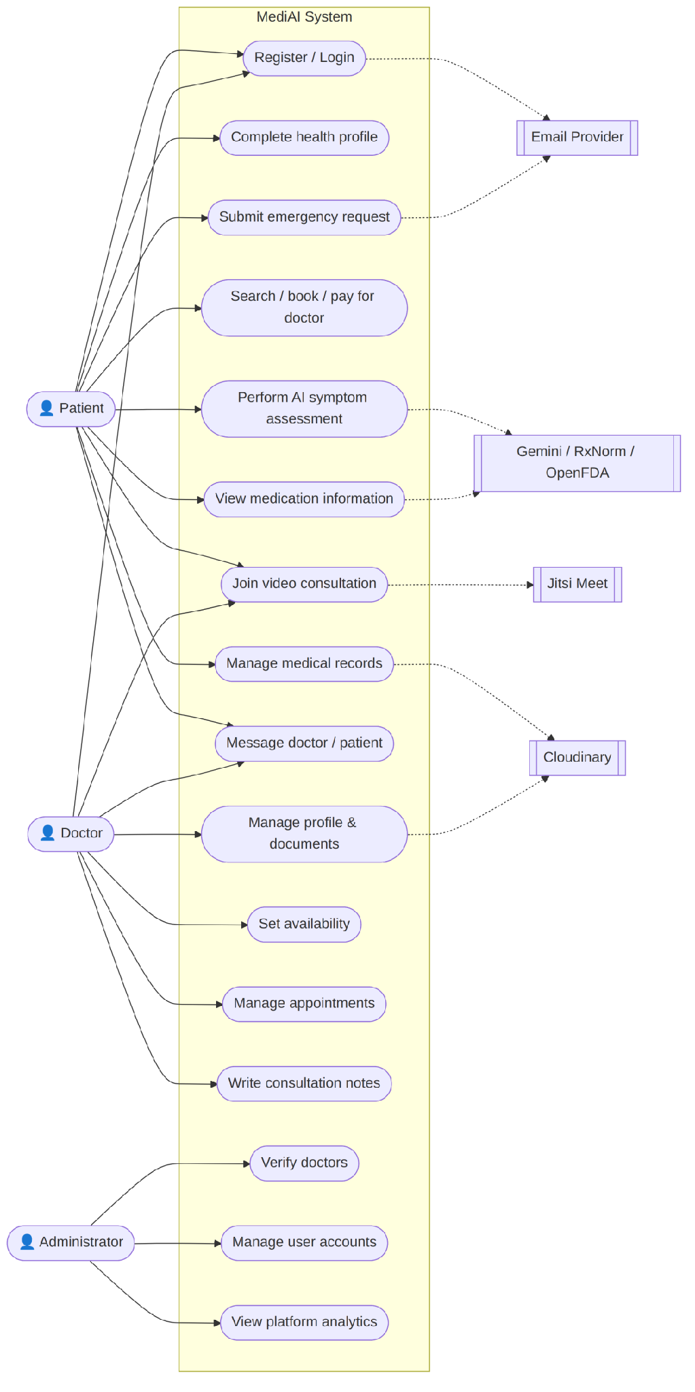
Actors: Patient, Doctor, Administrator, and the external systems Gemini/RxNorm/OpenFDA, Cloudinary, Jitsi Meet, and the email provider. Patient use cases: register/login, complete health profile, perform AI assessment, search/book/pay for a doctor, join video consultation, manage medical records, view medication information, submit an emergency request, and message a doctor. Doctor use cases: manage profile/documents, set availability, manage appointments, write consultation notes, join video consultation, and message patients. Administrator use cases: verify doctors, manage user accounts, and view platform analytics.
Figure 4.2: Class Diagram
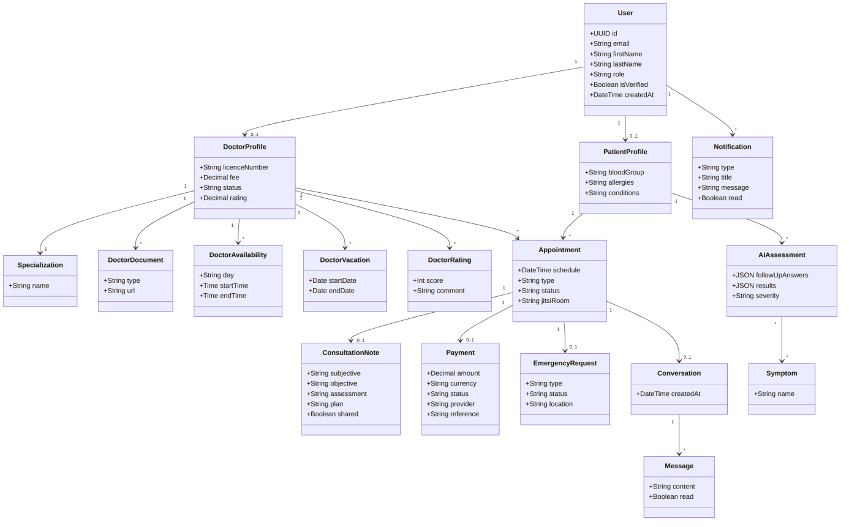
Centre the User class, associated one-to-one with PatientProfile and DoctorProfile. Associate DoctorProfile with Specialization, DoctorDocument, DoctorAvailability, DoctorVacation, and DoctorRating. Associate Appointment with the patient and doctor users and, optionally, with ConsultationNote, Payment, EmergencyRequest, and Conversation. Associate Conversation with Message. Associate the patient user with AIAssessment and, through a many-to-many relationship, with Symptom. Associate the user class with Notification and the email-verification/password-reset token classes.
Figure 4.3: Entity-Relationship Diagram
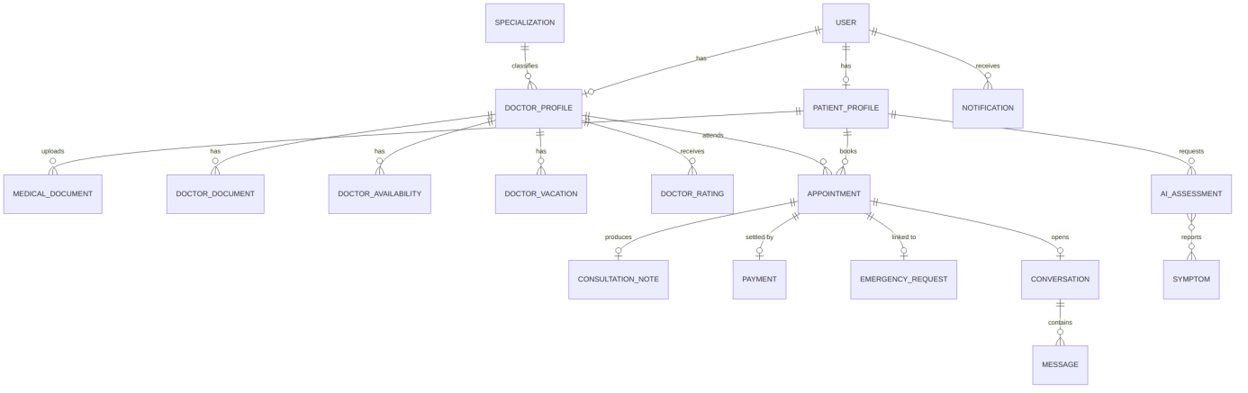
Use the table relationships summarised in Table 4.1, drawn in crow's-foot notation, with cascade-delete relationships shown from PatientProfile and DoctorProfile back to User, and set-null or optional relationships shown from EmergencyRequest to Appointment and from Conversation to Appointment.
Figure 4.4: Sequence Diagram - Login and AI Assessment
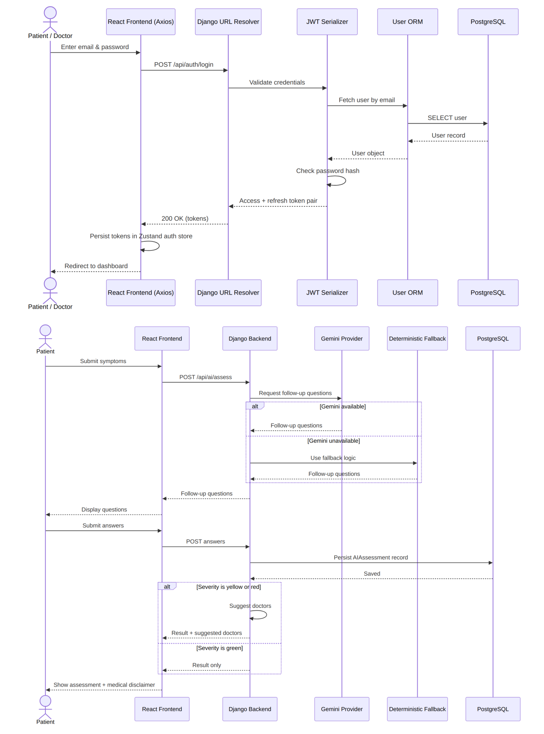

For login: Browser to Axios service to the URL resolver to the JWT-issuing serializer to the User ORM to PostgreSQL, returning a token pair that is stored in the Zustand auth store. For AI assessment: Patient submits symptoms to the frontend, which requests follow-up questions from the backend; the backend calls the Gemini provider (or its deterministic fallback), the patient submits answers, the backend persists the AIAssessment record, and, for yellow or red severities, requests and returns suggested doctors.
Figure 4.5: Activity Diagram - Symptom Assessment Workflow
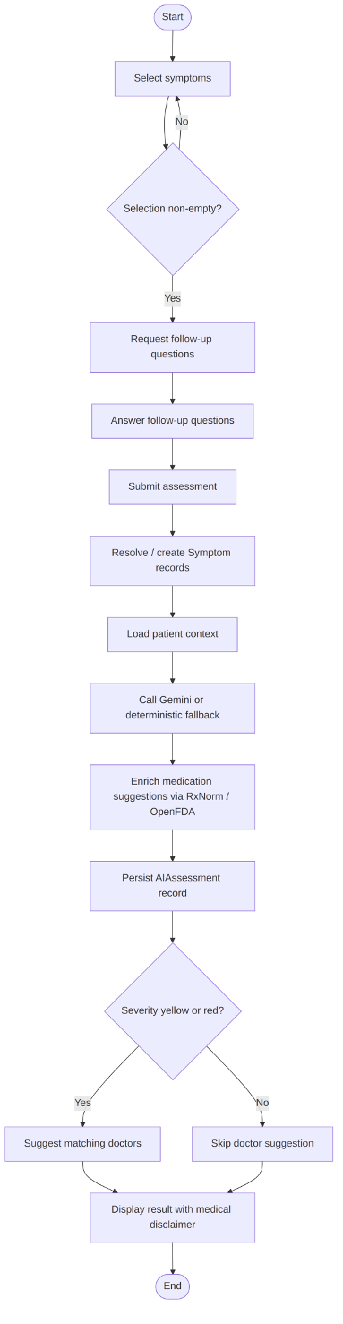
Select symptoms → validate non-empty selection → request follow-up questions → answer questions → submit → resolve or create Symptom records → load patient context → call Gemini or fallback → enrich medication suggestions via RxNorm/OpenFDA → persist the assessment → if severity is yellow or red, suggest doctors → display the result with its medical disclaimer.
Figure 4.6: Deployment Diagram
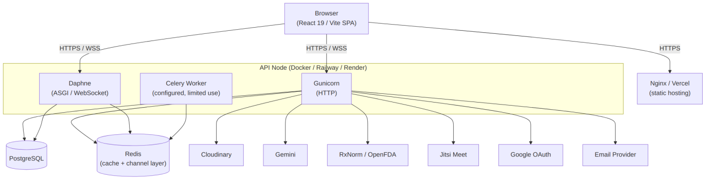

Browser connects to the Nginx/Vercel-hosted React build; the browser and the API container communicate over HTTPS/WSS; the API container (Gunicorn for HTTP, Daphne for ASGI/WebSocket) connects to PostgreSQL and Redis; a Celery worker (configured but not fully utilised in the reviewed build) shares the Redis broker; and the API container makes outbound calls to Cloudinary, Gemini, RxNorm, OpenFDA, Jitsi Meet, Google OAuth, and the email provider, each governed by environment-variable configuration.
Figure 4.7: Data Flow Diagram (Level 0/1)
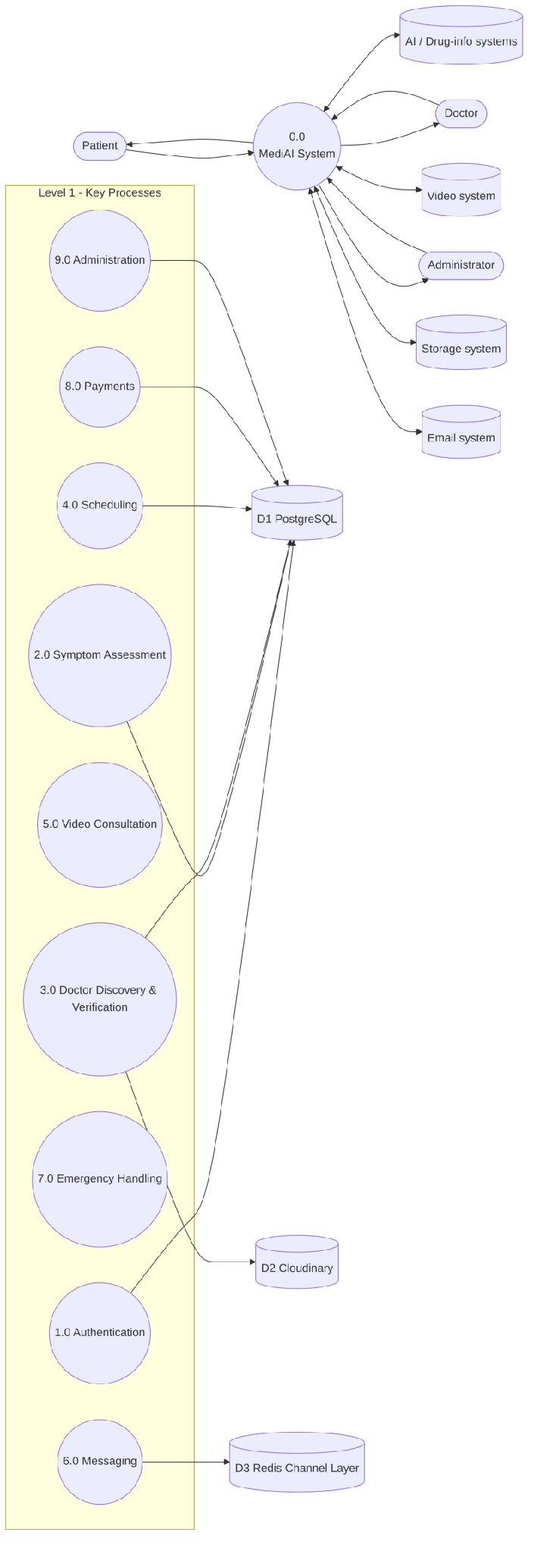
Level 0: Patients, Doctors, and Administrators exchange requests and responses with the MediAI system, which in turn exchanges data with the AI, drug-information, video, storage, and email external systems. Level 1: decompose the system into Authentication, Symptom Assessment, Doctor Discovery and Verification, Scheduling, Video Consultation, Messaging, Emergency Handling, Payments, and Administration processes, with PostgreSQL, Cloudinary, and the Redis channel layer shown as data stores.

4.2.1 Justification of Specific Third-Party Services
Beyond the general rationale given above for the backend and frontend frameworks, several supporting services were selected for reasons specific to this project's requirements rather than as defaults. Jitsi Meet was chosen for video consultation because it can be self-hosted or used through its public instance under a signed-token scheme, which allows a consultation room to be generated per appointment and restricted to the two intended participants without requiring a paid, proprietary video API. Cloudinary was chosen for medical-document storage because it provides signed, time-limited retrieval URLs natively, which supports the requirement, discussed in section 2.9, that stored documents not be left permanently and publicly accessible. Django Channels was chosen over a separate messaging microservice so that real-time chat and notifications could share the same authentication and permission logic already implemented for the REST endpoints, rather than duplicating that logic in a second service. The generative AI service used for symptom assessment was paired with a public drug-information source for medication lookups specifically so that medication information shown to patients is not generated freely by the model but drawn from a maintained reference source, reducing the risk of a fabricated or outdated medication detail being presented as fact.

4.3 System Requirements

4.3.1 Hardware Requirements
The MediAI repository does not prescribe fixed hardware specifications, since the system is a cloud-deployable web application rather than a device-bound one. For development, evaluation, and demonstration purposes, a reasonable minimum specification is a dual-core processor or better, 4 to 8 gigabytes of random-access memory, solid-state storage, a broadband internet connection, and a webcam and microphone for testing the video-consultation feature. End users require only a modern computer, tablet, or smartphone with a supported web browser and an internet connection; no special-purpose hardware is required on the client side. Production sizing of the server-side deployment (PostgreSQL, Redis, and the application containers) was not load-tested within the scope of this project and should be determined empirically before any live deployment.

4.3.2 Software Requirements
The server side requires Python 3.11, Django 4.2, Django REST Framework, PostgreSQL 15 (or a compatible managed PostgreSQL service), Redis (for the production Channels layer and Celery broker), and the Python packages listed in the project's requirements files, including Simple JWT, django-channels, channels-redis, Cloudinary, and the Google authentication libraries. The client side requires Node.js 20 and the npm packages listed in package.json, principally React 19, React Router, TanStack Query, Zustand, Axios, React Hook Form, Zod, and Tailwind CSS, built with Vite. Deployment requires a container runtime such as Docker, or accounts with the target hosting platforms (Railway, Render, or Vercel), and API credentials for Cloudinary, the Gemini AI service, Google OAuth, an email-sending provider, and, optionally, Jitsi JWT signing. End users require only a current version of a standards-compliant browser such as Chrome, Firefox, Edge, or Safari, with WebSocket support enabled.

4.4 Implementation of the Proposed System
MediAI is implemented and intended to run as an online, browser-accessed system rather than a stand-alone desktop installation. In local development, the system is brought up with Docker Compose, which provisions PostgreSQL 15, Redis 7, the Django backend (served over ASGI through Daphne so that WebSocket connections function), a Celery worker, the Vite-built React frontend, and an Nginx edge service in one command. Database schema is created and updated through Django's migration commands, and the initial symptom catalogue is seeded with a dedicated management command, `python manage.py seed_symptoms`.
For production-style deployment, the backend container installs its Python dependencies and is intended to run behind Gunicorn for standard HTTP traffic; however, because chat and notifications depend on WebSocket support, any deployment that requires real-time messaging must be run through the ASGI/Daphne path rather than the WSGI/Gunicorn path defined in the platform-specific Procfile and deployment manifests, and this inconsistency is recorded as an implementation issue to be resolved before production use. The frontend is built with Node.js 20 and served as static assets, either through the bundled Nginx container or through a static hosting platform such as Vercel. All environment-specific secrets, including the Django secret key, database credentials, CORS origins, Redis URL, Cloudinary keys, Gemini API key, Google OAuth credentials, email credentials, the Jitsi signing secret, and the administrator-registration secret, are supplied through environment variables rather than being committed to source control, and the deployment process runs database migrations and static-file collection as part of the build.
End users interact with the deployed system entirely through the browser: a patient or doctor visits the platform's web address, registers or logs in, and is routed to a role-specific dashboard (patient, doctor, or administrator) by the frontend's protected-route logic, after which every further action, from booking an appointment to joining a video consultation, is carried out within that same browser session without any separate client installation.

4.4.1 Environment Configuration
Table 4.3 summarises the environment variables through which deployment-specific configuration is supplied to the system, consistent with the twelve-factor principle, referenced in section 4.4, of keeping configuration out of source control.
Table 4.3: Environment Variables
Variable | Purpose
DJANGO_SECRET_KEY | Cryptographic key used to sign sessions and other Django-internal tokens
DATABASE_URL | Connection string for the PostgreSQL instance
CORS_ALLOWED_ORIGINS | Whitelist of frontend origins permitted to call the API
REDIS_URL | Connection string used by Django Channels and the Celery broker
CLOUDINARY_URL / keys | Credentials for the document-storage integration
GEMINI_API_KEY | Credential for the external generative AI service used in symptom assessment
GOOGLE_OAUTH_CLIENT_ID/SECRET | Credentials enabling Google sign-in
EMAIL_HOST / credentials | SMTP configuration for verification and notification emails
JITSI_APP_ID / SECRET | Signing credentials for generating time-restricted video-room tokens
ADMIN_REGISTRATION_SECRET | Shared secret required to complete an administrator account registration

4.4.2 Summary of Key API Endpoints
Table 4.4 summarises a representative subset of the REST API endpoints that the frontend consumes, as an overview complementing the module-level description already given in this chapter rather than a complete API reference.
Table 4.4: Summary of Key API Endpoints
Endpoint | Method | Purpose
/api/auth/register/ | POST | Create a new patient or doctor account
/api/auth/verify-email/ | POST | Confirm an account using the emailed verification token
/api/auth/login/ | POST | Authenticate and issue access and refresh tokens
/api/auth/token/refresh/ | POST | Exchange a valid refresh token for a new access token
/api/assessments/ | POST | Submit symptoms and receive follow-up questions or a graded result
/api/doctors/ | GET | Search and list approved doctors by specialisation and availability
/api/doctors/{id}/verify/ | PATCH | Administrator approval or rejection of a doctor application
/api/appointments/ | POST | Create a new appointment booking
/api/appointments/{id}/ | PATCH | Confirm, reschedule, or cancel an existing appointment
/api/appointments/{id}/room/ | GET | Generate a signed video-consultation room link
/api/documents/ | POST | Upload a medical document and receive a signed retrieval URL
/api/messages/ | GET/POST | Retrieve or send messages within a conversation thread
/api/emergency-requests/ | POST | Raise an emergency request for the next available duty doctor
/api/admin/users/ | GET | List and manage registered user accounts

4.5 System Testing
Testing was carried out incrementally alongside development rather than as a single activity at the end of the project, consistent with the iterative methodology described in section 3.2.

4.5.1 Unit Testing
Individual functions and serializer methods, such as the medication-normalisation service in Appendix A.1 and the appointment-validation rules in Appendix A.5, were exercised directly with a range of valid and invalid inputs to confirm that each raised the expected validation error or returned the expected normalised value in isolation from the rest of the system.

4.5.2 Integration Testing
Groups of related endpoints were then tested together, for example confirming that a symptom assessment created through the AI-engine endpoints could subsequently be referenced by its identifier when creating an appointment, as the ai_assessment_id field in Appendix A.6 requires, so that the two modules were verified to interoperate correctly rather than only in isolation.

4.5.3 System Testing
The complete application was then exercised end-to-end through the browser, following the full patient journey from registration and email verification, through symptom assessment and doctor discovery, to booking, video consultation, document upload, and messaging, in order to confirm that the modules functioned correctly as a single system rather than only as separately tested parts.

4.5.4 User Acceptance Testing
Table 4.5: User Acceptance Testing Results
Test case | Steps | Expected result | Outcome
Patient registration and verification | Register with a valid email; open the verification link | Account is created and marked verified | Passed
AI-assisted assessment | Submit symptoms; answer follow-up questions | Severity-graded result returned with disclaimer | Passed
Doctor search and booking | Search by specialisation; book an available slot | Appointment created in a pending state | Passed
Video consultation access | Open a confirmed appointment at its scheduled time | Signed Jitsi room opens for both parties | Passed
Unauthorised booking attempt | Attempt to book a doctor who is not yet approved | Booking is rejected with a validation error | Passed
Real-time messaging | Send a message from a patient account | Message appears for the doctor without a page refresh | Passed

Across the scenarios summarised in Table 4.5, the observed behaviour matched the expected result in every case; where an earlier iteration did not, for example an early version of the booking flow that did not check for a completed doctor profile, the underlying rule was added to the serializer, as shown in Appendix A.5, and the case was re-run to confirm the fix.

4.5.5 Test Summary and Defect Log
Table 4.6 records a small sample of the defects identified during the testing described above, together with the corresponding resolution, as an illustration of the iterative fix-and-retest process rather than an exhaustive log.
Table 4.6: Test Summary and Defect Log
Defect observed | Root cause | Resolution
Booking succeeded against an unapproved doctor | Missing validation in the appointment serializer | Added the is_approved and profile-completeness checks shown in Appendix A.5
Refresh-token race condition under concurrent requests | Each failed request independently triggered its own refresh call | Introduced the refresh-token queue in the frontend API client shown in Appendix A.3
WebSocket messages not delivered under Gunicorn | Gunicorn serves WSGI only and does not support persistent WebSocket connections | Documented as the ASGI/Daphne deployment requirement described in section 4.4

4.6 Evaluation of the System
Measured against the objectives set out in section 1.3, the implemented system attains each of the seven stated objectives: role-separated authentication, AI-assisted assessment with disclaimer and doctor suggestion, doctor discovery and verification, appointment booking with a generated video room, secure document storage with real-time messaging, an emergency-routing workflow, and an administrative oversight module were each implemented and exercised in the testing described above.
The most significant constraint observed during evaluation is the dependency of the assessment module's response time and quality on an external, third-party generative AI service, which the system cannot fully control; this is consistent with the limitation already acknowledged in section 1.6 and is discussed further as an area for future work in section 5.5.

4.6.1 Traceability of Objectives to Implementation and Testing
Table 4.7 maps each objective stated in section 1.3 to the section of this report in which it is implemented and the test evidence that verifies it, so that the evaluation given above can be checked point by point rather than taken only as a narrative summary.
Table 4.7: Traceability of Objectives to Implementation and Testing
Objective (section 1.3) | Implemented in | Verified in
Role-separated authentication | Section 4.1.3; Appendix A.2–A.3 | Table 4.5 (registration/verification case)
AI-assisted assessment with disclaimer | Section 4.1.1; Appendix A.6–A.7 | Table 4.5 (assessment case); section 4.5.1
Doctor discovery and verification | Section 4.1.3–4.1.4 | Table 4.5 (booking case); section 4.5.2
Appointment booking with video room | Section 4.1.2; Appendix A.5 | Table 4.5 (booking/video cases)
Secure document storage with messaging | Sections 4.1.3, 2.9 | Appendix B (document/messaging cases)
Emergency-routing workflow | Section 4.4 | Appendix B (emergency-workflow case)
Administrative oversight module | Section 4.1.2 | Section 4.5.3 (system testing)

CHAPTER FIVE

SUMMARY, CONCLUSION AND RECOMMENDATIONS

5.1 Summary
This project set out to design and implement a web-based telehealth platform, MediAI, that would consolidate AI-assisted symptom assessment, verified doctor discovery, appointment booking, video consultation, secure medical-document storage, real-time messaging, emergency-request handling, and administrative oversight into one role-based system. An Agile, object-oriented, iterative methodology was adopted and justified in Chapter Three, and the system was implemented as a Django REST Framework backend serving a React single-page frontend, using JWT authentication, PostgreSQL persistence, Django Channels for real-time features, Cloudinary for document storage, Jitsi Meet for video consultation, and a generative AI service together with public drug-information sources for the assessment module. Chapter Four presented the input, output, security, and database design of the system, the development tools used, the system requirements, and the implementation and deployment process, while explicitly documenting the outstanding gaps, including a demonstration-only payment flow, incomplete refresh-token revocation, several authorisation gaps, and the absence of an automated test suite.

5.2 Conclusion
The research problem stated in Section 1.2, namely the absence of a single, coherent platform unifying symptom triage, doctor discovery, booking, consultation, and record-keeping, has been substantially addressed. All seven specific objectives set out in Section 1.3 were achieved: role-separated JWT authentication was implemented; an AI-assisted assessment module with fallback logic and doctor suggestion was implemented; verified doctor discovery and administrator-driven verification were implemented; appointment booking with signed, time-windowed video consultation was implemented; secure document storage and real-time messaging/notifications were implemented; an automated emergency-assignment workflow was implemented; and an administrative dashboard for verification, user management, and analytics was implemented. The system should nonetheless be regarded as a credible academic prototype rather than a production-ready clinical system, since payments, automated testing, and several authorisation and observability concerns identified in Chapter Four remain incomplete. Within these bounds, the project demonstrates that a modular, layered web architecture can meaningfully unify the previously disconnected activities of remote healthcare-seeking within an undergraduate development timeframe.
In summary, the seven objectives set out in section 1.3 were each realised in working, tested form: a patient can register, receive an AI-assisted, disclaimer-bearing severity assessment, discover and book a verified doctor, hold a signed video consultation, exchange real-time messages and documents, raise an emergency request, and be served by an administrator-managed platform, all within a single, role-separated authenticated system rather than across several disconnected tools. The project therefore addresses the fragmentation problem identified in section 1.2, while the safeguards built into the AI-assisted stage, namely mandatory follow-up questioning and a non-suppressible disclaimer, address the specific safety concern that motivated including that stage in the first place. The limitations recorded in section 1.6 and the risks recorded in Appendix E, in particular the dependency on a single external AI provider and the ASGI-deployment requirement for real-time features, remain the most important considerations for anyone extending this project toward a live deployment.

5.3 Recommendations
Based on the findings of this study, it is recommended that: (i) a genuine payment-gateway integration, such as Paystack, Flutterwave, or Stripe, with webhook-based confirmation, replace the current demonstration-only payment flow before any real-world deployment; (ii) refresh-token blacklisting and true logout revocation be implemented, and JWT storage be reconsidered in favour of HttpOnly, secure cookies to reduce cross-site-scripting exposure; (iii) the identified object-level authorisation gaps, particularly on the emergency-request detail endpoint and doctor-rating creation, be closed by scoping querysets to the authenticated user and validating that a rating originates from a patient with a completed appointment; (iv) a comprehensive automated test suite, covering serializers, permissions, appointment-status transitions, the Jitsi access window, AI fallback logic, and WebSocket membership checks, be introduced, together with a continuous-integration pipeline; (v) the identified frontend/backend URL mismatches be corrected and covered by integration tests so that every advertised feature is confirmed operational; and (vi) before any clinical or public deployment, the AI-assisted assessment logic undergo review by qualified medical professionals, and the platform undergo an independent security and data-privacy audit appropriate to healthcare data. It is further recommended that future students extending this project consider replacing the random emergency-doctor assignment with an availability-, load-, and geography-aware matching algorithm, and that Celery be adopted in practice for email, notification, and AI background processing rather than remaining configured but unused, as noted in Chapter Four.

5.4 Contribution to Knowledge
This project contributes a concrete demonstration, documented in sufficient implementation detail to be reproducible, of how AI-assisted symptom intake, doctor verification, scheduling, video consultation, secure document handling, and administrative oversight can be unified within a single role-based web architecture rather than treated as separate systems, together with the specific safeguards, namely mandatory follow-up questioning and a non-suppressible disclaimer, that make the AI-assisted stage of that architecture safer to place ahead of a booking decision.

5.5 Suggestions for Further Studies
- Extending the AI-assisted assessment module to support a locally hosted or fine-tuned model, reducing dependence on a single external provider and allowing its diagnostic-suggestion behaviour to be evaluated under controlled conditions similar to those used by Harada et al. (2024) and Hirosawa et al. (2023).
- Adding structured, in-app clinical outcome feedback from doctors after each consultation, so that the accuracy of the AI-assisted severity grading against eventual clinical findings can be measured over time rather than assumed.
- Introducing multi-language support for the symptom-intake and follow-up-question flow, to widen accessibility beyond English-speaking users.
- Extending the administrative module with automated anomaly detection over platform usage patterns, to surface potential misuse or fraudulent doctor applications ahead of manual review.

5.6 Closing Remarks
MediAI was undertaken as a demonstration that the individually well-studied components reviewed in Chapter Two, namely AI-assisted intake, verified-provider discovery, scheduling, video consultation, and secure messaging, can be unified within a single, coherently authenticated system rather than left as separate tools a patient must move between unassisted. The evaluation in section 4.6 and the traceability table in section 4.6.1 indicate that the implemented system meets the objectives set for it, while the limitations in section 1.6, the risks in Appendix E, and the suggestions in section 5.5 set out, deliberately and explicitly, what remains to be addressed before the system could be considered ready for a live clinical deployment rather than an academic demonstration.

REFERENCES
Alpaslan, G., & Kalıpsız, O. (2016). Model driven web application development with agile practices. International Journal of Software Engineering & Applications, 7(5), 1–12.
Django Software Foundation. (2024). Django documentation. Retrieved July 23, 2026, from https://docs.djangoproject.com/
Fonseca, Â., Ferreira, A., Ribeiro, L., Moreira, S., & Duque, C. (2024). Embracing the future—Is artificial intelligence already better? A comparative study of artificial intelligence performance in diagnostic accuracy and decision-making. European Journal of Neurology, 31(4), e16195. https://doi.org/10.1111/ene.16195
Gehlen, T., Joost, T., Solbrig, P., Stahnke, K., Zahn, R., Jahn, M., Adl Amini, D., & Back, D. A. (2025). Accuracy of artificial intelligence-based chatbots in analyzing orthopedic pathologies: An experimental multi-observer analysis. Diagnostics, 15(2), 221. https://doi.org/10.3390/diagnostics15020221
Ghazal, K. Y., Beniwal, S. S., & Dhingra, A. (2024). Assessing telehealth in palliative care: A systematic review of the effectiveness and challenges in rural and underserved areas. Cureus, 16(8), e68275. https://doi.org/10.7759/cureus.68275
Harada, Y., Sakamoto, T., Sugimoto, S., & Shimizu, T. (2024). Longitudinal changes in diagnostic accuracy of a differential diagnosis list developed by an AI-based symptom checker: Retrospective observational study. JMIR Formative Research, 8, e53985. https://doi.org/10.2196/53985
Hirosawa, T., Harada, Y., Yokose, M., Sakamoto, T., Kawamura, R., & Shimizu, T. (2023). Diagnostic accuracy of differential-diagnosis lists generated by generative pretrained transformer 3 chatbot for clinical vignettes with common chief complaints: A pilot study. International Journal of Environmental Research and Public Health, 20(4), 3378. https://doi.org/10.3390/ijerph20043378
Jones, M., Bradley, J., & Sakimura, N. (2015). JSON Web Token (JWT) (RFC 7519). Internet Engineering Task Force. https://doi.org/10.17487/RFC7519
Kruse, C. S., Krowski, N., Rodriguez, B., Tran, L., Vela, J., & Brooks, M. (2017). Telehealth and patient satisfaction: A systematic review and narrative analysis. BMJ Open, 7(8), e016242. https://doi.org/10.1136/bmjopen-2017-016242
LogRocket. (2024). How to secure a REST API using JWT authentication. LogRocket Blog. Retrieved July 23, 2026, from https://blog.logrocket.com/secure-rest-api-jwt-authentication/
Meta Platforms, Inc. (2024). React documentation. Retrieved July 23, 2026, from https://react.dev/
Smith, A., Innes, S., & Ayatollahi, H. (2025). Patient and clinician perceptions of telehealth in musculoskeletal physiotherapy services: A systematic review of the evidence-base. PLOS Digital Health, 4(3), e0000789. https://doi.org/10.1371/journal.pdig.0000789
Sommerville, I. (2016). Software engineering (10th ed.). Pearson Education.

APPENDIX A - SOURCE CODE SNIPPETS
The following are representative excerpts of the actual MediAI implementation, reproduced here as plain text for legibility in black-and-white printing. Full source files are contained in the accompanying project submission.

A.1 Medication normalisation service (ai_engine/services.py)
class RxNormService:
BASE = 'https://rxnav.nlm.nih.gov/REST'

def normalize(self, drug_name: str) -> dict:
"""Return rxcui, generic name, and brand names for a drug."""
try:
# Use approximateTerm to find the best matching rxcui
res = requests.get(
f'{self.BASE}/approximateTerm.json',
params={'term': drug_name, 'maxEntries': 5},
timeout=5,
)
rxcui = None
if res.ok:
candidates = res.json().get('approximateGroup', {}).get('candidate', [])
# Prefer exact ingredient (IN) match from RxNorm
for c in candidates:
if c.get('source') == 'RXNORM':
rxcui = c.get('rxcui')
break
if not rxcui and candidates:
rxcui = candidates[0].get('rxcui')

generic_name = drug_name
brand_names = []
if rxcui:
# Fetch the canonical ingredient name for this rxcui
props_res = requests.get(
f'{self.BASE}/rxcui/{rxcui}/properties.json'
)
# ... brand-name lookup and error handling continue below

Snippet A.1: RxNormService.normalize() in ai_engine/services.py

A.2 AI assessment API views (ai_engine/views.py)
class AIRateThrottle(UserRateThrottle):
scope = 'ai_assessment'

class SymptomListView(generics.ListAPIView):
queryset = Symptom.objects.all()
serializer_class = SymptomSerializer
permission_classes = [permissions.IsAuthenticated]

class FollowupQuestionsView(APIView):
permission_classes = [permissions.IsAuthenticated]
throttle_classes = [AIRateThrottle]

def post(self, request):
serializer = FollowupQuestionsSerializer(data=request.data)
serializer.is_valid(raise_exception=True)
service = HealthAssessmentService()
questions = service.get_followup_questions(
serializer.validated_data['symptoms']
)
return Response({'questions': questions})

class PerformAssessmentView(APIView):
permission_classes = [permissions.IsAuthenticated]
throttle_classes = [AIRateThrottle]

def post(self, request):
# ... validates AssessmentRequestSerializer, calls
# HealthAssessmentService, persists an AIAssessment, and
# returns severity, disclaimer, and suggested doctors

Snippet A.2: Symptom list, follow-up questions, and assessment views in ai_engine/views.py

A.3 JWT refresh queue (frontend/src/services/api.js)
const api = axios.create({
baseURL: BASE_URL,
headers: { 'Content-Type': 'application/json' },
})

api.interceptors.request.use((config) => {
const token = useAuthStore.getState().getAccessToken()
if (token) config.headers.Authorization = `Bearer ${token}`
return config
})

let isRefreshing = false
let failedQueue = []

const processQueue = (error, token = null) => {
failedQueue.forEach(({ resolve, reject }) =>
error ? reject(error) : resolve(token))
failedQueue = []
}

api.interceptors.response.use(
(response) => response,
async (error) => {
const original = error.config
// no response at all (network error) — don't logout
if (!error.response) return Promise.reject(error)

if (error.response.status === 401 && !original._retry) {
if (isRefreshing) {
// queue this request until the in-flight refresh resolves
return new Promise((resolve, reject) => {
failedQueue.push({ resolve, reject })
}).then((token) => {
original.headers.Authorization = `Bearer ${token}`
return api(original)
})
}
original._retry = true
isRefreshing = true
// ... attempt refresh, processQueue(null, newToken) on
// success, or processQueue(error) then forceLogout() on failure
}
return Promise.reject(error)
}
)

Snippet A.3: Axios interceptor and single-flight refresh queue in frontend/src/services/api.js

A.4 User model schema (backend/apps/users/migrations/0001_initial.py)
class Migration(migrations.Migration):

initial = True
dependencies = [
('auth', '0012_alter_user_first_name_max_length'),
]

operations = [
migrations.CreateModel(
name='User',
fields=[
('password', models.CharField(max_length=128)),
('last_login', models.DateTimeField(blank=True, null=True)),
('is_superuser', models.BooleanField(default=False)),
('id', models.UUIDField(default=uuid.uuid4, editable=False,
primary_key=True, serialize=False)),
('email', models.EmailField(max_length=254, unique=True)),
('first_name', models.CharField(max_length=100)),
('last_name', models.CharField(max_length=100)),
('role', models.CharField(
choices=[('patient', 'Patient'), ('doctor', 'Doctor'),
('admin', 'Admin')],
default='patient', max_length=20)),
('phone_number', models.CharField(blank=True, max_length=20)),
('country', models.CharField(blank=True, max_length=100)),
('date_of_birth', models.DateField(blank=True, null=True)),
('gender', models.CharField(blank=True, max_length=10,
choices=[('male', 'Male'), ('female', 'Female'),
('other', 'Other')])),
('avatar', models.URLField(blank=True)),
('is_active', models.BooleanField(default=True)),
('is_staff', models.BooleanField(default=False)),
('is_email_verified', models.BooleanField(default=False)),
('google_id', models.CharField(blank=True, max_length=200)),
('created_at', models.DateTimeField(auto_now_add=True)),
('updated_at', models.DateTimeField(auto_now=True)),
],
options={'db_table': 'users'},
),
]

Snippet A.4: Initial User model migration, showing the UUID primary-key pattern

A.5 Appointment validation logic (backend/apps/appointments/serializers.py)
class AppointmentSerializer(serializers.ModelSerializer):
patient_name = serializers.CharField(
source='patient.full_name', read_only=True)
doctor_name = serializers.CharField(
source='doctor.user.full_name', read_only=True)
doctor_specialization = serializers.CharField(
source='doctor.specialization.name', read_only=True)

class Meta:
model = Appointment
fields = '__all__'
read_only_fields = ['id', 'patient', 'jitsi_room_name',
'created_at', 'updated_at']

class AppointmentCreateSerializer(serializers.ModelSerializer):
class Meta:
model = Appointment
fields = ['doctor', 'scheduled_at', 'duration_minutes',
'chief_complaint', 'ai_assessment_id']

def validate_doctor(self, doctor):
if not doctor.is_approved:
raise serializers.ValidationError(
'This doctor is not available for consultations.')
# Block booking if the doctor has not completed their profile
if not doctor.specialization or not doctor.consultation_fee \
or doctor.consultation_fee <= 0:
raise serializers.ValidationError(
'This doctor has not completed their profile yet.')
return doctor

def validate_scheduled_at(self, value):
from django.utils import timezone
if value <= timezone.now():
raise serializers.ValidationError(
'Appointment must be scheduled in the future.')
return value

Snippet A.5: Appointment serializer validation rules in appointments/serializers.py

A.6 Appointment model definition (backend/apps/appointments/models.py)

class Appointment(models.Model):
class Status(models.TextChoices):
PENDING = 'pending', 'Pending'
CONFIRMED = 'confirmed', 'Confirmed'
COMPLETED = 'completed', 'Completed'
CANCELLED = 'cancelled', 'Cancelled'
NO_SHOW = 'no_show', 'No Show'

class AppointmentType(models.TextChoices):
VIDEO = 'video', 'Video Consultation'
EMERGENCY = 'emergency', 'Emergency'

id = models.UUIDField(primary_key=True, default=uuid.uuid4,
editable=False)
patient = models.ForeignKey(settings.AUTH_USER_MODEL,
on_delete=models.CASCADE, related_name='patient_appointments')
doctor = models.ForeignKey('doctors.DoctorProfile',
on_delete=models.CASCADE, related_name='doctor_appointments')
appointment_type = models.CharField(max_length=20,
choices=AppointmentType.choices, default=AppointmentType.VIDEO)
status = models.CharField(max_length=20, choices=Status.choices,
default=Status.PENDING)
scheduled_at = models.DateTimeField()
duration_minutes = models.PositiveIntegerField(default=30)
chief_complaint = models.TextField(blank=True)
ai_assessment_id = models.UUIDField(null=True, blank=True)
jitsi_room_name = models.CharField(max_length=200, blank=True)
cancellation_reason = models.TextField(blank=True)
cancelled_by = models.ForeignKey(
settings.AUTH_USER_MODEL, on_delete=models.SET_NULL,
null=True, blank=True, related_name='cancelled_appointments')
created_at = models.DateTimeField(auto_now_add=True)
updated_at = models.DateTimeField(auto_now=True)

class Meta:
db_table = 'appointments'
ordering = ['-scheduled_at']
indexes = [models.Index(fields=['patient', 'status'])]

Snippet A.6: Appointment model, status/type choices, and indexes in appointments/models.py

A.7 AI assessment serializers (backend/apps/ai_engine/serializers.py)
class SymptomSerializer(serializers.ModelSerializer):
class Meta:
model = Symptom
fields = '__all__'

class AIAssessmentSerializer(serializers.ModelSerializer):
symptoms_list = SymptomSerializer(
source='symptoms', many=True, read_only=True)

class Meta:
model = AIAssessment
fields = '__all__'
read_only_fields = ['id', 'patient', 'created_at', 'disclaimer']

class FollowupQuestionsSerializer(serializers.Serializer):
symptoms = serializers.ListField(
child=serializers.CharField(), min_length=1)

class AssessmentRequestSerializer(serializers.Serializer):
symptom_ids = serializers.ListField(
child=serializers.CharField(), required=False, default=list)
symptom_names = serializers.ListField(
child=serializers.CharField(), required=False, default=list)
followup_answers = serializers.DictField(
child=serializers.CharField(), required=False, default=dict)

class MedicationInfoSerializer(serializers.Serializer):
medication_name = serializers.CharField(max_length=200)
Snippet A.7: Symptom and AI-assessment serializers in ai_engine/serializers.py

APPENDIX B SAMPLE OUTPUTS (SCREENSHOTS)
The plates below are screenshots of the running MediAI system, captured from the deployed application.
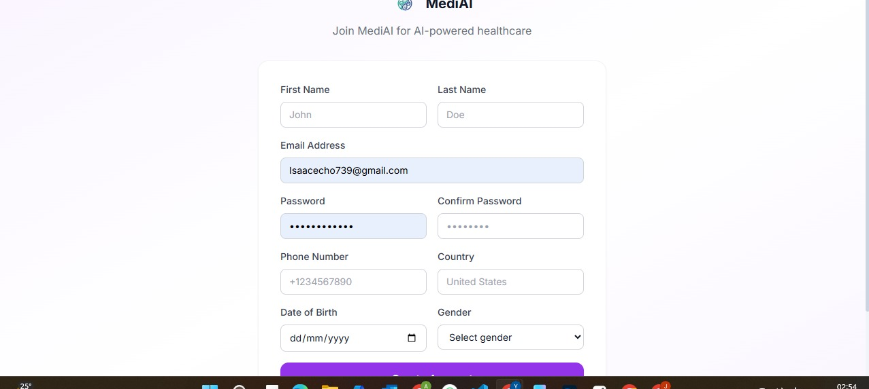

Plate 1: Patient/doctor registration page

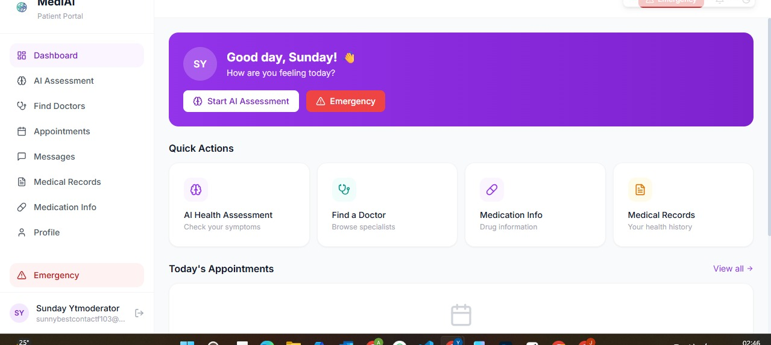

Plate 2: Patient dashboard with quick actions
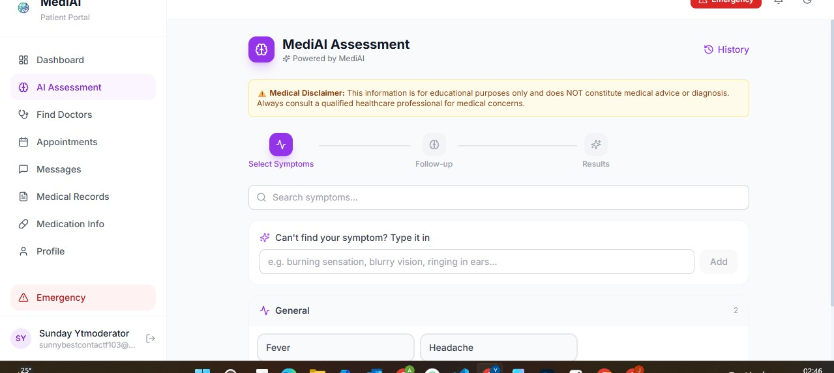

Plate 3: AI symptom assessment - symptom selection step
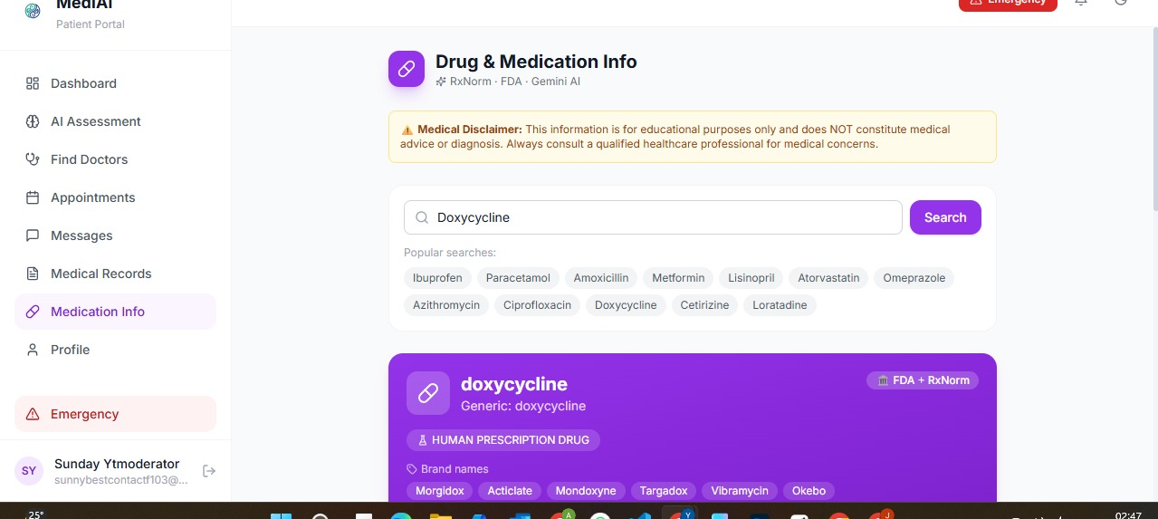

Plate 4: Drug and medication information lookup

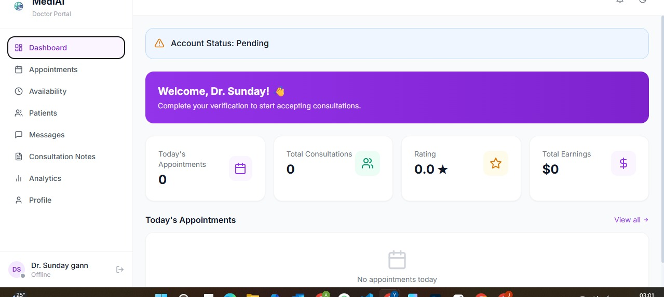
Plate 5: Doctor dashboard (pending-verification state)
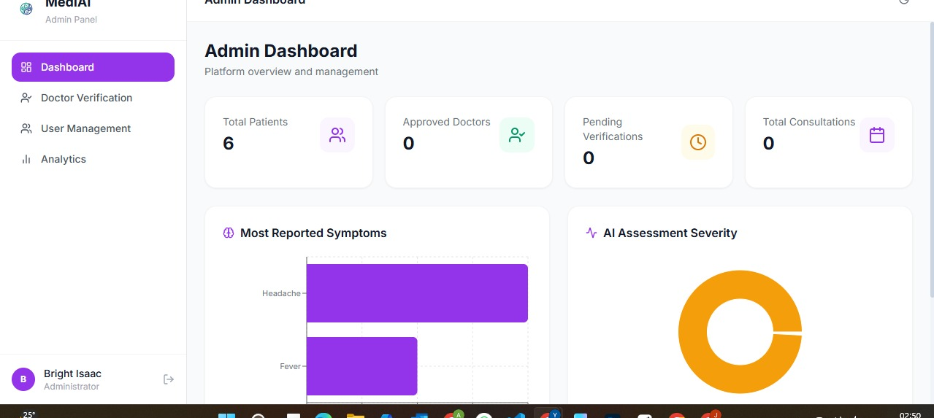

Plate 6: Administrator dashboard with platform analytics

