
MITSUBISHI ELECTRIC
PC DIVISION


Running DOS 6.xx Programs (e.g. Games) under Windows 95

Problems are being experienced running “DOS programs” under Windows 95. Following are some tips and tricks that may help make your programs run better.

Shortcut to “DOS program” Properties

To create a shortcut to your “DOS program” right click anywhere on the Desktop to bring up a small menu, left click on New then left click on Shortcut. You are then presented with a ‘Create Shortcut’ menu, in Command line enter in the command line that will run your program, including the drive letter and the path of your “DOS program”. Press <RETURN>, enter in a name for the shortcut and press <RETURN> to create the shortcut.

Right click on the newly created shortcut to bring up a small menu, left click on properties, left click on the Program Tab, and then left click on the Advanced button, and a window similar to below will appear.

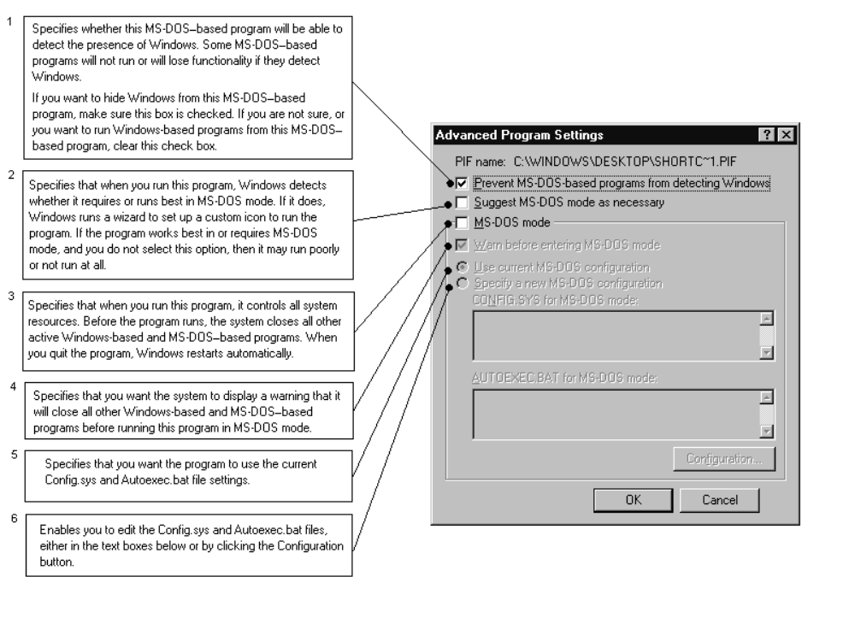
Figure 1

Options:
- Recommend ticked unless problems are experienced
- Recommend unticked unless problems with option 1 are experienced
- Recommend unticked unless problems with option 1 & 2 are experienced
- Recommend ticked if option 3 is ticked
- User preference if option 3 is ticked *see notes
- User preference if option 3 is ticked *see notes

* notes
If your “DOS program” will not function correctly with the recommended settings, set option 3 (MS-DOS mode) and select your current configuration or specify a new one This will cause your machine to reboot and run the “DOS program” and will not allow you to access Windows 95 without rebooting the machine.

If you specify current configuration it uses your current Config.sys and Autoexec.bat files.
If you specify a new configuration it allows you to manually create new Config.sys and Autoexec.bat files that are activated only when you run the “DOS program” .
Make sure you have your DOS sound and CD ROM drivers loaded into whatever configuration you specify.

Example Config.sys

device=c:\windows\himem.sys
dos=high,umb
devive=c:\windows\emm386.exe noems
files=40
device=c:\vibra16\drv\vibra16.sys /unit=0 /blaster=a:220 I:5 d:1 h:5
device=c:\vibra16\drv\ctmmsys.sys
device=c:\windows\command\atapi_cd.sys /d:mscd000 /I:0

This is assuming the sound card is a Sound Blaster Vibra 16 in the c:\Vibra16 directory, all other paths are correct, and all software is available in that path.
EMM386 may not be required if the “DOS program” uses DOS4GW DOS extender.

Example Autoexec.bat

set sound=c:\vibra16
set blaster=a220 i5 d1 h5 p330 t6
set midi=synth:1 map:e
c:\vibra16\diagnose /s
c:\vibra16\mixerset /p /q
c:\windows\command\mscdex.exe /d:mscd000 /m:12 /l:d
c:\windows\command\mouse.com

This is assuming the sound card is a Sound Blaster Vibra 16 in the c:\Vibra16 directory, all other paths are correct, and all software is available in that path.

If Figure 1 option 1 is set then the following may improve performance.

Left click on the Misc tab and a Window similar to below will appear.
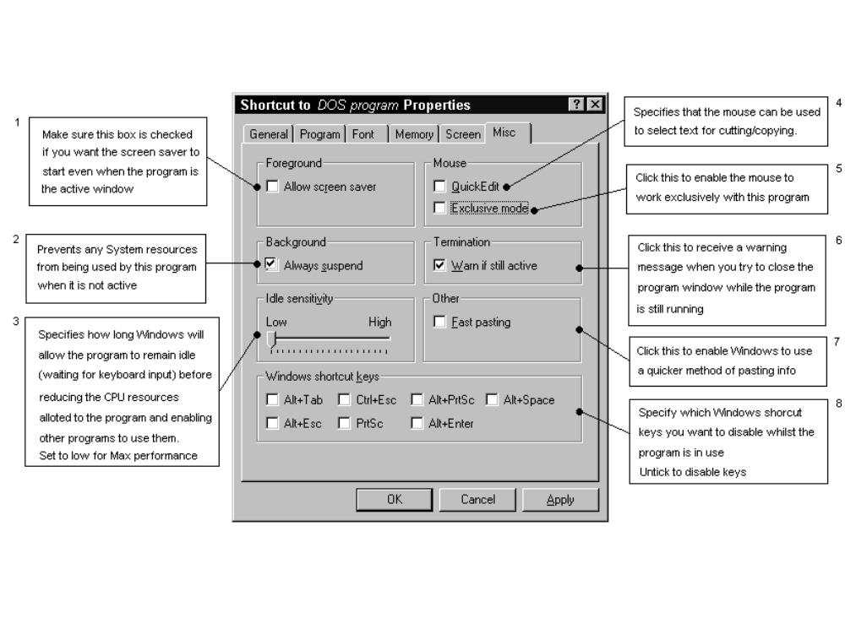
Figure 2

Options:
- Recommend unticked - although it doesn’t always work if Figure 3 option 1 is ticked.
- Recommend ticked
- Recommend set to low
- User preference
- Recommend unticked
- Recommend ticked
- Recommend unticked
- User preference - Recommend untick all

Left click on the Memory Tab and a window similar to below will appear.
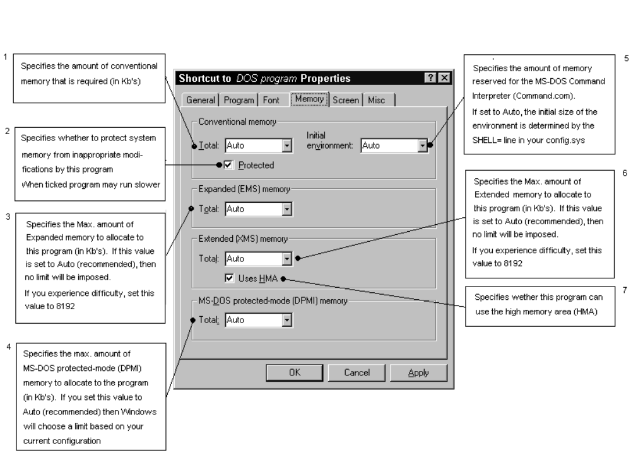
Figure 3

Options:
- Recommend set to Auto
- Recommend ticked
- Recommend set to Auto
- Recommend set to Auto
- Recommend set to Auto
- Recommend set to Auto
- Recommend Ticked

If problems are encountered e.g. “DOS program” requires specific amount of available memory, the above settings should be modified accordingly.

Windows 95 not seeing CD-ROM Drive after system crash from running Games CD’s’

It has been found that if a user exits from a games CD, that reboots into MS-DOS mode using a specified configuration, without using the correct exit sequence, a “missing Drive D” error, “CDR101” error or similar is reported on reboot. This is due to Windows 95 trying to reboot back into the game.

Detailed below is the process that is under taken by Windows 95 when it reboots into MS-DOS mode to run a game:

- User double clicks game icon.
- Windows 95 prompts user that machine is going to be rebooted to run the game.
- Windows 95 reboots the machine, renames AUTOEXEC.BAT to AUTOEXEC.WOS, CONFIG.SYS to CONFIG.WOS and creates new AUTOEXEC.BAT and CONFIG.SYS files based on the text in the advanced properties of the shortcut.
- User removes CD and switches off machine whilst still in game, or system crashes.
- User reboots machine.
- Windows 95 tries to bootup the machine back into the game and reports error.

To rectify the fault the following steps must be taken:

From reboot.

- Switch on machine
- If the message "Windows 95 is now starting your MS-DOS based program, press Esc now to cancel MS-DOS mode and Restart Windows 95" appears on the screen, press the <ESC> key. The machine should now restart Windows 95 correctly.

If the error keeps repeating itself.

- Reboot the machine.
- Press the function key <F8> when the syntax “Starting Windows 95” appears.
- The Microsoft Startup menu will appear.
- Select Option 7 “Safe Mode command prompt only”.
- When at the command prompt, type in the following commands:
DEL AUTOEXEC.BAT <RETURN>
DEL CONFIG.SYS <RETURN>
- Reboot the machine. This will boot into Windows 95 without any Autoexec.bat and Config.sys files. (if they are required then the .WOS files can be renamed)

