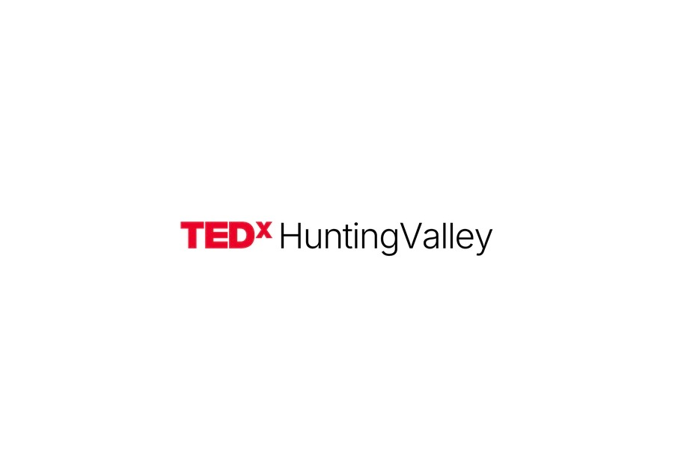
FOR IMMEDIATE RELEASE Contact: Charlie Martin & Jack Nelson | TEDxHuntingValley | tedxhuntingvalley@gmail.com

TEDXHUNTINGVALLEY SET FOR AUGUST 22 AT UNIVERSITY SCHOOL'S GUND AUDITORIUM
CLEVELAND'S FIRST INDEPENDENT COMMUNITY TEDX IN OVER A DECADE - AND IT'S RUN BY TWO HIGH SCHOOL JUNIORS
Student speaker applications open through May 11 for Cleveland-area high schoolers; all talks published to TEDx YouTube channel with 44 million subscribers worldwide

HUNTING VALLEY, Ohio - April 11, 2026 - Cleveland has not had an independent, community-organized TEDx event open to the public since June 2015, more than a decade of silence from a city with no shortage of ideas. That ends August 22.

TEDxHuntingValley, organized by University School juniors Charlie Martin and Jack Nelson with the guidance of licensed organizer Dr. Tyler Yoder, will take place on August 22, 2026 at Gund Auditorium at University School in Hunting Valley, Ohio. The event is fully licensed from TED and follows the standard TEDx format: live speakers, talks under 12 minutes, no panels, no PowerPoints.

Talks will be filmed and published to the TEDx YouTube channel, which has over 44 million subscribers and more than 8 billion total views across 241,000 published talks. The audience is capped at 100 attendees per TED licensing rules.

Theme: "The Invisible Engine: The Forces We Forget"
TEDxHuntingValley's theme centers on the hidden systems, forces, and dynamics that shape everyday life without ever announcing themselves, the algorithm quietly narrowing what you see and believe, gut bacteria influencing mood in ways the brain does not control, compound interest running silently behind every financial decision, the bias baked into a hiring process that no one will admit to. Ideas can come from any domain: biology, economics, psychology, technology, social structures. The thread is always the same: something powerful is running in the background of everything. The theme invites speakers to make that visible.

The Student Speaker Contest
A city-wide student speaker contest is currently open. Any high school student in the greater Cleveland area may apply - there is no GPA requirement, no extracurricular requirement, no prior speaking experience needed. Applications are evaluated entirely on the strength and clarity of the idea. Five student speakers will be selected.

Round 1 deadline: May 11, 2026 at 11:59 PM. Applications go to tedxhuntingvalley@gmail.com and include: a talk title, a 200-word core idea summary, a 400-600 word excerpt from the proposed talk, and one recommendation letter from a non-related adult.

"This is not a school showcase. A high school junior's idea is held to the exact same standard as anyone else's. Students and adults share the same stage with the same introduction. That is what makes it worth doing." - Charlie Martin, co-organizer

"We kept asking why Cleveland didn't have this anymore. We couldn't find a good answer. So we decided to stop waiting for someone else to fix it and just build it ourselves. If the idea is good enough, it doesn't matter how old you are." - Jack Nelson, co-organizer

The Coaching Arc: June Through July
Selected student speakers are not put on stage and told good luck. Starting in early June, each of the five selected speakers enters a structured talk development and coaching process that runs through July. The coaching focuses on refining the core idea, building talk structure, working on delivery, and pressure-testing the argument. By August 22, speakers have had months of real preparation - the same kind of development process used for professional TEDx events worldwide. The coaching is what separates a student who applied from a student who is ready.

Gund Auditorium: A Venue That Takes Ideas Seriously
The event will be held at Gund Auditorium at University School in Hunting Valley, Ohio. Gund Auditorium is a 500-seat professional performance venue with full professional sound and lighting - the kind of space that signals to speakers and audience alike that what happens here matters. University School is Ohio's leading independent school for boys and is providing the auditorium as venue partner. The production quality of the venue matches the ambition of the event: when a 16-year-old from Cleveland takes that stage on August 22, they are standing in front of professional equipment, a professional audience, and a camera that will send their talk to 44 million people.

About the Organizers
Charlie Martin and Jack Nelson are juniors at University School in Cleveland, Ohio. They applied for and received the TEDx license in 2025 with guidance from Dr. Tyler Yoder, a History instructor at University School and the licensed organizer. TEDxHuntingValley is operated independently, not as a school project.

About University School and Gund Auditorium
University School is Ohio's leading independent school for boys, located in Hunting Valley, Ohio. The school is venue partner for TEDxHuntingValley, providing Gund Auditorium as the event space.

About TED and the TEDx Program
TED is a nonprofit organization devoted to spreading ideas, usually in the form of short, powerful talks. TED began in 1984 as a conference where Technology, Entertainment and Design converged, and today covers almost all topics in more than 100 languages. The TEDx YouTube channel has over 44 million subscribers and more than 8 billion total views across 241,000 published talks from more than 44,000 TEDx events held in over 160 countries since 2009. TEDx events are independently organized under license from TED.

STORY ANGLES
Angle 1 - The Student Contest: Any Cleveland-area high school student can apply for a spot on a globally distributed speaking platform. The deadline is May 11. The selection process is a story about ideas, not credentials. What are teenagers in Cleveland thinking about in 2026?
Angle 2 - The Cleveland Gap: Cleveland's last independent community TEDx was June 2015. More than a decade passed with no public ideas platform of this kind. Two high school juniors noticed, applied for a license, and are building one from scratch. Why did it take this long, and what does it say about what Cleveland does and doesn't invest in?
Angle 3 - The Equal Stage Model: At TEDxHuntingValley, a student speaker is not introduced as a student. They are introduced as a TEDxHuntingValley speaker - identical to every adult on the same stage. No age qualifier. No asterisk. An idea is an idea. What happens to a community when it decides that a 16-year-old's idea deserves the same platform as a 45-year-old's?

Media Contact:
Charlie Martin and Jack Nelson
TEDxHuntingValley
tedxhuntingvalley@gmail.com
@tedxhuntingvalley

###

