PENETRATION TESTING REPORT
FOOTPRINTING & NETWORK SCANNING PHASES
W2-PM-FINAL | CYBERSECURITY | NETWORKWALKS
Pentester Name  (Cybersecurity Professional) | Temitayo Kara
Program/Batch | B083-Networkwalks
Date | 18 September 2026
Modules completed | W2-PM1 (Multiple Kali Tools)  W2-PM5 (Zenmap Scanning)
Client/Target | 1. Networkwalks.com (educational lab target)  2. My own local LAN network
Permission secured from client? | Yes
Phases covered | Phase 1: Reconnaissance & Footprinting  Phase 2: Scanning & Network Discovery  Phase 3-5: In Progress

1. Liability Disclaimer
These activities were performed only against the networkwalks.com domain, for which lab permission was granted as part of an educational cybersecurity program, and against my own local LAN network. All material in this report is for education and research purposes only. Nothing here should be used to break the law. The instructor, the authors and Networkwalks are not responsible for how this knowledge is used every action taken is the responsibility of the individual performing it. Misuse of these techniques can lead to criminal charges, heavy fines, loss of employment and a permanent criminal record. In most countries, unauthorized access to a computer system is a crime even when no damage is caused.

2. Introduction
This report covers footprinting the networkwalks.com domain using multiple Kali Linux tools (W2-PM1) and scanning my own local network with Zenmap (W2-PM5). One module covers the footprinting phase and the other covers the scanning phase, so together they show how an attacker moves from gathering public information to mapping live hosts on a network. It is the Week 2 part of my ongoing internship program at Networkwalks.
All commands were run in Kali Linux (footprinting) and against a local Windows-based LAN using Zenmap (scanning). Every step below includes the exact command used, the result observed, a screenshot as evidence, and a short note on why the finding matters from an attacker's point of view.

3. Tools Used
The table below lists each tool used in this report and its purpose.
Tool | Purpose
Kali Linux & Windows | Operating systems used for reconnaissance activities
WHOIS | Find domain registration details (owner, dates, name servers).
whatweb | Fingerprint web technologies (server, CMS, plugins, IP).
nslookup | Resolve the domain name to its IP address using DNS.
curl -I | Read the HTTP response headers of the website.
wafw00f | Detect whether a Web Application Firewall protects the site.
dnsrecon | Enumerate all DNS records (NS, MX, SPF, TXT, SRV).
Zenmap (Nmap GUI) | Scan the local subnet to find live hosts and topology.

4. Activities Performed

4.1 Footprinting & Reconnaissance
I performed reconnaissance against the networkwalks.com domain using six Kali Linux tools: WHOIS, WhatWeb, Nslookup, Curl, Wafw00f and DNSRecon. Each tool was used to collect a different type of information about the target.
First, I used WHOIS to obtain publicly available domain registration information and identify the domain's name servers. The domain is registered with GoDaddy.com, LLC, was created on 6 November 2019, and expires on 6 November 2027. Registrant and technical contact details are masked using Domains By Proxy privacy protection, and DNSSEC is not enabled.
I then used WhatWeb to identify the technologies used by the website. The results identified WordPress 7.1.1 and WP Download Manager 3.3.58, along with an Apache server banner, jQuery 3.7.1, Bootstrap 7.1.1, and a publicly listed contact email exposed by the site.
Using Nslookup, I resolved the domain name to its IP address. The result identified 192.232.216.135.
I used Curl with the -I option to inspect the HTTP response headers. This confirmed the Apache server, HttpOnly/Secure session cookie flags, a Referrer-Policy header, and exposed the WordPress REST API endpoint /wp-json/.
Next, I used Wafw00f to determine whether a Web Application Firewall was protecting the website. The result identified ModSecurity (SpiderLabs).
Finally, I used DNSRecon to enumerate DNS records. The results identified the name servers (running BIND 9.16.23-RH), an MX record pointing to mail.networkwalks.com, an SPF (TXT) record using a soft-fail (all) policy, a Google site-verification TXT record, and eight SRV autodiscover records confirming a cPanel-based hosting environment.

4.2 Network Scanning with Zenmap
For the second activity, I used Zenmap to perform network discovery on my local network. The practical required me to identify my local IP address and subnet, discover live hosts, and generate a network topology.
I first identified my local IP address and LAN subnet as 192.168.100.0/24. I then entered the subnet into Zenmap and ran a host-discovery (ping) scan to identify active hosts.
The scan identified 5 distinct live hosts on the subnet:
- 192.168.100.1 (gateway)
- 192.168.100.4
- 192.168.100.74
- 192.168.100.115
- 192.168.100.125
In total, 8 discovery responses were recorded (some hosts responded to more than one probe, accounting for the duplicate entries in the raw scan output).
After completing the scan, I opened the Topology section in Zenmap to generate a visual map showing the scanning host at the centre and each discovered live host as a connected node.
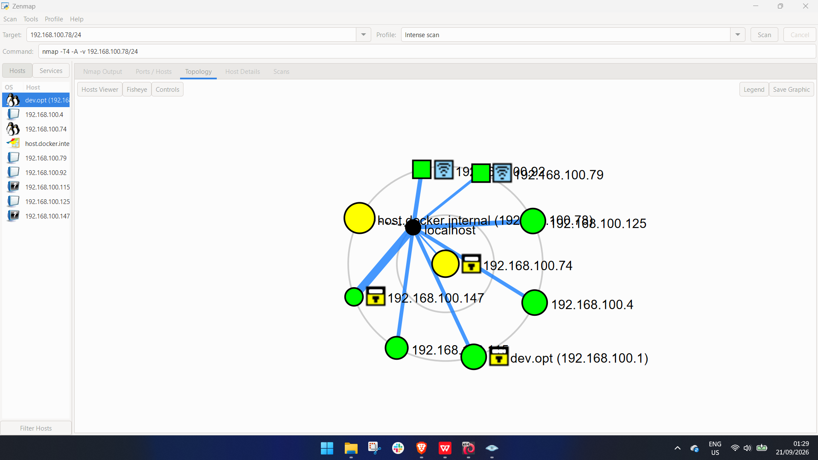

5. Risk Analysis / Impact
Based on the information collected during the footprinting and network scanning activities, I identified the following potential risks.
# | Risk / Finding | Evidence / Observation | Potential Impact | Risk Level
1 | WordPress version & plugin exposed | WhatWeb identified WordPress 7.1.1 and WP Download Manager 3.3.58 | Attackers may cross-reference exposed versions against public vulnerability databases to find known exploits | ● Medium
2 | Server IP address identifiable | Nslookup resolved the domain to 192.232.216.135 | Provides information about the network location of the web service | ● Low
3 | HTTP technical information exposed | Curl returned response headers and exposed the /wp-json/ REST endpoint | May assist technology fingerprinting and further enumeration | ● Low
4 | WAF technology identifiable | Wafw00f identified ModSecurity (SpiderLabs) protecting the site | Reveals information about the web application's security architecture | ● Low
5 | DNS infrastructure information exposed | DNSRecon identified name server software version, mail server, SPF and SRV records | DNS information can help build a broader infrastructure profile | ● Medium
6 | Soft-fail SPF policy | TXT record uses all rather than -all | Slightly weakens protection against email spoofing of the domain | ● Low
7 | Multiple live hosts visible on local network | Zenmap identified 5 live hosts on the 192.168.100.0/24 subnet | Unknown or unauthorized devices may potentially be present on the network | ● Medium
Risk level key: ● Medium ● Low
The risks above are observations from the footprinting and scanning exercises, not confirmed vulnerabilities.
The practical exercises primarily involved information gathering and host discovery. No exploitation or vulnerability validation was performed as part of these two modules.
Therefore, the presence of information such as a software version, IP address or DNS record does not by itself mean that the system is vulnerable. Further authorized security testing would be required to confirm any actual vulnerability.

6. Recommendations
- Review publicly exposed technology information: organizations should regularly review what information about their web technologies, CMS and plugins is publicly visible.
- Keep software updated: CMS platforms, plugins and other web technologies should be regularly updated and reviewed against current security advisories.
- Review HTTP headers: response headers should be reviewed to determine whether unnecessary technical information is being exposed.
- Review DNS records regularly: ensure only required information and services are publicly exposed, and consider a hard-fail SPF policy and DNSSEC.
- Properly configure and monitor the WAF: keep ModSecurity enabled and tuned, since it already blocks naive attacks.
- Perform regular internal network discovery: periodically scan internal networks to identify active devices.
- Investigate unknown devices: any unexpected device discovered during network scanning should be investigated and verified.
- Maintain network documentation: network topology and device information should be documented and updated regularly.
- Perform security testing with authorization: reconnaissance and scanning should only be performed against systems and networks with appropriate authorization.

7. Conclusion
During Week 2 of my Cybersecurity & Ethical Hacking internship, I completed practical activities covering footprinting, reconnaissance and network scanning.
In the footprinting activity, I used six Kali Linux tools to collect information about the target domain. I learned how WHOIS can provide domain information, WhatWeb can identify web technologies, Nslookup can resolve domain names, Curl can inspect HTTP headers, Wafw00f can identify a WAF, and DNSRecon can provide additional DNS information.
In the network scanning activity, I used Zenmap to identify my local network configuration, discover active hosts, and create a network topology.
The exercises showed me that information gathering is an important part of cybersecurity. Even before attempting to exploit a system, a security professional can learn a significant amount about an environment by carefully analyzing publicly available information and network responses.
I also learned that technical findings should be documented clearly. A good cybersecurity report should explain what was performed, what was discovered, what the observation means, what risk it may create, and what can be done to reduce that risk.
Finally, I learned that reconnaissance and scanning must always be performed within an authorized scope. These activities were completed as part of the assigned educational cybersecurity lab.

8. Evidences Collected
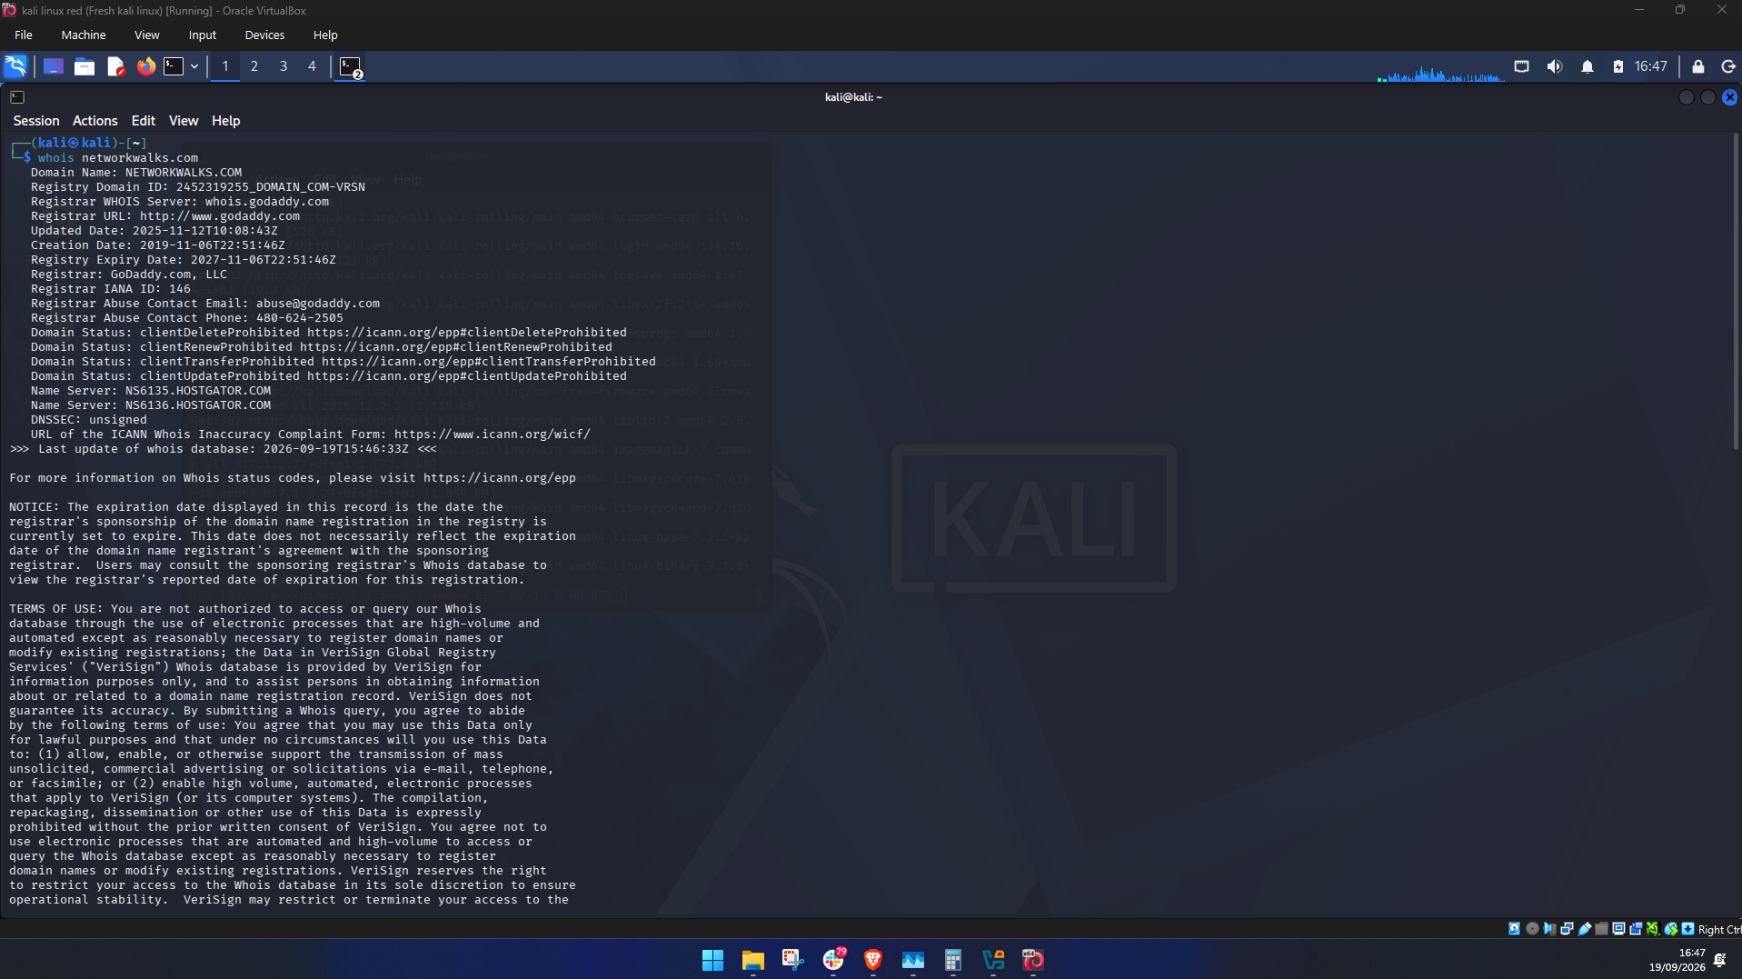
WHOIS lookup result for networkwalks.com
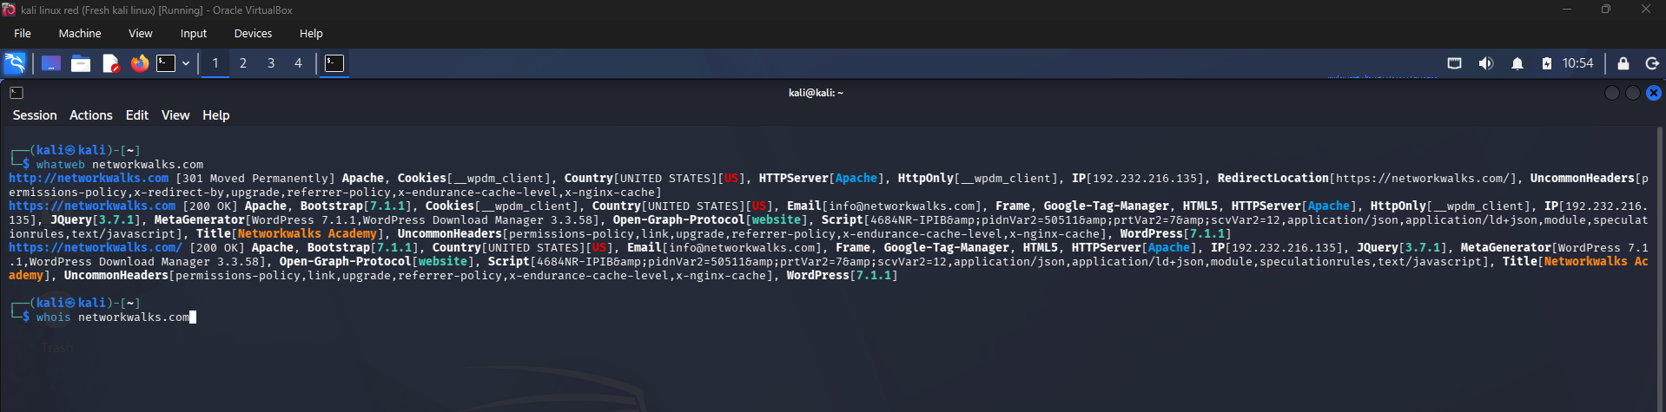
WhatWeb fingerprinting output
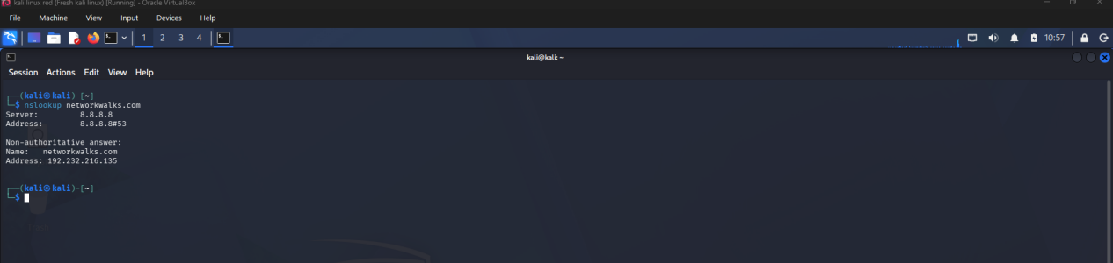
DNS resolution of networkwalks.com
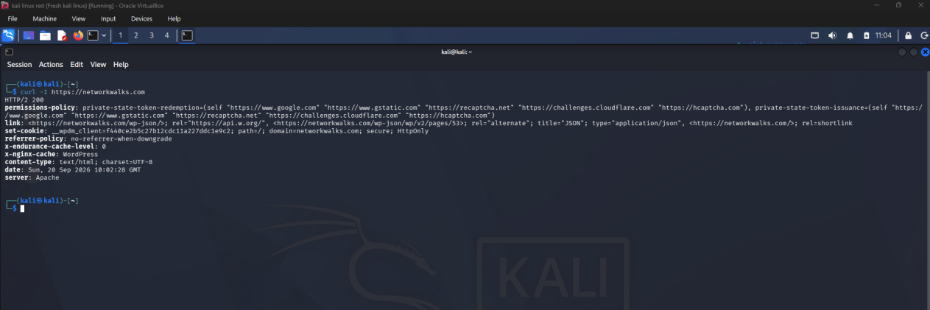
HTTP response headers
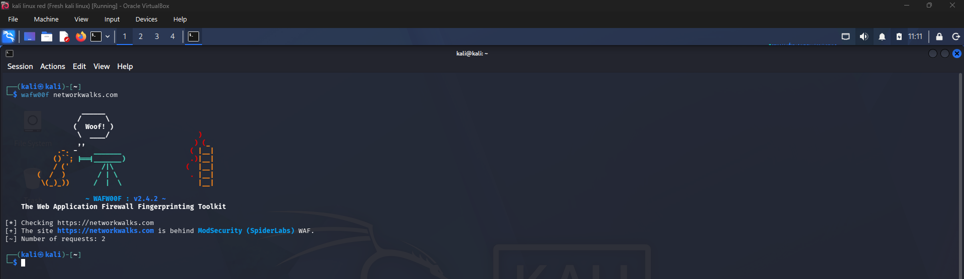
WAF detection result
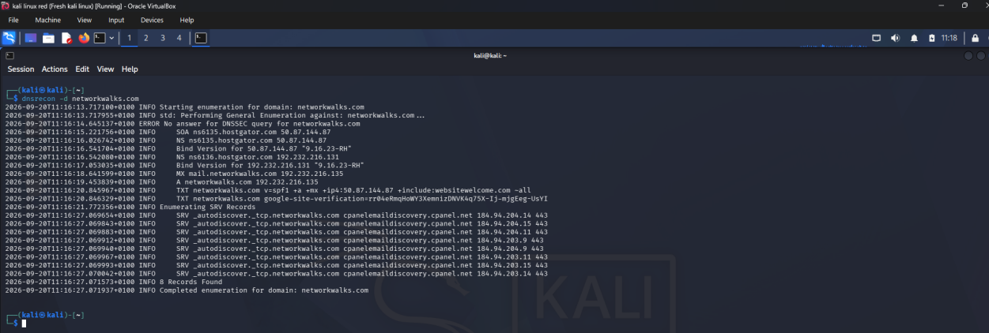
DNS enumeration results
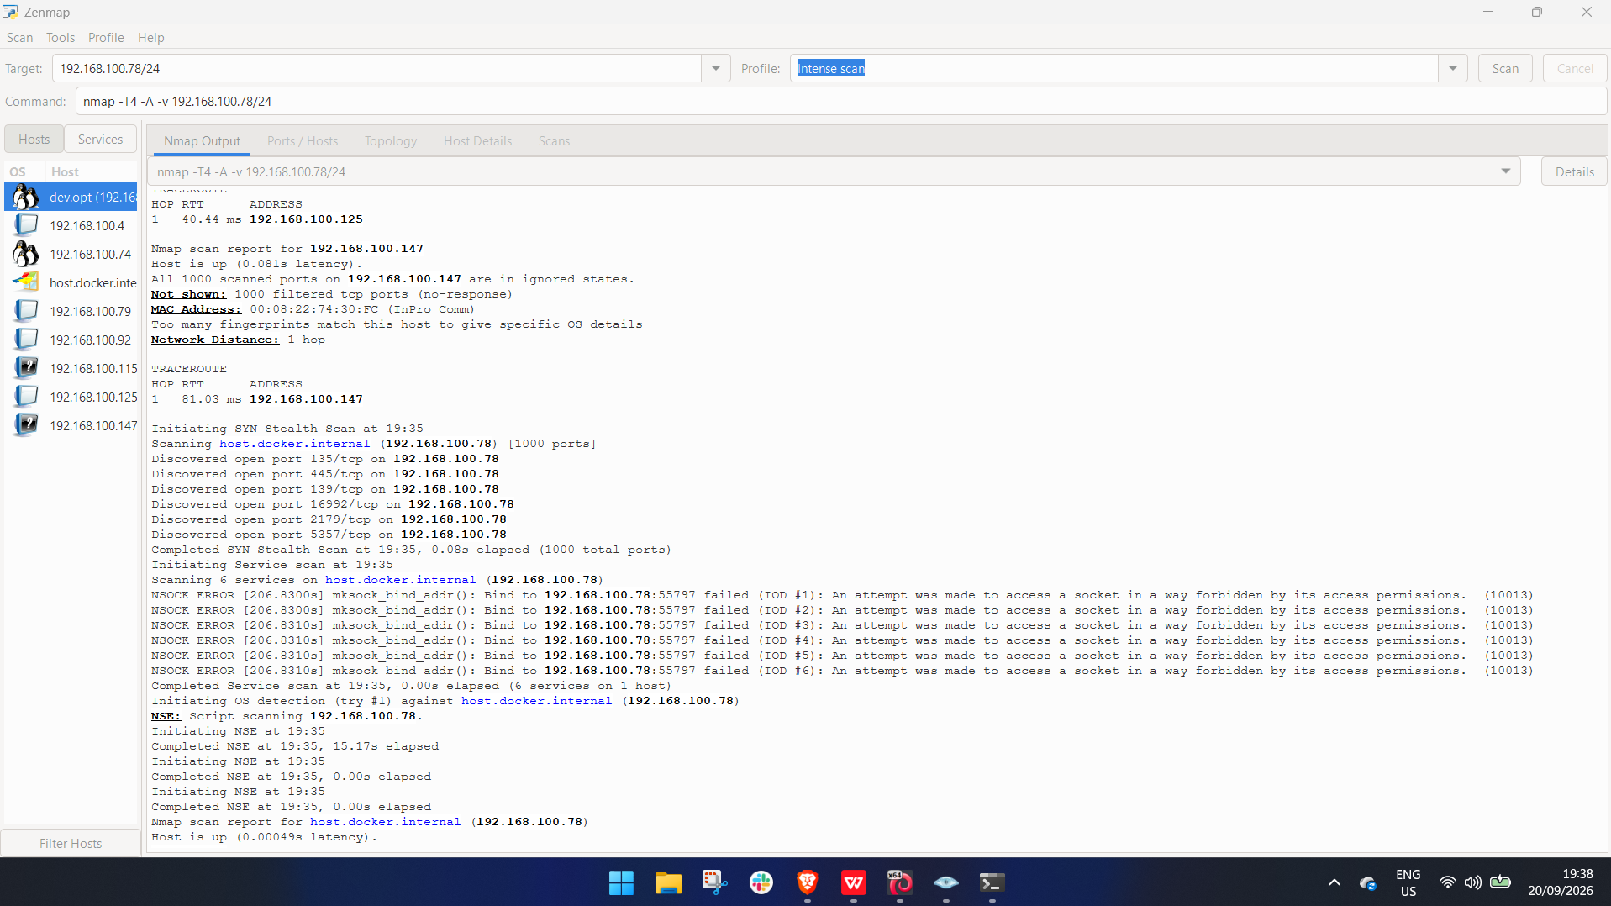
Zenmap host-discovery scan results
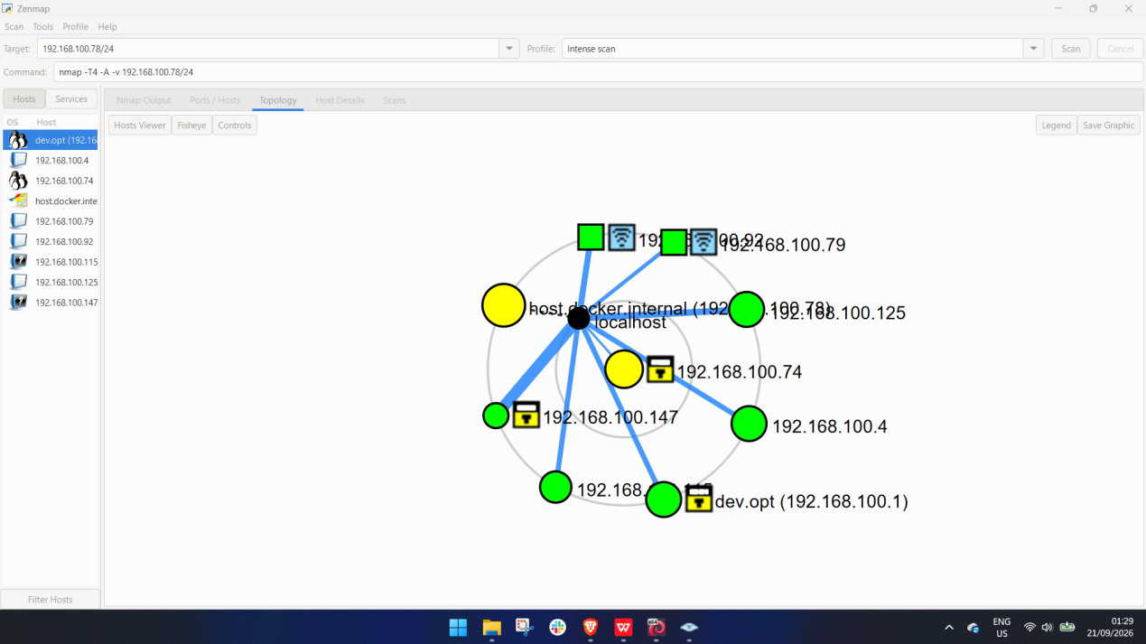
Network topology view
-End-
Author
Temitayo Kara
Cybersecurity Professional: B083-Networkwalks
LinkedIn: https://www.linkedin.com/in/temikara
Project Information
Program Name: Cybersecurity program at Networkwalks | Week: 02 | Repository: https://github.com/codelab-git

