Group Pandas:

Jianlei (ella) Chen: ella199161@gmail.com

Chuxuan Yang: yangchuxuan@gwmail.gwu.edu

Nikhil Swami: nikhilswami7@gwu.edu

Model

Proficiency $P_{r}$, Participation $P_{a}$, Graduation $G$

Base case: does not consider the adjustment of the assessment system and funding, and national budget

First the graduation percentage should directly

$$G=G_{0}+\sum_{i=0}^{3}{w_{i}{P_{r}}_{(4-i)}}$$

Where $G_{0}$ is the base minimum graduation rate. Like my professors always say, you can’t fail everyone. The second term represents the scaled effect of each year’s proficiency prior to graduation. (If the class average is D in the junior year of high school, you know not many of them are going to make it to graduate). $w_{i}$ is the weight for each year, such that the performance in the freshmen year tells less about the graduation.

Case 2: Assessment factor and funding considered:

$$\frac{dp_{r}}{dt}=s+kF$$

$$\frac{dG}{dt}=\frac{d\sum_{i=0}^{3}{w_{i}{P_{r}}_{(4-i)}}}{dt}+kF$$

$$\frac{dG}{dt}=\sum_{i=0}^{3}{w_{i}(s_{i}+kF_{i}(t-i))}+kF$$

Solving the first equation gives:

$$P_{r}\left(t\right)=P_{r}\left(0\right)+{s_{1}t+s}_{2}+tkF$$

$$G\left(t\right)=G\left(0\right)+s_{1}t+s+A\sum_{i=1}^{∞}{e_{i}^{-k\left(i\right)}F\left(t-i\right)}$$

Final case: The last case considers performance as a general that the more money put in the better it will be. The next thing we should do is go back to look at proficiency as percentage that it actually have a threshold value.

$$\frac{dp_{r}}{dt}=s+{ke}^{-τF}$$

So that

$$P_{r}\left(t\right)=P_{r}\left(0\right)+{s_{1}t+s}_{2}-τke^{-τF}$$

Here we define 1/ $τ$ as half-life of funding effect.

With

$$G\left(t\right)=G\left(0\right)+s_{1}t+s+A\sum_{i=1}^{∞}{e_{i}^{-k\left(i\right)}e^{-τF}}$$

Using our model: Due to time we only have time to look at national data. Let look at the following case

Case: Half life $1/τ$ big funding affect is long lasting:

$$F_{eff}=\frac{F_{1}+F_{2}+F_{3}+F_{4}}{4}$$

The effecting funding to one class is the average funding of the past 4 years.

With national average data we have

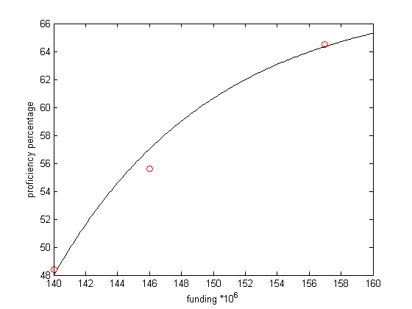

The blacking is the fitting line of

$$P=48+20*(1-e^{-0.1(F-140)})$$

The suggest the half life is 10 years meaning it takes 10 year for the funding effect to reduce to half. 48 is a combination of base prof and external effect. The base proficiency suggests that most state will reach this level no matter what. 140 is the base funding level most state get. Funding below that level will not be considered.

Selected data:

P=[64.5 55.6 48.4]; (12-15)

G=[84 75 76];(12-15)

F=[175 170 145 138 131 147] ${10}^{6}$\* (10-15)