Hypothesis Testing Assignment-03

Q-1 A F&B manager wants to determine whether there is any significant difference in the diameter of the cutlet between two units. A randomly selected sample of cutlets was collected from both units and measured? Analyze the data and draw inferences at 5% significance level. Please state the assumptions and tests that you carried out to check validity of the assumptions.

Ans-1 The assumption for the above question is as follows-

Null Hypothesis as Ho: μ1 = μ2 (There is no difference in diameters of cutlets between two units).

Thus, Alternate Hypothesis as Ha: μ1≠μ2 (There is significant difference in diameters of cutlets between two units)

2 Sample 2 tail test is applicable.

So, I have practically found out the p-value and analyzed both the data as follows-

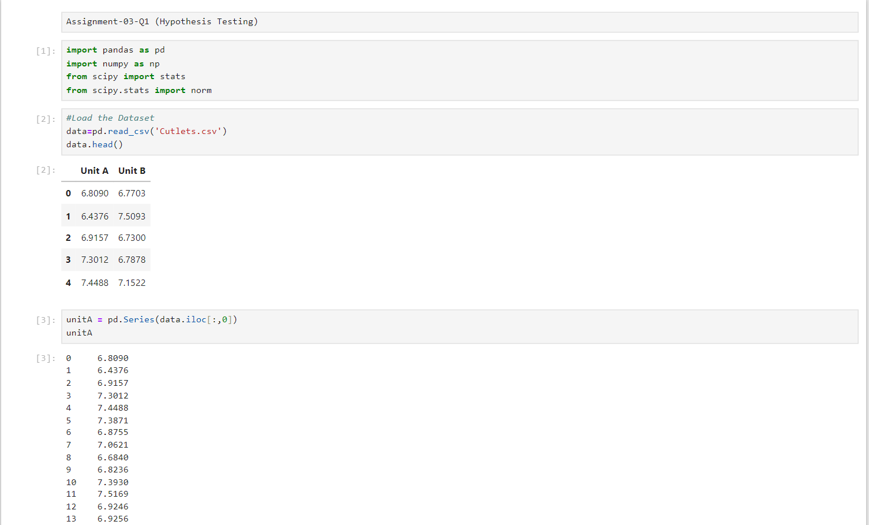

The difference between the p-value and the α = 0.05 (At 5% Significance level) is that the p-value = 0.472 and α = 0.05.

Q-2 A hospital wants to determine whether there is any difference in the average Turn Around Time (TAT) of reports of the laboratories on their preferred list. They collected a random sample and recorded TAT for reports of 4 laboratories. TAT is defined as sample collected to report dispatch.

Analyze the data and determine whether there is any difference in average TAT among the different laboratories at 5% significance level.

Ans-2 We have analyzed the data and found that there is a difference in average TAT among the different laboratories at 5% significance level as below-

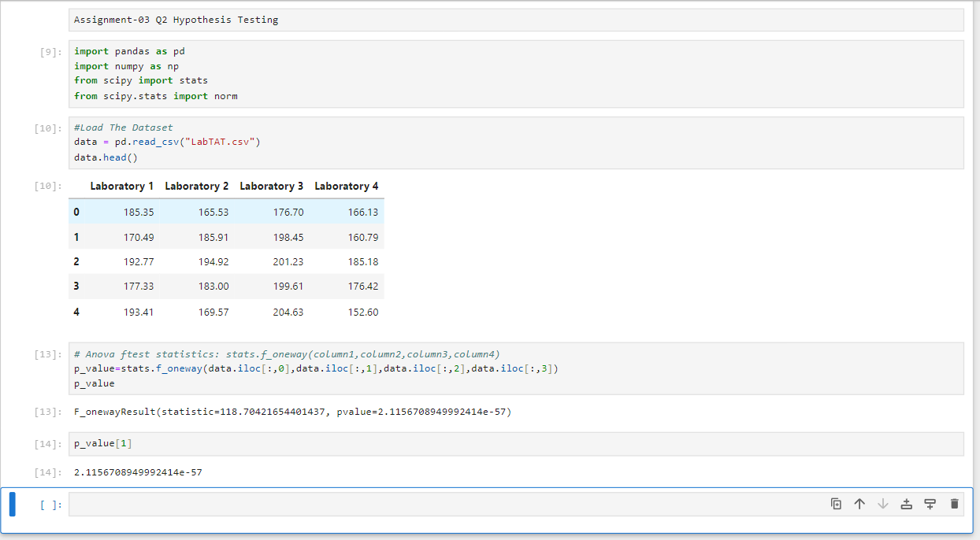

Q-3 Sales of products in four different regions is tabulated for males and females. Find if male-female buyer rations are similar across regions.

|  |  |  |  |  |
| --- | --- | --- | --- | --- |
|  | East | West | North | South |
| Males | 50 | 142 | 131 | 70 |
| Females | 435 | 1523 | 1356 | 750 |

1. Check p-value
2. If p-Value < alpha, we reject Null Hypothesis

Ans-3 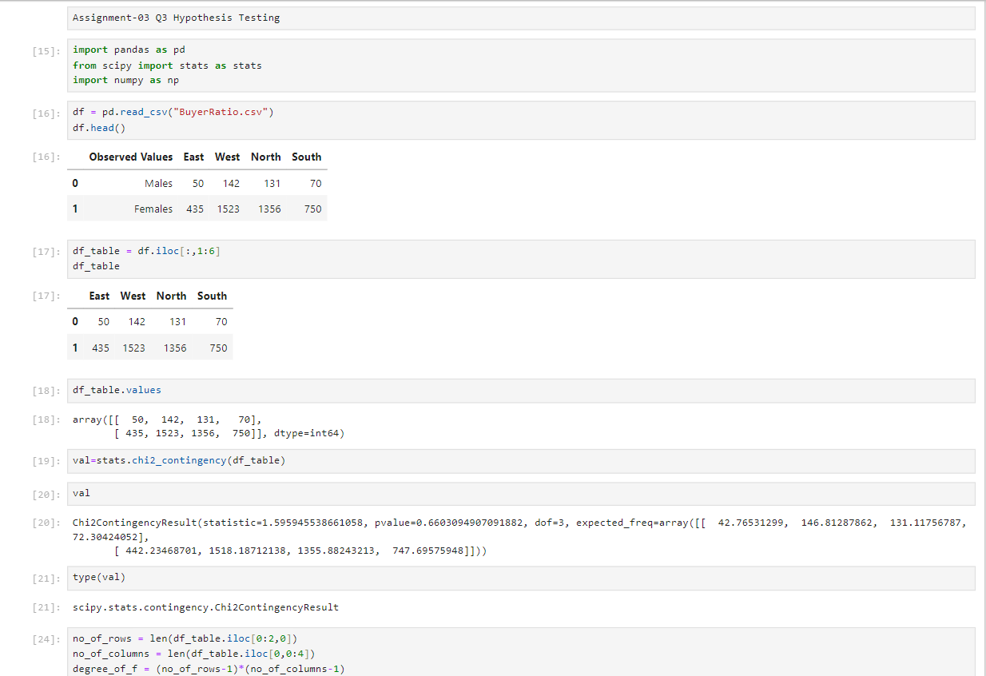

In the given figures above, I have successfully calculated the p-value and found out that the overall scenario is Independent and fails to reject H0 (Null Hypothesis).

Q-4 Telecall uses 4 centers around the globe to process customer order forms. They audit a certain % of the customer order forms. Any error in order form renders it defective and must be reworked before processing. The manager wants to check whether the defective % varies by Centre. Please analyze the data at *5%* significance level and help the manager draw appropriate inferences.

Ans-4 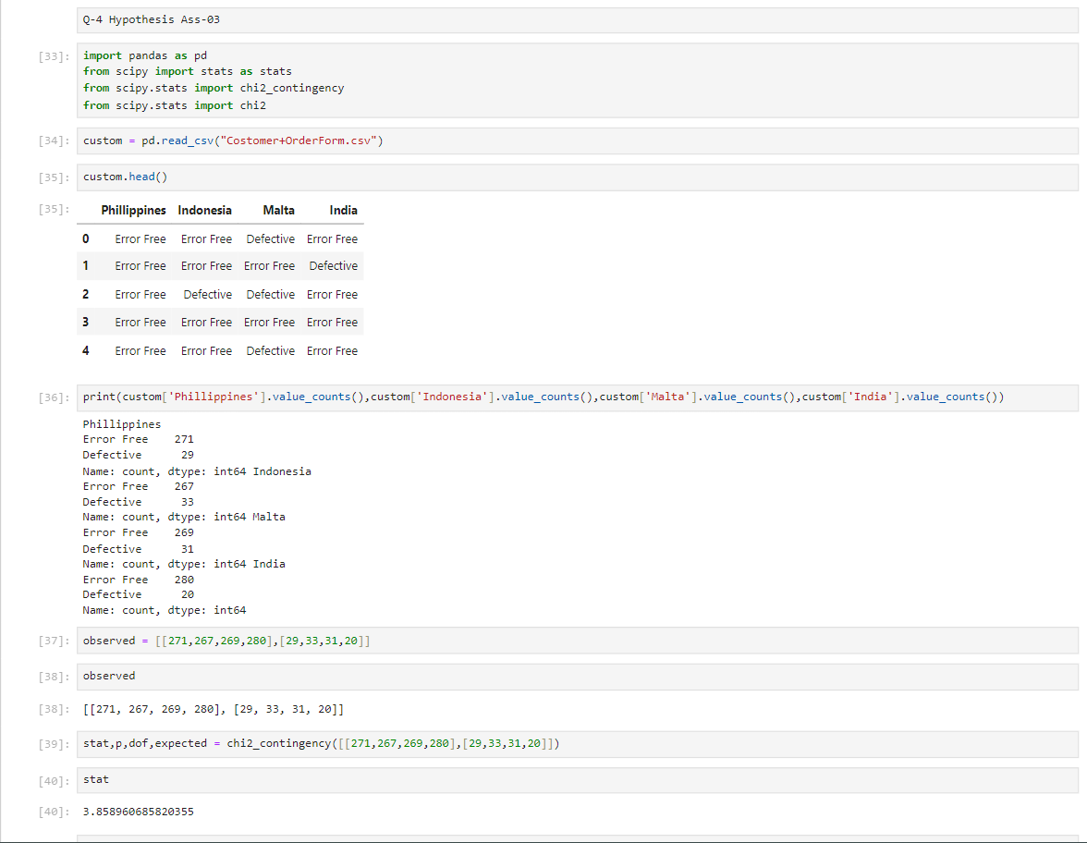

In the given figures above,

Null Hypothesis ($H_0$): The defective percentage is the same across all centers.

Alternative Hypothesis ($H_1$): The defective percentage varies by center.

The significance level is given as 5%, so alpha = 0.05.

Since, chi-square statistic is less than 7.815 therefore we fail to reject null hypothesis.