METİN YAVUZ
COURS PROJET
HTML DESİNG

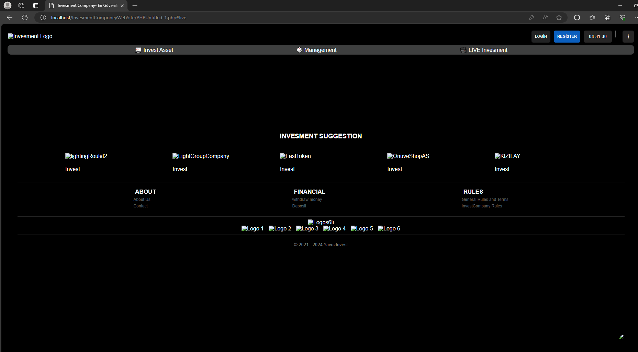
HTML CONNECTİON TO pgAdmin

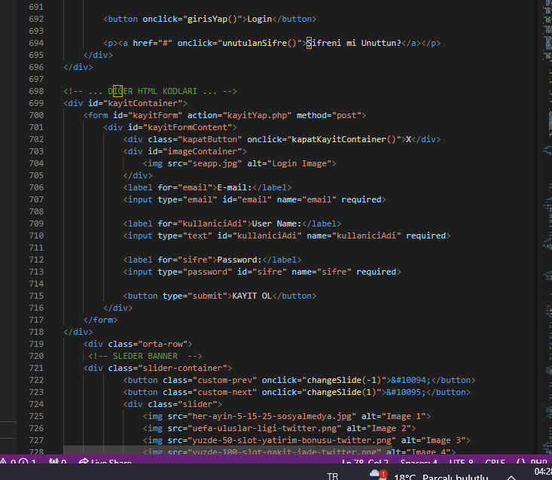

Ajax code

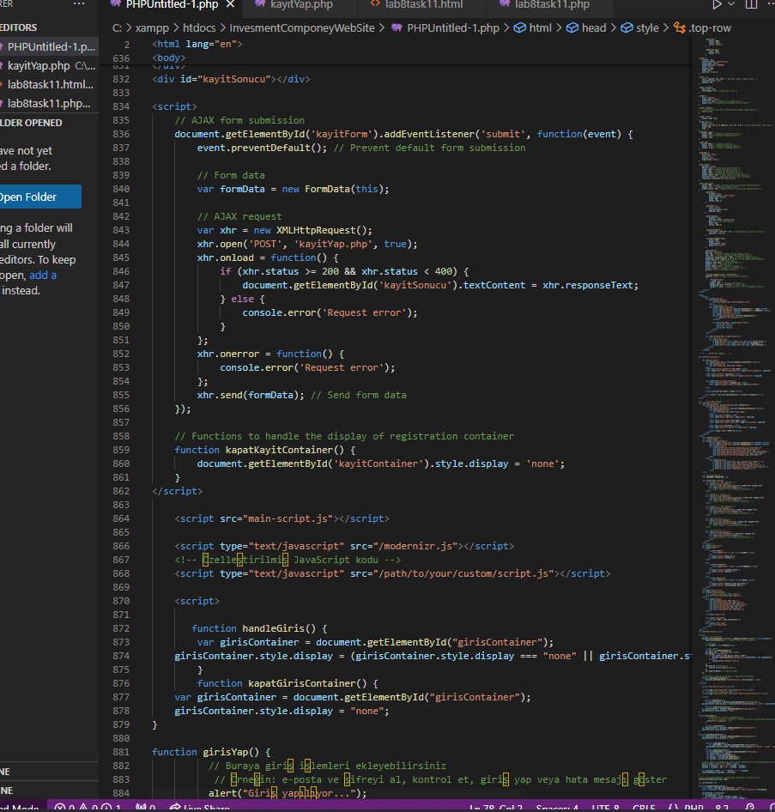
Overview:
This PHP script facilitates user registration by inserting user data into a MySQL database table. It securely hashes the user's password using the password_hash() function before storing it in the database. Additionally, it checks for existing email or username to prevent duplicate registrations.

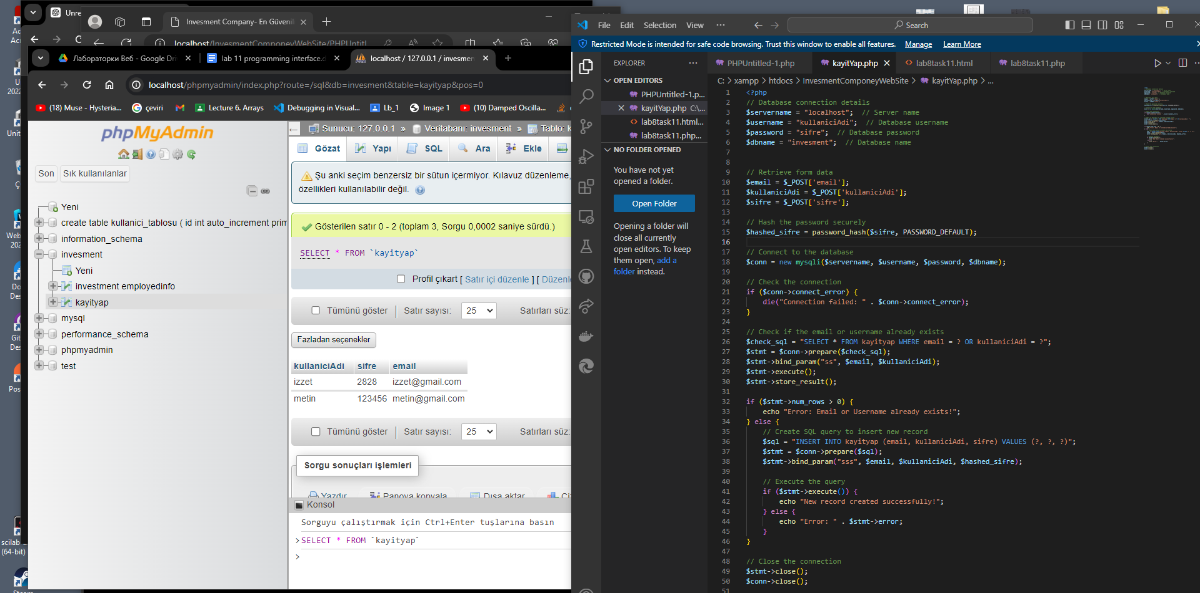
Database Connection:
- The script connects to a MySQL database using provided connection details such as server name, username, password, and database name.
- If the connection fails, it terminates the script and displays an error message.

Form Data Retrieval:
- User registration form data such as email, username, and password are retrieved using the $_POST superglobal array.

Password Hashing:
- The password entered by the user is securely hashed using the password_hash() function with the PASSWORD_DEFAULT algorithm.

Database Operations:
- The script prepares a SQL statement to check if the provided email or username already exists in the database.
- If a matching record is found, it displays an error message indicating that the email or username already exists.

OUTPUT :
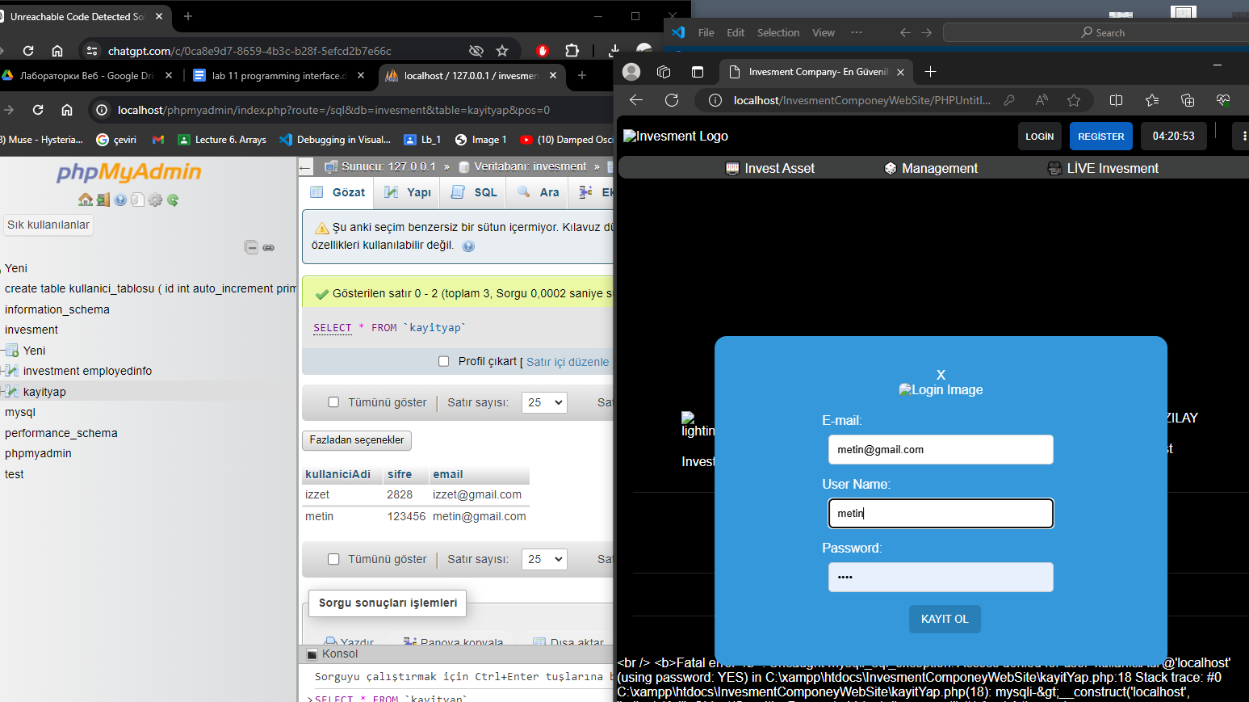
- If no matching record is found, it prepares an SQL statement to insert the new user record into the database.
- The hashed password along with the email and username are inserted into the database table.
- Upon successful execution of the SQL statement, it displays a success message indicating that a new record has been created.
- If an error occurs during database operations, it displays the error message.

Error Handling:
- The script includes error handling to gracefully handle database connection errors and SQL execution errors.
- It uses die() function to terminate the script execution and display error messages.

Conclusion:
This PHP script provides a secure and reliable user registration process by ensuring data integrity, password security, and preventing duplicate registrations. It seamlessly integrates with a MySQL database to store user registration information.

