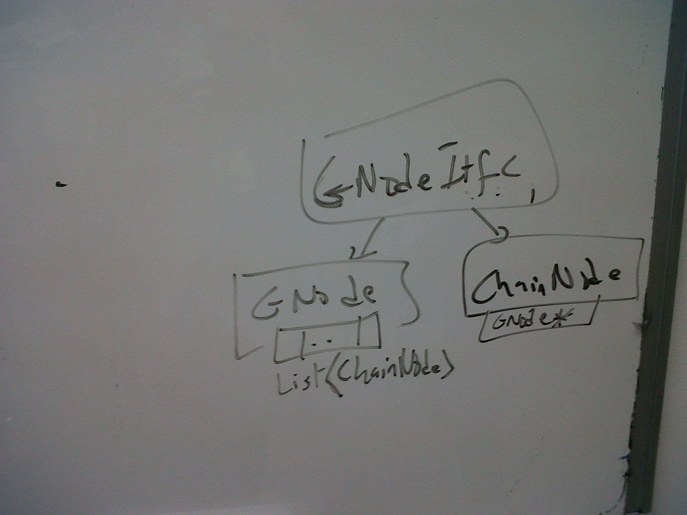
NarratorNode //abstract interface
{
NarratorNode * firstChild()
NarratorNode * nextChild(NarratorNode * current)
NarratorNode * firstParent()
NarratorNode * nextParent(NarratorNode * current)

ChainNarratorNode * firstNarrator()
ChainNarratorNode * nextNarrator(ChainNarratorNode * current)

<NarratorNode *, ChainNarratorNode *> prevInChain(ChainNarratorNode *)
<NarratorNode *, ChainNarratorNode *> nextInChain(ChainNarratorNode *)

Qstring CanonicalName()
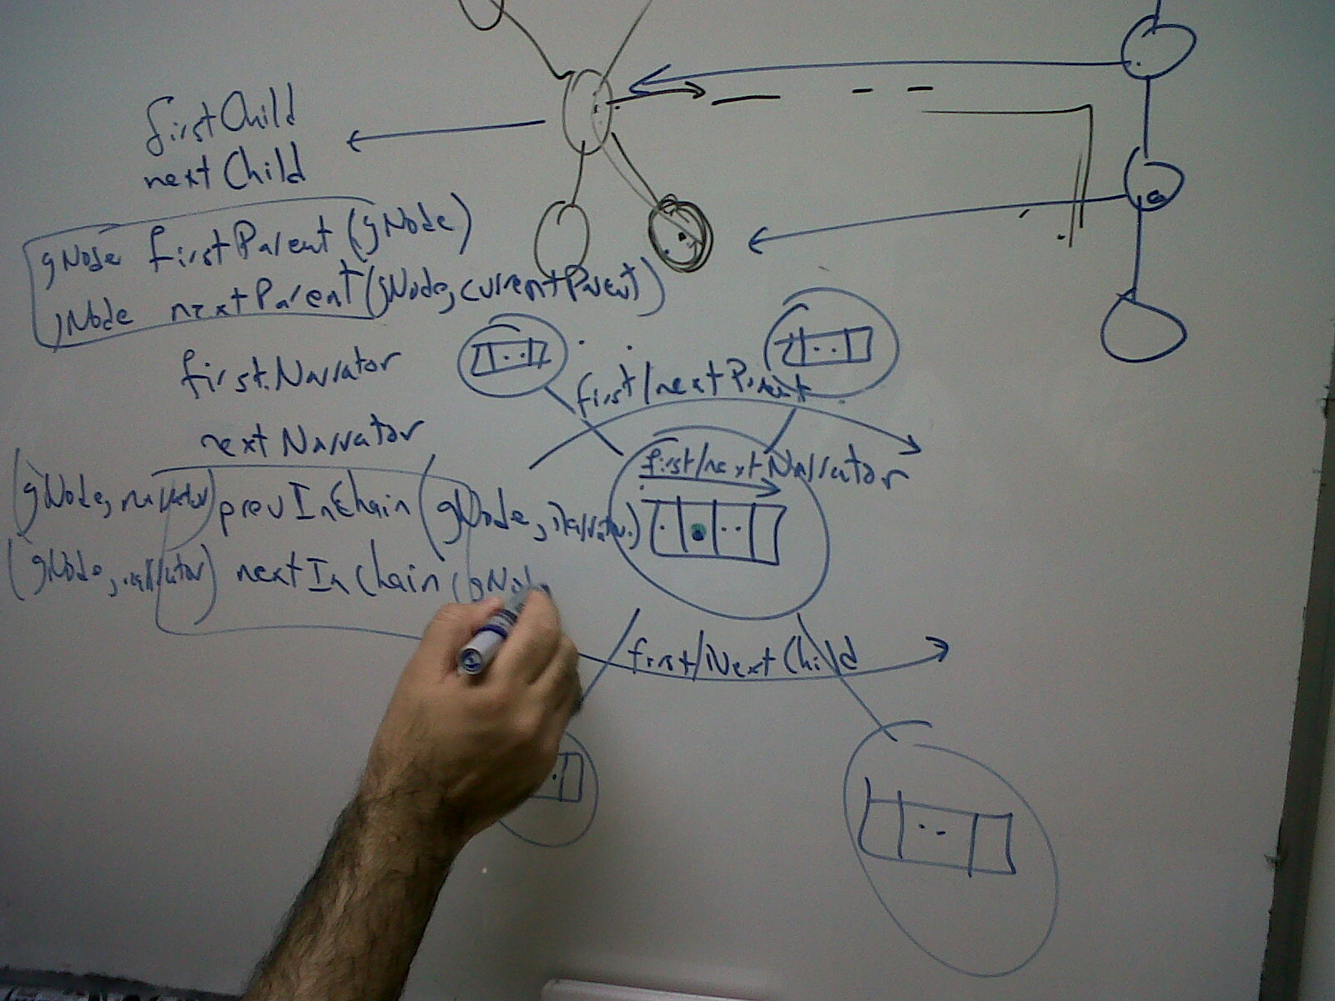
}

ChainNarratorNode: public NarratorNode
{
private:
NarratorNode * narrNode;
public:

NarratorNode * firstChild()
{
return nextInChain();
}
NarratorNode * nextChild(NarratorNode * current)
{
return null;
}

NarratorNode * firstParent()
{
return prevInChain();
}
NarratorNode * nextParent(NarratorNode * current)
{
return null;
}

ChainNarratorNode * firstNarrator()
{
return this;
}
ChainNarratorNode * nextNarrator(ChainNarratorNode * current)
{
return null;
}

<NarratorNode *, ChainNarratorNode *> prevInChain(ChainNarratorNode * node)
{
assert (node==this);
ChainNarratorNode * prev=node.prevInChain();
return <prev.getCorrespondingNarratorNode(), prev>;
}
<NarratorNode *, ChainNarratorNode *> nextInChain(ChainNarratorNode * node)
{
assert (node==this);
ChainNarratorNode * next=node.nextInChain();
return <next.getCorrespondingNarratorNode (), next>;
}

<ChainNarratorNode *> prevInChain()
<ChainNarratorNode *> nextInChain()

NarratorNode * getCorrespondingNarratorNode()
{
if ( narrNode==NULL)
return this;
else
return narrNode;
}

QString CanonicalName()
{
return this.getText();
}
}

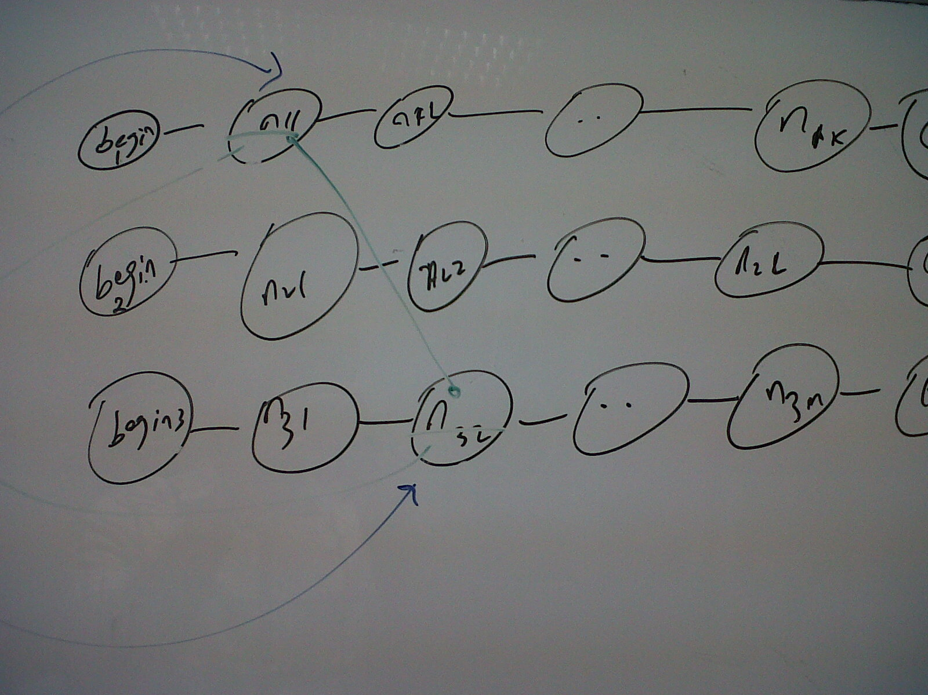
GraphNarratorNode: public NarratorNode
{
private:
Qlist<ChainNarratorNode> * equalnarrators;
public:

NarratorNode * firstChild()
{
return equalnarrators[0].getPrevInChain().getCorrespondingNarratorNode();
}
NarratorNode * nextChild(NarratorNode * current)
{
return qualnarrators[equalnarrators.find(current).getIndex()+1] .getPrevInChain().getCorrespondingNarratorNode(); //inefficient
}

NarratorNode * firstParent()
NarratorNode * nextParent(NarratorNode * current)//similar to above

ChainNarratorNode * firstNarrator() //similar to above
ChainNarratorNode * nextNarrator(ChainNarratorNode * current)

<NarratorNode *, ChainNarratorNode *> prevInChain(ChainNarratorNode * node)
{
ChainNarratorNode * prev=node.prevInChain();
return <prev.getCorrespondingNarratorNode(), prev>;
}
<NarratorNode *, ChainNarratorNode *> nextInChain(ChainNarratorNode * node)
{
ChainNarratorNode * next=node.nextInChain();
return <next.getCorrespondingNarratorNode (), next>;
}

QString CanonicalName()
{
//return smallest among names
}

}

