* The maintenace page can be got the added rows “Report”

There are two buttons such as “Add” and “View”

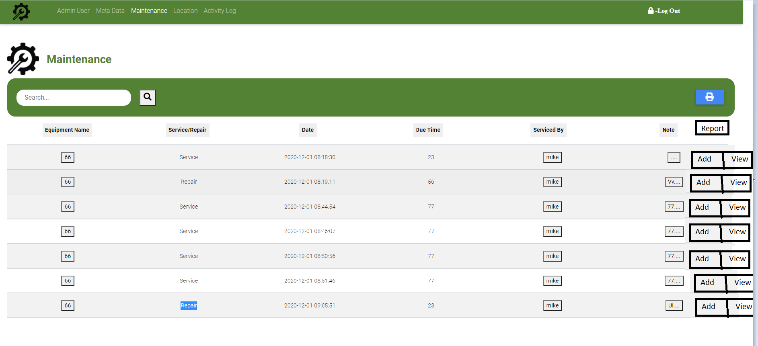

The use can upload the file using the “Add” button.

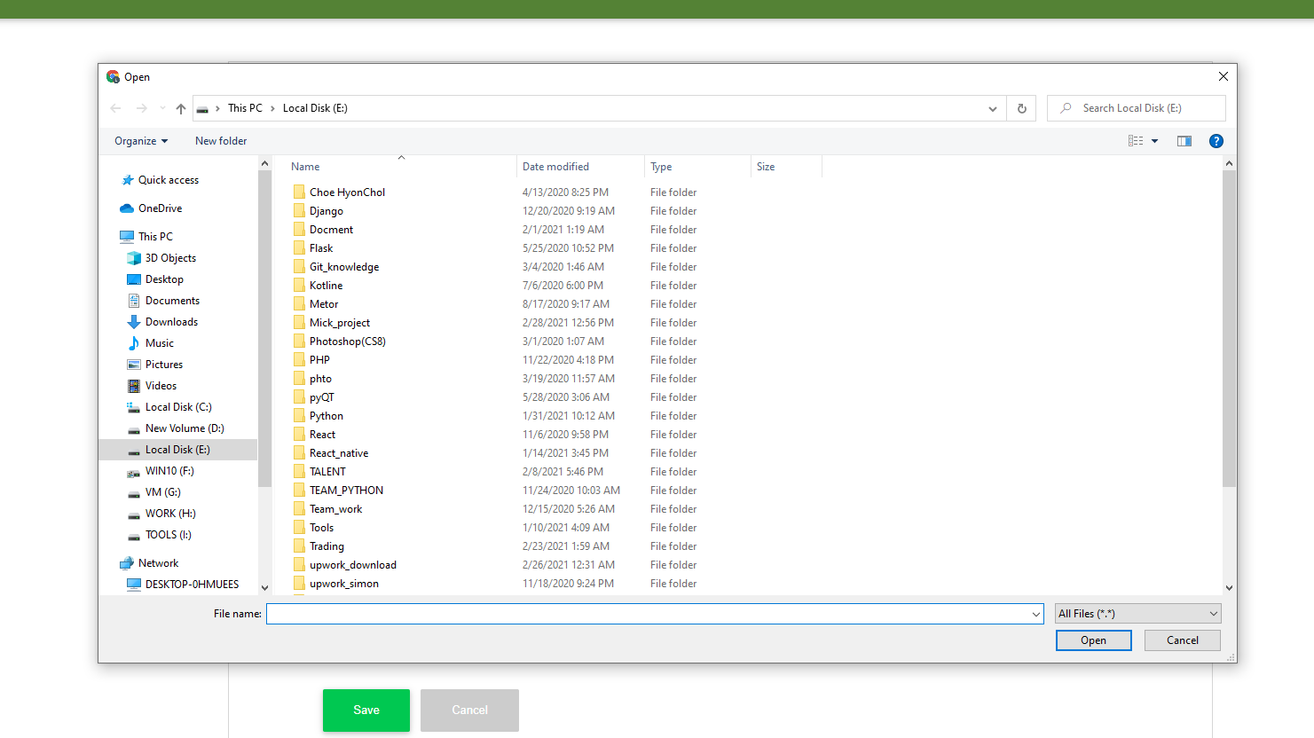

After that, upload window will be shown and can be uploaded. The uploaded files can be saved on the server folders such as ”equipment/service” and “equipment/repair”

The uploaded file name and path would be saved on the db.

* The user can see all reports about the specific equipement and it can be showed by pressing “view” button on the page.

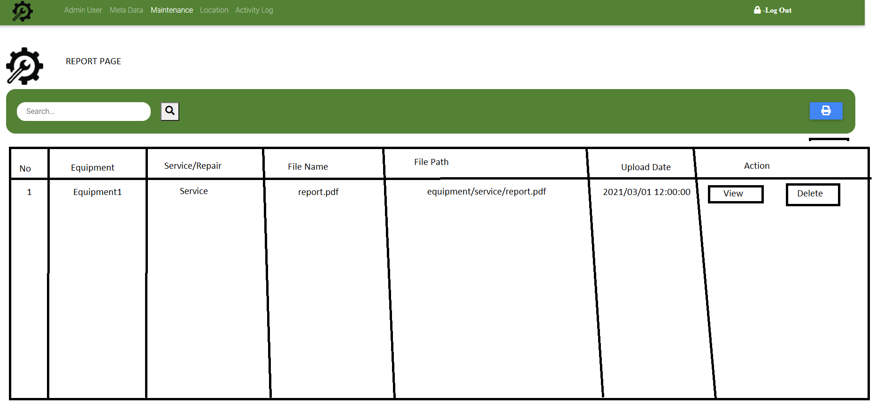

* To implement these features, need to be migrate the db for the report and built the end point on the backend.