Authentication Flow:

1. Access onlyfans.com using selenium
2. Set the credentials

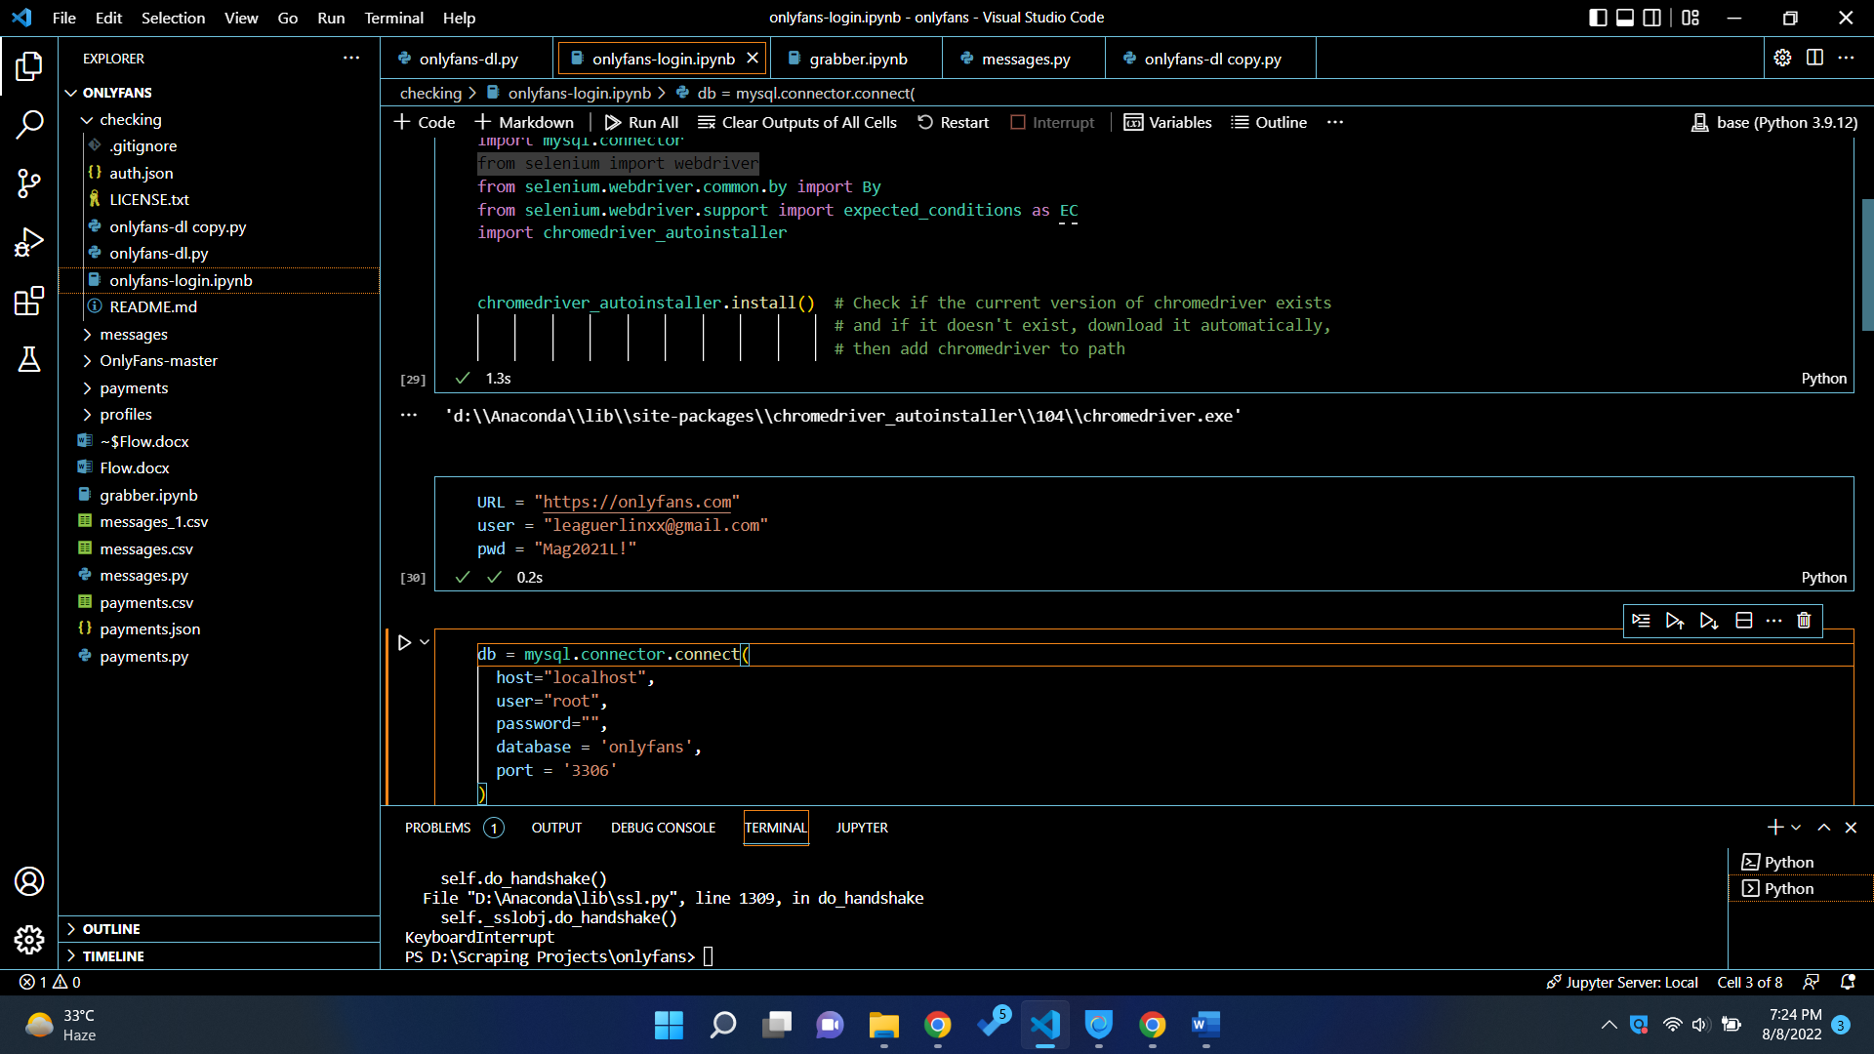

1. Login using the selenium
2. Get the session/user is details using cookies
3. 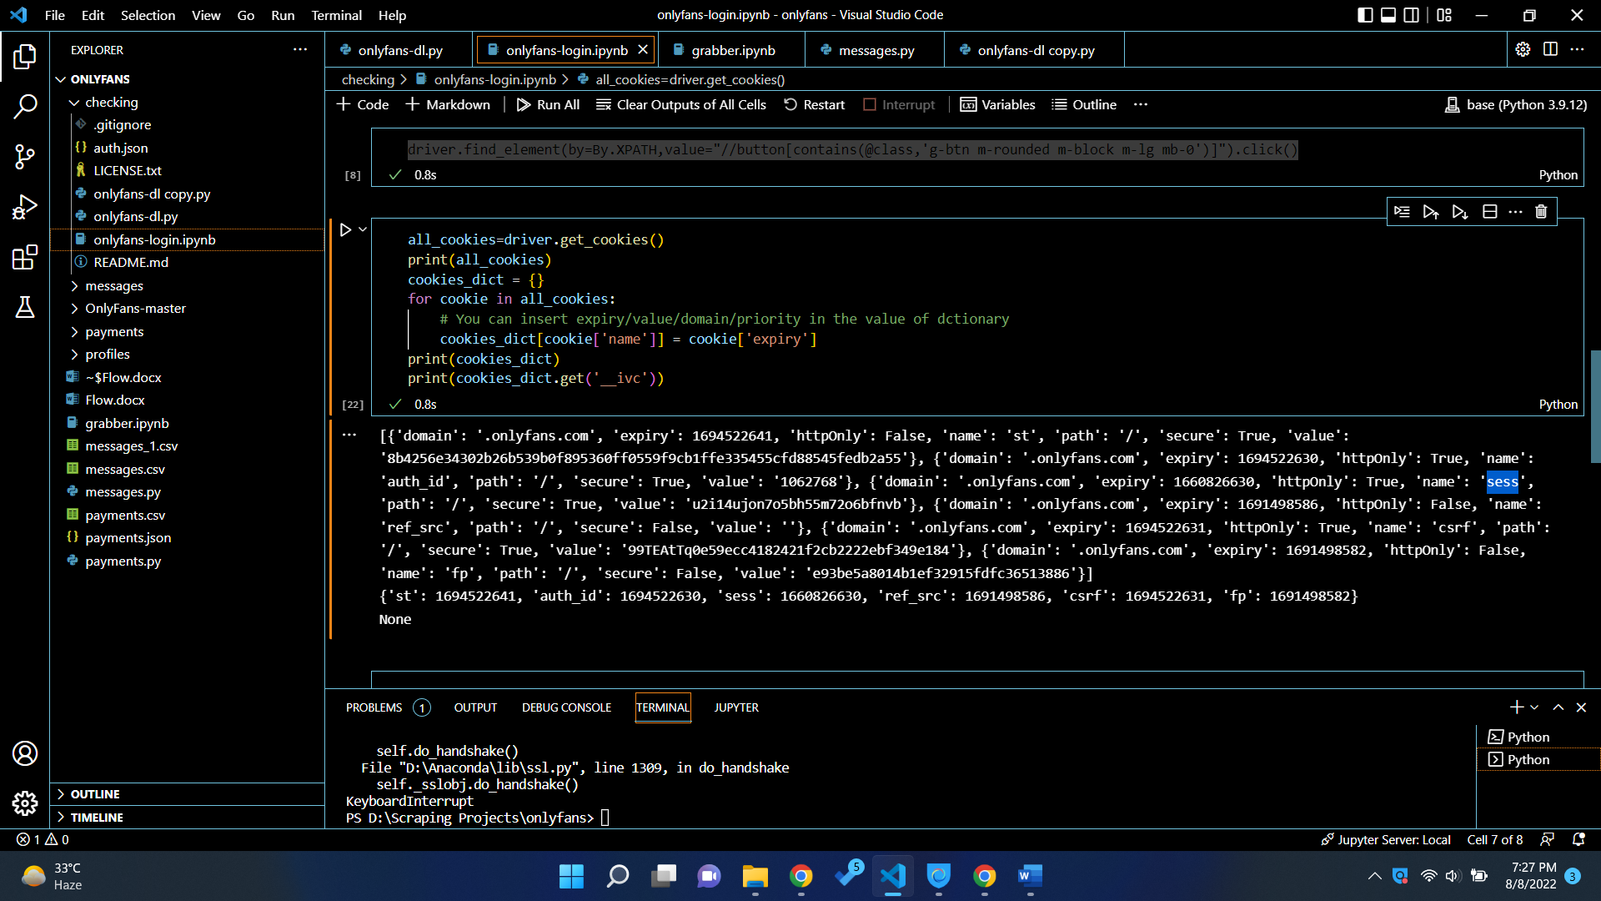
4. Store it in db for future use, we don’t need to login again and again.
5. We need the header request variable
6. x-bc: 76720151e705a1f2860f3f482dc83aef23f3d3fa
7. 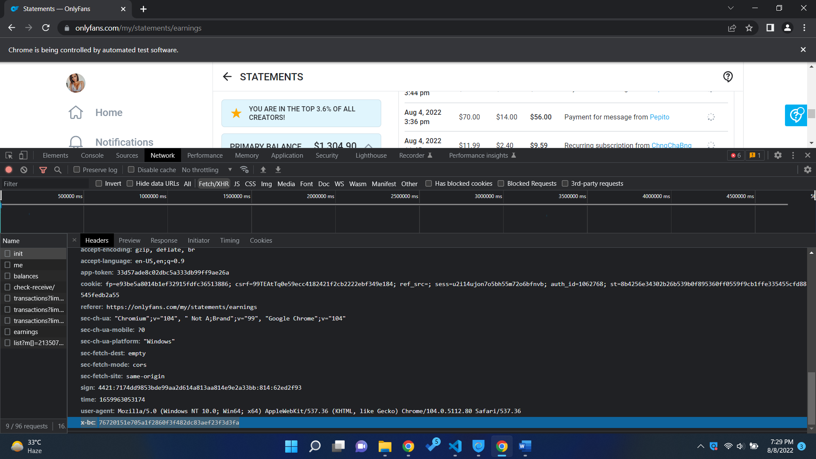
8. Save the details in DB.

Application Flow:

1. Now we have stored all the details like user id, sess, x-bc
2. We can send API request
3. 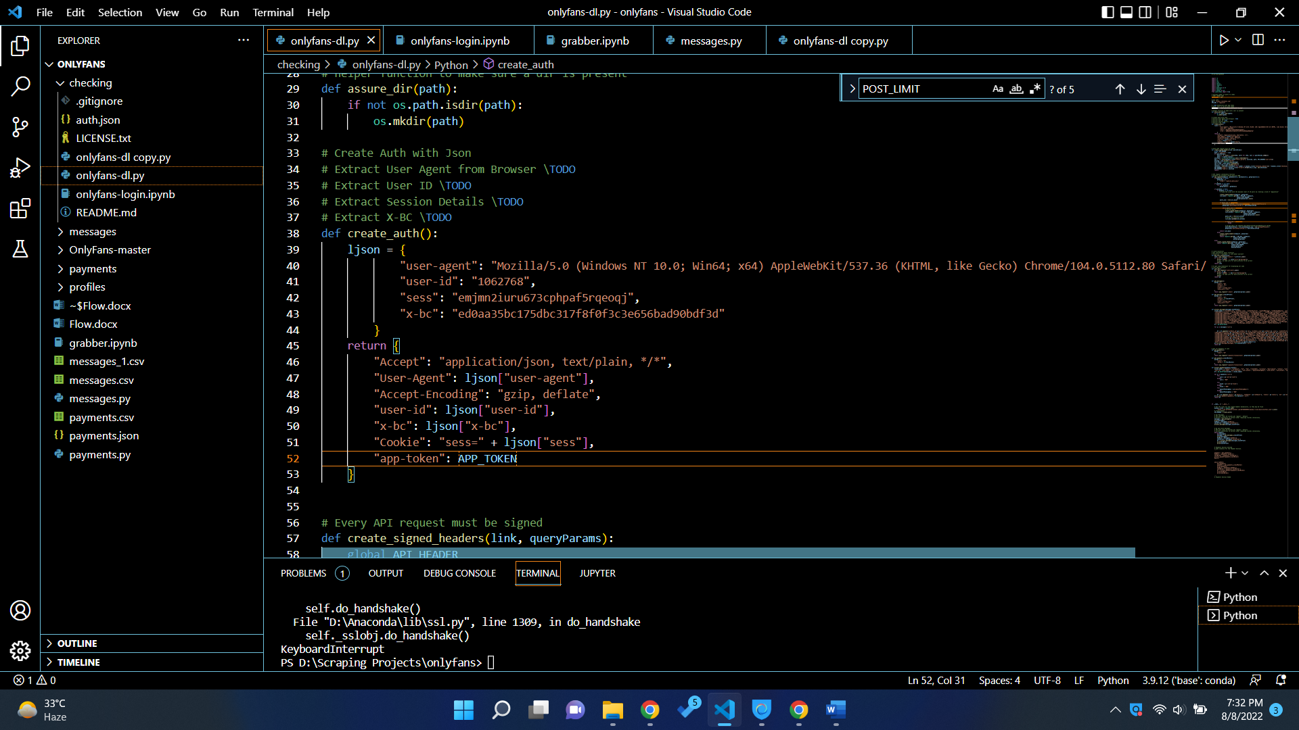
4. App token is static for now.
5. Every API request must be signed
6. So we generated that signed request using the function def create_signed_headers(link, queryParams):
7. We have API request convenience function to entertain all the API request at one place
8. To get messages from server we have get_messages() function
9. 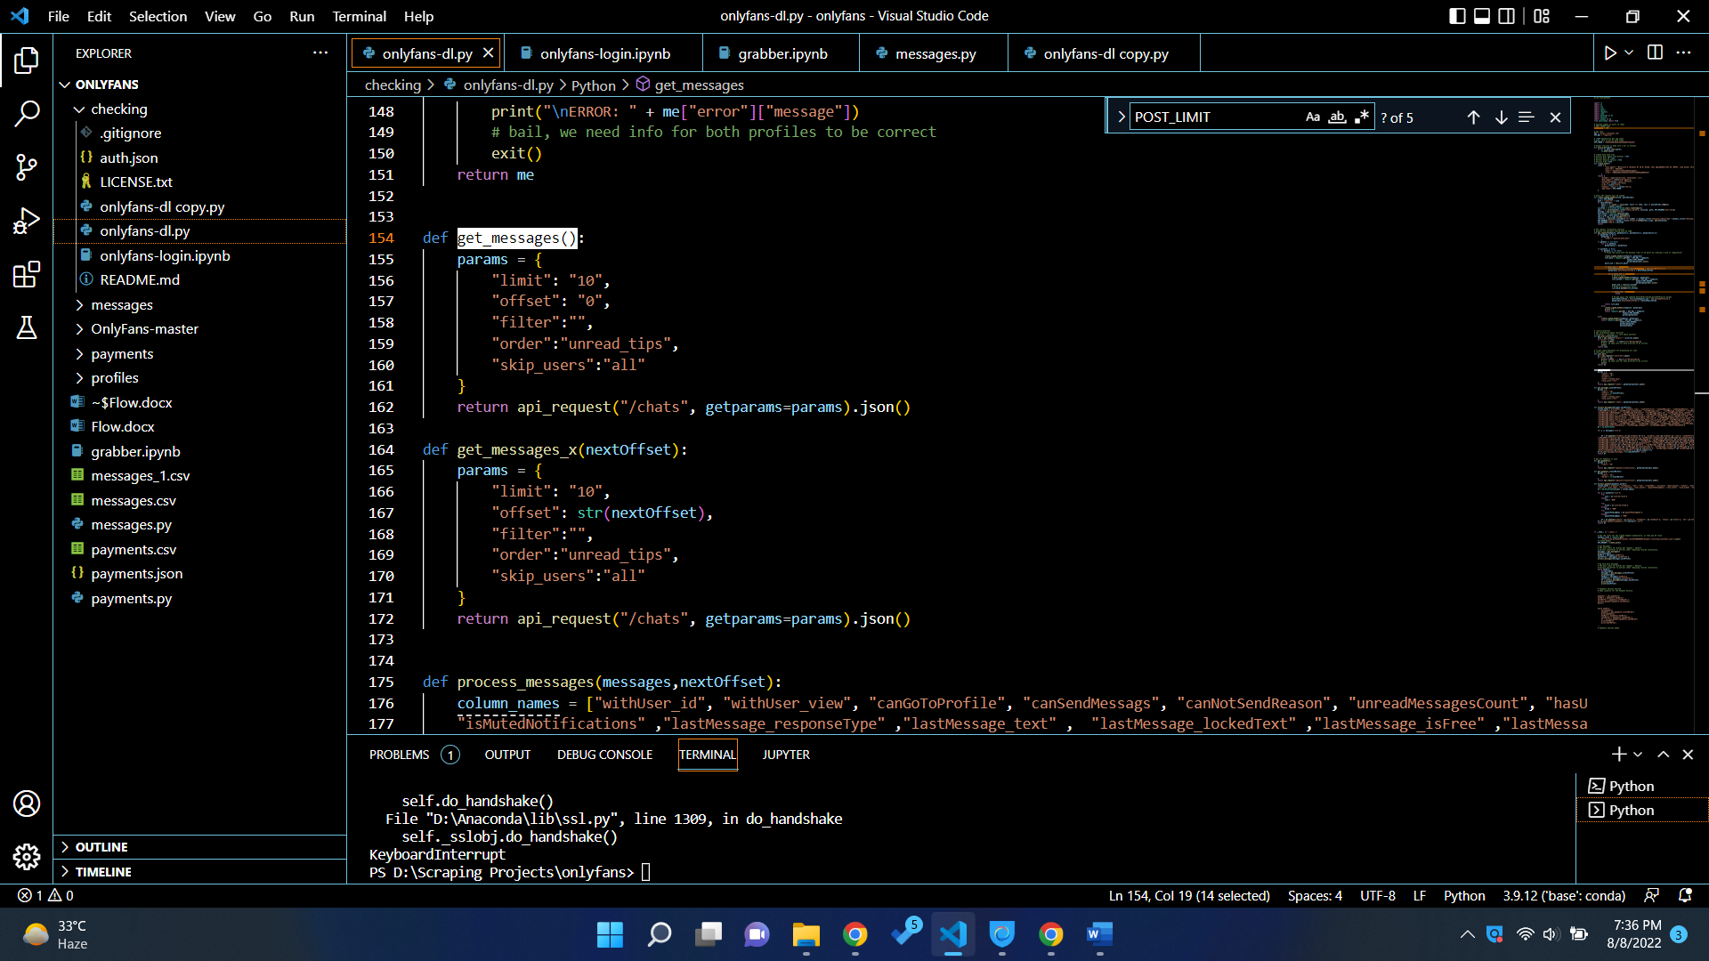
10. For Payments we have
11. A screenshot of a computer

    Description automatically generated with medium confidence
12. Once we have data, we can store it in DB, CSV, or any other place.
13. For now, the script is storing it in CSV files.
14. Then I am contacting all the CSVs and I share the messages and payments CSVs with you.
15. I inserted the CSVs in DB as well; we can automate this process once we deploy this on server.
16. Or I can store all the information in local database.