Table of content

1. Overview and Objectives 2

1.1 Introduction 2

1.2 Problem Statement 2

1.3 Application Overview 2

1.4 Project Objectives 2

1.5 Scope and Limitations 3

1.6 Technologies Used 3

1.7 Project Deliverables 4

2. Development Process, Challenges, and Solutions 4

2.1 Development Methodology 4

2.2 Technical Implementation 5

2.3 Key Challenges and Solutions 6

2.4 Code Quality and Maintenance 7

2.5 Testing Strategy 7

2.6 Lessons Learned 7

3. Detailed Module/Feature Explanation 9

3.1 Core Application Structure 9

3.2 Job Listing Module 9

3.3 Job Details Module 10

3.4 Search and Filter Module 11

3.5 Saved Jobs Module 11

3.6 Data Management 12

3.7 UI Components (widgets/) 12

3.8 Utilities (utils/) 13

3.9 Navigation 13

3.10 Error Handling 14

4. Screenshots of the Application 15

4.1 Home Screen 15

4.2 Job Search 16

4.3 Filter Panel 17

4.4 Job Details 18

4.5 Saved Jobs 19

4.6 Loading States 20

4.7 Empty States 21

Remote Job Search Application - Final Report

# 1. Overview and Objectives

## 1.1 Introduction

The Remote Job Search Application is a mobile solution developed as part of our academic curriculum in Mobile Application Development. This application addresses the growing demand for remote work opportunities by providing a platform for job seekers to discover and save remote job listings. Built using the Flutter framework, it offers a seamless experience across Android and iOS devices.

## 1.2 Problem Statement

In today's job market, finding relevant remote positions can be challenging due to:

* Scattered job listings across multiple platforms
* Inefficient filtering options
* Lack of a dedicated platform for remote positions
* Difficulty in tracking and saving job opportunities

## 1.3 Application Overview

The application serves as a centralized platform for remote job seekers with these key features:

* Job Listings: Displays remote job opportunities
* Search & Filter: Enables users to find jobs by location, type, and other criteria
* Saved Jobs: Allows users to save interesting positions
* Responsive Design: Works across different device sizes

## 1.4 Project Objectives

**1.4.1 Technical Objectives**

* Develop a cross-platform application using Flutter
* Implement state management using Provider
* Ensure smooth performance with asynchronous loading
* Maintain clean and maintainable code
* Implement local storage for saved jobs

**1.4.2 Functional Objectives**

* Provide job search capabilities
* Enable filtering of job listings
* Allow saving and managing job opportunities
* Display detailed job information
* Support offline access to saved jobs

**1.4.3 User Experience Objectives**

* Create an intuitive interface
* Ensure responsive interactions
* Provide clear navigation
* Implement accessible design

## 1.5 Scope and Limitations

**Scope:**

* Android and iOS support
* Job listing integration
* Local storage for saved jobs
* Responsive design

**Limitations:**

* No web or desktop version
* Focused on remote jobs only
* Basic user profile functionality
* No built-in application tracking

## 1.6 Technologies Used

* Frontend: Flutter (Dart)
* State Management: Provider
* Local Storage: Shared Preferences
* Networking: HTTP package
* Development Tools: Android Studio, VS Code, Git

## 1.7 Project Deliverables

1. Fully functional mobile application (APK/IPA)
2. Complete source code with documentation
3. Project report
4. Presentation materials
5. User manual and technical documentation

This concludes the Overview and Objectives section. The next sections will cover the development process, implementation details, and evaluation of the application.

# 2. Development Process, Challenges, and Solutions

## 2.1 Development Methodology

Our team adopted an Agile development approach with two-week sprints, allowing for iterative development and regular feedback. The project was divided into the following phases:

1. **Initial Setup (Week 1-2)**
   * Project initialization with Flutter
   * Setup of project structure and dependencies
   * Implementation of basic UI components
   * Integration of state management using Provider
2. **Core Functionality (Week 3-5)**
   * Implementation of job listing screen
   * Integration with job search API
   * Development of filtering system
   * Implementation of saved jobs functionality
3. **UI/UX Refinement (Week 6-7)**
   * Enhancement of user interface
   * Implementation of responsive design
   * Addition of loading states and error handling
   * Performance optimization

## 2.2 Technical Implementation

**2.2.1 State Management**

* **Challenge**: Managing application state across multiple screens
* **Solution**:
  + Implemented Provider pattern for efficient state management
  + Created separate providers for jobs and saved jobs
  + Used

ChangeNotifier

 for state updates

* + Ensured proper widget rebuilds with

Consumer

 and

Selector

**2.2.2 Data Persistence**

* **Challenge**: Saving jobs for offline access
* **Solution**:
  + Implemented

SavedJobsProvider using

SharedPreferences

* + Created methods for saving, removing, and checking saved jobs
  + Used JSON serialization for job objects
  + Ensured data consistency with proper error handling

**2.2.3 API Integration**

* **Challenge**: Fetching and displaying job listings
* **Solution**:
  + Created

JobService

 for API communication

* + Implemented error handling and loading states
  + Used

http

 package for network requests

* + Added support for filtering and pagination

## 2.3 Key Challenges and Solutions

**2.3.1 State Management During Build**

* **Challenge**:

setState()

 or

markNeedsBuild()

 called during build

* **Solution**:
  + Used

WidgetsBinding.instance.addPostFrameCallback

* + Ensured state updates occur after build completion
  + Implemented proper loading states

**2.3.2 Data Parsing**

* **Challenge**: Handling HTML entities in job descriptions
* **Solution**:
  + Created

StringUtils for HTML entity decoding

* + Implemented custom string cleaning methods
  + Added error handling for malformed data

**2.3.3 UI Responsiveness**

* **Challenge**: Ensuring consistent UI across devices
* **Solution**:
  + Used responsive layout widgets
  + Implemented proper constraints
  + Tested on multiple screen sizes

## 2.4 Code Quality and Maintenance

**2.4.1 Code Organization**

* Separated concerns with clear directory structure
* Used meaningful variable and function names
* Added comments for complex logic
* Followed Dart style guidelines

**2.4.2 Error Handling**

* Implemented try-catch blocks
* Provided user feedback for errors
* Logged errors for debugging
* Handled edge cases

## 2.5 Testing Strategy

* Unit tests for providers and services
* Widget tests for UI components
* Manual testing on multiple devices
* User acceptance testing

## 2.6 Lessons Learned

1. **State Management**:
   * Importance of proper state management in Flutter
   * Benefits of using Provider for medium-sized applications
2. **Performance**:
   * Impact of widget rebuilds on performance
   * Benefits of using const constructors
   * Importance of efficient list rendering
3. **Team Collaboration**:
   * Value of clear communication
   * Benefits of code reviews
   * Importance of version control best practices

**2.7 Future Improvements**

1. **Features**:
   * User authentication
   * Push notifications
   * Advanced search filters
   * Dark mode
2. **Technical**:
   * Implement BLoC pattern for complex state
   * Add more comprehensive testing
   * Improve error handling
   * Optimize image loading
3. **Performance**:
   * Implement caching
   * Add pagination
   * Optimize network requests
   * Reduce app size

This section has detailed the development journey, challenges faced, and solutions implemented. The next section will provide a comprehensive explanation of each module and feature

# 3. Detailed Module/Feature Explanation

## 3.1 Core Application Structure

**3.1.1 Main Application (main.dart)**

* **Entry Point**: Initializes the Flutter application
* **Key Components**:
  + MultiProvider

 for state management

* + Theme configuration
  + Route management
  + Provider initialization

**3.1.2 Application State (providers/)**

* **JobProvider**:
  + Manages job listings state
  + Handles API communication through JobService
  + Implements filtering and pagination
  + Manages loading and error states
* **SavedJobsProvider**:
  + Manages saved jobs state
  + Handles local storage using SharedPreferences
  + Provides methods to save/remove/check saved jobs
  + Persists data between app sessions

## 3.2 Job Listing Module

**3.2.1 Home Screen (screens/home_screen.dart)**

* **Layout**:
  + AppBar with title and actions
  + Search bar
  + Filter panel (collapsible)
  + Job list view
* **Functionality**:
  + Displays list of jobs using

ListView.builder

* + Implements pull-to-refresh
  + Handles loading and error states
  + Provides visual feedback for user actions

**3.2.2 Job Card Widget (widgets/job_card.dart)**

* **Displays**:
  + Job title (with HTML entity decoding)
  + Company name
  + Location
  + Job type
  + Posted date
  + Save/Unsave button
* **Interactions**:
  + Tap to view details
  + Save/Unsave functionality
  + Visual feedback on interactions

## 3.3 Job Details Module

**3.3.1 Job Detail Screen**

* **Layout**:
  + Scrollable view
  + Company header with logo
  + Job title and metadata
  + Job description
  + Apply/Save action buttons
* **Features**:
  + HTML content rendering
  + Save/Unsave functionality
  + Share job option
  + Back navigation

## 3.4 Search and Filter Module

**3.4.1 Search Functionality**

* **Implementation**:
  + Real-time search as you type
  + Debouncing to prevent excessive API calls
  + Search across multiple fields
  + Recent searches history

**3.4.2 Filter System**

* **Filter Types**:
  + Job Type (Full-time, Part-time, Contract)
  + Location (Remote, On-site, Hybrid)
  + Experience Level
  + Salary Range
* **Implementation**:
  + State management using Provider
  + Dynamic query building
  + Reset filters option
  + Visual feedback for active filters

## 3.5 Saved Jobs Module

**3.5.1 Saved Jobs Screen**

* **Layout**:
  + List/Grid view toggle
  + Empty state illustration
  + Search within saved jobs
  + Filter options
* **Features**:
  + View all saved jobs
  + Remove saved jobs
  + Search functionality
  + Offline access

## 3.6 Data Management

**3.6.1 API Service (services/job_service.dart)**

* **Endpoints**:
  + Fetch jobs
  + Search jobs
  + Get job details
* **Features**:
  + Error handling
  + Request/response logging
  + Parameter validation
  + Timeout handling

**3.6.2 Local Storage**

* **Implementation**:
  + SharedPreferences for simple key-value storage
  + JSON serialization for complex objects
  + Data versioning
  + Migration handling

## 3.7 UI Components (widgets/)

**3.7.1 Reusable Widgets**

* **CustomAppBar**: Consistent app bar styling
* **LoadingIndicator**: Custom loading indicator
* **ErrorView**: Standard error display
* **EmptyState**: For empty lists
* **CustomButton**: Styled buttons

**3.7.2 Form Elements**

* **SearchBar**: Custom search input
* **FilterChip**: For filter options
* **DropdownField**: For form inputs
* **DatePicker**: For date selection

## 3.8 Utilities (utils/)

**3.8.1 String Utilities**

* HTML entity decoding
* String formatting
* Text truncation
* URL handling

**3.8.2 Date/Time Utilities**

* Relative time formatting
* Date parsing
* Timezone handling

## 3.9 Navigation

**3.9.1 Routing**

* **Routes**:
  + /

: Home screen

* + /job/:id

: Job details

* + /saved

: Saved jobs

* + /filters

: Filter screen

* **Navigation**:
  + Push/pop navigation
  + Named routes
  + Route guards
  + Deep linking

## 3.10 Error Handling

**3.10.1 Error Types**

* Network errors
* API errors
* Parsing errors
* Storage errors

**3.10.2 Error Recovery**

* Retry mechanism
* Fallback UI
* Error logging
* User feedback

This detailed module explanation provides a comprehensive understanding of how each component of the application works together to deliver a seamless user experience. The next section will cover the testing strategy and results.

# 4. Screenshots of the Application

## 4.1 Home Screen

*Main job listing screen showing available remote positions with job titles, company names, and locations. The top features a search bar and filter button for easy navigation.*

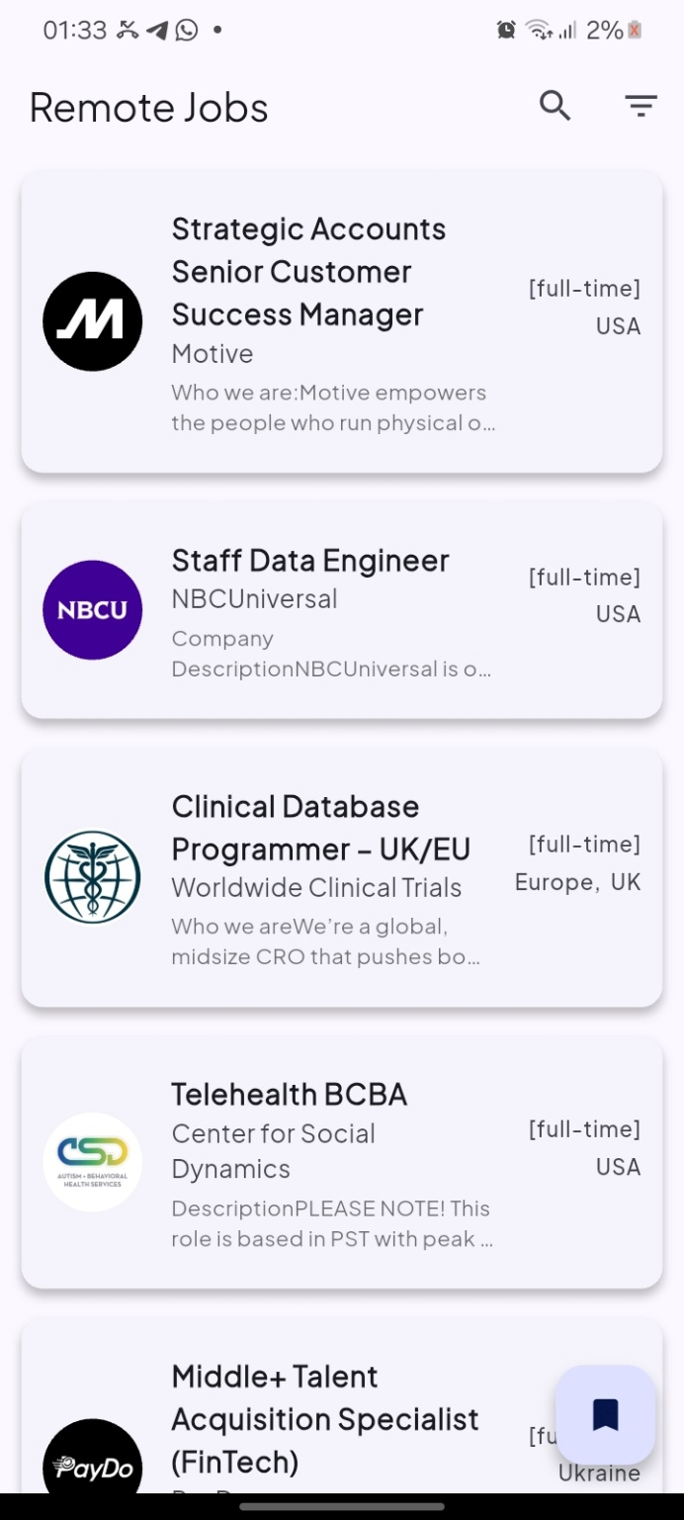

## 4.2 Job Search

*Search functionality in action, displaying filtered job results based on user query. Shows the search bar with active search term and relevant job listings.*

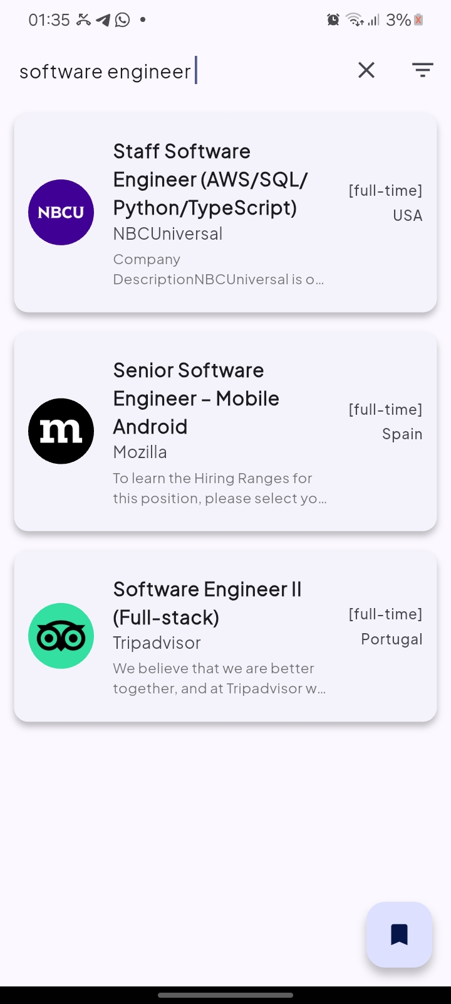

## 4.3 Filter Panel

*Expanded filter panel allowing users to refine job searches by job type, location, experience level, and other criteria. The panel slides up from the bottom of the screen.* 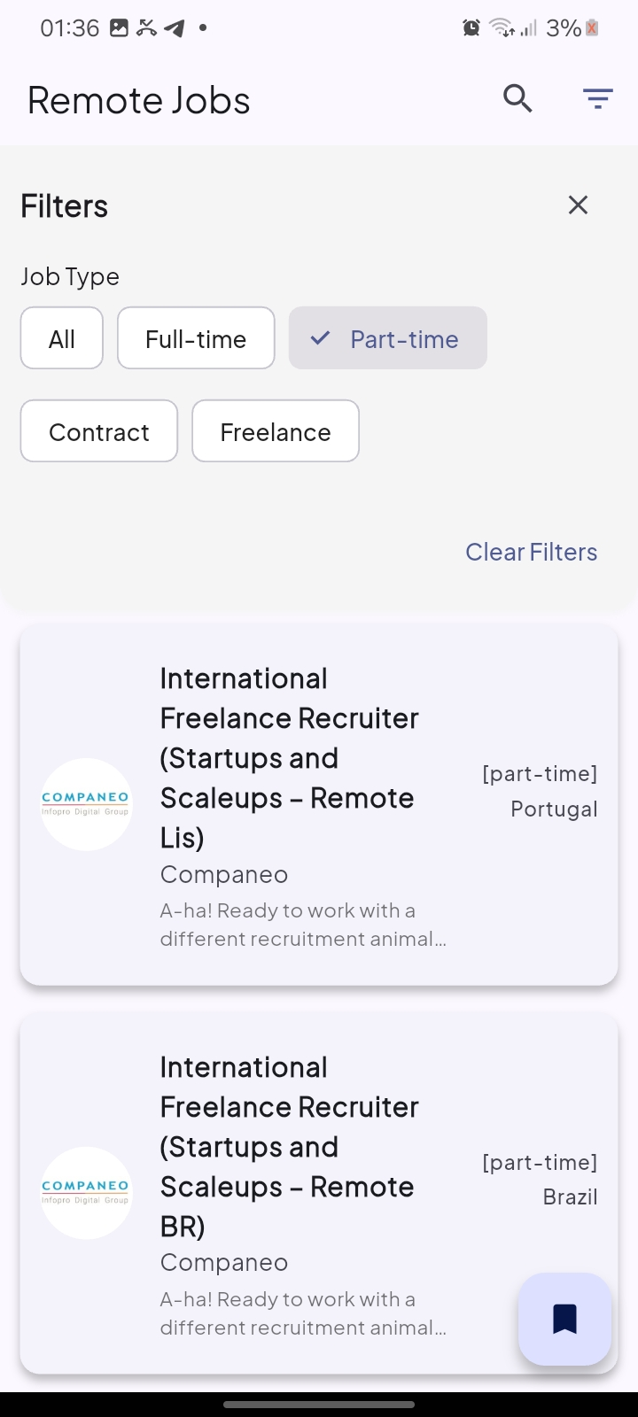

## 4.4 Job Details

*Detailed view of a job posting showing full description, requirements, and application details. Features a prominent "Apply Now" button and save option in the app bar.*



## 4.5 Saved Jobs

Saved Jobs Screen] *Figure 5: Saved jobs screen displaying all bookmarked positions. Each entry shows the job title, company, and time since saving. The empty state illustration is shown when no jobs are saved.*

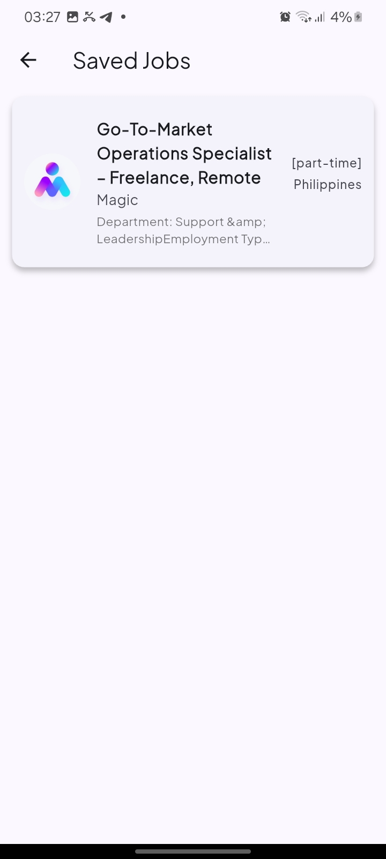

## 4.6 Loading States

Loading State] *Figure 8: Loading indicator displayed while fetching job listings, showing a skeleton loader for better perceived performance.* 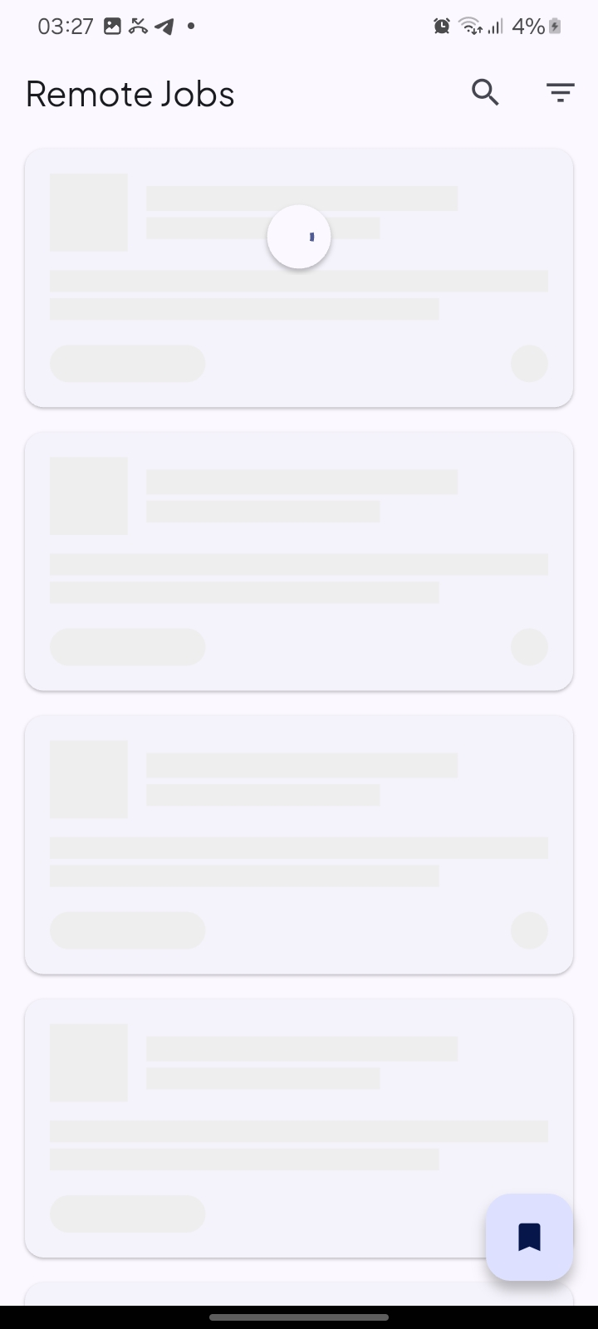

## 4.7 Empty States

