This document provides the necessary evidence for the project, demonstrating the normalized database structure (3NF) and the ability to execute complex SQL queries for the analytical findings.

Part 1: Normalized Database Schema Evidence (3NF)
The following queries prove that the data is correctly structured into a central Fact table (Incident) and three Dimension tables (Country, Industry, AttackType) using Foreign Keys (FKs).

Evidence 1.1: Incident Fact Table (Includes FKs)
Shows the core event data with foreign keys linking to dimension tables.
SELECT TOP 10 * FROM Incident;

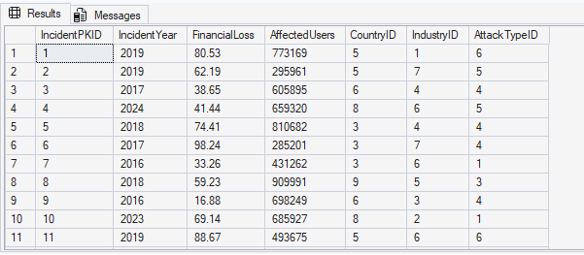

Evidence 1.2: Country Dimension Table
Lookup table for geographical location normalization.
SELECT * FROM Country;

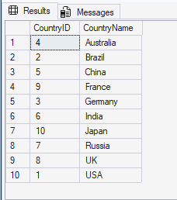

Evidence 1.3: Industry Dimension Table
Lookup table for industry classification normalization.
SELECT * FROM Industry;

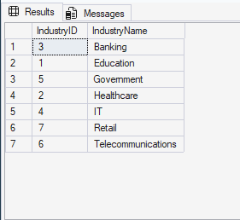

Evidence 1.4: AttackType Dimension Table
Lookup table for attack vector normalization.
SELECT * FROM AttackType;

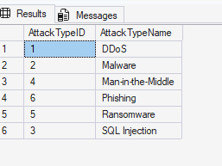

Part 2: SQL Query Execution Proof (7 Queries Total)
This section contains the seven production queries, including the three original queries used for the main report charts and the four advanced, complex queries required for technical proof.

Original Analysis Queries (For Report Charts)

Query 1: Financial Risk Exposure by Industry (Report Slide 5)
Goal: Calculates the total cumulative financial loss for each industry to determine overall financial risk exposure.
SELECT
T2.IndustryName,
SUM(T1.FinancialLoss) AS Total_Loss_in_Millions
FROM
Incident T1
JOIN
Industry T2 ON T1.IndustryID = T2.IndustryID
GROUP BY
T2.IndustryName
ORDER BY
Total_Loss_in_Millions DESC;

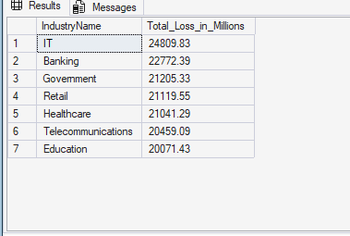

Query 2: Cybersecurity Incident Volume Trend (Report Slide 6)
Goal: Counts the total number of incidents per year to analyze long-term attack volume trends.
SELECT
IncidentYear,
COUNT(IncidentPKID) AS Total_Incidents
FROM
Incident
GROUP BY
IncidentYear
ORDER BY
IncidentYear ASC;

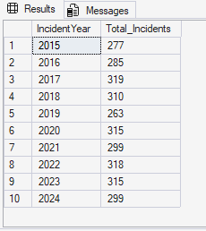

Query 3: AI-Driven Incident Risk Ranking (Report Slide 7 - Top 5)
Goal: Calculates the custom AI Risk Score for all incidents and ranks the top 5 highest-risk events based on financial loss and affected users.
SELECT TOP 5
T2.CountryName,
T3.AttackTypeName,
T4.IndustryName,
T1.FinancialLoss,
T1.AffectedUsers,
(T1.FinancialLoss + T1.AffectedUsers / 1000.0) AS Risk_Score
FROM
Incident T1
JOIN Country T2 ON T1.CountryID = T2.CountryID
JOIN AttackType T3 ON T1.AttackTypeID = T3.AttackTypeID
JOIN Industry T4 ON T1.IndustryID = T4.IndustryID
ORDER BY
Risk_Score DESC;

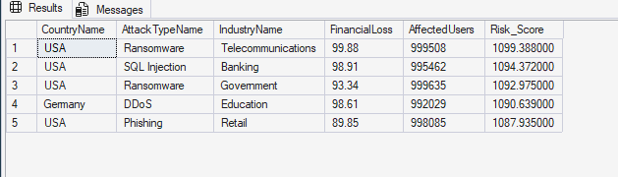

Advanced Complex Queries (For Technical Proof)

Query A: Attack Type Impact Factor (Loss/Incident Ratio)
Goal: Determines the average severity of each attack type by calculating the ratio of total financial loss to the total number of incidents (SUM(Loss) / COUNT(Incidents)).
SELECT
A.AttackTypeName,
SUM(T1.FinancialLoss) / COUNT(T1.IncidentPKID) AS Impact_Factor
FROM Incident T1
JOIN AttackType A ON T1.AttackTypeID = A.AttackTypeID
GROUP BY
A.AttackTypeName
ORDER BY
Impact_Factor DESC;

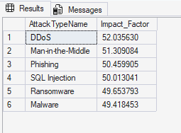

Query B: Loss Containment Success (Lowest Loss/User Ratio)
Goal: Identifies industries that are most successful at limiting damage by ranking the lowest average financial loss per affected user.
SELECT TOP 5
I.IndustryName,
AVG(T1.FinancialLoss / T1.AffectedUsers) AS Avg_Loss_Per_User_Ratio
FROM
Incident T1
JOIN
Industry I ON T1.IndustryID = I.IndustryID
WHERE
T1.AffectedUsers > 0
GROUP BY
I.IndustryName
ORDER BY
Avg_Loss_Per_User_Ratio ASC;

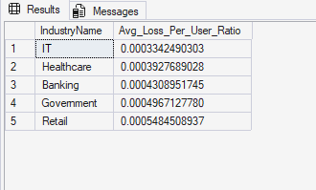

Query C: Highest Total Loss by Industry in the USA
Goal: Identifies the top 3 industries within the USA that have incurred the highest total cumulative financial loss.
SELECT TOP 3
I.IndustryName,
SUM(T1.FinancialLoss) AS Total_Loss_in_USA
FROM
Incident T1
JOIN
Industry I ON T1.IndustryID = I.IndustryID
JOIN
Country C ON T1.CountryID = C.CountryID
WHERE
C.CountryName = 'USA'
GROUP BY
I.IndustryName
ORDER BY
Total_Loss_in_USA DESC;

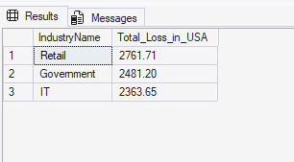

Query D: Attack Type Frequency by Country (Pivoted View)
Goal: Creates a pivoted view using conditional aggregation (CASE WHEN) to compare the frequency of Phishing attacks versus DDoS attacks by country.
SELECT
C.CountryName,
SUM(CASE WHEN A.AttackTypeName = 'Phishing' THEN 1 ELSE 0 END) AS Total_Phishing_Count,
SUM(CASE WHEN A.AttackTypeName = 'DDoS' THEN 1 ELSE 0 END) AS Total_DDoS_Count
FROM
Incident T1
JOIN
Country C ON T1.CountryID = C.CountryID
JOIN
AttackType A ON T1.AttackTypeID = A.AttackTypeID
GROUP BY
C.CountryName
HAVING
COUNT(T1.IncidentPKID) > 50
ORDER BY
COUNT(T1.IncidentPKID) DESC;

