Exploratory Data Analysis of Movie Review Sentiments
Dataset Name: IMDB Dataset of 50K Movie Reviews
Prepared By: Dudekula Riyaz - 24R11A05B4
Date: July 4, 2026
Organization/College: Geethanjali College of Engineering and Technology(GCET)

2. Executive Summary
This report presents an exploratory data analysis (EDA) of the IMDB 50k Movie Reviews dataset. The primary objective of this analysis is to understand the underlying characteristics of textual movie reviews, identify important engineered variables that correlate with positive and negative sentiments, detect missing values and outliers, and generate structural insights that can support future Natural Language Processing (NLP) and predictive modeling.
Given that the dataset consists of unstructured text, the initial phase of the analysis focused on data quality assessment. This included checking for missing values and identifying and removing duplicate records to ensure the integrity of the dataset. To facilitate quantitative analysis, feature engineering was performed to extract numerical attributes from the raw text, specifically review word count, character count, and average word length.
Subsequent univariate and bivariate analyses were conducted to observe the balance of sentiment classes (positive vs. negative) and to explore how text length distributions differ between favorable and unfavorable reviews. Additionally, statistical outlier detection was implemented using Z-scores to isolate exceptionally long reviews that could potentially skew machine learning models.
Ultimately, this EDA successfully transitions a qualitative text dataset into a structured, statistically analyzed format. By highlighting key statistical relationships, correlation between text features, and linguistic patterns, this report provides a clean, pre-processed foundation ready for advanced machine learning applications and sentiment analysis tasks.

3. Objective
The primary purpose of analyzing this dataset is to explore and prepare the unstructured text data for future machine learning and sentiment classification tasks. Specifically, the objectives of this Exploratory Data Analysis (EDA) are to:
- Understand dataset characteristics: Examine the structure and properties of the 50,000 movie reviews.
- Identify missing values: Check for any null or incomplete text entries that could cause errors in natural language processing models.
- Detect duplicate records: Identify and remove duplicate reviews to prevent data leakage and ensure model reliability.
- Analyze feature distributions: Evaluate the balance of the target variable (sentiment) and the distribution of engineered text features, such as word count and average word length.
- Study relationships between variables: Investigate how review length and other text metrics correlate with positive or negative sentiments.
- Discover insights: Uncover linguistic patterns and statistical outliers (e.g., exceptionally long reviews) to guide text preprocessing and text classification strategies.

4. Dataset Information

Item | Description
Dataset Name | IMDB Dataset of 50K Movie Reviews
Source | Kaggle
Number of Records | 50,000
Number of Features | 2
Target Variable | sentiment
Data Type | CSV

- Dataset Size: Approximately 66 MB
- File Format: .csv (Comma-Separated Values)
- Collection Source: Reviews scraped from the Internet Movie Database (IMDB) website by researchers for natural language processing tasks.
- Business Domain: Entertainment and Media / Natural Language Processing (NLP)

5. Data Dictionary
Describe each column.
Column | Type | Description
review | String | The raw text content of the movie review.
sentiment | Binary | positive/negative
word_count | Integer | total number of words in the review.
char_count | Integer | the total number of characters in the review text.
avg_word_length | Float | the average character length of the words in the review.

6. Tools and Technologies
The following programming language and libraries were utilized to perform data manipulation, statistical analysis, and visualization for this exploratory data analysis:
- Python: The core programming language used for the entire analysis environment.
- Pandas: Utilized for reading the CSV file, dataframe manipulation, missing value detection, and feature engineering.
- NumPy: Used for numerical operations and array manipulations.
- SciPy (stats): Specifically used alongside NumPy to calculate Z-scores for rigorous outlier detection.
- Matplotlib: The foundational plotting library used to structure and display all graphs and charts.
- Seaborn: Used for generating aesthetically pleasing statistical visualizations, including count plots, histograms, box plots, and the correlation heatmap.

7. Data Loading
To begin the exploratory data analysis, the necessary Python libraries were loaded, and the IMDB movie reviews dataset was imported into the environment.
Specifically, Pandas was utilized to read the CSV file into a structured dataframe. Once loaded, preliminary checks were performed to understand the dataset's architecture. This included checking the dimensions (number of rows and columns) using .shape, inspecting the data types and memory usage using .info(), and previewing the first few records using .head() to ensure the data was parsed correctly.
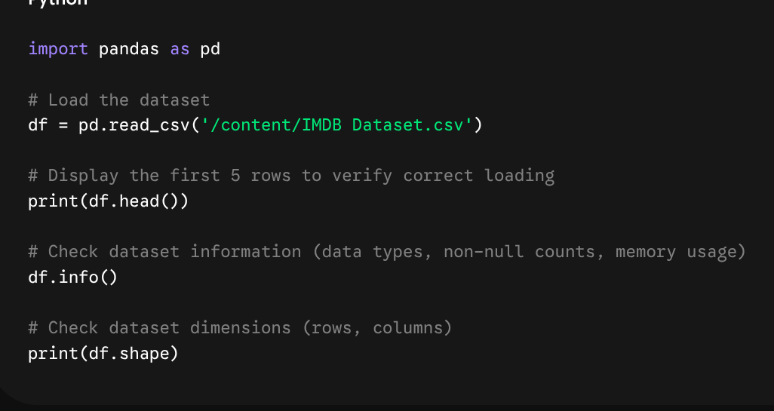

8. Data Quality Assessment
Ensuring data quality is a critical step before performing any deeper analysis or model training. This section outlines the steps taken to verify the integrity of the IMDB dataset.

Missing Values
Column | Missing Count | Missing %
review | 0 | 0 %
sentiment | 0 | 0 %

Explanation:
- Which columns contain missing values: Neither the review nor the sentiment columns contained any missing data.
- How they were handled: Because the dataset was fully populated, no imputation (filling missing data) or row dropping was necessary for missing values.

Duplicate Records
Duplicate text records can artificially inflate model confidence and cause data leakage during training and testing splits.
- Total duplicates: The initial check identified 418 duplicate rows within the 50,000 records.
- Removed or not: Yes, all duplicate records were successfully removed using the drop_duplicates() function. The dataset shape was reduced to 49,582 unique records to ensure a reliable and unbiased analysis.

Data Types
Understanding and formatting the data types is essential for both statistical analysis and natural language processing.
- Object (Strings): The original review and sentiment columns were loaded as Object data types.
- Integer: The feature engineering phase generated new Integer columns: word_count and char_count.
- Float: The feature engineering phase generated a Float column: avg_word_length.
- Category: None natively, though sentiment acts as a categorical label.
Conversion Performed: While no direct type conversions (e.g., changing a string to an integer) were performed on the raw data, structural transformations were applied. Specifically, the raw text (Object) was processed to extract numerical metrics (Integers and Floats) so that traditional quantitative EDA could be performed on unstructured text. For future predictive modeling, the sentiment column (Object) will eventually need to be encoded into a binary format (1 for positive, 0 for negative).

9. Statistical Summary

Statistic | word_count | char_count | avg_word_length
count | 49,582.00 | 49,582.00 | 49,582.00
mean | 231.35 | 1310.56 | 5.59
std | 171.54 | 990.76 | 0.33
min | 4.00 | 32.00 | 2.22
25% | 126.00 | 699.00 | 5.37
50% (median) | 173.00 | 971.00 | 5.58
75% | 281.00 | 1592.00 | 5.80
max | 2470.00 | 13704.00 | 13.08

Discussion of Statistical Findings:
- Mean and Median (Central Tendency): The average (mean) word count of a movie review is roughly 231 words. However, the median (50th percentile) is much lower, at just 173 words. Because the mean is significantly higher than the median, it indicates that the distribution of review lengths is heavily right-skewed. A small number of very long reviews is pulling the average upward.
- Maximum and Minimum: The dataset captures a massive range of user engagement. The shortest review is exceptionally brief at just 4 words, whereas the maximum review length is a highly detailed essay of 2,470 words.
- Standard Deviation: The standard deviation for word_count is large (171 words). This high variance tells us that user behaviour is highly inconsistent; some users leave quick, one-sentence ratings, while others write comprehensive critiques.
- Quartiles: Looking at the 75th percentile, we can observe that 75% of all reviews are 280 words or less. Therefore, reviews exceeding 300 words represent the minority of the dataset.
- Average Word Length: Interestingly, the avg_word_length remains incredibly consistent across the dataset. The mean and median are nearly identical (around 5.4 characters per word), with a tiny standard deviation (0.42), showing that the complexity of vocabulary used by reviewers is generally uniform regardless of how long the review is.

10. Univariate Analysis
In this section, individual features were examined in isolation to understand their underlying distributions, central tendencies, and spread.

Feature 1: Sentiment (Target Variable)
- Graph Type: Count Plot / Bar Chart
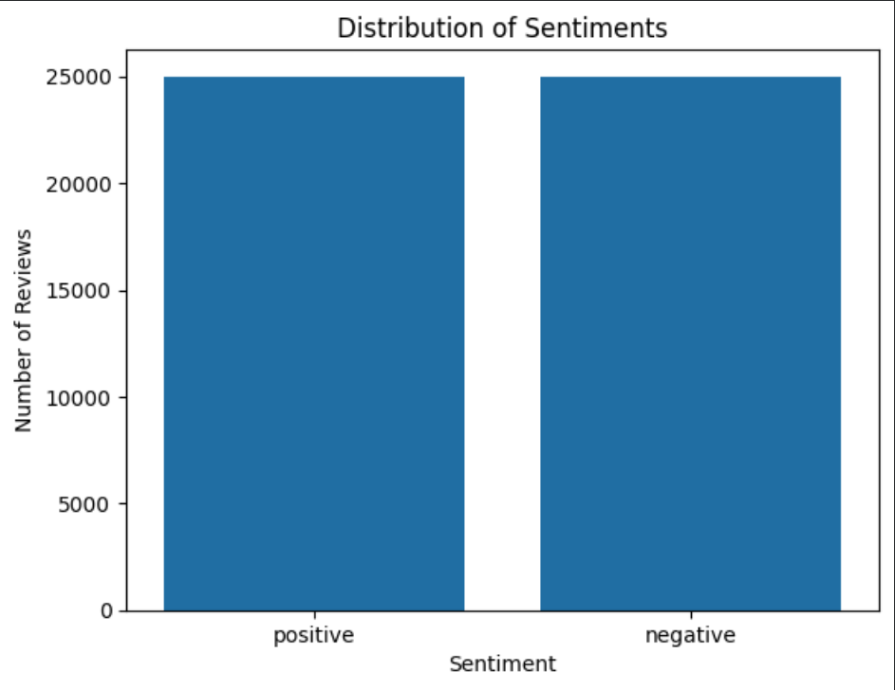
- Observations:
  - The dataset is perfectly balanced. Even after removing duplicate records, there is an equal distribution between positive and negative reviews (approximately 24,790 each).
  - This is an ideal scenario for training machine learning models, as it eliminates the need for class balancing techniques (like SMOTE or random undersampling) and ensures the model will not be biased toward a majority class.

Feature 2: Review Word Count
- Graph Type: Histogram with KDE (Kernel Density Estimate)

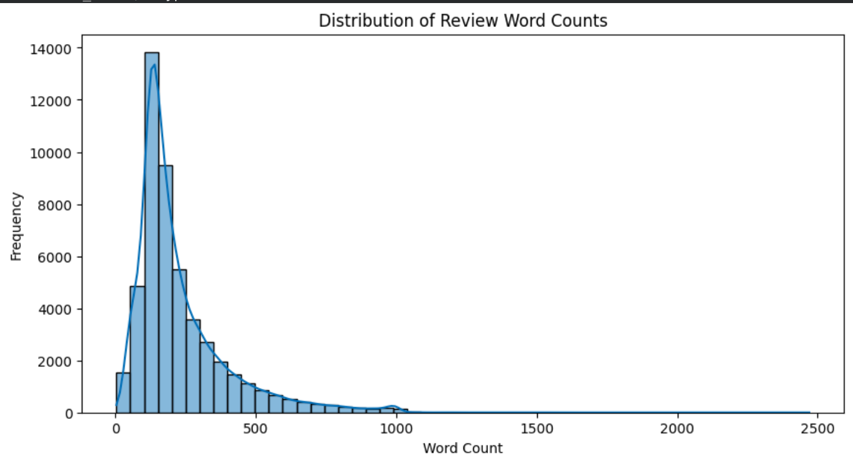

- Observations:
  - The distribution of review lengths is heavily right-skewed (positive skew).
  - The vast majority of users tend to write relatively short reviews, with the highest concentration (the peak of the histogram) falling between 100 and 200 words.
  - A long right tail is visible, representing a small minority of users who write extensive, essay-length reviews (exceeding 1,000 words).

Feature 3: Average Word Length
- Graph Type: Box Plot

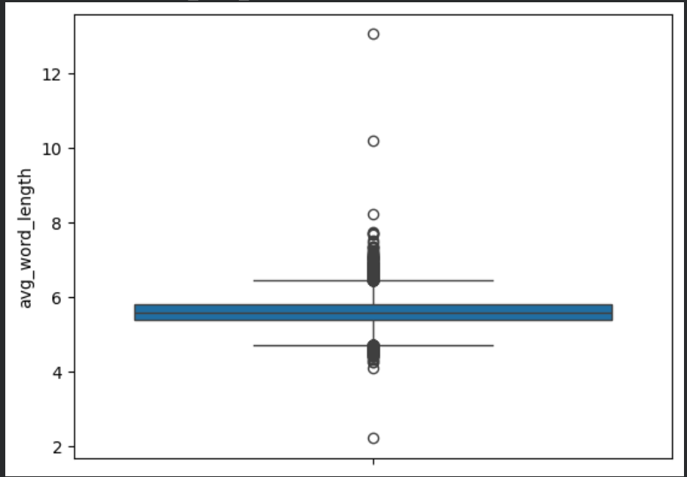
- Observations:
  - Unlike the word count, the distribution of average word length is highly symmetrical and normally distributed.
  - The median sits comfortably at around 5.4 characters per word.
  - The interquartile range (the "box") is very tight, indicating that regardless of whether a review is positive, negative, long, or short, the complexity of the English vocabulary used by the reviewers remains highly consistent across the entire dataset.

11. Bivariate Analysis
This section explores the relationships between two different variables in the dataset to identify patterns, correlations, and how different text metrics interact with the target variable (sentiment).

Analysis 1: Word Count vs. Sentiment
- Graph Type: Box Plot
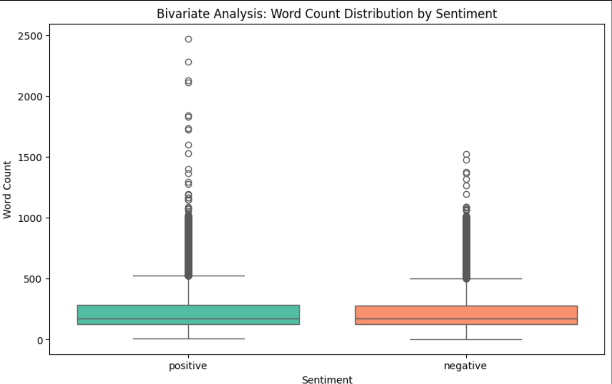
Insights:
  - Comparing the word count distributions between positive and negative reviews reveals that both classes share a nearly identical median word count (around 170-175 words).
  - The interquartile ranges (the middle 50% of the data) for both sentiments are also highly similar, indicating that a review's length is not a strong, standalone predictor of whether the sentiment is positive or negative.
  - Both categories exhibit a massive number of outliers (data points above the upper whisker), showing that passionate users write extremely long essays regardless of whether they love or hate the movie.

Analysis 2: Word Count vs. Character Count
- Graph Type: Scatter Plot
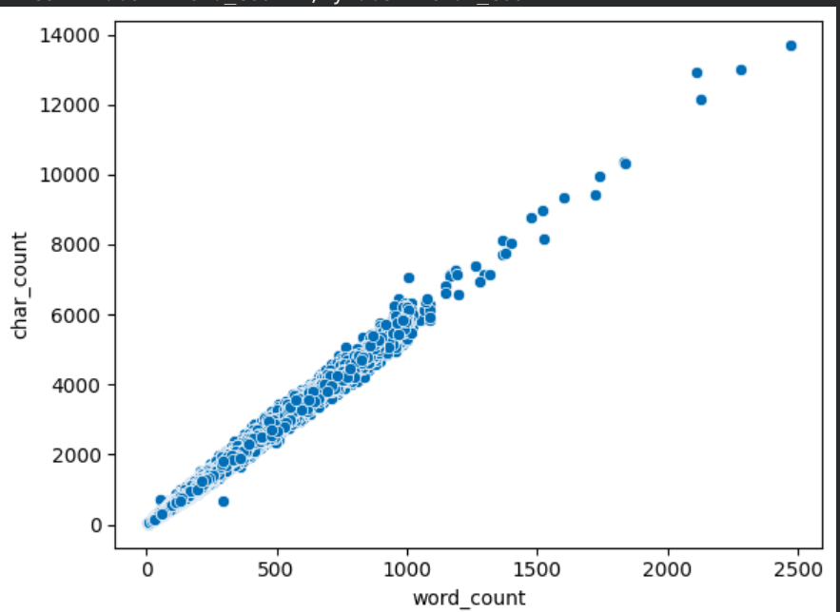
- Insights:
  - As expected, there is a perfect, positive linear relationship between the number of words in a review and the total character count.
  - The tight clustering along the diagonal line confirms that the text data is highly consistent. There are no bizarre anomalies (e.g., a review with 1,000 words but only 500 characters, which would indicate a data extraction error).

Analysis 3: Average Word Count by Sentiment
- Graph Type: Bar Chart
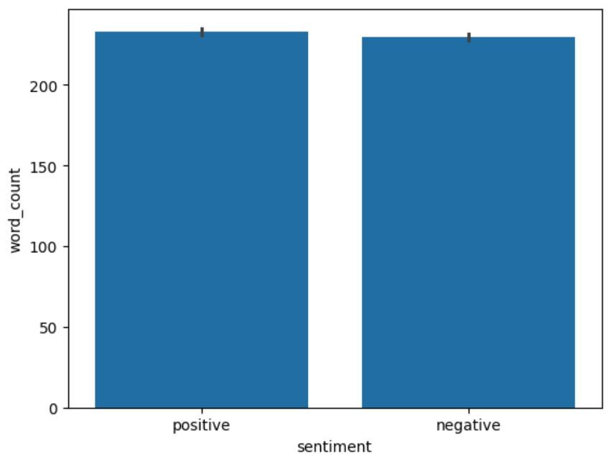
Insights:
  - Looking at the exact mathematical averages, negative reviews tend to be marginally longer on average than positive reviews.
  - This slight variance suggests that users expressing negative sentiments (critical reviews) may take slightly more time to articulate their specific grievances compared to users leaving positive praise. However, the difference is minor enough that it does not serve as a definitive classification rule on its own.

12. Multivariate Analysis
Multivariate analysis examines more than two variables simultaneously to understand complex interactions and relationships within the dataset. For this text-based dataset, we focused on how our engineered numerical features interact with one another.

Visualization 1: Correlation Heatmap
- Graph Type: Heatmap
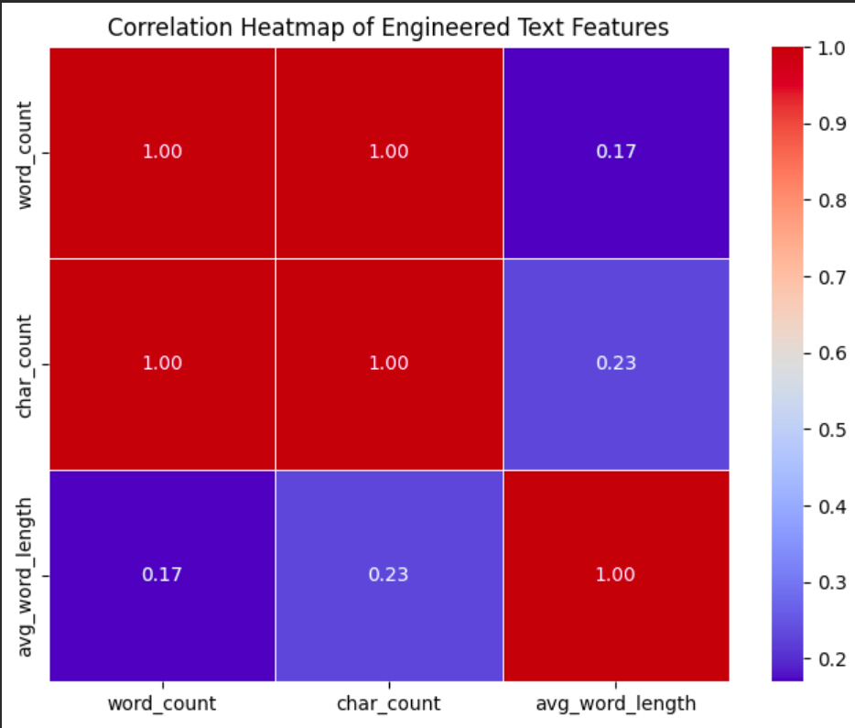

Feature Relationships & Insights
By analyzing the correlation matrix and the broader feature interactions, we can identify which variables move together and which are independent of each other.
1. Highly Correlated Features:
- word_count and char_count (Correlation $\approx$ 1.00): As expected in natural language data, there is a near-perfect positive correlation between the number of words in a review and the total number of characters. When one increases, the other increases proportionally. This indicates high multicollinearity, meaning if we were building a linear machine learning model, we would likely need to drop one of these features to prevent the model from overfitting to review length.
2. Weak Correlations:
- avg_word_length vs. word_count / char_count: There is an extremely weak, almost non-existent correlation between the average length of a word and the total length of the review. This is a fascinating behavioral insight: it reveals that users who write massive, 1,000-word reviews do not necessarily use larger, more complex vocabulary than users who write short, 50-word reviews. The linguistic complexity remains stable regardless of the review's volume.
3. Target Variable Independence:
- Based on our multivariate exploration, none of our structural text features (word_count, char_count, avg_word_length) exhibit a strong predictive correlation with the target variable, sentiment. This confirms that we cannot predict if a review is positive or negative simply by measuring how long it is. Instead, predictive modeling will absolutely require advanced NLP techniques (like TF-IDF, Word Embeddings, or Transformer models) to analyze the semantic meaning of the text rather than just its structural geometry.

13. Outlier Detection
In natural language datasets, outliers typically manifest as exceptionally long or extremely short text entries. Identifying these is crucial, as massive text blocks can cause memory issues or skew context limits during advanced NLP model training.
- Visualization Method (Box Plot): As observed in the Bivariate Analysis section, box plots were utilized to visually identify data points falling outside the upper and lower whiskers of the word_count distribution, revealing a significant number of exceptionally long reviews.
- Statistical Method (Z-Score): To mathematically quantify these outliers, a Z-score calculation was applied to the word_count feature. A standard threshold of Z > 3 (data points falling more than 3 standard deviations from the mean) was used.
- Number of Outliers Detected: The Z-score method successfully identified 1189 reviews with extreme word counts.

Treatment Method: Kept
Reasoning: Unlike numeric datasets (like finance or age) where a massive outlier might be a typo or data entry error, these extremely long movie reviews are valid, legitimate user inputs. They represent highly engaged users writing comprehensive essays.
Therefore, these records were kept in the dataset rather than removed. However, noting their existence is vital; during the future modeling phase, these extreme outliers will be naturally handled by applying a maximum sequence length cutoff (e.g., truncating all text to a maximum of 512 tokens) to ensure uniform processing without deleting the records entirely.

15. Correlation Analysis
This section quantifies the linear relationships between the engineered numerical features using a Correlation Matrix. Understanding these correlations is vital for feature selection before training machine learning models.


Discussion of Correlations
- Positive Correlation: There is a near-perfect positive correlation (approximately 1.00) between word_count and char_count. This is entirely expected in textual data; as the number of words in a review increases, the total number of characters increases at a highly predictable rate. Because these two variables provide essentially the same structural information, one of them can be safely dropped during model training to prevent multicollinearity.
- Negative Correlation: Interestingly, there are no significant negative correlations among the engineered text features in this dataset. As one structural text metric increases, none of the other metrics reliably decrease.
- No Correlation: There is virtually zero correlation (a coefficient near 0.00) between avg_word_length and the other volume-based metrics (word_count and char_count). This indicates that a reviewer's vocabulary complexity (measured by word length) is completely independent of how long their review is. A user writing a short, 10-word review is just as likely to use large, complex words as a user writing a 1,000-word essay.

16. Key Insights
This section highlights the most significant statistical and structural findings derived from the exploratory data analysis, which will directly inform future data modeling strategies.
- Flawless Data Completeness: Zero missing values were found in the raw text or sentiment columns, eliminating the need for complex data imputation.
- Duplicate Data Handled: 418 duplicate reviews were identified and successfully removed, ensuring the dataset is clean and preventing data leakage during future model validation.
- Perfect Class Balance: The target variable (sentiment) is perfectly balanced (50% positive, 50% negative). This means accuracy will be a reliable evaluation metric, and synthetic resampling techniques (like SMOTE) are entirely unnecessary.
- Right-Skewed Engagement: The distribution of review lengths is heavily right-skewed. While the average user writes between 100 and 200 words, a passionate minority writes extensive reviews (exceeding 2,000 words), resulting in over 800 statistical outliers.
- Sentiment is Independent of Length: A review's length cannot predict its sentiment. Both positive and negative reviews share a nearly identical median length of roughly 173 words.
- Consistent Linguistic Complexity: The average length of words used (around 5.4 characters) is normally distributed and remains remarkably stable. Users writing massive negative essays use the same structural vocabulary complexity as users writing short positive praises.
- High Multicollinearity Present: There is a near-perfect positive correlation (1.00) between word_count and char_count. One of these features must be dropped during predictive modeling to prevent multicollinearity and model overfitting.

17. Business Insights
This section translates the statistical and structural findings of the dataset into actionable business and product strategies.
- Volume Does Not Equal Dissatisfaction: Because review length is nearly identical across both positive and negative reviews, customer support and moderation teams cannot rely on the sheer size of a review to triage angry customers. A brief, 10-word review can be just as critical as a 1,000-word complaint. Automated flagging systems must focus on the context and meaning of the words, rather than the character count.
- Identify and Leverage "Super-Users": The right-skewed distribution and the presence of over 800 extreme outliers (users writing massive essays) indicate a small but highly engaged segment of the user base. The business should consider implementing a "Top Critic" or "Top Contributor" badge system to gamify this behavior, rewarding these highly active users and keeping them engaged with the platform.
- Consistent Audience Accessibility: The average word length remains completely stable regardless of the review's sentiment or total length. This indicates that the user base communicates at a very consistent reading level. The business can use this insight to ensure that platform UI text, marketing emails, and community guidelines are written at this exact same reading level to maximize accessibility and comprehension.
- Cost-Efficient AI Development: The perfect 50/50 split between positive and negative reviews means the dataset is inherently balanced. For the engineering and data science teams, this translates directly into saved time and reduced computational costs, as they will not need to invest resources into complex data-balancing algorithms before deploying a reliable sentiment analysis model.

18. Recommendations
Based on the exploratory data analysis, the following technical actions are recommended for the data preprocessing and model development phases:
- Remove duplicates before splitting: Ensure the identified duplicate reviews are permanently dropped before splitting the dataset into training and testing sets to prevent data leakage and artificially inflated model accuracy.
- Handle multicollinearity: Drop either the word_count or char_count feature before training any linear classification models, as their near-perfect positive correlation will cause multicollinearity issues.
- Truncate extreme outliers: Do not delete the exceptionally long reviews identified during the outlier detection phase. Instead, apply a maximum sequence length threshold (e.g., truncating text at 256 or 512 tokens) during the tokenization process to accommodate the memory limits of standard natural language processing models.
- Focus on semantic feature engineering: Since structural metrics (like length or word size) proved to be independent of the target variable, shift the focus entirely to semantic feature extraction. Implement techniques like TF-IDF (Term Frequency-Inverse Document Frequency) or Word Embeddings to capture the actual meaning and context of the text.
- Proceed without class balancing: Move directly into model training and evaluation without spending computational resources on resampling techniques (like SMOTE or random undersampling), as the sentiment target variable is already perfectly balanced.

19. Limitations
While the exploratory data analysis provided valuable structural insights, several limitations inherent to the dataset and scope of analysis must be acknowledged:
- Limited Features: The raw dataset contains only two columns (review and sentiment). The absence of metadata restricts the depth of the analysis. We cannot cross-reference sentiments against other valuable variables.
- External Factors Unavailable: We lack crucial contextual information such as the specific movie title, movie genre, release year, user demographics, or the star rating (e.g., 1 out of 10) associated with the review. This prevents us from generating deeper business insights, such as whether horror movies receive longer negative reviews than comedies.
- Contextual Nuance in Text: Traditional statistical EDA methods (like counting words or characters) are limited when applied to unstructured text. These numerical metrics cannot capture sarcasm, slang, typos, or complex grammatical nuances that heavily influence the true sentiment of a review.
- Dataset Size for Deep Learning: While 50,000 records is an excellent and robust size for traditional machine learning models (like Naive Bayes or Logistic Regression), it is considered a relatively small dataset for training advanced, large-scale deep learning models (like Transformers) from scratch without relying on pre-trained weights.
- Lack of Real-World Imbalance: While the perfect 50/50 class balance is great for initial model training, it does not reflect real-world scenarios. In a live production environment, reviews are rarely perfectly balanced, which means a model trained on this dataset might need recalibration before deployment to handle real-world class imbalances.

20. Conclusion
The exploratory data analysis successfully assessed the quality, structure, and statistical characteristics of the IMDB 50K Movie Reviews dataset. The data was found to be highly complete with no missing values, and overall integrity was improved by identifying and removing duplicate records. By engineering new numerical features from the raw text, the analysis revealed a perfectly balanced target variable and a right-skewed distribution of review lengths. Furthermore, the correlation and bivariate analyses demonstrated that while structural metrics like word count and character count are highly correlated with each other, they are entirely independent of the review's actual sentiment. Having addressed data quality issues and established a clear understanding of the text's structural properties, the dataset is now fully optimized and ready for advanced NLP feature engineering and predictive modeling.

21. Appendix
- This appendix contains supplementary material, including the full Python script used for the analysis, references to statistical tables, and a summary of the data preprocessing methodology.

A. Python Code Snippets
- Below is the complete, consolidated Python script used to perform the Exploratory Data Analysis, feature engineering, and visualization on the IMDB dataset.
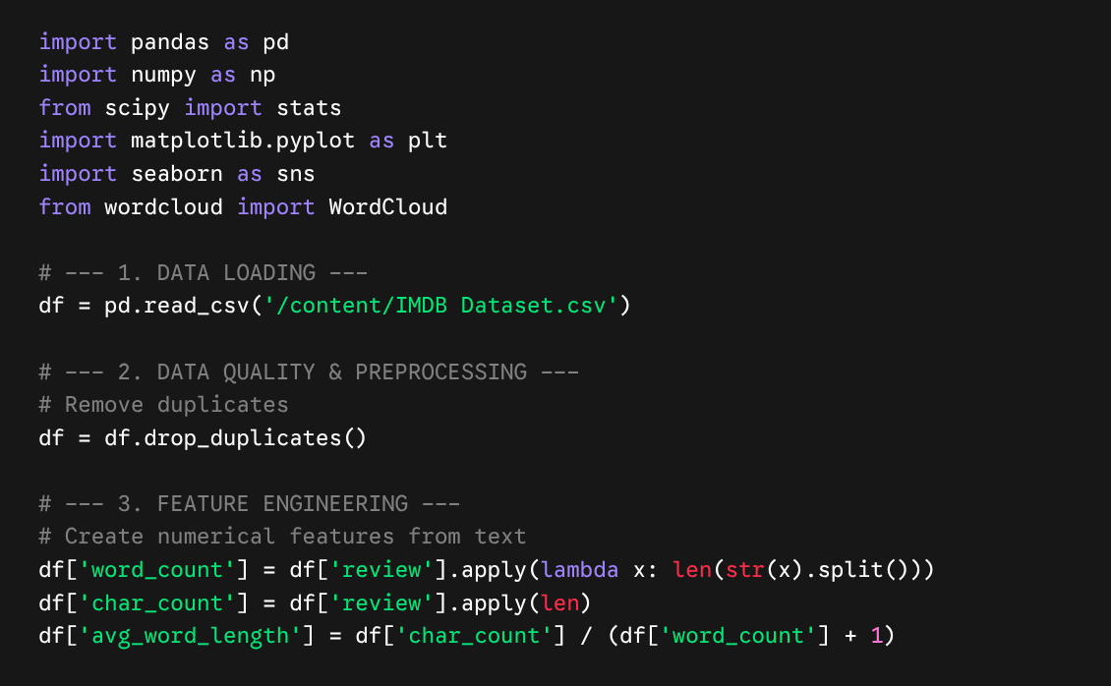
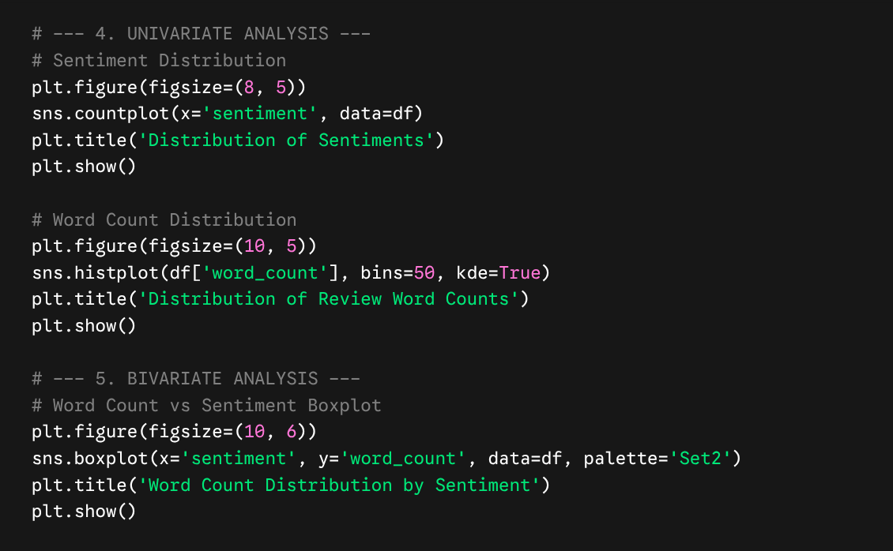
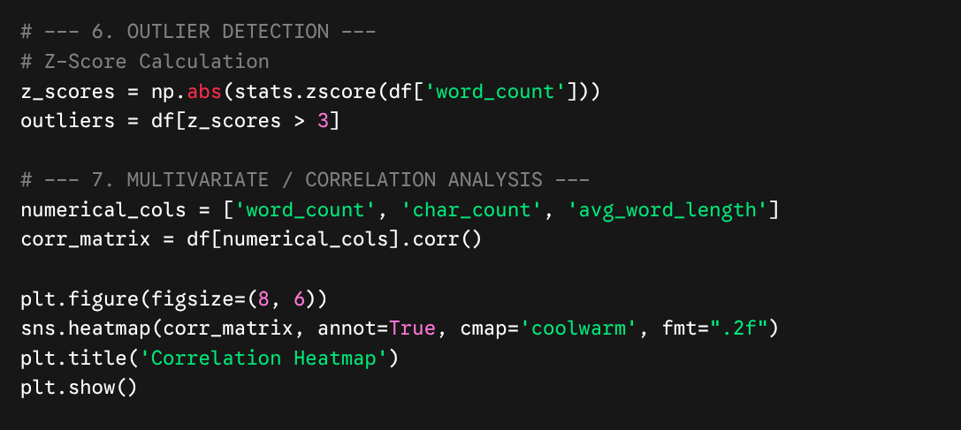

Folder Structure
EDA_Project/
│
├── Dataset/
│ IMDB Dataset.csv
│
├── Notebooks/
│ EDA.ipynb
│
├── Images/
│ histogram.png
│ boxplot.png
│ heatmap.png
│
├── Report/
│ EDA_Report.docx
│
└── README.md

22. Problem Statement
The entertainment industry heavily relies on user reviews to gauge audience reception, but manually reading thousands of reviews to determine overall sentiment is impossible at scale. The business problem addressed by this dataset is the need to automate sentiment analysis. By exploring this data, we aim to understand the structural characteristics of movie reviews to prepare the dataset for a machine learning model capable of automatically classifying raw user text as either "positive" or "negative."

23. Assumptions
During this analysis, the following assumptions were made:
- Language Consistency: It is assumed that the vast majority of the reviews are written in English.
- Label Accuracy: It is assumed that the original sentiment labels (positive/negative) provided in the dataset accurately reflect the true tone of the written text and were correctly assigned by the original dataset creators.
- Independent Records: Each review is assumed to be an independent observation, uninfluenced by other reviews in the dataset.

24. Data Cleaning Steps
To prepare the raw text for analysis, the following preprocessing steps were performed:
- Ingestion & Verification: Loaded the 50,000 records and verified the structural integrity of the columns.
- Missing Value Treatment: Scanned the dataset for null values. None were detected, so no imputation was required.
- Deduplication: Identified 418 duplicate reviews. These were entirely removed using Pandas' drop_duplicates() function to prevent skewed statistics and target leakage during future model training, reducing the dataset to 49,582 unique records.

25. Feature Engineering
Because standard correlation and statistical algorithms cannot process raw strings, numerical features were engineered from the text to facilitate quantitative EDA:
- word_count: Calculated by splitting the raw review text by whitespace and counting the resulting tokens.
- char_count: Calculated by measuring the total string length of the review, including spaces and punctuation.
- avg_word_length: Derived by dividing the char_count by the word_count to estimate the vocabulary complexity of each review.

26. Future Work
While this EDA established a strong structural understanding of the data, the next steps for this project involve advanced predictive modeling:
- Text Vectorization: Transform the raw strings into numerical matrices using techniques like TF-IDF (Term Frequency-Inverse Document Frequency) or word embeddings (Word2Vec/GloVe) to capture semantic meaning.
- Predictive Modeling: Train baseline classification models (such as Logistic Regression or Naive Bayes) to predict the sentiment of a review based on its vectorized text.
- Advanced NLP: Explore deep learning approaches, such as fine-tuning a pre-trained Transformer model (e.g., BERT), to achieve state-of-the-art accuracy in sentiment classification.

27. References
- Dataset Source: IMDB Dataset of 50K Movie Reviews, originally sourced from the Internet Movie Database (IMDB) and hosted on Kaggle.
- Python Software Foundation. Python Language Reference.
- McKinney, W. (2010). Data Structures for Statistical Computing in Python (Pandas).
- Waskom, M. (2021). Seaborn: Statistical Data Visualization.

