Living smart at Smart Home

A smart approach to enhance home automation using IoT and AI

1Vishnu Sivan, 2Hema Dileep, 3Romario Johnson

P.G Scholar

,Dept.Computer Applications

Mar Athanasius College of Engineering

Kothamangalam, India

4Shinu S Kurian

Assistant Professor

Dept.Computer Applications

Mar Athanasius College of Engineering

Kothamangalam, India

***Abstract***— In this approach presents the design of a Smart home system which is based on IoT and AI using user emotions and behaviors. The Internet of Things (IOT) technology establishes a connection between all things and the Internet via sensing devices and implements intelligence in the identification and management. Artificial Intelligence is evolving as a technology for developing automatic systems that can perceive the environment, learn from environment, and can make decision using case based reasoning. A smart home is one in which the various electrical and electronic appliances are wired up to a central computer control system so that they can either be switched on or off at certain times. The proposed system will be constructed by extending the existing system with additional features to support user feelings. It is done by using artificial intelligence for recognizing facial expressions and body movements. Here instead of predefined automatic configurations the system will respond according to the behavior of the user.

**Index Terms**— **Smart Home, IoT, AI, Emotion**

**Recognition, Security, Energy Saving**

# **Introduction**

Smart home is a well-equipped system that concentrates mainly on energy saving concept. Incorporating emotion recognition, Internet of things (IoT) and online shopping with the system will enhance the saving perspective and also provide more satisfaction to the user.

"Smart Home" is the term commonly used to define a residence that has appliances, lighting, heating, air conditioning, TVs, computers, entertainment audio & video systems, security, and camera systems that are capable of communicating with one another and can be controlled even from a remote place by a time schedule, from any room in the home, as well as remotely from any location in the world by a portable smart device.

An emerging important feature of a smart home is conservation of the earth's limited resources. More and more people are becoming aware of the ability to make their homes truly smart and green by utilizing home controllers integrated with all home sub­systems to increase energy savings by controlling lighting, window coverings, HVAC, irrigation and by monitoring usage. Many home controllers have built in monitoring systems whereby they calculate and log usage by all connected devices, giving the home owner heightened awareness and the knowledge to make changes as necessary. These systems can even be accessed over the Internet from anywhere in the world so the house owner can adjust consumption anytime, anywhere. Thermostat is the best example for this purpose.

smart technology currently on the market include internet enabled and controlled refrigerators, smart thermostats like the Nest thermostat, smart lights with light occupancy sensors and smart door locks and security systems. Most of these smart home devices now include a mobile app for managing them via a smartphone

In this decade, Internet of Things (IoT) is also another emerging technology. Internet of Things (IoT) is a system of connected physical objects that are accessible through the internet. Simply, this is the concept of basically connecting any device with an on and off switch to the Internet (and/or to each other). This includes everything from cellphones, coffee makers, washing machines, headphones, lamps, wearable devices etc.

Another rich technology become popular in future will be the AI. Artificial intelligence is a branch of computer science that aims to create intelligent machines. Machine perception deals with the capability to use sensory inputs to deduce the different aspects of the world, while computer vision is the power to analyze visual inputs with few sub-problems such as facial, object and speech recognition.

The interaction between humans and computers will be more natural if computers are able to perceive and respond to the human’s non-verbal communication such as emotions and expressions. Although several approaches have been proposed to recognize human emotions based on facial expressions or speech, relatively limited work has been done to fuse these two, and other, modalities to improve the accuracy and robustness of the emotion recognition system. The results reveal that the system based on facial expression gave better performance than the system based on just acoustic information for the emotions considered.

Smart Home with smart devices is established with the help of IoT. Nowadays Smart home is a well-defined infrastructure with only one intension is to save energy. The insertion of emotion recognition will extend the scope of the system. Instead of making the smart devices on or off, here the system will respond automatically according to their happiness level. There not only focus on the facial expression but also their behavior. By this enlarge the scope of the system.

* 1. **Existing system**

The existing system is mainly concentrate on the basics of energy consumption and remote access. Smart home achieves this by the help of IoT. There are certain number of sensors and smart devices which enables the remote access. Also some of them can have certain kind of intelligence too. Let’s take an example of Thermostat, a device that automatically regulates temperature, or that activates a device when the temperature reaches a certain point. It is a part of Smart Home. But such devices are activated based on situations. It doesn’t depend on user emotions.

* 1. **Proposed system**

The existing systems are situation based. It could not depend on the user feelings. Let’s take an example, if the user is not well and can’t operate on the system. It makes some automatic configurations to make the user comfortable. But it may not be appropriate. The proposed system will construct by extending the existing system with additional feature to support user feelings. It is done by using artificial intelligence for recognizing facial expressions and body movements. Here instead of automatic configuration the system will respond according to the behavior of the user. The system just acts like a human support. Also smart devices are able to purchase essential things by online, that is it enables online shopping. As an example, if the user buys milk regularly after some days, the refrigerator will automatically order the milk online if feels it is necessary. Our intension is to maintain the user happy and satisfied as far as possible.

**2. THE SMART HOME STRATEGY**

Smart Home is a common term refers to automate the home appliances using controllers. In the proposed system we made a slight change to improve the efficiency of smart homes with the help of Artificial intelligence and Internet of Things (IoT). It is already implemented in some of the developed nations. The system requires few components to make such changes. The components are [3],

Controller

Device

I/O Interface

User

1. Controlled Devices:

In traditional way, the devices such as home appliances are operated by the user manually or may operate automatically on or off. But our aim is to enhance the features of the devices and improve access level. The controlled devices (Air Conditioner, Light, Fan, Gate and Motor) are connected with a controller which is used to make the configuration of the device according to predictions and the previous stored results.

1. Controller:

Controller is the core part of the system which is responsible to control the home appliances with improved level of access and enhanced prediction mechanism to take automatic configuration for the respective devices. Each device (like A/C, Light, Fan etc.) are connected by the respective controllers. Controllers are able to make changes by the behavior analysis and made respective changes.

1. I/O Interfaces:

The main idea is to establish a better communication between user and devices. For this we introduce some efficient sensors which act as an interface between user and devices and are capable of sensing the user’s emotions and thus to make automatic changes on the respective device. The sensors are repeatedly tracking the user changes including their emotion as such.

The diagrammatic representation of smart home is simply [1],

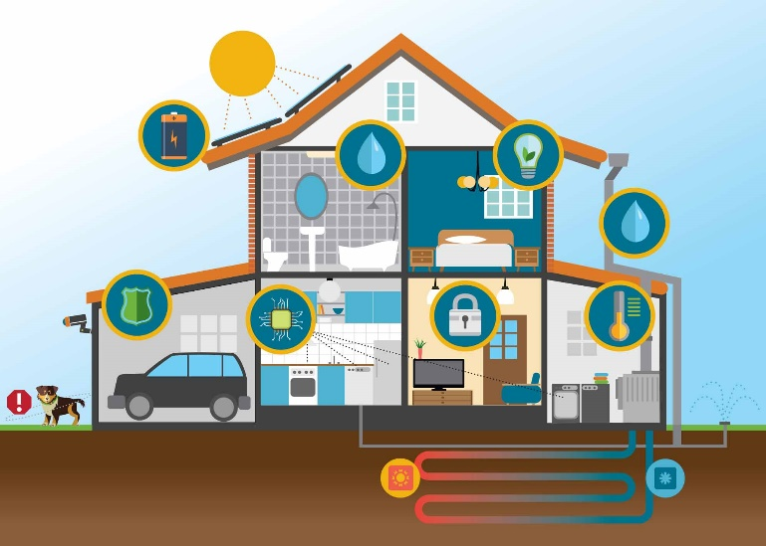

The components are described as the following manner [1],

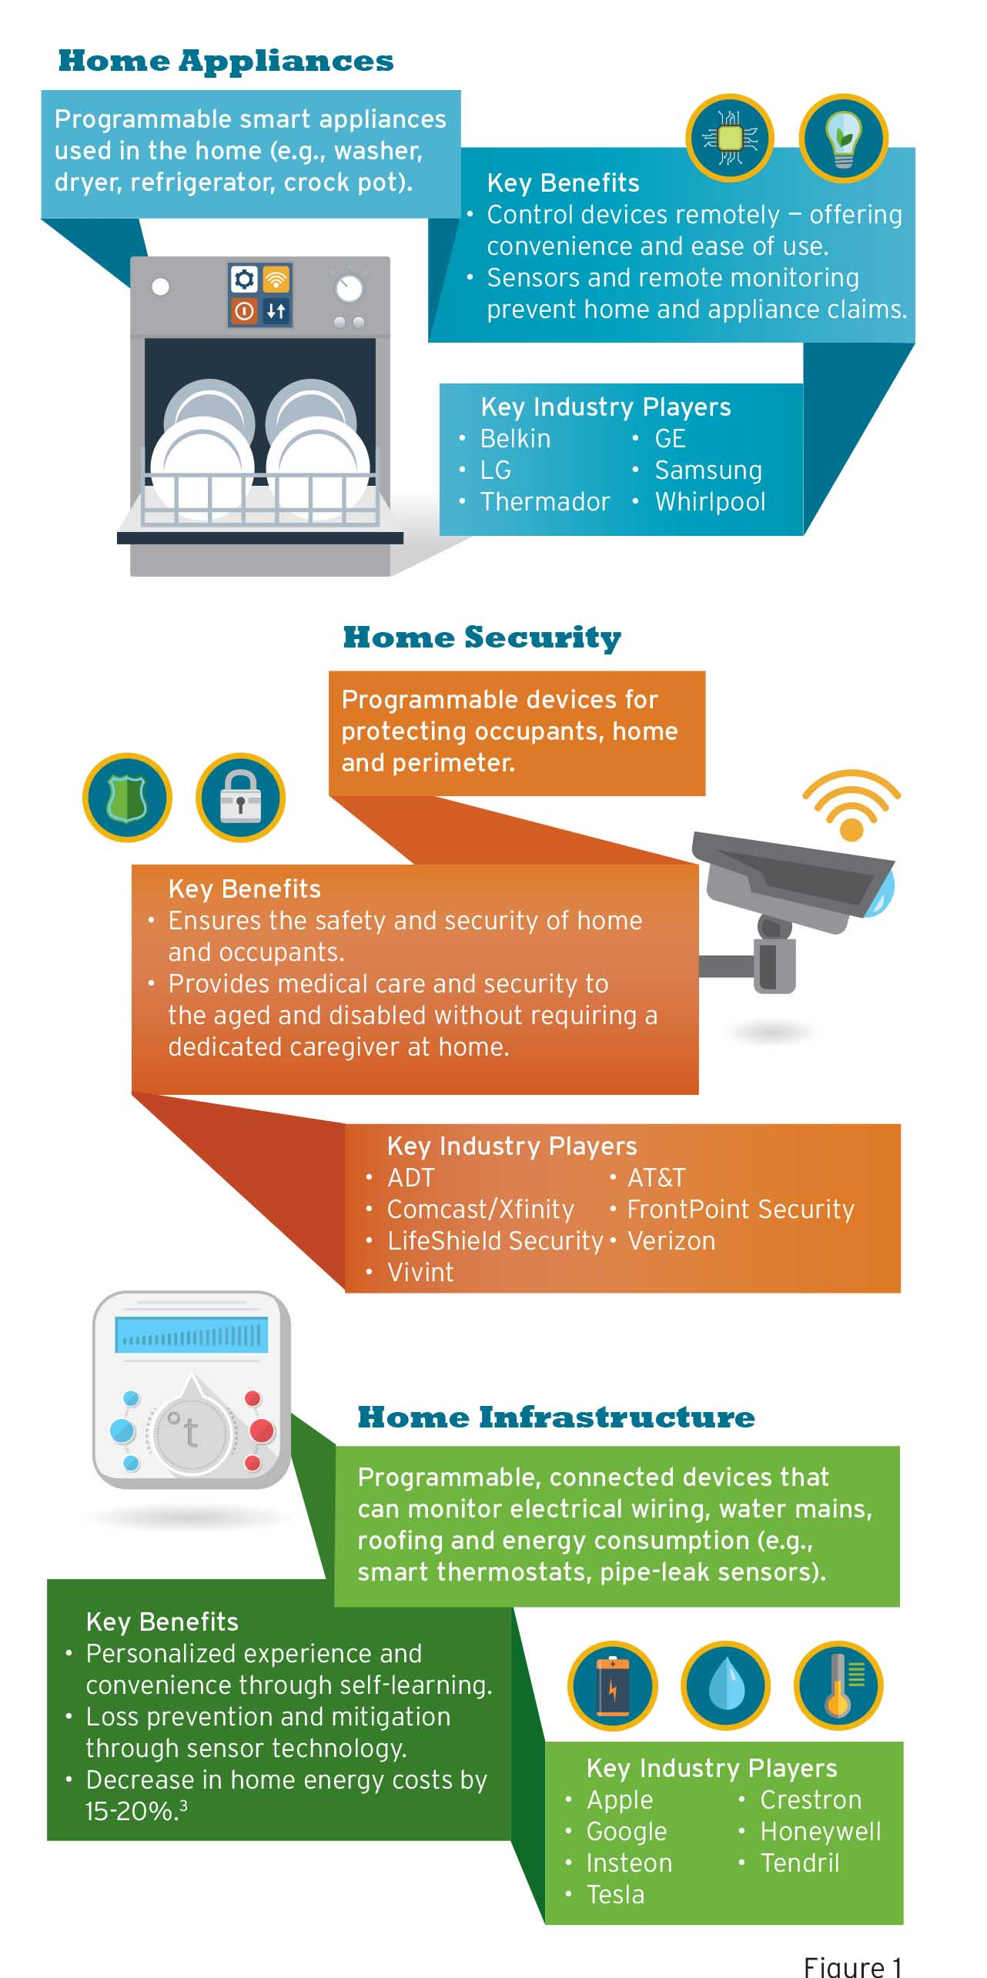

**2.2 Paradigm**

Our ancient concept of Smart Home realizes that it is a way to establish remote access to the devices. Nowadays we are living in a busy world and automated things become popular. The proposed system has a self-learning capability to respond to the situations accordingly. Simply says that to maintain the user happiness.

Here controller is the heart of the system. It learns from the situations and predicts the configuration of the home appliances according to the changes in user’s behaviors. When automatic changes are done by the controller by prediction is accepted by the user then the behavior, accepted configuration, situation and all are store in the behavioral table. Behavioral table is a database which holds the configuration. If the user automatically gets the required configuration it will increase his/her happiness level. If the user rejects or updates automatic changes done by the controller it will lead to faulty prediction and update the new changes in behavior table. Then again controller continue the learning process. Then again the same situation is occurring then the controller will readjust the settings according to behavior table data. The process is continuing just like as a human being learning.

The diagrammatic representation for the process of user emotions and reconfiguration is

Capture data on User Interaction

Accept by I/O interfaces

(Sensors)

Pass information to the controller,

if it necessary

Controller extract user changes,

Make necessary configuration as stated in prediction

User acceptance review and

Environmental changes

Accumulate the updated configuration, user behavior and situation

The system is repeatedly watching the each and every movement of the user and makes predictions about the user to manage the home equipment’s in such a way that it increases the happiness level of the user. Here the system is capable for taking the emotions and the behavior of the user to improve the way of interaction between the systems. But here the user is not directly communicating to the equipment, he/she is communicating to the I/O interface and it may sensors or cameras. If any action performed by the authenticated user is analyzed by the controller, then it takes necessary action by prediction.

After capturing the user’s emotions by the I/O interface it immediately passes that information to the controller. It analyzes the data to know whether it is valid or not (for example, the user just rises and down their hand and it doesn’t make any changes in his emotion or activity). If the data is valid then the data is take for analysis and predict the action to be taken to decrease the user’s effort to operate on the home appliances. Else just ignores the data. Controller refreshes its state and the I/O interface continues its capturing.

If the data is valid then controller will extract the data and scrap situation and the user behavior vector from it. Then search it in the behavior table and if a match is found then immediately update the configuration of respective device. If the user is not accepting the auto configuration done by the corresponding device controller, then update the behavior table entry with the relative change ratio. Relative ratio is explaining by an example, if the controller is adjusting the A/C cooling by 20o then later time the user changes it into 22o, here the relative change ratio is 2. If the situation is again occurring, then if the calculated cooling will be 21o then the controller is adjusting the cooling into 23o. it is a typical example for the relative change ratio. The controller will apply this to any device like fan, light etc…

Finally, the changes done by the controller is updated in behavior table with the situation, user behavior and the device configuration.

The controller here is a self- learning system which is capable of taking action automatically according to the user’s behavior. Let us take an example,

If a person is suffering from fever and is not able to do all the things as a common man and most of time they take rest or may be on the bed. The controller will aim to keep track of the situation or the state and behavior of the user (here the situation is that the user in fever) so that the system can make automatic configurations and actions to reduce the user’s effort and it will be a great help. At this point the controller will take data repeatedly from the I/O Interfaces then after analysis, it predicts that the user is not well so that the cooling level of AC should not only be adjusted with the environment but also slightly down and make a warm surrounding and also save the device configuration, user state and situation on the behavior table. if the user rejects the automatic changes done by the controller on A/C then the controller is learning that the user need more/less cool than the currently adjusted range. So it updates the behavior table with latest configuration. Later the same situation is again occurring at that time the controller will recollect the configuration from the behavior table and readjust the device configuration. So controller is continuously learning from the situations.

**3. FEATURES**

**Effectual Power Utilization**

Eco friendly energy generation in the home is the fundamental key attribute of the energy conservation in the smart homes. The self-generated solar power has already become popular. By analyzing the user's emotions and situations the house hold electrical appliances will be turned on or off and thus the energy can be saved. There will be situations such as If, for example, a homeowner leaves the TV and video game box on all day, and the house members are far away from the home then the system can automatically detect the absence of users by using sensors and cameras and it can turn off the switches automatically. That is the smart homes are designed in such a way that the energy can be saved even if they forgot to turn off the switches properly. More over the system will automatically adjusts the temperature and lights within the home according to the changes in our surroundings. It also ensures that the automatic changes are adaptable for its users.

The effectual power utilization can be achieved by using the ultra-efficient heat pumps which warm and cool your home by moving heat from one space to another. It can reduce primary energy consumption by 30-40 percent. Another way to save energy includes Advanced Window Controls. It is a window system which uses sensors and microprocessors to automatically adjust shading based on the amount of sunlight available sunlight and the time of day to ensure proper lighting and comfort, saving energy in an intellectual manner.

**Security**

The security is an essential feature of all the systems. The system is more secure from previous one. The system is active only on the presence of an authenticated user.

Let’s us consider an example, if an authenticated user is needed to open a door, walk near to the door and then the system automatically checks the authenticity of the user with his physical structure (mainly the facial expression) then door will be automatically opens for him. Simply it reduces the effort to open the door manually. If the person who want to open the door is not an authenticated user, the system will not respond automatically but he/she can manually open the door if he/she has the key.

**Efficient Interaction**

Nowadays most of us are busy and hence we all required a system with less input and maximum output. Here changes are made with traditional system by including the user behavior as the input so the input to the system is less compared to the traditional one. Because the proposed system will respond automatically with the user changes. If the user is not satisfying, then they can change the inputs and the system will also learn the change.

**Waste management**

The main issue with most of the houses are the waste management. Bio-gas plants are one of the simple solution for bio- degradable wastes. In the proposed system will have a bio-gas plants which has the facility to indicate the level of bio-wastes in the plant. The level should be notified in the smart device also. When the plant become full will indicates notification to the user. But the non-degradable wastes are another issue. It is solved by electrical decomposition. Such kind of wastes is decomposed with the help of electrical supply.

**Fault Detection**

If any of the home appliances become failure, then immediately the controller will take some auto correct options to recover from the failure. If it is recovers then the failure and successful recovery information is passed into the connected smart device else, it makes alarms to indicate the device failure and send the information to the connected smart device. It is a crucial situation that to detect the fault and correction mechanism to recover from it. It also challenges to the security feature.

For example, if the gates are not working then we can’t ensure the security. So the system should take care of the faulty detection. It is done by analyzing the electric supply usage of each and every device from it starting then take various factors like voltage current load etc. to predict the component failure.

**4. ADVANTAGES**

**Security**

Keep the devices and software as simple as possible in order to reduce the surface area available to attack and so that we can achieve security. Do not sue people who made security faults to you and ensure that the updates are secure. By providing artificial intelligence more secure sensors are attached with locking system and all which enables automatically only in the presence of an authenticated user. More over by monitoring the household activities and making all of the information available on your mobile device the smart home strategy establishes more security.

**Ease of Access**

We all may had some feelings such as we forgot to do something. The scenarios may occur while we are travelling to the work place or in an airplane ready to go on vacation. We ask ourselves that if we forgot to lock our home properly or we switched off the lights fans etc. In such situations smart homes offers a wide range of features from sensing the temperature of the home to monitoring the activities of family members. With the help of IoT the house owners can make sure that all the doors are locked and also can adjust the temperature suitable for pets and for elderly family members if any with a few touch on their smart device.

**Acumen Home Appliances**

The smart home technology includes a self-learning system which tracks the user’s behavior and performs activities accordingly. It makes use of Wi-Fi or internet to let you get access control even if you are away from the home. The system uses a continues learning process to make the devices such as air conditioner, fan, and other electronics equipment’s to perform in consonance with the user’s choice.

**5.CONCLUSION**

Automation will able to improve the system’s efficiency and abate the effort from user’s side in order to interact with the house hold things. The proposed system will be slightly different from the existing one but it is more concentrate on user’s behavior or emotion. It has a prediction mechanism based on the user’s behavior and take necessary configuration to maintain the user’s happiness. Here the system is attaining prediction by the help of Artificial intelligence, the controller in the system is responsible to take such prediction based on the situations and moreover it provides remote access to the devices (A/C, Light, Door, Gate etc.), the system will provide notification in the smart device which is connected into the system via internet with some recommendations to made changes and if the user does not like the recommended option then there is also have a manual setting facility which have the existing system have already obtained.

This system is more secure than the existing one because here the system is responding upon the user changes and the environmental changes and only the presence of authenticated user can enable or use the system. In the case of other users, the system responds in the ordinary manner (as like existing system).

The system is easier to access. The existing one requires user’s interaction to change the device configuration according to the user’s need but here the I/O interfaces continuously track the user’s changes and pass it to the controller, according to the data the controller made the configuration automatically. So it needs less interaction than the previous one.

The smart home has a core feature is that to reduce the power usage. For that we implement remote access based on IoT. The power usage can be reduced by dimming the intensity of light in day times, level down the cooling level in winter days’ similar settings can be done the system accordingly. The proposed system provides situation based quick response. In the case of power, the smart home automatically readjusts the usage of light and cooling system and all home appliances by prediction mechanism. It will reduce the power usage. It also includes an effectual waste management system.

The existing system takes any actions while the environmental changes are reported via the connected smart device, but in the case of new strategy there are few more mechanisms for recovering automatically from the issue and make recommendations for the situation. The proposed system is capable of generating predictions and conclusions and so as to make recommendations by the help of IoT and AI technology. However, the new smart home strategy will become more powerful as well as helpful technology for the next generation builders.

# **6. References**

1. Agil Francis is a Principal/Director with Cognizant Business Consulting’s Insurance Practice, “Next-Generation Insurance: Tapping into the Intelligence of Smart Homes” (references)
2. Vinay sagar K N1, Kusuma S M2, Student IV SEM, M.Tech, Digital Communication. Engg., MSRIT, Bangalore, India , “Home Automation Using Internet of Things”
3. Suraj Bhatia, Students, Department of Electronics and Telecommunication, Thadomal Shahani Engineering College, Bandra, Mumbai, “Technology, Systems and Implementation of a Smart Home Automation System: A Review” *(references)*
4. Chih-Yung Chang, Department of Computer Science and Information Engineering, Tamkang University, No. 151, Yingzhuan Road, Tamsui District, New Taipei City 25137, Taiwan; “Design and Implementation of an IoT Access Point for Smart Home”
5. M. B. I. REAZ, department of electrical, electronic and systems engineering, universiti kebangsaan malaysia 43600, ukm, bangi, selangor, Malaysia, “Artificial intelligence techniques for advanced smart home implementation ”
6. Dhiren Tejani, Ali Mohammed A. H. Al-Kuwari, Energy Conservation in Smart Home, 5th IEEE InternationalConference on Digital Ecosystems and Technologies,Daejeon, Korea, May 2011
7. Jaszczyk P, Król D (2010). Updatable multiagent OSGi architecture for smart home system. Agent and Multi-Agent Systems: Technologies and Applications. 6071: 370-379.
8. U.A. Bakshi, V.U. Bakshi, “Principles of Control Systems”, chapter 1, page 1-2, Technical Publications.
9. Press Release: “Smart Home Revenues to reach $71 billion by 2018, Juniper Research Finds,” Juniper Research, February, 2014
10. “SAMSUNG to Acquire SmartThings, Leading Open Platform for the Internet of Things,” samsung.com, August, 2014.

http://www. samsung.com/us/news/23607/.

1. “Google Unveils Brillo, Its Answer for Smartifying Your Home,” wired.com, May, 2015. http://www.wired.com/2015/05/googleunveils-brillo-answer-smartifying-home/.
2. Al-Ali, Member, IEEE & M. AL-Rousan,“Java-Based Home Automation System R.” IEEE Transactions on Consumer Electronics, Vol. 50, No. 2, MAY 2004
3. “Vision of Smart Home: The Role of Mobile in the Home of the Future,” GSMA, March, 2016