Research Question and Objective
For this part of the assignment, I wanted to understand how well people interpret my map of global polio vaccination coverage and the accompanying infographic. My main question was whether users can quickly understand the key message and identify important patterns such as low-vaccination regions. The purpose of the test was to see how clear and usable my design is, how people read it, and whether the visual hierarchy works the way I intended. Also, as specific design question, I wondered if a low vaccination rate is rather expected to be in a dark color, or in a brighter one.
Participants
The test was carried out with classmates from my study program. This group was ideal because they represent a typical audience for this type of visualization, they have at least basic map literacy, and they were easily available for short online testing sessions. Their feedback reflects how a regular viewer without a public health background would interpret the design.
Materials
The materials used in the test included my final combined layout containing the map and the infographic, the RealEye.io platform for webcam-based eye tracking and a set of short interpretation questions shown during the test. The test was conducted entirely online, using participants' own laptops and webcams.
Experiment Setup and Tasks
Participants accessed the RealEye link, completed the webcam calibration, and were faced with the setup as listed below:
Welcome Window:
Hello and welcome to this eye-tracking study. Please place your phone/tablet/notebook in a stable position. No video data of you will be stored at any point!

Task 1 (Map – high coverage is in a dark color/shade):
You will now see a map of the world. Check which continent has the highest vaccination rate and continue by pressing any key.

Questions after the first task:
- Which continent had the highest vaccination rate? (“Asia”, “Europe”, “Africa”, “South America”, “North America”)

- How did you get to your answer? (“Intuition”, “By looking at the legends”, “I knew it beforehand”)

Task 2 (Graph):
The following graph will show the vaccination rates over the last years and continue by pressing any key.

Questions after the second task:
- On a scale of 1-5, how clear is the graph for you (possible rating from 1-5, where 5 is the highest/clearest)

- Do you think the overall vaccination rate is declining or increasing? (“Declining”, “Increasing”, “I don’t know”

Task 3 (Map – high coverage is in a light color/shade):
You will now see a map of the world. Check which continent has the lowest vaccination rate and continue by pressing any key.

Questions after the third task:
- Which continent had the lowest vaccination rate? (“Asia”, “Europe”, “Africa”, “South America”, “North America”)

- How did you get your answer? (“Intuition”, “By looking at the legends”, “I knew it beforehand”)

Task 4 (Zoomed in map):
In the following map, click onto the area where you would expect a high coverage of POLIO vaccination

Questions after the fourth task:
- none

Task 5 (Full infographic):

Questions after the last task:
- Is the message of the infographic clear to you? (“Yes”, “No”)

- Do you feel pressured by the infographic? Does it appear cluttered or empty? (“No negative emotions”, “Too cluttered”, Too empty”)

- Does the infographic advocate for, or against vaccination? (“Pro vaccination”, “Contra vaccination”)

- At last, what is your experience level when it comes to maps and or infographics? (“I already created at least one map”, “I am proficient in cartography and or map design”, “Maps? I only use Google Maps”)

All tasks were shown for 30 seconds. The user had the possibility to advance by pressing any key on the keyboard. One of the tasks required user interaction though (Task 4, as the user is supposed to click onto a location). During the session, RealEye recorded where participants looked first, how long they focused on different areas, and how their gaze moved across the design. After completing the tasks, they filled out a short questionnaire with ratings on clarity and usability along with open comments.
Results
Task 1 – Question 1:
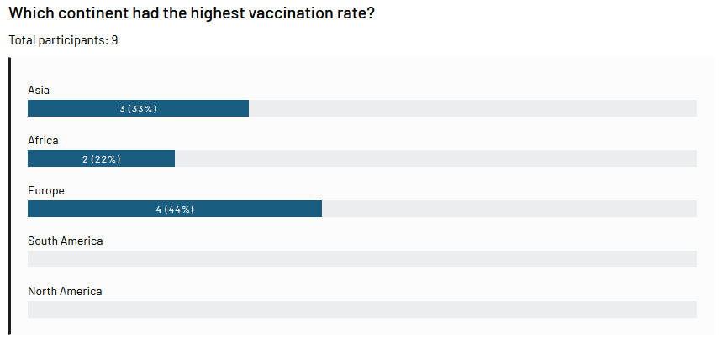
Task 1 – Question 2:
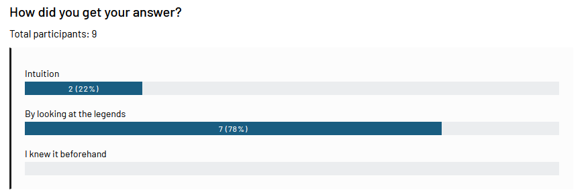

Task 2 – Question 1:
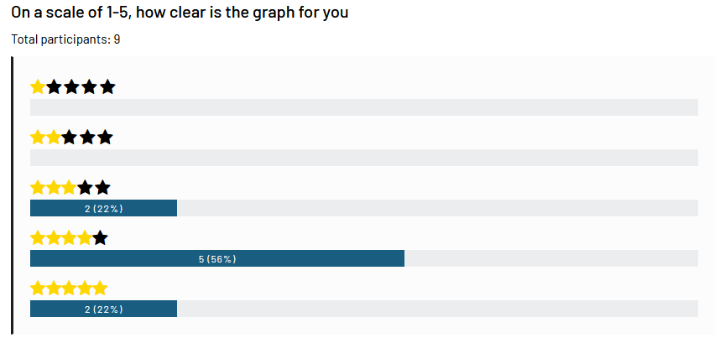
Task 2 – Question 2:
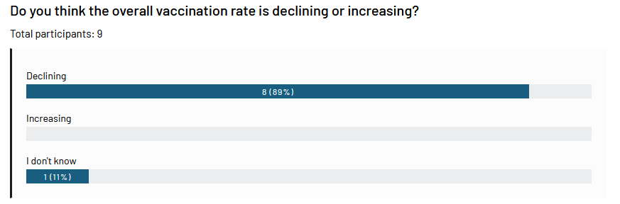
Task 3 – Question 1:
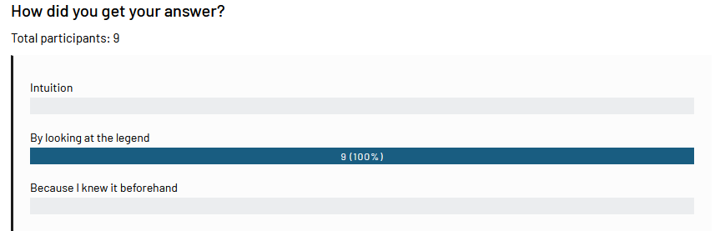

Task 4:
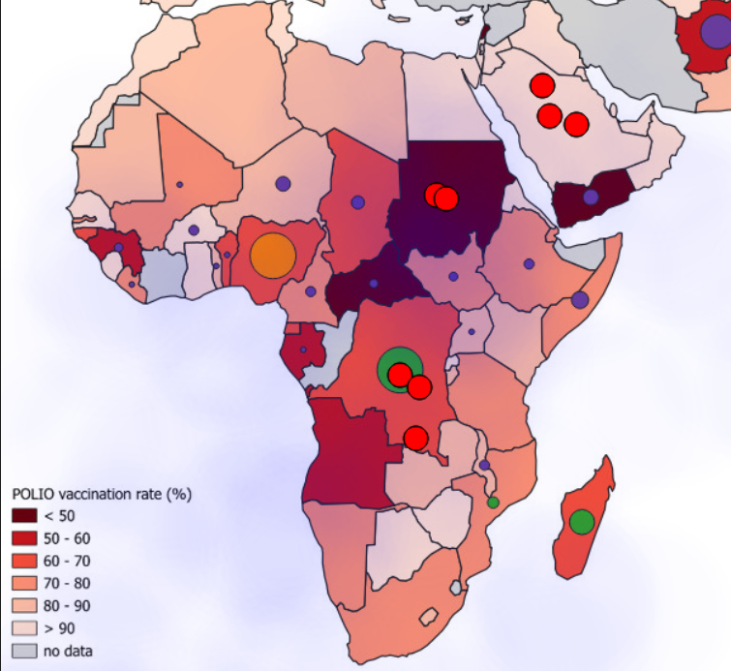

Task 5 – Question 1:
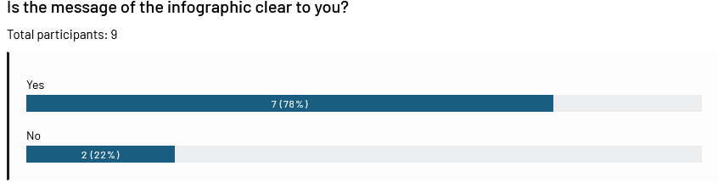

Task 5 – Question 2:
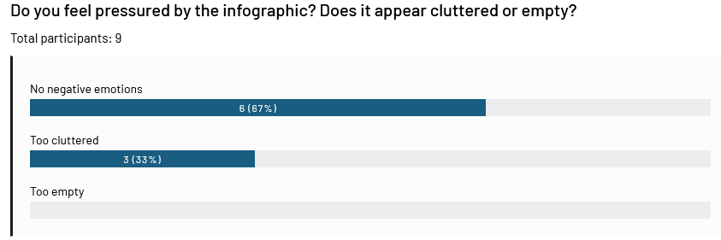
Task 5: Question 3:
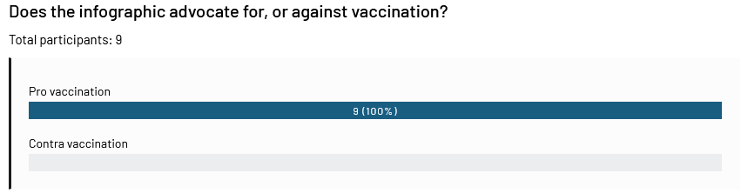
Task 5: Question 4:
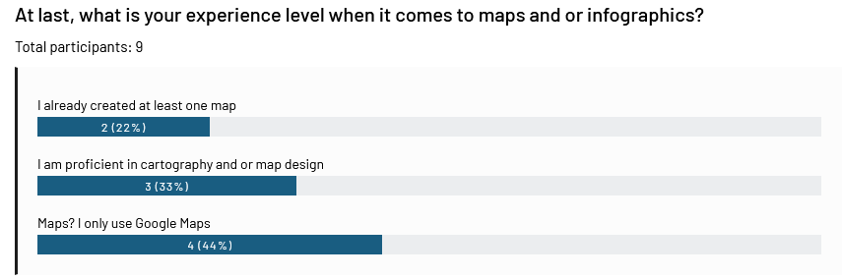

The metrics I chose for were if the questions were answered correctly and if everything was clear for the participants. Also, in the stimuli, I checked the heatmaps and verified the AOI reports as in the example below:
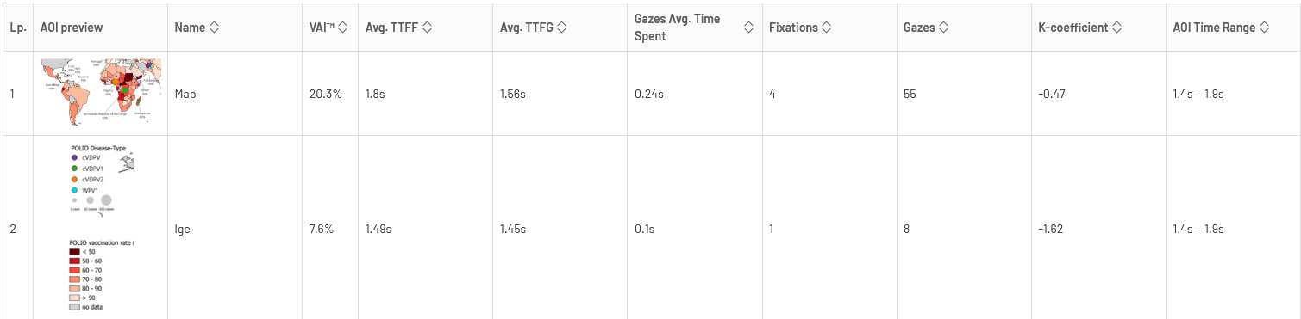
Conclusion
Backed up by the results, it seemed like people are more likely to expect a higher value at darker colors. Task 4 is the best example – the task was clicking onto areas with a high coverage but most of the participants selected areas with a lower coverage (because they had a darker color). As the participants had various backgrounds (a nice mix) this was especially interesting, considering even experienced people “failed” at this task as they apparently relied on their intuition. This underlined my expectation and is exactly the reason why I had 2 identical maps with an inverted color scheme to verify my claim. The message of the infographic was mostly clear, while some felt that it was a bit too cluttered.

