**Consent Agreement**

**For Vessel Response Plan**

DONJON-SMIT LLC hereby agrees to provide Salvage and Marine Fire Fighting services as referenced within 33 CFR 155.1052(f) and consents to be listed within Vessel Response Plans issued by the below referenced company.

This agreement remains valid only for vessels carrying Group V petroleum as cargo.

This agreement remains valid for one year from the date of issue and will renew automatically for each subsequent one-year period.

This agreement may be terminated by either party by giving the other party 30 days written notice of such termination.

|  |  |
| --- | --- |
| Company: | ${companyName}  ${companyAddress} |

By: Issue Date: ${issueDate}

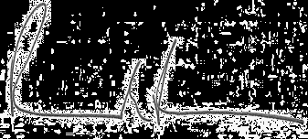

DONJON-SMIT, LLC

Richard Fredricks

Vice President