PRJ_277: Evidence-Linked News and Public Reaction Analysis for Government Initiatives
Manoj H V
School of Computer Science and Engineering
Branch: Information Science and Engineering
Presidency University
manoj.20231ise0076@presidencyuniversity.in
Abstract: Monitoring coverage of a public programme requires distinguishing outlet text from reactions posted by readers and retaining a source trail for every summary and label. This paper presents PRJ_277, a cloud-hosted research prototype for collecting and comparing online news about Government of India initiatives across English, Hindi, Kannada, Tamil, and Telugu. A researcher supplies a topic, aliases, publication interval, language set, and optional publisher selection. The service queries Google News and Bing News RSS, captures publisher pages when accessible, and otherwise saves a labelled feed excerpt. The system normalizes metadata, detects language, deduplicates content, and stores provenance in Cloudflare D1. TypeSafe JEV returns structured estimates for government relevance, article sentiment, target-specific stance, and topic; Google Gemini produces summaries and key points linked to exact stored sentences. A separate workflow searches public Bluesky posts and Hacker News comments, matches records by article link or headline terms, and labels at most six items per platform. This sample is not a poll. The deployed Worker groups results within a research query as a candidate coverage set; it does not perform semantic cross-story clustering. This paper describes the system design and implementation boundaries; it reports no human-labelled benchmark or population-level sentiment estimate.
Index Terms: multilingual media analysis, sentiment analysis, stance detection, public reactions, evidence provenance, Cloudflare Workers, research prototype.

I. INTRODUCTION
Government initiatives are reported through a changing mix of national and regional outlets. A researcher who wants to study one programme over a selected date range must locate relevant stories, compare how outlets frame them, preserve the original evidence, and distinguish reporting from public discussion. PRJ_277 is a research prototype for that workflow. A user enters a topic such as Swachh Bharat Mission, optional alternate names, a date interval, supported languages, and optional outlet choices. The system collects a bounded sample, records its provenance, analyzes article text, and presents source-linked comparisons.
The system separates three objects that are often collapsed in informal media dashboards: the evaluative tone of an article, the article's stance toward an identified policy target, and the sentiment expressed by a public post or comment. Stance is target-conditioned: the same text can express a favorable or unfavorable position toward a named proposition, and the target must be explicit to interpret the label [1]. Social-media sentiment is also sensitive to short-form language, sarcasm, and platform conventions; domain-specific methods such as VADER were designed for microblog text, but their results do not establish cross-language validity for this prototype [2]. Accordingly, PRJ_277 exposes labels as model-assisted research cues rather than verified facts.
This paper makes four contributions. First, it specifies a cloud-hosted, query-driven collection pipeline for five Indian languages. Second, it describes evidence-linked article analysis that stores model identity, confidence, timestamp, and source sentences. Third, it introduces a separate, link- or headline-matched sample of public reactions. Fourth, it documents the practical limits of the current hosted story grouping and public-post sample so that displayed counts are not interpreted as exhaustive media coverage or population opinion.
II. DESIGN SCOPE AND DATA MODEL
A. Research workflow
The primary user journey is dashboard, research query, candidate story comparison, article detail, and evidence/source inspection. Search parameters include a topic, aliases, start and end dates, language selection, optional supported outlets, and a bounded per-language result count. The current interface supports English, Hindi, Kannada, Tamil, and Telugu. Each record retains its source URL, discovery URL, publisher name, language, publication time, collection time, collection method, content kind, and content hash. The interface labels synthetic demonstration records and keeps them out of online model calls and public-reaction scans.
B. Persisted entities
Cloudflare D1 stores source and article metadata, raw and cleaned article text, analysis output, story membership, processing-job state, and public-reaction collection runs. The principal records are sources, articles, article_analysis, stories, story_articles, processing_jobs, reaction_runs, and public_reactions. A reaction record retains its exact text, platform identifier, permalink, date when available, engagement counters, match basis, sentiment label, and confidence. A research result can therefore be traced from an overview metric to a story group, article, source, original text, model decision, and public-post evidence. D1 provides a SQLite-compatible relational store through a Cloudflare binding [6].
C. Scope boundaries
The deployed Worker is the subject of this paper. The repository also contains a local FastAPI reference workflow, but the hosted path does not require a local server, Docker, or downloaded model weights. Current cloud story groups are query-scoped candidate coverage sets. Global semantic search, full embedding-based cross-query clustering, manual cluster correction, broad platform coverage, and production-scale evaluation remain outside the present implementation.

III. SYSTEM ARCHITECTURE
Fig. 1 presents the deployed component boundaries. A Next.js 15 and React 19 client is written in TypeScript and adapted by OpenNext for the Cloudflare Workers runtime. The Worker serves typed REST routes, coordinates discovery and capture, invokes optional remote analysis providers, and persists records in Cloudflare D1. News feeds, publisher pages, and public-discussion services are external inputs. Provider credentials remain in Worker secrets. The figure describes the deployed hosted path, not the separate local FastAPI reference workflow.
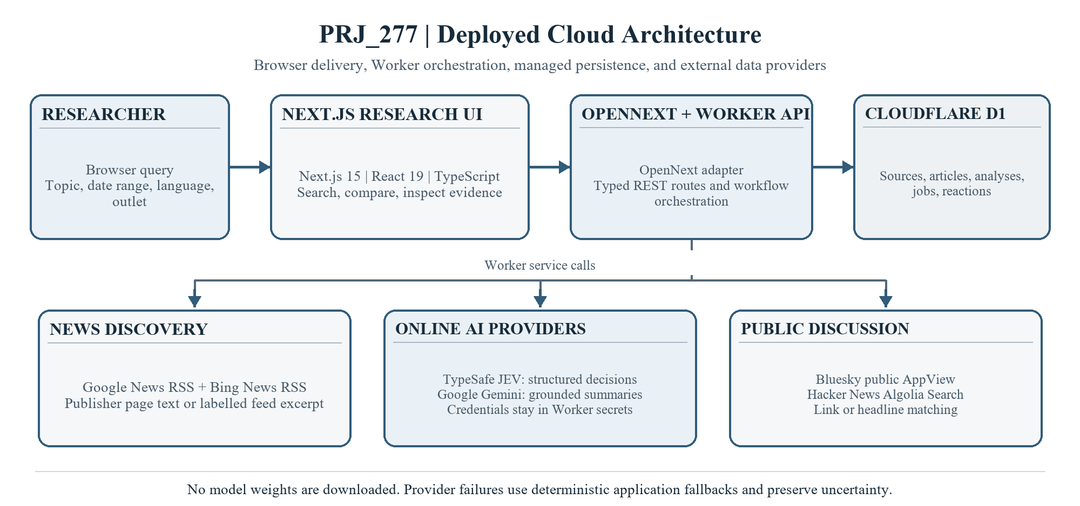
Fig. 1. Deployment architecture for the PRJ_277 Cloudflare Workers system.
JEV and Gemini are separate optional providers called from the Worker. JEV supplies structured classifications; Gemini generates evidence-linked prose. The Worker keeps both credentials server-side. Deterministic application code handles normalization, evidence checks, and limited provider-failure fallbacks. The hosted path downloads no model weights.
TABLE I. DEPLOYED TECHNOLOGY STACK
Layer | Technology | Role in PRJ_277
Presentation | Next.js 15, React 19, TypeScript, Recharts, Lucide React | Topic search, filters, coverage views, and article/evidence inspection.
Web runtime and API | OpenNext 1.20.6, Cloudflare Workers, TypeScript route handlers, Wrangler | Hosts the Next.js application and coordinates REST routes, ingestion, analysis, and deployment.
Persistence | Cloudflare D1 | Stores sources, articles, analyses, jobs, query-scoped groups, and public-reaction records.
News acquisition | Google News RSS, Bing News RSS, publisher HTTP pages | Discovers candidates and captures accessible article text, with labelled feed excerpts when page capture is limited.
AI providers | TypeSafe AI JEV, Google Gemini API | JEV returns structured decisions; Gemini generates summaries and key points linked to source sentences. Credentials are Worker secrets.
Public discussion | Bluesky public AppView, Algolia Hacker News Search API | Finds link- or headline-matched public posts and comments for a bounded reaction sample.

IV. ONLINE COLLECTION AND NORMALIZATION
For each selected language, the collector queries Google News RSS and Bing News RSS using the topic and aliases. It applies the selected date interval and, where requested, supported outlet-domain restrictions. The current per-language limit is configurable from one to three records. Candidate results are checked against publication dates, outlet selection, and script-based language evidence. The collectors are discovery feeds, not an exhaustive index of every publisher or article.
The Worker follows public HTTP or HTTPS article links under host and redirect checks, extracts paragraph text from accessible pages, and stores a cleaned page when enough usable text is present. If capture is blocked or the extracted page is too short, the feed description is retained with content_kind set to feed_excerpt. The record preserves the discovery URL and marks the content type so a researcher can tell a publisher-page capture from a feed excerpt. HTML entities are decoded, markup is removed, whitespace is normalized, and a SHA-256 hash over normalized title and content is used with URL matching to suppress duplicates. Publication and collection timestamps are stored separately.
Language detection uses Unicode script ranges for Devanagari, Kannada, Tamil, Telugu, and Latin-script English. Its confidence value is an evidence score from the detected script, not a calibrated probability. It can fail for transliteration, short text, or code-switching. Synthetic seed records are marked explicitly and remain separate from collected media in the user interface.
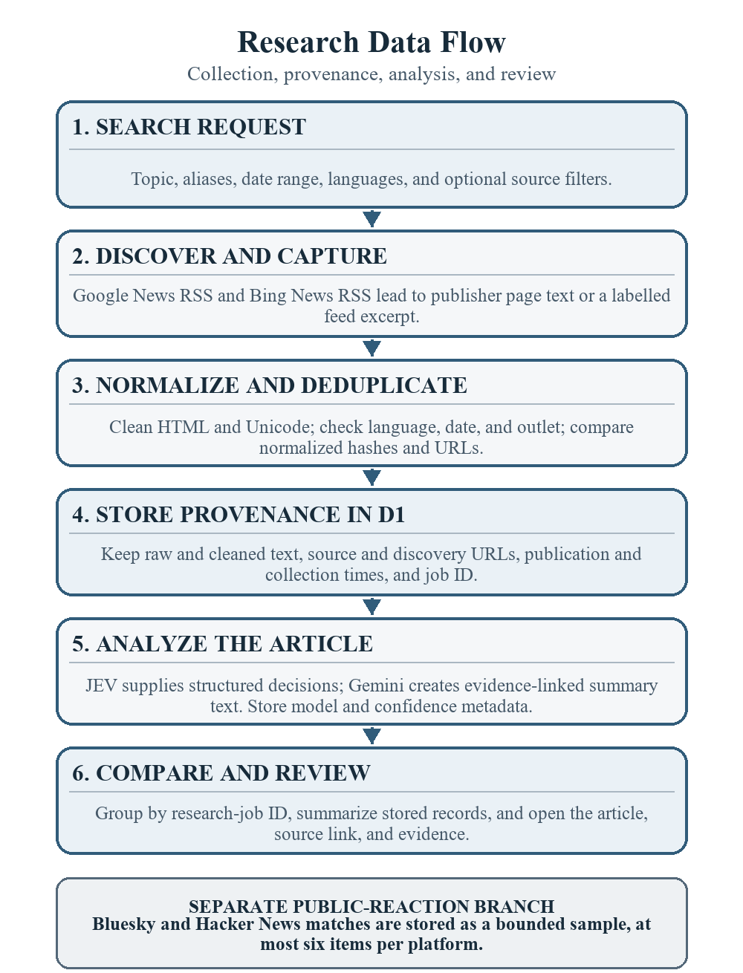
Fig. 2. Research data flow and provenance from query to evidence review.
V. ARTICLE ANALYSIS AND STORY COMPARISON
A. Relevance, sentiment, and stance
TypeSafe AI JEV is the structured decision provider for collected, non-synthetic articles when the server-side TypeSafe credential is configured [3]. It receives the detected language and a bounded title-plus-text excerpt (up to 12,000 characters by default) and answers four separate questions: whether the main subject materially concerns a Government of India policy, scheme, institution, or action; the article's overall evaluative tone; its framing toward a Union Government target; and its single primary topic. JEV returns a probability for relevance, and the application labels an article relevant only when that probability meets the configurable 0.55 default threshold. Sentiment, stance, and topic are categorical choices with confidence and alternative probabilities; their default minimum confidence is 0.60. Provider and model, input size and truncation, token use, confidence, effective labels, thresholds, and analysis time are retained with the record.
The application turns those answers into explicit, inspectable labels. A relevance score below 0.55 is shown as below threshold; it does not mean that the article contains no government mention. Sentiment is the article's overall evaluative tone. Stance is a separate estimate of the article's own framing toward an explicit detected Union Government policy or action target; it is not inferred from sentiment, a quoted speaker alone, or relevance. Without a detected target, stance remains unclear. JEV sentiment below 0.60 confidence or an uncertain choice becomes uncertain; stance below 0.60 or an unclear choice becomes unclear. A primary topic enters topic counts only when confidence meets 0.60 and its choice is neither other nor uncertain. These are model-assisted estimates, not verified facts. JEV supplies no quote-level rationale, so provider decisions are shown separately from source-derived evidence, which researchers should inspect alongside the original article.
B. Summaries and evidence
Google Gemini has a distinct role: it generates an article-language summary and key points; it does not decide JEV's relevance, sentiment, stance, or topic fields [4]. Gemini receives bounded source text split into exact sentences with zero-based evidence IDs, and returns structured JSON containing a two- or three-sentence summary and up to four key points linked to those IDs. The application validates the output, rejects key points with invalid, repeated, or out-of-range IDs, and attaches the exact stored source sentence as evidence. Summary wording remains generated interpretation, not verified fact. Provider, model, generation time, input length and truncation, and checked evidence are retained. Transient errors are retried; a persistent 503 can trigger the Gemini 3.7 Flash fallback. If generation remains unavailable or malformed, provider status is recorded and a limited deterministic extractive or rule-based summary is used. JEV classifications and Gemini prose therefore remain separate, independently configured decisions.
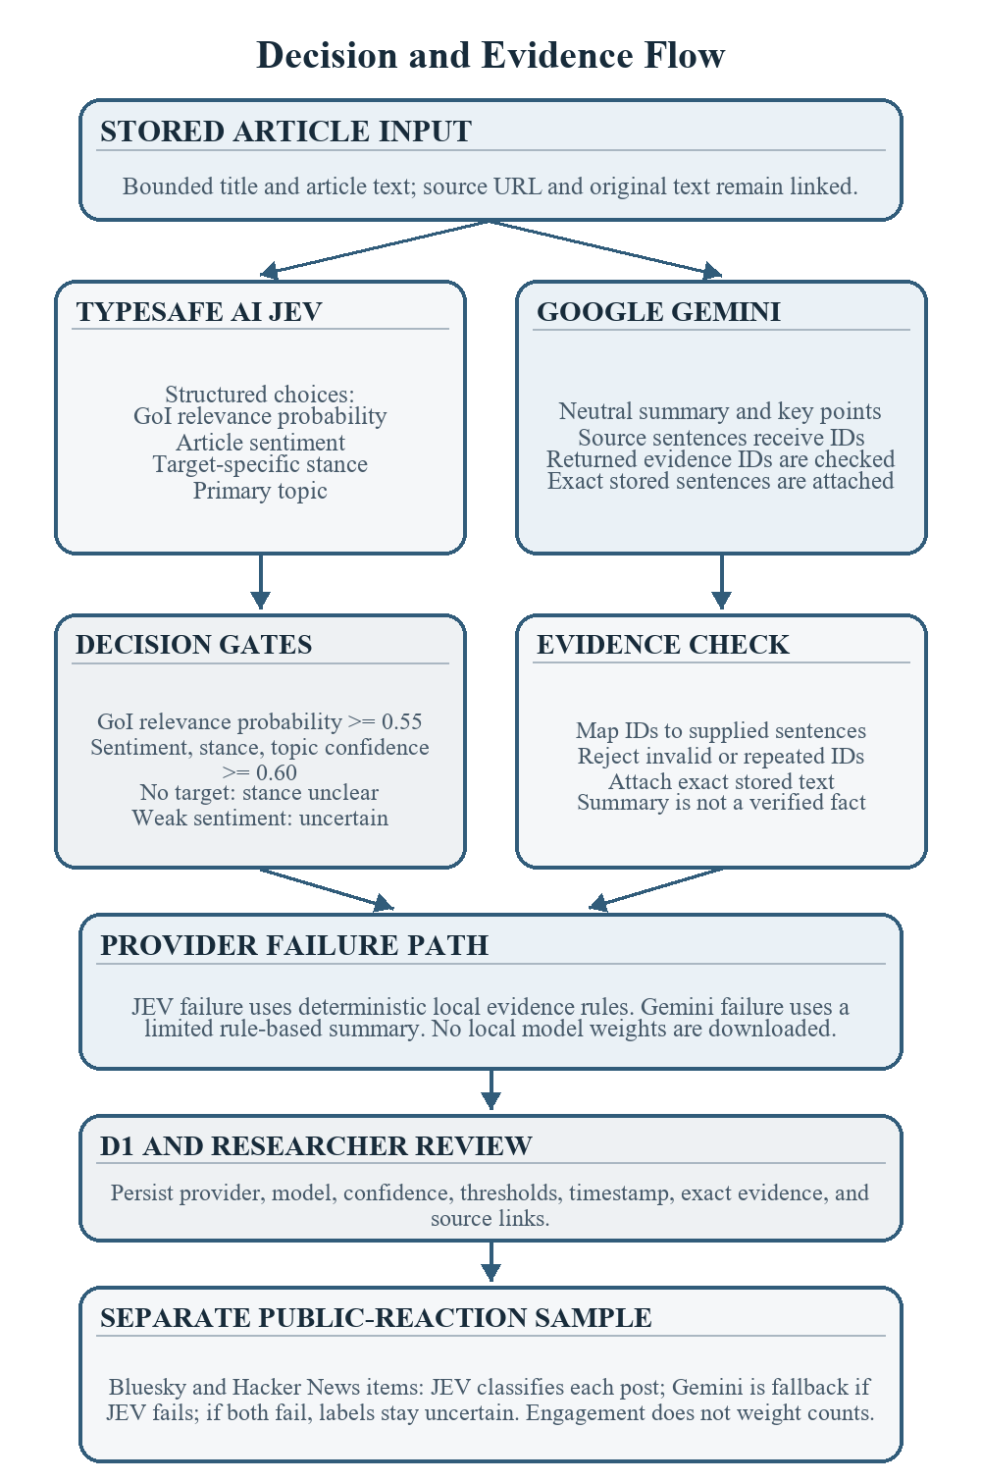
Fig. 3. JEV and Gemini decision gates, evidence checks, and public-reaction fallback path.
C. Candidate story sets and comparison
For a cloud research run, the Worker assigns collected records to a candidate story group keyed by the search-job identifier. It computes descriptive topic, language, source, sentiment, and stance summaries over those stored records and links comparison items to article identifiers. The grouping is intended to answer which outlets appeared in one bounded query result; it is not a semantic determination that all reports describe the same event. The deployed Worker does not download or run the local FastEmbed multilingual model. Cross-query semantic clustering and researcher correction of clusters are future work.
VI. PUBLIC REACTION COLLECTION
Public-reaction analysis is initiated from a collected, non-synthetic article. The Worker searches Bluesky's public AppView post-search endpoint and the Hacker News Search API for comments [7], [8]. It queries the article URL and headline-derived terms, then retains posts or comments that match the source link or sufficiently overlap the title/discussion title. Results are deduplicated and limited to at most six records per platform, for a maximum of twelve per scan. Each retained item includes the original post or comment link, exact text, publication time when available, match basis, and platform engagement counters.
Each matched public post or comment receives its own sentiment decision toward the article's central issue. JEV returns positive, negative, mixed, neutral, or uncertain; a JEV confidence below 0.60 is mapped to uncertain. If JEV fails, Gemini can supply per-post labels and a cautious sample summary; if both providers fail, items remain uncertain and the interface reports that analysis was unavailable. Gemini themes link back to the exact collected post text. Engagement counts are contextual only and do not weight the distribution; a five-minute per-article cache limits repeat calls. Public-reaction labels remain separate from the article's tone and stance, and each item links to its original post or comment for review.
The resulting distribution describes only the posts returned by the queried services and retained by the link/headline rules. A headline match can be a conversation about the same issue rather than a response to the specific article. Platform indexing, language, access, and user demographics shape the sample; one person may contribute multiple posts. The output is not a poll and does not estimate what all readers, voters, or the public believe. Reddit, YouTube, X, and publisher comment sections are not included in this release.
VII. IMPLEMENTATION STATUS AND EVALUATION SCOPE
The deployed client uses Next.js and TypeScript; OpenNext adapts the application to Cloudflare Workers, and D1 stores state. The Worker exposes overview, story, article, source, language, topic, research-job, ingestion, provider-status, and public-reaction routes. Metrics shown by the dashboard are derived from stored rows. The online workflow does not depend on a local FastAPI process or model download.
Project documentation records that the initial six-of-ten capability groups were verified in the local reference demo on September 23, 2026, with frontend type-check and production-build checks. The deployment notes also record that the hosted JEV and Gemini provider-status path and one real article analysis were exercised. Those checks establish implementation paths only; they are not a human-labeled accuracy study. The current manuscript reports no measured precision, recall, macro-F1, latency distribution, source-recall rate, or representative public-opinion estimate. The available project record does not report an independently annotated public-reaction sample.
A suitable next evaluation would build a time-bounded sampling frame per language and outlet, preserve query and retrieval logs, and annotate relevance, article tone, target stance, post matching, and post sentiment with bilingual reviewers. Inter-annotator agreement and per-language macro-F1 should be reported separately; model confidence should be calibrated against held-out labels. Reaction coverage should be reported as search and match counts by platform, language, and date, without extrapolating sample proportions to the general population.
VIII. LIMITATIONS AND RESPONSIBLE USE
Search feeds return a changing and incomplete sample. Publisher sites may block requests or expose only snippets. Optional source filters, provider ranking, date parsing, relevance cues, and language checks can omit relevant material or include false matches. Unicode-script detection does not reliably resolve code-switching or transliteration. Article text and public posts are not independently fact-checked. LLM labels are probabilistic, provider output may change, and confidence is not a guarantee of correctness. JEV does not return sentence-level rationale; Gemini summaries can still misrepresent context even when displayed evidence sentences are exact.
Public posts are available only through two public search services and the matching logic. A low or zero count means few matching indexed posts were returned, not that readers had no reaction. Engagement counts do not equal unique people or represent agreement. Coverage comparisons summarize a selected sample and must not be called objective outlet bias, truth, political support, or overall source quality. Researchers should review the underlying article and post text before using a label in a conclusion.
IX. CONCLUSION
PRJ_277 provides a cloud-hosted workflow for collecting a bounded multilingual news sample, retaining article provenance, generating separate article and public-post analyses, and following comparison outputs back to their evidence. Its central design choice is separation: article sentiment, target-specific stance, and public-post sentiment are stored and presented as distinct signals. The present cloud grouping remains query-scoped, and reaction estimates are limited to a small indexed sample. Next steps are a human-reviewed multilingual benchmark, clearer capture and match-quality metrics, broader platform/source coverage, and validated semantic clustering before any population-level or cross-outlet claims are attempted.

REFERENCES
[1] S. M. Mohammad, S. Kiritchenko, P. Sobhani, X. Zhu, and C. Cherry, “SemEval-2016 Task 6: Detecting stance in tweets,” in Proc. 10th Int. Workshop Semantic Evaluation (SemEval-2016), San Diego, CA, USA, 2016, pp. 31–41, doi: 10.18653/v1/S16-1003.
[2] C. Hutto and E. Gilbert, “VADER: A parsimonious rule-based model for sentiment analysis of social media text,” in Proc. 8th Int. AAAI Conf. Weblogs and Social Media (ICWSM), vol. 8, no. 1, 2014, pp. 216–225, doi: 10.1609/icwsm.v8i1.14550.
[3] TypeSafe, “SystemOne and Models API reference,” TypeSafe API Documentation. [Online]. Available: https://api.typesafe.ai/docs. [Accessed: Sep. 25, 2026].
[4] Google, “Generate content with the Gemini API,” Google AI for Developers. [Online]. Available: https://ai.google.dev/gemini-api/docs/generate-content. [Accessed: Sep. 25, 2026].
[5] OpenNext, “Cloudflare adapter,” OpenNext Documentation. [Online]. Available: https://opennext.js.org/cloudflare. [Accessed: Sep. 25, 2026].
[6] Cloudflare, “D1 overview,” Cloudflare Developers Documentation. [Online]. Available: https://developers.cloudflare.com/d1/. [Accessed: Sep. 25, 2026].
[7] Bluesky, “app.bsky.feed.searchPosts API reference,” Bluesky HTTP API Reference. [Online]. Available: https://docs.bsky.app/docs/api/app-bsky-feed-search-posts. [Accessed: Sep. 25, 2026].
[8] Algolia, “Hacker News Search API.” [Online]. Available: https://hn.algolia.com/api. [Accessed: Sep. 25, 2026].

