Nicholas Garrett
Professor Zibran
CS 4417
2/14/2022

Assignment 1

Because I realized that I do not currently have a card reader for my laptop to flash the Kali ARM OS onto the RPi’s SD card, I decided to try and create a VM for it in VirtualBox. I have ordered a microSD card reader, and when it arrives I will put the Kali ARM onto my actual RPi.
In the mean time, I will have to try and make due with having the Kali ARM on a VM.

First, I began by installing the Kali ARM iso.
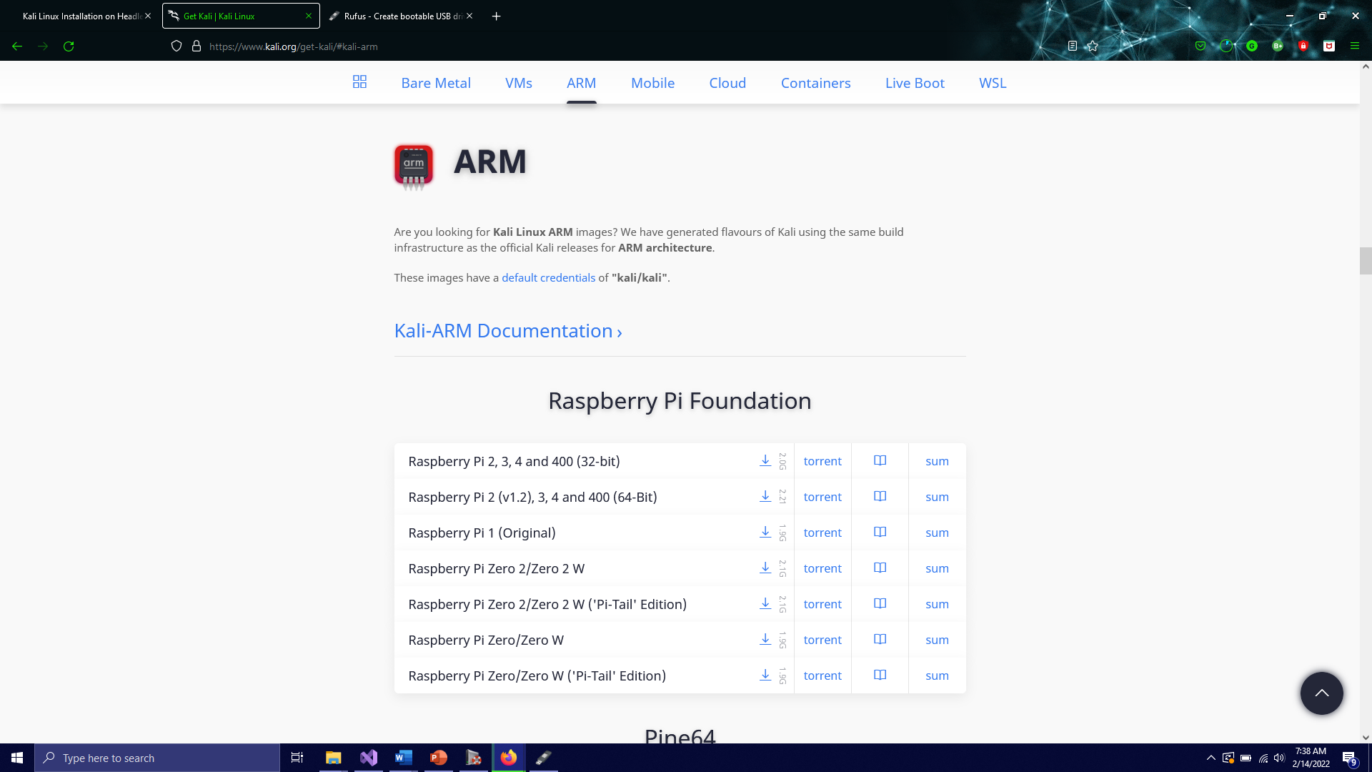

Next, I installed the OS using a head to make it easier for me. I will simply run the VM in headless mode to fulfill the headless requirement.
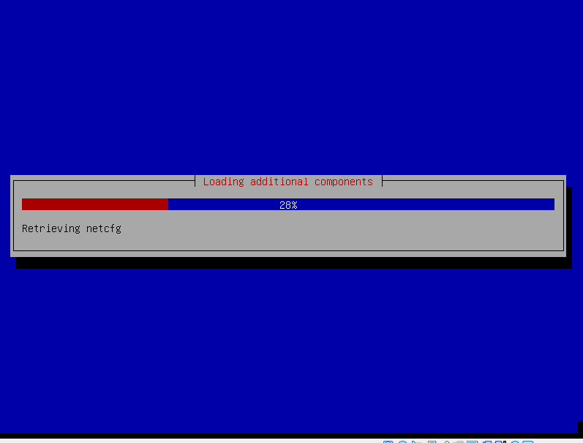

I did this step multiple times unfortunately. The virtual drive that I made was not quite large enough for the OS to install into, which I had not even thought to consider until installation errors plagued me for hours.
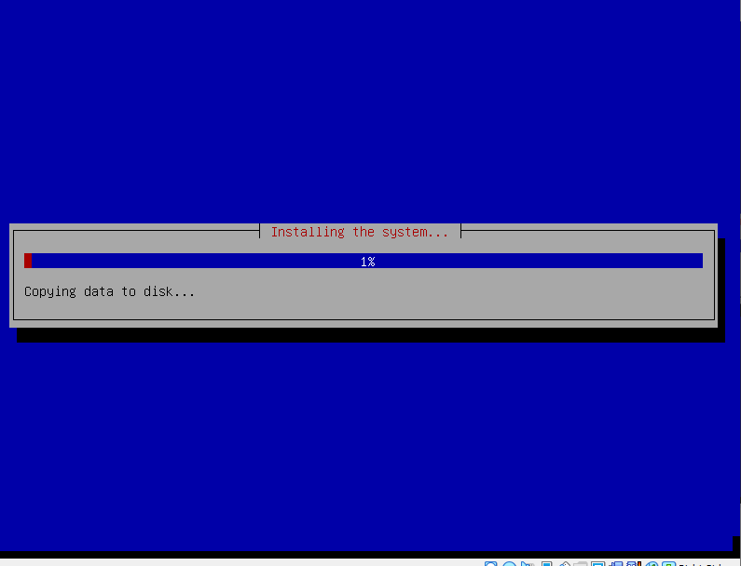
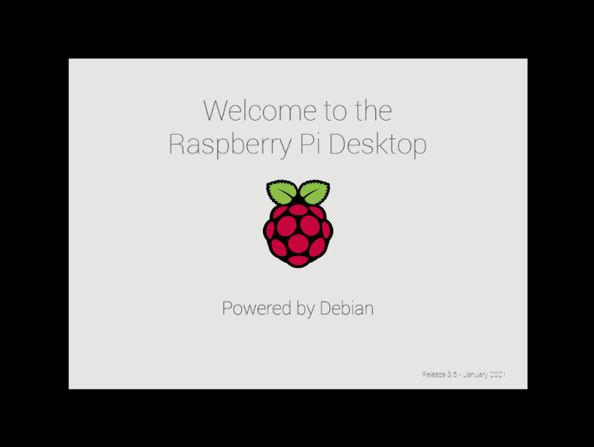

Tada!
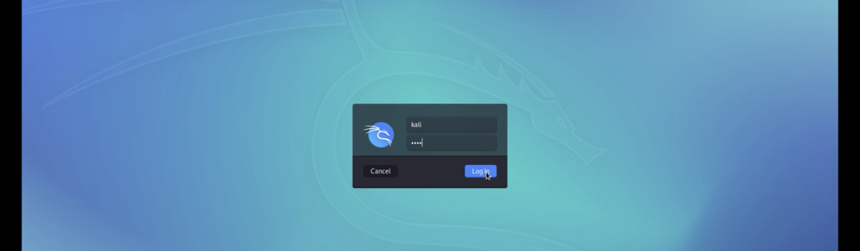

Now, all I have to do is boot the VM in headless mode and use it as a headless system. As I said, when my SD card reader arrives, I will do as the instructions state and install the Kali ARM on the actual RPi in a headless configuration. Though until that time, this will simply have to suffice.

