3rd year project
Feasibility Study and
Project Plan

Brian Shannon

Simple peer to peer file
Sharing with encryption.
Table of Content

Introduction 3
1.0Iteration of Static and Dynamic model: (bm) 3
1.1a Static Model 3
2.0 Screen Design (bs) 6
3.0 Persistent Storage Design (bs) 6
File Index system, Design 6
Record recover 6
4.0 Network Design (bm) 7
4.1 Frame Layout 7
4.2 Network Topology 9
4.2.1 Linear Bus Topology 9
4.2.2 Network Components 10
5.0 Controls Design (bs) 10
Error logs 10
6.0 Testing Plan 11
Testing Schedule 12

.

Introduction

The following document has been produced by the Project Development Team (PDT) in accordance with the design phase of the Software Development Lifecycle (SDLC). The purpose of this document is to illustrate and describe the overall design of the proposed system.

Iteration of Static and Dynamic model: (bm)

The inputs to this section of the design phase were the Static and Dynamic models produced in the user requirements specification (URS) document. After carefully scrutinising the structure of the class model from the URS, the team came to several relatively clear and simple conclusions.

1.1a Static Model

The fact that this system will be designed to function as a peer to peer (p2p) program helps to reduce conceptual complexity of the project. It is felt that the attributes and operations displayed in the initial Class model will suffice in contributing to a solid base upon which the project design can be commenced. Only slight adjustments have been made as some functionality was omitted from the original model.

Revised Class Model
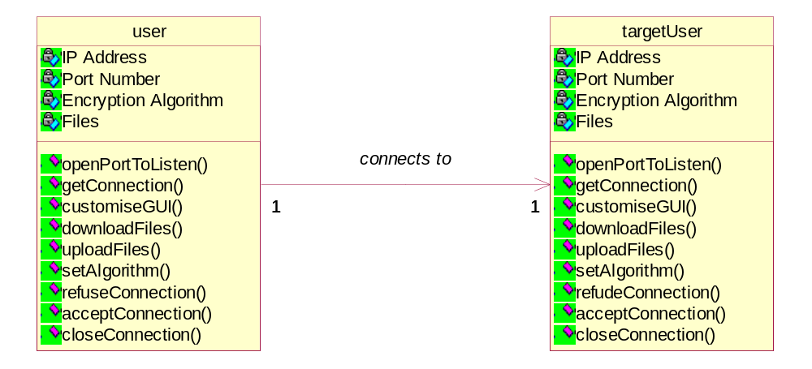

1.1b Dynamic Model

After careful investigation of the object sequence diagram produced in the URS document the PDT have came to the conclusion that the logic and level of complexity displayed is sufficient to further develop the system. This program will predominantly perform just one main function and this main procedure is depicted in the previously produced activity model. Again, the concise p2p nature of the intended system enabled the PDT to quickly gain a conceptual grasp of how the system would function from the outset.

Activity Model
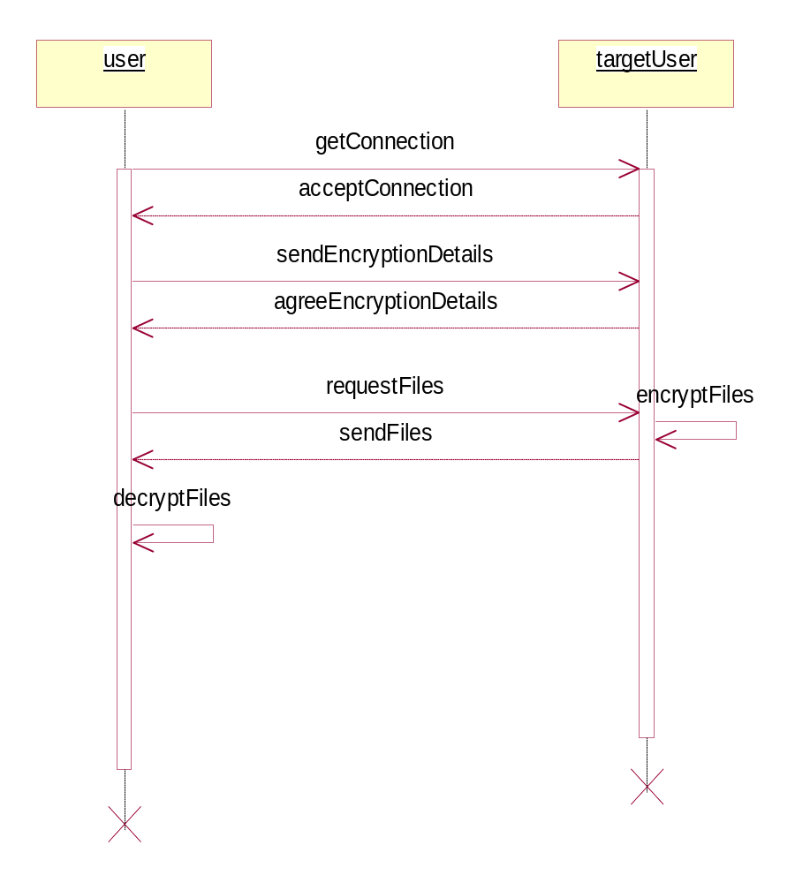

A State Transition Diagram was also developed by the PDT based on this re-examination of the Activity model which was concluded in the URS. This graphic representation again displays the core function of the proposed system.

State Transition Diagram
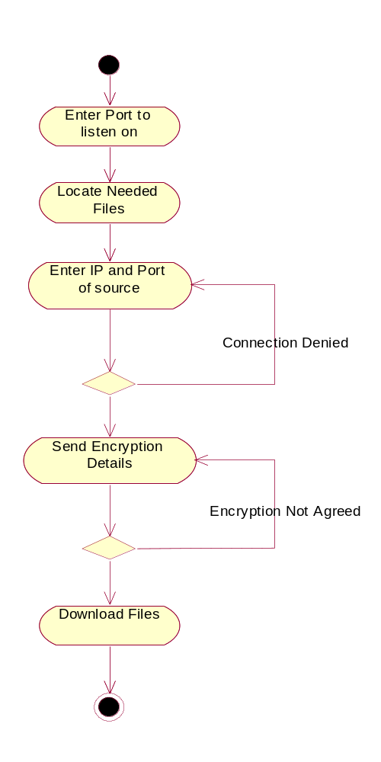

2.0 Screen Design (bs)

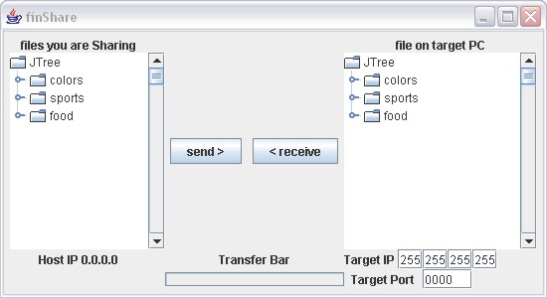

3.0 Persistent Storage Design (bs)

File Index system, Design
An array will be used to index all the files to be shared. It will be a 3 dimensional array. The compartments will contain:

- The IP address of the target computer that has the file
- The file ID, this is a unique identifier for each file.
- The file name as on the file system.

When a remote user connects to the programme, they must send a list of the files and their ids. The client programme uses this new information to populate the array.

Record recover
The user wishing to download a file selects a file from the list. Then the ID is looked up in the array and passed to the request component.

4.0 Network Design (bm)

The base purpose of the project proposed by the PDT is to deliver varying amounts of data from an end user along a network to another end user. It is felt by the PDT that research into network technologies is critical to ensure that adequate data transfer is provided by the program.

4.1 Frame Layout

The network that will be used is an Ethernet Bus framework; this will be discussed in more detail in the next section. The Ethernet standard defines a basic data frame format that is required for all physical devices connected to the network. The basic data frame format contains the seven fields shown:

1) Preamble (PRE) - Consists of 7 bytes. The PRE is an alternating pattern of ones and zeros that tells receiving stations that a frame is coming, and that provides a means to synchronize the frame-reception portions of receiving physical layers with the incoming bit stream.

2) Start-of-frame delimiter (SOF) - Consists of 1 byte. The SOF is an alternating pattern of ones and zeros, ending with two consecutive 1-bits indicating that the next bit is the left-most bit in the left-most byte of the destination address.

3) Destination address (DA) - Consists of 6 bytes. The DA field identifies which station(s) should receive the frame. The left-most bit in the DA field indicates whether the address is an individual address (indicated by a 0) or a group address (indicated by a 1). The second bit from the left indicates whether the DA is globally administered (indicated by a 0) or locally administered (indicated by a 1). The remaining 46 bits are a uniquely assigned value that identifies a single station, a defined group of stations, or all stations on the network.

4) Source addresses (SA) - Consists of 6 bytes. The SA field identifies the sending station. The SA is always an individual address and the left-most bit in the SA field is always 0.

5) Length/Type - Consists of 2 bytes. This field indicates either the number of MAC-client data bytes that are contained in the data field of the frame, or the frame type ID if the frame is assembled using an optional format. If the Length/Type field value is less than or equal to 1500, the number of bytes in the Data field is equal to the Length/Type field value. If the Length/Type field value is greater than 1536, the frame is an optional type frame, and the Length/Type field value identifies the particular type of frame being sent or received.

6) Data - Is a sequence of n bytes of any value, where n is less than or equal to 1500. If the length of the Data field is less than 46, the Data field must be extended by adding a filler (a pad) sufficient to bring the Data field length to 46 bytes.

7) Frame check sequence (FCS) - Consists of 4 bytes. This sequence contains a 32-bit cyclic redundancy check (CRC) value, which is created by the sending MAC and is recalculated by the receiving MAC to check for damaged frames. The FCS is generated over the DA, SA, Length/Type, and Data fields.

Basic Ethernet Frame Format

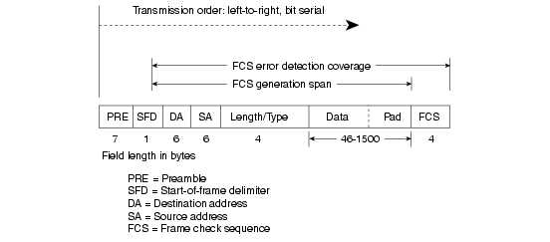
source: cisco.com

4.2 Network Topology

As previously mentioned, this project will be structured upon an Ethernet network. The term Ethernet refers to the family of local-area network (LAN) products covered by the IEEE 802.3 standard. Ethernet is the world’s major LAN technology (it is currently used for approximately 85 percent of the world's LAN-connected PCs and workstations) because its protocol has the following characteristics:

• Is easy to understand, implement, manage, and maintain

• Allows low-cost network implementations

• Provides extensive topological flexibility for network installation

4.2.1 Linear Bus Topology

The bus topology has been adopted by the PDT as this is the structure available within the campus of the institute. Flexibility of choice of topology is not available to the PDT as the project has to be implemented within the confines of an already existing network established in a lab of the college. The PDT already has extensive experience of working with networks based on the bus topology. There is already a lot of software research being undertaken by the PDT as part of this project so it is felt that experimenting with new network topologies would add overwhelmingly to the workload. A linear bus topology consists of a main run of cable with a terminator at each end. All nodes (file server, workstations, and peripherals) are connected to the linear cable.

Basic Bus Topology
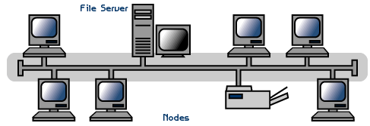

4.2.2 Network Components

Most networks comprise of two different type of device, data terminal equipment (DTE) and data communication equipment (DCE).
DTE devices are the source and destination of data frames sent along the network i.e. work stations, print servers, file servers. The DTE devices that will be used by the PDT will be the PCs with in-built network cards that are provided by the college for use by registered students. As it has previously been stressed, the project involves sending files from one workstation to another so no other DTE devices shall be required.
DCE devices will be required to ensure a viable link is established enabling communication and file transfer between end nodes. In this case, the framework provided consists of 10baseT UTP cabling which extends from each nodes network card. This cable then links to other DCE devices such as hubs and routers which can navigate traffic around the network based on Internet Protocol (IP) address information.

Conclusion
The PDT feel that based on their previous experience working with network architecture and protocols that side of the project will not present too many difficult obstacles. The fact that the working network is already in place is of great benefit to the team as they can focus on how to get the developed software to utilise the Ethernet base that’s provided.

5.0 Controls Design (bs)

Error logs
- File not found
  - This error occurs if the file has moved or has been renamed and thus can’t be found.
- PC not found
  - This is a network error when a connection on the port can’t be made
- Network timeout
  - This error occurs when no communication can be made with the network at all.
- Port not open
  - No information can be sent to the port on the local machine
- File transfer timeout
  - A send or receive will just not begin.
- File transfer failed
  - The file transfer has stop after it as begin.
- Unknown error
  - The reason for the error is unknown
- Address error
  - The IP address in the file index system can not be reached
- Designated end of file error
  - A file is still being sent after the end of the file as been received.

6.0 Testing Plan

6.1 Unit Testing:
Focuses on the modules within the software. Important control paths are tested to uncover errors within the modules. All the interfaces are tested to assure that information properly flows into and out of the modules

Unit testing well be dun during the Build Stage.

Module | Task | Description | True? | Note:
Network | open | can create a sock object
 | close | can close the sock object
 | listen | the sock object can actively listen for connections
 | except connection | can handle incoming connections
 | connection | can keep a connection
 | set port of send | Can set the port number to sent on.
 | set port to receive | Can set the port number to listen on.
 | set IP of send | can set the IP address of the target computer
Encryption | acquire file | crypt object can acquire file
 | file divided in parts | the part made it easier encrypt
 | encrypt a part
 | encrypt all parts
 | add key | add key to the encrypted file
 | Decrypt | Decrypt a file with the same encryption

6.2 Integration testing:
Tests the system as a whole. Ensuring all modules communicate with the correct interfaces, also to test the interfaces to the modules/programs/subsystems is correct.

Integration Testing will be done nearer to the end of the Build Stage.
Module | Task | Description | True? | Note:
User interface | Download Button | Download the selected file from the target PC
 | Refresh list Button | Refresh the list of files sheared by the target PC
 | Help Button | opens the help document
 | Control Panel Button | open the control panel window
 | Cpanel/ apply Button | settings will be apply after the ap is restarted
 | Cpanel/ colour list | the list of colour can drop down correctly
 | Cpanel/ colour select | can select from the drop down list
 | IP text Field | …
 | Set IP Button | send the IP in the field to the sock
 | Browse my PC | Browse true folders to select a folder to up/download
 | select a file | select a file from the target computer to download
Bounder test | port number | from 1040 to 7000
 | IP number | 0.0.0.1 to 255.255.255.254

6.3 Client testing:
Client testing is performed by the end user with support from the project team to ensure that the application works as desired.

The test sheet will contain details of what is to be tested to help guide the process and a signoff space to indicate the approval of the target users.

After considering the full testing process, we feel that to hold a client testing faze would just generate the same data as in the system wide test. So we will omit client testing and focus more on the system test.

Testing Schedule

In-depth testing will take place according to guidelines and project timetable provided to all students. At this point, the set schedule states that system testing including the production of documented test results be completed for Tuesday 2nd of May 2006. Testing occurs through all stages of software development but a rigorous regime of testing will occur on the finished system in the final week leading up to this date.

