**Building DICOM Cleaner with Google Integration Demo**

1. Clone repository that contains updated DICOM Cleaner project : <https://github.com/codeminders/dicomcleaner.git>
2. Build this project using ant tool. There is build.xml file for Ant.

Execute: “*ant* ” or “*ant –f build.xml*”

1. After execution there is dist folder with dicomCleaner.jar in it. It is ready for execution.

**Executing DICOM Cleaner with Google Integration**

1. There is “dist” folder with exported jar file dicomCleaner.jar. To run DICOM Cleaner execute:

java –jar dicomCleaner.jar

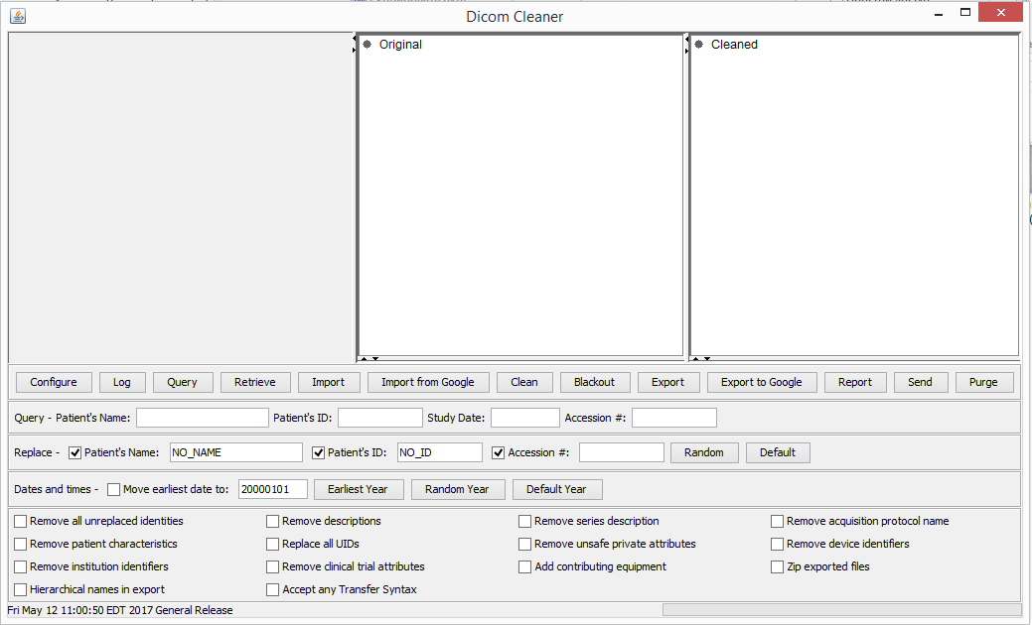

1. Press “Import from Google”.
2. Sign in to Google with your account connected to GHC.
3. Choose source for import service by choosing project, location, dataset and dicomStore:

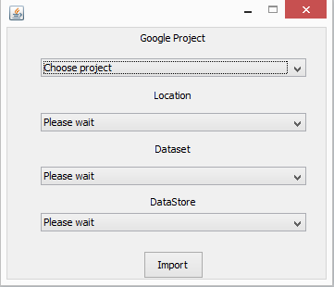

1. Press “Import”. Wait till data will be imported from Google.
2. Choose dicom files for anonymization, by clicking on “Original”

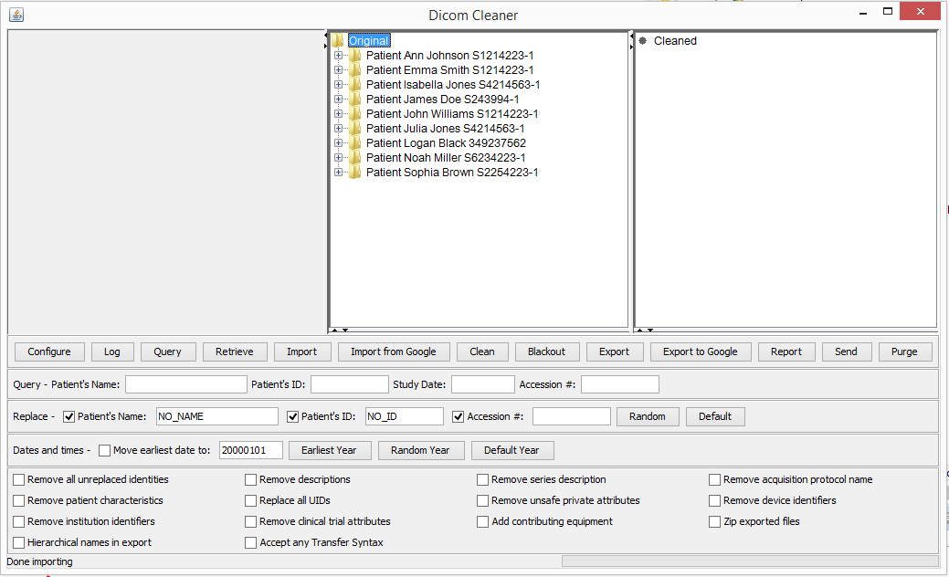

1. Press “Clean”, wait till the end of this process.
2. Choose files for pixel anonymization.

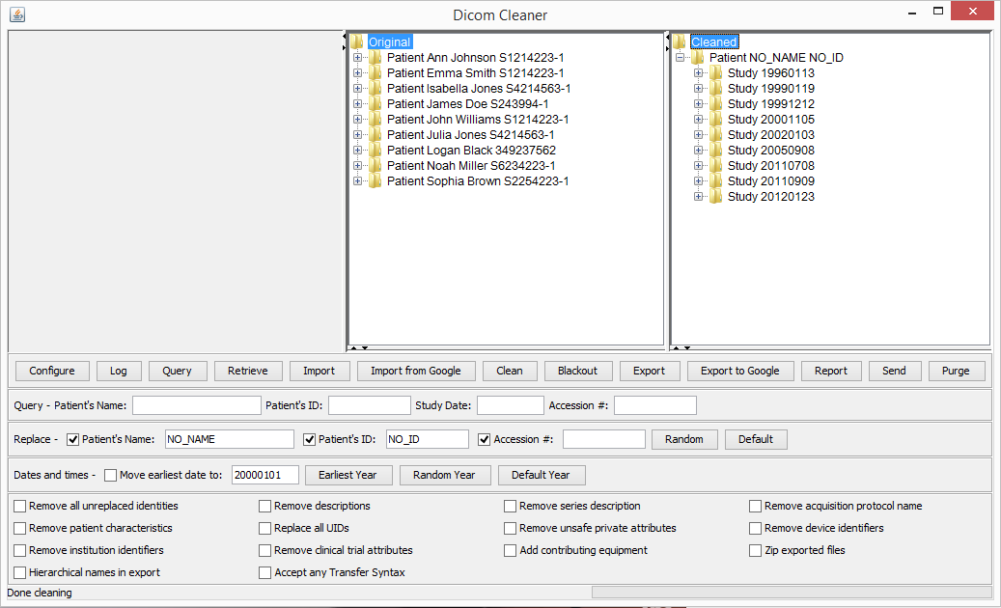

1. Press “Blackout”. Tool for pixel anonymization should appear with first image in it.

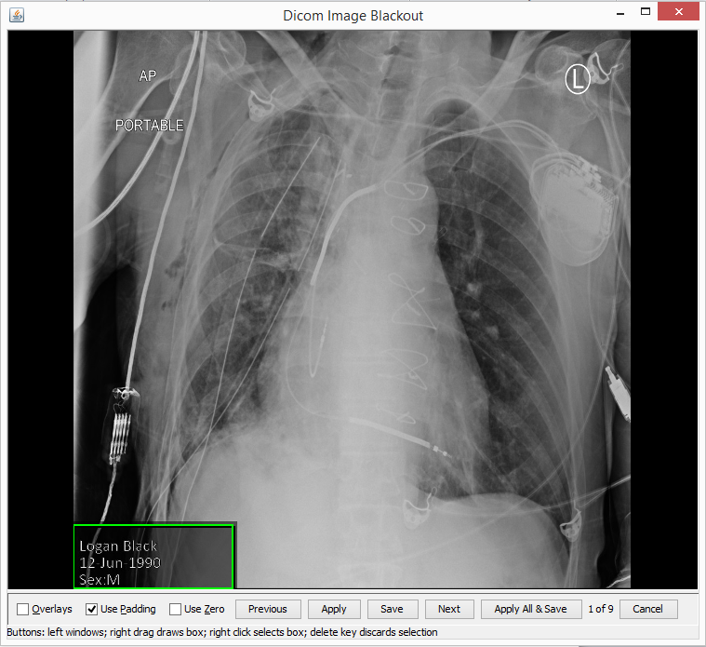

1. With right mouse button choose all places where image need pixel anonymization. Then press “Apply”, “Save” and “Next”. Repeat this procedure with all images.
2. Press “Export To Google”. Choose Project, Location, Dataset and enter DataStore (new or old)

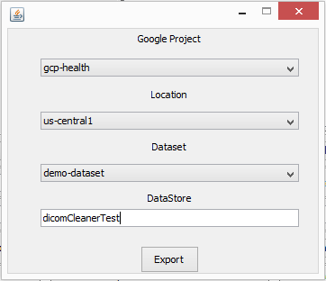

1. Wait till data will be exported.
2. Press “Report” to see the result report.

