Evaluation report: default strategy
dataset platform-v3-extended · 14 cases · embedder hash:v1:1024 · LLM none · vector store local
Generated 2026-10-30 07:50:49 UTC

Headline metrics
Metric | Value | Meaning
Recall@5 | 100.0% | share of gold passages found in the top 5
Precision@5 | 20.0% | relevant results in the top 5 (÷5)
MRR | 0.833 | mean reciprocal rank of the first relevant result
Faithfulness* | 53.1% | lexical proxy (not RAGAS)
Answer relevancy* | 19.7% | embedding proxy (not RAGAS)
Latency p50 / p95 | 17 / 31 ms | end-to-end per question
Tokens / query | 0 | provider-reported
Est. cost / query | $0.00000 | from MKA_PRICE_TABLE

Retrieval
MRR 0.833 over 3 cases with gold passages
K | Recall@K | Precision@K | nDCG@K
1 | 66.7% | 66.7% | 0.667
3 | 100.0% | 33.3% | 0.877
5 | 100.0% | 20.0% | 0.877

Answers and citations
Metric | Value
route_accuracy | 100.0%
keyword_accuracy | 100.0%
exact_count_accuracy | 100.0%
data_accuracy | 100.0%
abstention_accuracy | 100.0%
abstained_or_flagged_low_confidence | 100.0%
answer_rate_on_answerable | 100.0%
faithfulness_lexical (proxy) | 53.1%
answer_relevancy_embedding (proxy) | 19.7%
faithfulness_llm_judge | —
answer_relevancy_llm_judge | —
false_answer_rate_on_unanswerable | 0.0%
citation_accuracy | 100.0%
citation_gold_precision | 83.3%
required_sources_cited | 100.0%
stale_or_forbidden_content_absent | 100.0%

Agent execution
Measure | Value
Execution success rate | 100.0%
Cases with an agent failure | 0
Verified answer rate | 92.9%
Tool calls | 14
Failed tool calls | 0
Failed tool call rate | 0.0%
Cases with invalid citations | 0

By question type
Type | Cases | Correct | Recall@5 | MRR | Route accuracy | p50 ms
abstain | 1 | 100.0% | — | — | — | 15.3
analytics | 2 | 100.0% | — | — | 100.0% | 18.8
compare | 2 | 100.0% | — | — | 100.0% | 17.4
contradiction | 1 | 100.0% | — | — | 100.0% | 14.6
hindi | 5 | 100.0% | 100.0% | 1.000 | 100.0% | 15.0
parallel | 1 | 100.0% | — | — | 100.0% | 26.6
semantic | 2 | 100.0% | 100.0% | 0.750 | 100.0% | 29.2
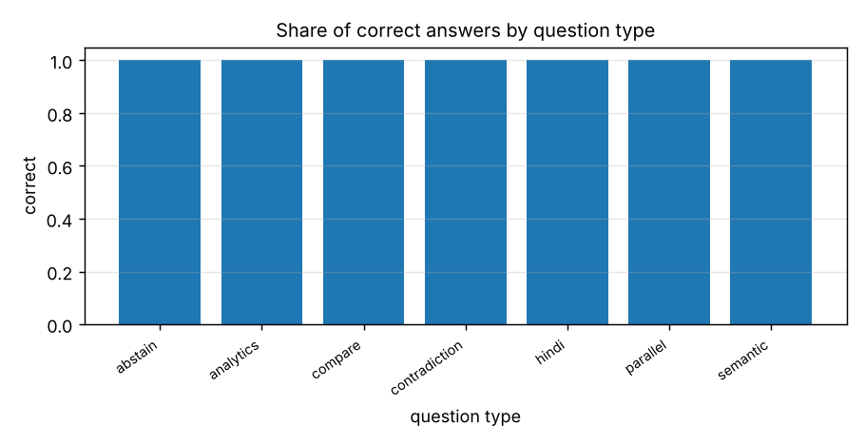

Failures (0)
None.

All cases
ID | Type | Route | Verified | Recall@5 | ms | Question
x01 | semantic | semantic | yes | 1.00 | 38 | How many days of annual leave do full-time employees accrue?
x02 | semantic | semantic | yes | 1.00 | 20 | How many days a week is remote work allowed?
x03 | compare | compare | yes | — | 19 | What changed in leave_policy.txt?
x04 | contradiction | compare | yes | — | 15 | Do leave_policy.txt and hr_faq.txt contradict each other?
x05 | compare | compare | yes | — | 16 | Compare supplier_a.txt and supplier_b.txt
x06 | hindi | exact | yes | — | 14 | "छुट्टी" कितनी बार आया है
x07 | hindi | semantic | yes | 1.00 | 23 | कर्मचारियों को कितनी छुट्टी मिलती है
x08 | hindi | data | yes | — | 19 | बिक्री का कुल योग क्या है?
x09 | hindi | data | yes | — | 15 | सबसे अधिक बिक्री किस कर्मचारी की है?
x10 | hindi | summarize | yes | — | 10 | hindi_policy.txt का सारांश दें
x11 | analytics | data | yes | — | 23 | Show the monthly revenue trend
x12 | analytics | data | yes | — | 15 | Are there any outliers in revenue?
x13 | parallel | parallel | yes | — | 27 | How many times does "Anjali Rao" appear, and what is the highest revenue?
x14 | abstain | semantic | no | — | 15 | What is the CEO's favourite colour?
Faithfulness/relevancy marked (proxy) are lexical/embedding heuristics, not RAGAS; the LLM-judge values exist only when an LLM is configured.
Token counts are provider-reported when available, otherwise estimated at ~4 characters per token; cost uses MKA_PRICE_TABLE.
citation_accuracy = share of returned citations whose page/row exists and whose excerpt occurs there (checked by the Verification Agent); agent execution success = no internal error or timeout in any agent node.

Sources
Document | Version | Type | Indexed | Hash
leave_policy.txt | 2 | txt | 2026-10-30T07:50:48+00:00 | 6f836604cf37
hr_faq.txt | 1 | txt | 2026-10-30T07:50:48+00:00 | fde8047743fa
supplier_a.txt | 1 | txt | 2026-10-30T07:50:48+00:00 | 180ecd1369a8
supplier_b.txt | 1 | txt | 2026-10-30T07:50:48+00:00 | 0b61d346f5d7
hindi_policy.txt | 1 | txt | 2026-10-30T07:50:48+00:00 | 37e53e5e19a1
bikri.csv | 1 | csv | 2026-10-30T07:50:48+00:00 | eac200f27472
orders.csv | 1 | csv | 2026-10-30T07:50:48+00:00 | 054b27688c41

