Evaluation report: default strategy
dataset synthetic-mixed-v1 · 42 cases · embedder hash:v1:1024 · LLM none · vector store local
Generated 2026-10-31 14:59:45 UTC

Headline metrics
Metric | Value | Meaning
Recall@5 | 90.9% | share of gold passages found in the top 5
Precision@5 | 18.2% | relevant results in the top 5 (÷5)
MRR | 0.909 | mean reciprocal rank of the first relevant result
Faithfulness* | 88.9% | lexical proxy (not RAGAS)
Answer relevancy* | 26.7% | embedding proxy (not RAGAS)
Latency p50 / p95 | 30 / 43 ms | end-to-end per question
Tokens / query | 0 | provider-reported
Est. cost / query | $0.00000 | from MKA_PRICE_TABLE

Retrieval
MRR 0.909 over 22 cases with gold passages
K | Recall@K | Precision@K | nDCG@K
1 | 90.9% | 90.9% | 0.909
3 | 90.9% | 30.3% | 0.909
5 | 90.9% | 18.2% | 0.909

Answers and citations
Metric | Value
route_accuracy | 100.0%
keyword_accuracy | 92.3%
exact_count_accuracy | 100.0%
data_accuracy | 100.0%
abstention_accuracy | 75.0%
abstained_or_flagged_low_confidence | 100.0%
answer_rate_on_answerable | 97.2%
faithfulness_lexical (proxy) | 88.9%
answer_relevancy_embedding (proxy) | 26.7%
faithfulness_llm_judge | —
answer_relevancy_llm_judge | —
false_answer_rate_on_unanswerable | 25.0%
citation_accuracy | 100.0%
citation_gold_precision | 60.7%
required_sources_cited | —
stale_or_forbidden_content_absent | —

Agent execution
Measure | Value
Execution success rate | 100.0%
Cases with an agent failure | 0
Verified answer rate | 90.5%
Tool calls | 49
Failed tool calls | 0
Failed tool call rate | 0.0%
Cases with invalid citations | 0

By question type
Type | Cases | Correct | Recall@5 | MRR | Route accuracy | p50 ms
abstain | 4 | 75.0% | — | — | — | 26.4
data | 9 | 100.0% | — | — | 100.0% | 27.4
exact | 6 | 100.0% | 100.0% | 1.000 | 100.0% | 19.9
intel | 2 | 100.0% | — | — | 100.0% | 33.9
semantic | 21 | 90.5% | 90.5% | 0.905 | 100.0% | 30.4
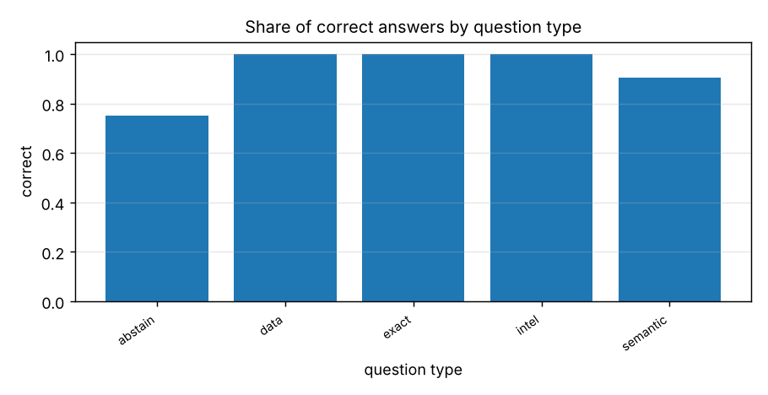

Strategy comparison
Strategy | Recall@5 | Precision@5 | MRR | nDCG@5 | p50 ms | p95 ms | $/query
semantic | 86.4% | 17.3% | 0.833 | 0.841 | 25.5 | 43.3 | 0.00000
keyword (BM25) | 86.4% | 17.3% | 0.864 | 0.864 | 24.1 | 31.7 | 0.00000
hybrid | 86.4% | 17.3% | 0.833 | 0.841 | 22.2 | 37.8 | 0.00000
hybrid + lexical rerank | 86.4% | 17.3% | 0.864 | 0.864 | 26.9 | 37.1 | 0.00000
hybrid + rerank + parent-child + corrective | 90.9% | 18.2% | 0.909 | 0.909 | 24.8 | 42.2 | 0.00000
hybrid + multi-query + graph | 90.9% | 18.2% | 0.909 | 0.909 | 27.6 | 40.9 | 0.00000
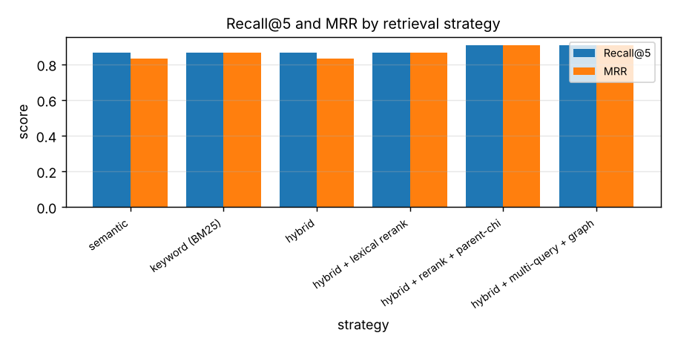

Failures (3)
Case | Question | Why
h01 | How much vacation time do staff get yearly? | keywords_ok, no relevant passage in top 5
h03 | What is the cost of the Pro subscription per month? | keywords_ok, no relevant passage in top 5
a02 | What was the weather in Pune yesterday? | abstained_ok

All cases
ID | Type | Route | Verified | Recall@5 | ms | Question
s01 | semantic | semantic | yes | 1.00 | 79 | How many days of annual leave do full-time employees accrue?
s02 | semantic | semantic | yes | 1.00 | 39 | How many unused leave days can be carried over?
s03 | semantic | semantic | yes | 1.00 | 33 | When is a doctor's note required for sick leave?
s04 | semantic | semantic | yes | 1.00 | 44 | How many days a week can employees work remotely?
s05 | semantic | semantic | yes | 1.00 | 40 | Within how many days must expense reports be filed?
s06 | semantic | semantic | yes | 1.00 | 27 | Above what amount are receipts mandatory?
s07 | semantic | semantic | yes | 1.00 | 22 | How often must passwords be rotated?
s08 | semantic | semantic | yes | 1.00 | 28 | Within how many hours must a security incident be reported?
s09 | semantic | semantic | yes | 1.00 | 30 | How long must customer data be retained?
s10 | semantic | semantic | yes | 1.00 | 27 | What notice is required to terminate the agreement for convenience?
s11 | semantic | semantic | yes | 1.00 | 49 | Within how many days must invoices be paid?
s12 | semantic | semantic | yes | 1.00 | 32 | Which law governs the agreement?
s13 | semantic | semantic | yes | 1.00 | 40 | How long does the confidentiality obligation last after termination?
s14 | semantic | semantic | yes | 1.00 | 31 | What is the return policy for products?
s15 | semantic | semantic | yes | 1.00 | 26 | How long is the hardware warranty?
s16 | semantic | semantic | yes | 1.00 | 30 | When will the mobile app launch?
s17 | semantic | semantic | yes | 1.00 | 38 | Who signed the reseller agreement with Delta Systems?
s18 | semantic | semantic | yes | 1.00 | 30 | What is the main risk to the launch?
h01 | semantic | semantic | no | 0.00 | 30 | How much vacation time do staff get yearly?
h02 | semantic | semantic | yes | 1.00 | 18 | How soon do we have to tell the security team about a breach?
h03 | semantic | semantic | yes | 0.00 | 30 | What is the cost of the Pro subscription per month?
e01 | exact | exact | yes | 1.00 | 20 | Does Anjali Rao appear in the documents?
e02 | exact | exact | yes | — | 17 | How many times does "Delta Systems" appear?
e03 | exact | exact | yes | — | 17 | Find SKU-1003
e04 | exact | exact | yes | — | 34 | Search for "Zaphod Beeblebrox"
e05 | exact | document_search | yes | — | 35 | Where does clause 8 appear?
e06 | exact | exact | yes | — | 20 | How many times does "Bob Mehta" appear?
d01 | data | data | yes | — | 30 | What is the total sales?
d02 | data | data | yes | — | 25 | Which employee has the highest sales?
d03 | data | data | yes | — | 26 | What is the average sales?
d04 | data | data | yes | — | 28 | What is the total sales in the North region?
d05 | data | data | yes | — | 27 | Which region has the highest total sales?
d06 | data | data | yes | — | 25 | How many customers are in the UK?
d07 | data | data | yes | — | 29 | Are there duplicate emails in customers.csv?
d08 | data | data | yes | — | 29 | Show the top 3 employees sorted by sales
d09 | data | data | yes | — | 27 | What is the median sales?
a01 | abstain | semantic | no | — | 22 | What is the capital of Mongolia?
a02 | abstain | semantic | yes | — | 38 | What was the weather in Pune yesterday?
a03 | abstain | semantic | no | — | 31 | Who won the football world cup in 1998?
a04 | abstain | semantic | no | — | 20 | What is the CEO's favourite colour?
i01 | intel | summarize | yes | — | 38 | How is Anjali Rao related to Dev Patel?
i02 | intel | summarize | yes | — | 30 | Extract all the entities from meeting_notes.md
Faithfulness/relevancy marked (proxy) are lexical/embedding heuristics, not RAGAS; the LLM-judge values exist only when an LLM is configured.
Token counts are provider-reported when available, otherwise estimated at ~4 characters per token; cost uses MKA_PRICE_TABLE.
citation_accuracy = share of returned citations whose page/row exists and whose excerpt occurs there (checked by the Verification Agent); agent execution success = no internal error or timeout in any agent node.

Sources
Document | Version | Type | Indexed | Hash
hr_policy.pdf | 1 | pdf | 2026-10-31T14:59:43+00:00 | ba9b0b05a100
security_policy.pdf | 1 | pdf | 2026-10-31T14:59:43+00:00 | dabd44ecf45e
service_agreement.docx | 1 | docx | 2026-10-31T14:59:43+00:00 | 4c5876822788
sales_q1.xlsx | 1 | xlsx | 2026-10-31T14:59:43+00:00 | a3456d50fc4a
customers.csv | 1 | csv | 2026-10-31T14:59:43+00:00 | ac028fe25d35
meeting_notes.md | 1 | md | 2026-10-31T14:59:43+00:00 | 346fd8191637
product_faq.txt | 1 | txt | 2026-10-31T14:59:43+00:00 | da8a3daa756b
inventory.json | 1 | json | 2026-10-31T14:59:43+00:00 | a85550f8d5d8

