DBS311_Lab07_W9_S20_Mongo comments

Lab 7b – Week 9

**MongoDB – Create/Delete Database/Collection/Documents)**

**Objective**

***Upload screenshots of successful run with outputs in a single document in blackboard within the deadline. Absolutely no email submission will be accepted. Capture screenshots of your code as well. Make sure the timestamp is visible in your screenshots.***

# *Due by Saturday, July 24th by 11:30pm, Late penalty is 100%.*

For Lab 7a

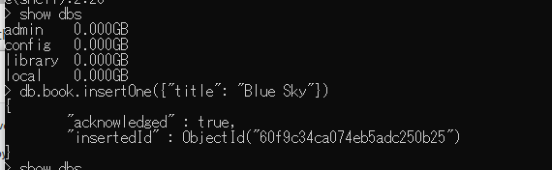

|  |
| --- |
| > db.student.insertOne ({  ... ... ... "first_name" : "Sarah",  ... ... ... "last_name" : "Stone",  Watch the name of what was entered this semester is different  ... ... ... "email" : "stone@email" ,  ... ... ... "status" : "full-time",  ... "gpa": "3.4" ,  ... "program" : "CPA"  ... }  ... )  **The output is as follows if successful:**  {  "acknowledged" : true,  "insertedId" : ObjectId("5f14533e055a850fa57b8d97")  } |

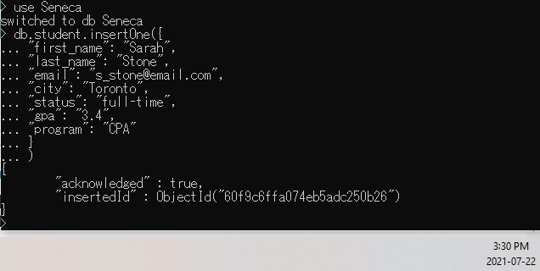

**FIND COMMAND**

Write a command to check if the document has been created successfully.

You use *find()* method to search and fetch documents.

See the following example:

db.student.find()

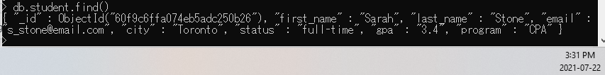

|  |
| --- |
| db.student.find()  { "_id" : ObjectId("5f14533e055a850fa57b8d97"), "first_name" : "Sarah", "last_name" : "Stone", "email" : "stone@email", "status" : "full-time", "gpa" : "3.4", "program" : "CPA" }  > |

To see the result in *JSON* format, you can run the following statement:

db.student.find().forEach(printjson)

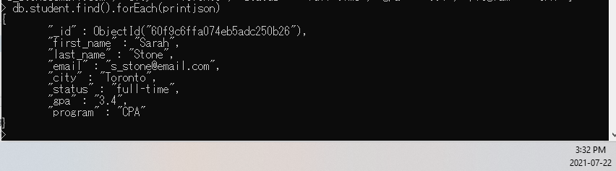

|  |
| --- |
| db.student.find().forEach(printjson)  {  "_id" : ObjectId("5f14533e055a850fa57b8d97"),  "first_name" : "Sarah",  "last_name" : "Stone",  "email" : "stone@email",  "status" : "full-time",  "gpa" : "3.4",  "program" : "CPA"  } |

Now remove Sarah

|  |
| --- |
| db.student.remove({"first_name": "Sarah"})  WriteResult({ "nRemoved" : 1 }) 🡸 and the result is |

What is the message as a result of your delete statement? Copy the message in the following box:

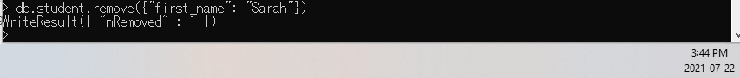

|  |
| --- |
| WriteResult({ "nRemoved" : 1 }) |

To see if the document is removed successfully, write a search statement to see if the document exists.

(We look for one document not all).

|  |
| --- |
| Doing the following  db.student.find({"first_name": "Sarah"}) 🡸 nothing happens |

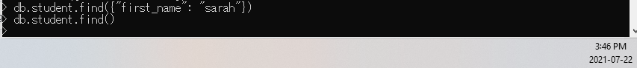

Define a variable named *starray* and add these two document to the variable.

(You are storing more than one document, so you need to define an array.

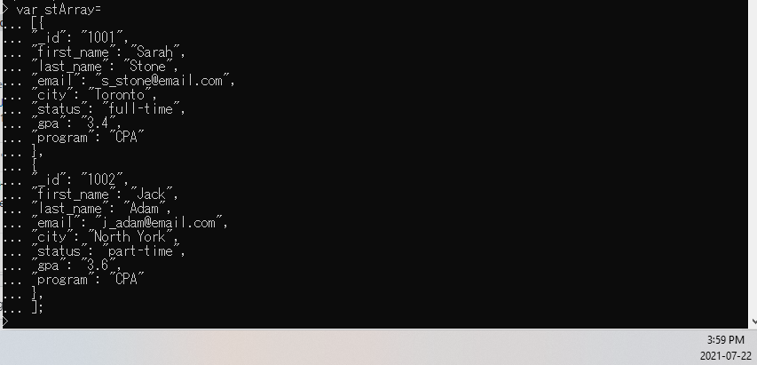

What message is displayed after you execute the insert statement. Copy the message in the following box:

|  |
| --- |
| BulkWriteResult({  "writeErrors" : [ ],  "writeConcernErrors" : [ ],  "nInserted" : 3, ….. inserted 3  "nUpserted" : 0,  "nMatched" : 0,  "nModified" : 0,  "nRemoved" : 0,  "upserted" : [ ]  }) |

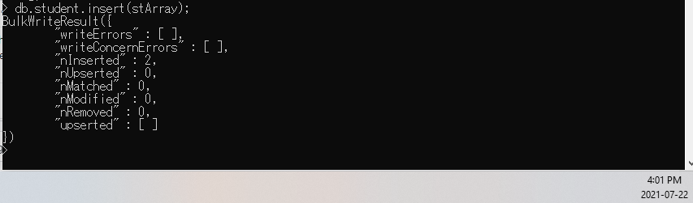

Write a statement that shows all documents inserted in your collection *student*:

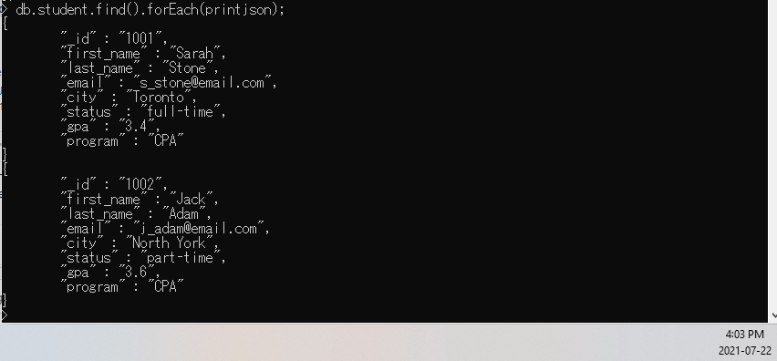

|  |
| --- |
| db.student.find().forEach(printjson);  NOTE: It is forEach --- watch the case |

Remove all documents

|  |
| --- |
| db.student.remove ({});  WriteResult({ "nRemoved" : 3 }) |

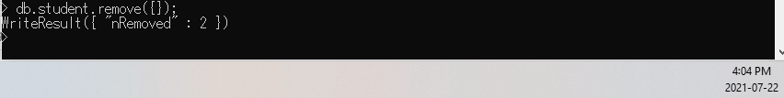

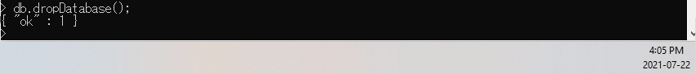What message is displayed after you execute the drop statement? Copy the message in the box below:

|  |
| --- |
| db.dropDatabase();  { "dropped" : "seneca", "ok" : 1 } |